1.)
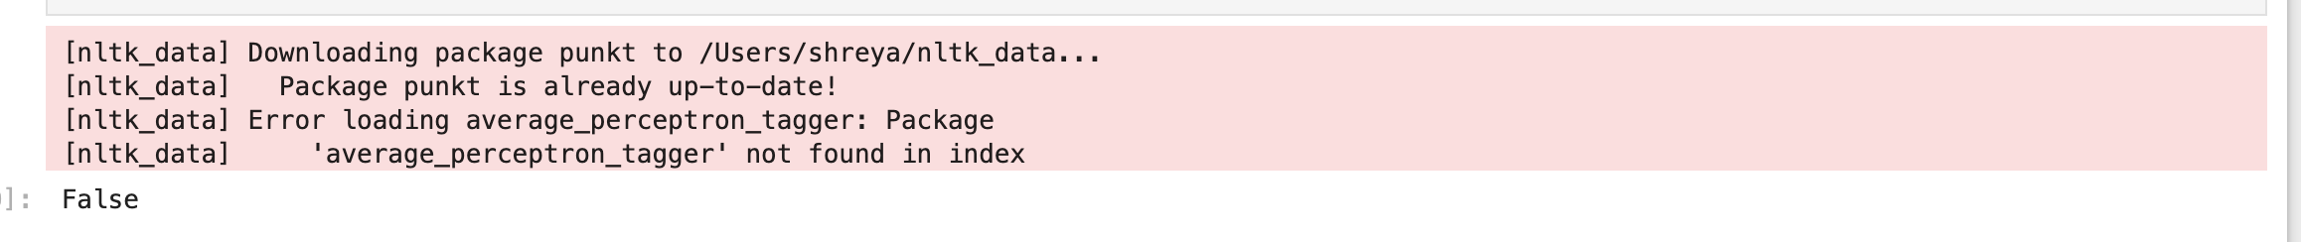
Error Description:
While performing Part-of-Speech tagging using the NLTK library, a LookupError occurred due to the absence of the required NLTK resource averaged_perceptron_tagger.
Resolution:
The error was resolved by downloading the missing NLTK resource using the nltk.download() function. After downloading the required package, the program executed successfully without errors.

2.)
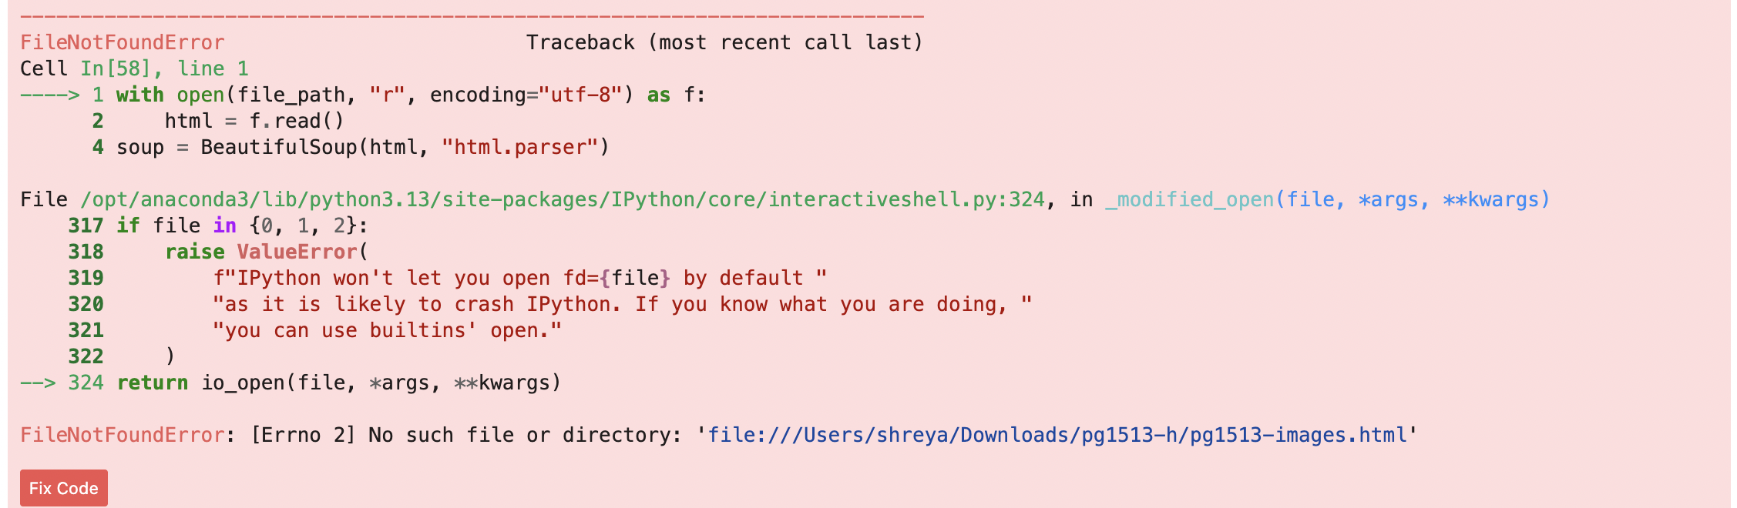
Error Description:
A FileNotFoundError occurred while attempting to read an HTML file using Python’s open() function. The system was unable to locate the specified file path.
Resolution:
The error was resolved by removing the file:/// prefix and providing the correct local file path. After correcting the path, the file was successfully accessed and processed.

