Teaching assistant intervention in online courses: a comparative study of two massive open online courses

Insert Subtitle Here

FirstName Surname†  
 Department Name  
 Institution/University Name  
 City State Country  
 email@email.com

FirstName Surname  
 Department Name  
 Institution/University Name  
 City State Country  
 [email@email.com](mailto:email@email.com)

FirstName Surname  
 Department Name  
 Institution/University Name  
 City State Country  
 email@email.com

ABSTRACT

In Massive Open Online Courses (MOOCs), discussion forum is a platform that provides communication and interaction between its users, such as students, teachers and teaching assistants. In this research, we focus on the teaching assistants’ interactions with other learners within the discussion forum of two courses with different subject matter, the first is a computer science and the second a humanities course. The purpose of this study is to scaffold teaching assistants’ discussions in both courses and explore the characteristics of their intervention in them. The method we used to achieve that is a comparative qualitative analysis. We employ a coding scheme, a hybrid version of Chandrasekaran’s taxonomy, in order to categorize the messages of teaching assistants within the forum of both courses. Two coders performed the labeling on a subset of the discussion data by using the proposed coding scheme. The results reveal quite notable differences in the characteristics of teaching assistants’ interventions within the two courses discussion forum. Despite the common aspects of their behavior, which include answering to students’ questions about the course material and helping learners with their problems on assignments, differences were found on the characteristics of their messages. In the computer science course, teaching assistants were more formal in their dialogues, with shorter messages and with a more robust way of speaking. On the other hand, in humanities course, teaching assistants’ vocabulary was more informal, their messages were more extended with a more familiar way of answering. The results of this study may provide us with useful implications for designing discussion interventions in MOOCs in the future based on their subject matter.

CCS CONCEPTS

• **Education** 🡪 E-learning, Learning analytics

KEYWORDS

Learning analytics, Massive Open Online Courses, discussion forum, teaching assistant intervention

ACM Reference format:

FirstName Surname, FirstName Surname and FirstName Surname. 2018. Insert Your Title Here: Insert Subtitle Here. In *Proceedings of ACM Woodstock conference (WOODSTOCK’18). ACM, New York, NY, USA, 2 pages.* <https://doi.org/10.1145/1234567890>

1 INTRODUCTION

MOOCs nowadays have become a very popular tool for distance education due to the variety of the available courses found online and the flexibility they provide with the course material. Through technology-based platforms, such as discussion forums, they provide opportunity for interactions among learners inside the course’s environment. In discussion forum, learners can interact with their peers and the instructional staff and dive deeper in the course’s content, search for solutions in their problems and give help to other learners. Prior work has shown that the active participation in the discussion forum help learners improve their learning performance [1, 5, 6]. A part of this improvement is due to the intervention of instructors in learners’ discussions. Their role is to guide learners within the course’s platform, help them with their questions and generally support their learning experience.

To provide a more engaging and effective learning experience to learners, there has been a lot of research on instructor interventions within forum discussions [4]. The role of instructors and teaching assistants within the discussion forum is an important factor in the evolution of the learners’ participation and outcome. The level of instructor intervention may influence discussion and participation of learners in unexpected ways [2]. In his research, Mazzolini [3] studied the effect of instructor intervention on student participation in online discussion forums. The findings of this study showed that higher frequency of instructor posting resulted to shorter dialogues and less frequent learner posting. Another study by Balaji [7] revealed that facilitating discourse has a strong positive effect on the students’ interactions in discussion forums. The findings of this study also indicate that the instructor’s role in online discussion is essential for maintaining the interest and motivation of learners to participate and engage with the course material.

In this study, we collected data from the discussion forum of two completed courses in different subjects, one related to technology (Introduction to Programming) and the other in humanities (World History of Religion). They were collected from Mathesis, a prominent Greek MOOCs platform based on OpenEdX technology. In this platform, there is a distinction in the roles of the instructor, the forum moderator and teaching assistant of an online course. Instructor is the main teacher of the course, he performs the video lectures, provides the course’s content and rarely participates in the forum to answer to other learners’ questions. The moderator’s role is to maintain a healthy climate within the course’s discussion forum, delete improper messages and intervene if a message does not comply with the forum’s rules (e.g. posting solutions of the course’s assignments). Teaching assistant, on the other hand, is a learner, who is informally authorized by the course’s staff to help other learners within discussion forum, answer to their questions and improve their learning experience. He is usually a high-graded learner, with high-level of engagement within the course and he voluntarily accepts this role. This role is quite unusual because in most MOOC platforms the course’s personnel provides this kind of assistance to learners, within specific restrictions and rules. In this context, teaching assistants’ role is quite different because they are also learners of the course and their behavior and intervention might reveal interesting characteristics. In both courses, teaching assistants intervened in forum discussions and offered help to other learners, but the question is if the different subject matter of the courses can result in different characteristics in these types of interactions.

Specifically, in this work we ask the following research questions:

1. Are there any differences in teaching assistant interventions within the discussion forum of two courses with different subject matter?
2. If yes, then what differences are there observed in teaching assistants’ interaction with other learners and why they occur?

We consider that answering these research questions will give us important insights about how teaching assistants behave within courses with different subject matters discussion forum and provide us implications for designing discussion interventions in MOOCs in the future.

In this work, to answer these research questions, we perform a qualitative analysis on teaching assistants’ messages. We choose randomly a subset of 200 discussions teaching assistants intervened to, for each course. Next, we use a hybrid coding scheme based on Chandrasekaran’s taxonomy, which includes only the instructor intervention categories, to label teaching assistants’ messages. Two coders performed the labeling of the messages in the coding scheme categories. The results and discussion are presented below.

2 RELATED WORK

2.1 Research on instructor intervention in discussion forums

Instructor and teaching assistant intervention within the discussion forum has been a topic of interest of many studies. In his study, Tomkin [8] investigates the impact instructors and other instructional staff have on student learning outcome and participation rates within the discussion forum of a physics course. By dividing enrolled students in two control groups using an A/B test, one without and the other with instructional interaction, they tried to identify differences in students’ learning outcomes. The results showed that there was no significant difference between the two groups in terms of completion rates, but did have on forum badge completion. In a similar work of An [12], they divided students in three groups with different facilitation approaches to identify differences on students’ participation rates. In the first group instructors were responding in students’ messages directly and students should reply to at least two other student posts, in the second the same but without being necessary to answer to other peer posts and in the third group, students could only communicate with other peers and not with instructors. Results showed that in group 2, interaction of students with other peers rarely occurred because students chose to communicate more with the instructors. In groups 1 and 3, students tended to more communicate with other peers when the instructor intervention was minimal.

These studies give important insights about how the design of instructional staff intervention can alter learners’ participation rates in the discussion forum.

2.2 Research on forum classification tasks

In the field of forum classification models, Wise [10] build a predictive model in order to categorize and identify threads based on whether or not they relate to the course’s content. The results revealed some useful evidence where content-related threads contained some distinct linguistic features over the unrelated threads and the classifier accuracy was quite satisfying (>0.77).

In his work, Chandrasekaran [9] studies the problem of instructor intervention in discussion forum and builds a binary classifier in order to predict whether an instructor or not must intervene in a discussion thread. The results of this study showed that such a decision problem is quite difficult to solve and the classifier’s accuracy differs in courses with different subject matter. In another work, Chandrasekaran [11] studies ways for automatic guidance of instructors in discussion forums. He proposes a new taxonomy of transactive contributions of instructors. He uses natural language processing techniques to analyze discussion forum texts, categorize them and then conditional random fields (CRF), a supervised machine learning technique, to create a predictive model. He proposes a type of dashboard that would use this model and give feedback to instructors by mentioning them which threads are urgent to be intervened by them and discusses the difficulties of such an implementation.

3 ANALYSIS OF TEACHING ASSISTANTS’ CONTRIBUTION

3.1 Context of the study

For this study, we retrieved data from two MOOCs offered in 2017 on the mathesis.cup.gr platform. The first course, ‘*Introduction to Python’* (IP), was an introductive course to computer programming through Python. The second course, ‘*World History: Man versus Divine*’ (WH), aimed to introduce learners to the history of Asian religions during the Second Circle of World History. The duration of the two courses were 6 and 9 weeks, respectively. The instructional design of both courses consisted of video lectures, assignments and weekly tests, supported by a structured forum. Our study was based on anonymized discussion forum data. Students were encouraged to use the forum and contribute by posting questions and comments related to the course. The participation in the forum was optional. In each course, some participants emerged as particularly active in the forum and were available to support their fellow students, while they demonstrated good understanding of the subject matter. These were soon contacted by the course instructors and were assigned the role of *teaching assistants* (*TAs*)and were also asked to contribute in subsequent editions of the courses. The number of students that took the role of teaching assistants, was three for the IP course and four for the WH course. The TA’s role was to watch the forum discussions regularly and help other learners with their questions and problems on a voluntary basis.



**Figure 1: Forum structure: threads, posts, replies**

3.2 Analysis of data

The discussion forums of both the courses under study, have been structured in three levels, *threads* that are related to a specific topic or period of learning (e.g. thread for week 1), *posts* that are messages posted in the context of a thread, and *replies* to posts (Figure 1).

We are going next to describe the contribution of the Teaching Assistants in these forums. Table 1, summarizes the TAs activity in the forums of the two courses.

As we can see in Table 1, there are some similarities as well as notable differences in the patterns of teaching assistants’ participation in the two courses. In terms of activity, as measured by the number of messages posted, the two courses have similar characteristics, the three TAs of the Python course posted on average 38.6 messages per course-week, while the four TAs of the history course posted 37.8 messages per course-week, i.e. in both courses the TAs on average posted almost 8 messages per working day. In terms of length of these messages, the history course TAs wrote lengthier messages (average length 58 words) compared to those of the Python programming course (average length 42 words). This may imply that TAs in the history course were more analytic than those of the programming course, in their replies. By comparing the response time, the history course TAs were much faster in responding to messages with average response time 4 hours, against 13.3 hour average response time of those of the programming course. Finally, the number of posts in which on average teaching assistants intervened was on average, very similar, i.e. 143.7 for the programming course, against 150.5 for the history course. This high number of posts they replied to implies a high engagement of TAs within the discussion forums.

|  |  |  |
| --- | --- | --- |
|  | IP Course | WH Course |
| Avg number of replies posted per TA, per week | 38.6 | 37.8 |
| Avg number of words per reply | 42.6 | 58.0 |
| Avg number of posts with TAs participation | 143.7 | 150.5 |
| Avg response time (hours) to a message | 13.3 | 4.0 |

**Table 1: Posted messages of TAs in both courses**

Next we discuss the characteristics of the TA posts, i.e. the posts in which teaching assistants intervened. The features of these posts are included in Table 2.

|  |  |  |
| --- | --- | --- |
|  | IP Course | WH Course |
| Avg length* of the posts with TA participation | 5.3 | 7.2 |
| Avg number of TA’s replies per post | 1.3 | 2.8 |
| Avg number of non-TA per post | 2.4 | 2.8 |

*total number of replies a post had

**Table 2: Posting activity measures of TAs in both courses**

The average length of posts the teaching assistants replied to, differed considerably, it was much higher in the history course (7.2 messages against 5.3 in the programming course). So, teaching assistants of the history course tend to participate in longer conversations that those of the programming course. They also tend to reply more in each post they participate. In the history course, the teaching assistants posted 2.8 replies on average in each post they intervened, while in the programming course, just 1.30. This may be explained due to the fact that in the programming course, which is a technology-related one, learners usually post problems to which teaching assistants can give exact replies usually in a single message, while in the history course, students problems relate to historical events, in which the teaching assistants reply engaging in a lengthy dialogue with the learners.

4 ANALYSIS OF TA INTERVENTIONS

In this section, we proceed with analysis of the content of teaching assistants’ interventions, in the two courses. It is common in a MOOC study, to use mostly quantitative data form traces of students’ behavior [13, 14]. As content analysis of such large volumes of data is a tedious process. In this section, we attempt to analyze a sample of teaching assistants’ interventions, in order to classify them and observe patterns of their interventions in the two courses, as their behaviors are better understood through the content of the their interactions with other learners within the discussion forum of a course.

4.1 Coding scheme

In the study that follows, the unit of analysis is the message. The objective was to classify by hand-coding a random sample of each courses’ teaching assistants’ messages. By manually diving deeper in the TAs messages’ content, we aim at comparing their patterns of behavior across the two courses.

First we randomly choose 200 posts in which TAs had intervened and used a coding scheme based on a hybrid model of Chandrasekaran’s taxonomy [11] to categorize the TAs messages in them. Our coding scheme, which is presented in Figure 2, is adapted from the ‘*Instructor Interventions’ taxonomy* proposed by Chandrasekaran. We do not include the peer interventions because we wish to focus only on the TA interventions in student conversation.

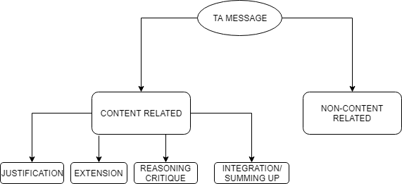

Figure 2: Coding scheme used for categorizing TAs' messages

As we can see from Figure 2, the coding scheme contains two levels of message categorization. In the first level, the general content of the message is checked. If the message is related to the course’s content it is labeled as ‘*Content related’*, if not as ‘*Non-content related*’. To label a message as ‘Content related’, the TA’s message should relate to the video lectures’ content, the course’s assignments or weekly tests and problems or questions that learners faced within the course’s material. If the message is irrelevant to the course, then it is labeled as ‘Non-content related’.

In the second level, if the message is related to the content of the course, then it must be specifically assigned to one of the following categories.

1. **Justification message**: Message containing analytical explanation of a theory or a solution that was proposed. The TA provides evidence and explains in detail the solution of a problem a learner faces.
2. **Extension message**: The problem that was discussed is solved but the TA proposes alternative solutions and explains the pros and cons of each one to the learner.
3. **Reasoning Critique**: TA makes his own statement on a problem. He makes criticism on an issue and by referring to his own experience he proposes the solution.
4. **Integration/Summing up**: TA gives directly the solution without being analytical to it. His message implies that the current conversation should end with his statement.

4.2 Coding of the transcripts

Two coders were selected for this coding task. The principal investigator discussed the coding scheme with the coders, who then coded all the TA messages from the randomly selected posts. The coders were encouraged to refine the protocol as they coded. Their results were evaluated for interrater reliability using Cohen’s kappa (k). Cohen’s kappa is a chance-corrected measure of interrater reliability. In calculating Cohen’s kappa, reliability is reported after accounting for the possibility of chance agreement between coders [15]. In our five-category coding scheme the results showed a kappa coefficient 0.90. This interrater reliability is considered high, so it demonstrates a reliable coding, based on the fact that a consensus was achieved, on which to base our analysis.

5 RESULTS AND DISCUSSION

In response to the first research question, we hand-coded a random subset of discussions from the two courses’ forum data. The results of the coding are presented in this section. In Figure 3, the results of the coding at the first level of categorization across the two courses.

We see that in IP course almost 75% of the messages were content related, while the WH course messages were more evenly distributed in the two categories. In IP course, most posts related with problems learners faced with Python code. TAs intervened in these conversations and tried to provide solutions to them by giving coding examples or guiding learners. The conversations that did not relate with the course content were mostly problems learners faced with the MOOC platform, assignment deadlines and installation problems of the Python environment used. On the other hand, in WH, the fact that half of the interventions were coded as ‘*Non-content related’* can provide us with some insights on the patterns of behavior of TAs in this course. They had the tendency to act more socially and intervene in conversations that were even irrelevant with the course’s content. There were conversations where users were introducing themselves to each other or generally with more social content and TAs were engaged by participating, without necessarily offering specific help to learners. To further analyze the TAs behavior, in Figure4 we present the results from the second level categorization.

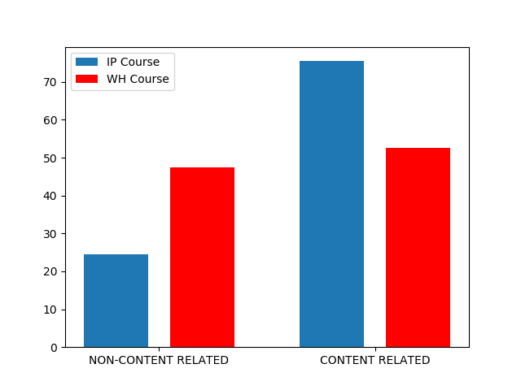

Figure 3: First level of categorization of the two courses messages

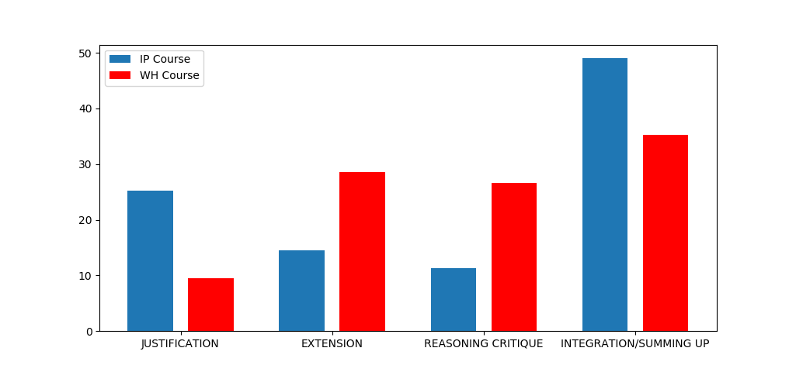

Figure 4: Second level of categorization of the two courses messages

In Figure 4, the ‘Contented related’ messages of the TAs in both courses, are distributed in different classes. Some noticeable difference can be seen between the two courses.

In the IP course, almost half of the TAs’ interventions are classified as contributing towards *integration of a problem*. In the examined data, most of messages (49.1%) were direct answers to learners’ questions about Python code problems. Such messages mostly contained a short explanation of the solution and the rest of the message contained the correct code that responds to the question. After such interventions, the conversations were closed or sometimes a thankful message followed by the student.

The second message class, in terms of size, was that of ‘*Justification’* interventions (25.4%). In such interventions, TAs tend to answer to theoretical questions of learners. These questions related to the use of Python libraries, methods of Python classes, functionality of Python interpreter and other subject related questions about the programming language that needed clarifications. These messages were quite long in length, containing a lot of programming terminology and sometimes examples of code that learners could run to understand better the corresponding concepts. The last two categories that were less common in the data sample were those of ‘*Extension messages’* (15.9%) and the ‘*Reasoning Critique’* (9.6%) interventions. The only occasions that did ‘*Extension’* interventions occur were in conversations in which the students were discussing the performance of different solutions to a problem. In these conversations, the TA intervention just added some more information to the learners’ discussion and did not, in principle, solved any specific problem. The TAs just proposed another correct solution and the conversation would continue after that. The last category, ‘*Reasoning Critique’*, occurred even less frequently. In these cases, the TAs intervened in discussions where they proposed a solution as the correct one by referring to their own experience as programmers.

In WP course, on the other hand, there are some notable differences. We can see that in this course also the ‘*Integration of a problem*’ is the most common category in TA intervention (37.4%). This is quite expected as a result, because TA’s role is to help learners overcome their problems and propose solutions to them. So ‘Integration of a problem’ should be the most common type of intervention in both discussion forums. The differences that are observed exist in the other three categories. The second most frequent type of intervention that occurred within the forum was the ‘*Extension’* (28.3%)*.* In many conversations learners were discussing historical facts and religion specific issues that were presented through the video lectures. In these conversations the TA’s intervention just added more information and historical resources to the conversation in order to extend the learners’ knowledge on the discussed theme. Such information were links to historical websites, references to historical books or details that were not observed by learners through the video lecture. In a similar percentage (26.1%) the ‘*Reasoning Critique’* intervention occurred. Many conversations contained an exchange of opinions between learners in different historical facts and decisions that were taken by historical people. These conversations also occurred from the content of the video lectures. TA took the opportunity to intervene and express their own opinion and critiques not only to the historical facts, but also to other learners’ opinions. Such interventions resulted to long dialogues and in some cases to controversies between learners and TA. The last category that was least occurred was the ‘*Justification*’ intervention (8.2%). This intervention occurred in a very small frequency and contained conversations where the video lectures theory was not well understood by learners. TA took the chance to intervene and in an analytical way explain them their questions and fill their theory holes.

Another notable difference that is observed in the two courses TA interventions is the type of conversations that they develop with learners and their attitude within their messages. TAs in IP course were more direct in their messages with a more formal style of speaking, while in the WH course the answers were quite extended and the way of messaging was more informal. This may be verified through our Table 1 and 2 measurements. Such observations imply also differences between the two courses’ TA.

As we can see, to answer our first research question, it is quite obvious from our analysis that there are differences in TA’s interventions in the discussion forum of these two different subject related courses. For the second research question, these differences that are observed between the two courses’ TA interventions, may rely on many factors. A factor which may relate in such differences is the course’s subject matter. In our study we analyzed a computer science and a humanities course. Computer science lessons belong to technology-based context and in most times the conversations that occur relate with problems learners face with the tools of the course and ways of using them. This may explain the fact that ‘*Justification’* and ‘*Integration’* interventions occurred mostly in IP course. On the other hand, in a humanities course, most questions may rely in historical facts and generally on theory-based context. This may explain the quite frequent ‘*Extension*’ and ‘*Reasoning Critique*’ interventions within the forum. Historical facts are presented through the course and usually the learners want to explore in much more detail facts that relate with them or make their own statements about them. As for the only common frequently occurred category, ‘*Integration/Summing up*’, as we said it may be expected to be the most frequent because this depicts the general role of TA within the discussion forum. Their role is to give learners solutions to their problems and finish such conversations where the solution is tried to be explored by learners.

6 CONCLUSION

In this paper we adopted qualitative approach in order to explore the differences between the instructional staff interventions in the discussion forum of two courses with different subject matter. More specifically we focused on teaching assistants, whose role is quite different our courses’ structure. To achieve that collected discussion forum data from two courses with different subject matter, we develop a coding scheme based on Chandrasekaran’s taxonomy [11] and trained two coders with it in order to label a subset of them.

The results revealed some quite notable differences between the characteristics of the two courses’ TA interventions. It is quite clear that the different subject matter plays an important role in the type of conversations created within the discussion forum, and moreover in the type of TA interventions that occur within them. Another factor that may be causing such differences may be the educational level of the participants and generally the characteristics of the learners. This factor we may say that also relies on the subject matter of the course, because we can say that different types of learners have interest in different types of courses.

This study give us quite useful insights about the differences between TA interventions in courses with different subject matter. In future research we want to explore deeper such differences by coding a much bigger sample of our dataset and expand such analysis in other courses with different context (Physics, Philosophy etc). Such analysis may provide us implications for understanding better the TA’s behavior within the discussion forum and design discussion interventions in MOOCs in the future.

7 REFERENCES

[1] Smith, M. K., Wood, W. B., Adams, W. K., Wieman, C., Knight, J. K., Guild, N., & Su, T. T. (2009). Why peer discussion improves student performance on in-class concept questions. Science, 323(5910), 122-124.

[2] Mazzolini, Margaret, and Sarah Maddison. "When to jump in: The role of the instructor in online discussion forums." Computers & Education 49.2 (2007): 193-213.

[3] Mazzolini, Margaret, and Sarah Maddison. "Sage, guide or ghost? The effect of instructor intervention on student participation in online discussion forums." Computers & Education 40.3 (2003): 237-253.

[4] Yang, Diyi, David Adamson, and Carolyn Penstein Rosé. "Question recommendation with constraints for massive open online courses." Proceedings of the 8th ACM Conference on Recommender systems. ACM, 2014.

[5] Barab, Sasha A., and Thomas Duffy. "From practice fields to communities of practice." Theoretical foundations of learning environments 1.1 (2000): 25-55.

[6] Chi, M. T., Siler, S. A., Jeong, H., Yamauchi, T., & Hausmann, R. G. (2001). Learning from human tutoring. Cognitive Science, 25(4), 471-533.

[7] Balaji, M. S., and Diganta Chakrabarti. "Student interactions in online discussion forum: Empirical research from'media richness theory'perspective." Journal of Interactive Online Learning 9.1 (2010).

[8] Tomkin, Jonathan H., and Donna Charlevoix. "Do professors matter?: Using an a/b test to evaluate the impact of instructor involvement on MOOC student outcomes." Proceedings of the first ACM conference on Learning@ scale conference. ACM, 2014.

[9] Chandrasekaran, M. K., Kan, M. Y., Tan, B. C., & Ragupathi, K. (2015). Learning instructor intervention from mooc forums: Early results and issues. arXiv preprint arXiv:1504.07206.

[10] Wise, Alyssa Friend, Yi Cui, and Jovita Vytasek. "Bringing order to chaos in MOOC discussion forums with content-related thread identification." Proceedings of the Sixth International Conference on Learning Analytics & Knowledge. ACM, 2016.

[11] Chandrasekaran, M., Ragupathi, K., Kan, M. Y., & Tan, B. (2015). Towards feasible instructor intervention in MOOC discussion forums.

[12] An, Heejung, Sunghee Shin, and Keol Lim. "The effects of different instructor facilitation approaches on students’ interactions during asynchronous online discussions." Computers & Education 53.3 (2009): 749-760.

[13] Breslow, L., Pritchard, D. E., DeBoer, J., Stump, G. S., Ho, A. D., & Seaton, D. T. (2013). Studying learning in the worldwide classroom research into edX's first MOOC. Research & Practice in Assessment, 8, 13-25.

[14] Brinton, C. G., Chiang, M., Jain, S., Lam, H., Liu, Z., & Wong, F. M. F. (2014). Learning about social learning in MOOCs: From statistical analysis to generative model. IEEE transactions on Learning Technologies, 7(4), 346-359.

[15] Banerjee, M., Capozzoli, M., McSweeney, L., & Sinha, D. (1999). Beyond kappa: A review of interrater agreement measures. Canadian journal of statistics, 27(1), 3-23.