# Set Python Path

C:\Python27

My Computer > Properties > Advanced System Settings > Environment Variables > Edit

* Right-click 'My Computer'.
* Select 'Properties' at the bottom of the Context Menu.
* Select 'Advanced system settings'
* Click 'Environment Variables...' in the Advanced Tab
* Under 'System Variables': Click Edit

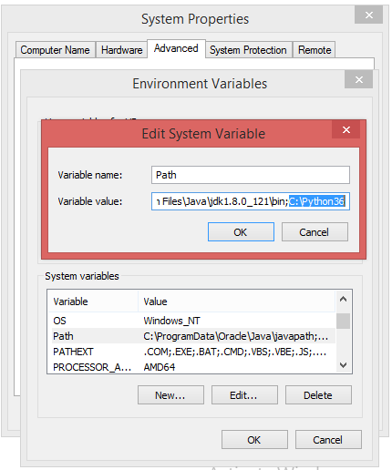

Just type "python" on the **command line**

