# Vagrant

Vagrant gets integrated with hypervisors like VirtualBox and gives as a command line interface to automate vm lifecycle.

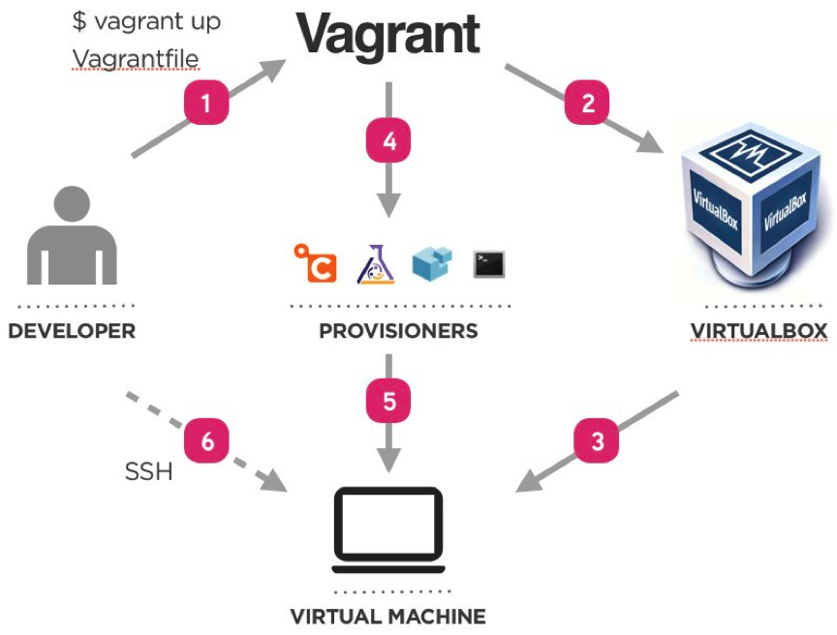

1. The user creates a Vagrantfile, which is a declarative file (written in Ruby) that describes the type of machine needed, as well as how to configure and provision that machine. The user uses Vagrant to execute the Vagrantfile.
2. Vagrant uses VirtualBox as a provider. It can also use other providers.
3. The machine is up.
4. Vagrant invokes a provisioner to configure the machine.
5. The provisioner provisions the machine. It can be a simple shell script or Ansible, for example.
6. One can access the deployed machine by ssh.

That’s it. You can manage and launch virtual machines with a few commands. And its complexity is as much as you want.

Once you or someone else creates a single Vagrantfile, you just need to vagrant up and everything is installed and configured for you to work.

Other members of your team create their development environments from the same configuration, so whether you are working on Linux, Mac OS X, or Windows, all your team members are running code in the same environment, against the same dependencies, all configured the same way. Say goodbye to "works on my machine" bugs.

## Installing Vagrant on windows.

1. Download the free VirtualBox for your operating system from [the VirtualBox website](https://www.virtualbox.org/wiki/Downloads).
2. After download, just run the binary and install it.
3. Download [Vagrant](https://www.vagrantup.com/downloads.html).
4. Again, just run the binary to install it.
5. Download git, Install with default settings.

## Vagrant Cloud

Vagrant boxes are VM images which already has the OS and softwares installed in them. We just need to download these boxes from vagrant cloud by using our vagrant CLI.

<https://app.vagrantup.com/boxes/search>

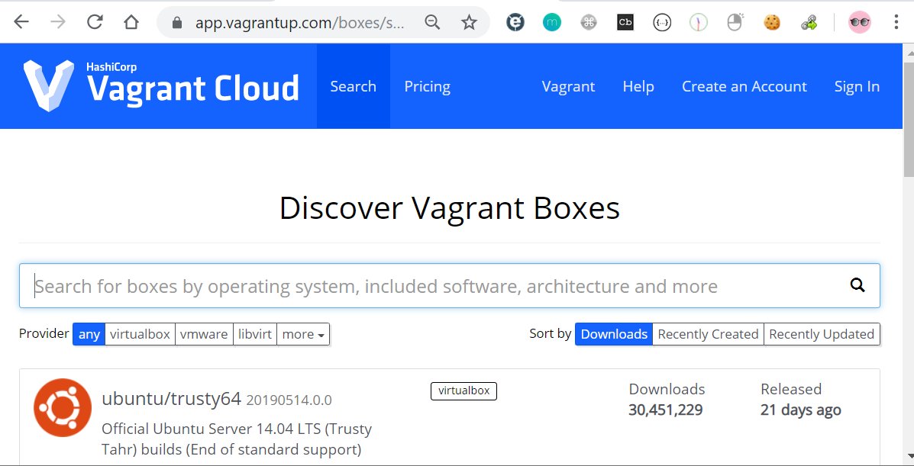

## Vagrant commands

**Creating a VM**

* vagrant init -- Initialize Vagrant with a Vagrantfile and ./.vagrant directory, using no specified base image. Before you can do vagrant up, you'll need to specify a base image in the Vagrantfile.
* vagrant init <boxpath> -- Initialize Vagrant with a specific box. To find a box, go to the [public Vagrant box catalog](https://app.vagrantup.com/boxes/search). When you find one you like, just replace it's name with boxpath. For example, vagrant init ubuntu/trusty64.

**Starting a VM**

* vagrant up -- starts vagrant environment (also provisions only on the FIRST vagrant up)
* vagrant resume -- resume a suspended machine (vagrant up works just fine for this as well)
* vagrant provision -- forces reprovisioning of the vagrant machine
* vagrant reload -- restarts vagrant machine, loads new Vagrantfile configuration

**Getting into a VM**

* vagrant ssh -- connects to machine via SSH
* vagrant ssh <boxname> -- If you give your box a name in your Vagrantfile, you can ssh into it with boxname. Works from any directory.

**Stopping a VM**

* vagrant halt -- stops the vagrant machine
* vagrant suspend -- suspends a virtual machine (remembers state)

**Cleaning Up a VM**

* vagrant destroy -- stops and deletes all traces of the vagrant machine
* vagrant destroy -f -- same as above, without confirmation

**Boxes**

* vagrant box list -- see a list of all installed boxes on your computer
* vagrant box add <name> <url> -- download a box image to your computer
* vagrant boxes remove <name> -- deletes a box from the machine
* vagrant package -- packages a running virtualbox env in a reusable box

**Tips**

* vagrant -v -- get the vagrant version
* vagrant status -- outputs status of the vagrant machine

$ vagrant init [url]

$ vagrant up

$ vagrant halt

$ vagrant destroy [--force]

$ vagrant reload

$ vagrant ssh

$ vagrant status

## Vagrantfile

A Vagrantfile is basically a configuration file that describes an environment. It will include things like the boxes used, networking, CPU and memory, providers used, shell scripts to run for provisioning among others.

1.Vagrant is a command-line based tool. Once installation is complete, open a console window and create a new directory called 'ubuntubox’ to Create Ubuntu VM using vagrant

cd ~

mkdir ubuntubox

cd ubuntubox

2.To add a box, goto box repository: <https://app.vagrantup.com/boxes/search> and find the Box.

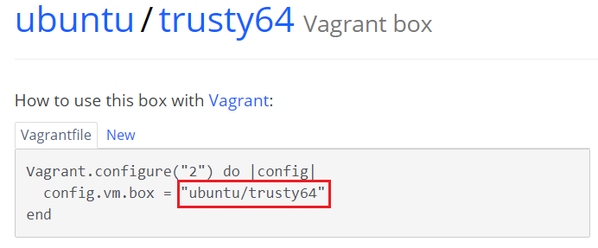

3.Use above box name & run below command

$ vagrant box add <name>

$ vagrant box add ubuntu/trusty64

In the above command, you will notice that boxes are namespaced. Boxes are broken down into two parts - the **username and the box name** - separated by a slash

4.It will download the Box to your local System, **Windows** : C:\Users\<Username>\.vagrant.d\boxes **Linux/Mac: ~/.vagrant.d/boxes**

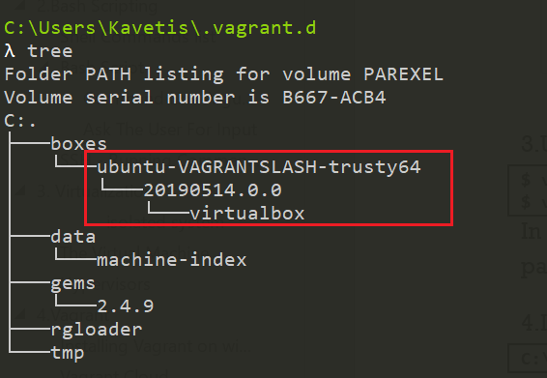

5.Create a new folder where you want to use as vagrant environment & use init to initializes the current directory to be a Vagrant environment by creating an initial [Vagrantfile](https://www.vagrantup.com/docs/vagrantfile/) if one does not already exist. Im using C:\Ops\vagrant\ubuntubox folder

C:\Ops\vagrant\ubuntubox

λ vagrant init ubuntu/trusty64

A `Vagrantfile` has been placed in this directory. You are now

ready to `vagrant up` your first virtual environment! Please read

the comments in the Vagrantfile as well as documentation on

`vagrantup.com` for more information on using Vagrant.

Open file, it contains

Vagrant.configure("2") do |config|

config.vm.box = "ubuntu/trusty64"

end

5.Start the Environment

$ vagrant up

Vagrant up commands read the configuration from the Vagrantfile.

6. connect to Environment

$ vagrant ssh

Username/Password : vagrant/vagrant

To Set Shared folder, edit vagrantfile as

config.vm.synced_folder "D:\\DevOps\\Instl\\VagrantBoxes\\SyncFolder", "/vagrant"

we named our syncd folder as “vagrant”, you can find the files in Syncfolder by going /vagrant/

## Vagrant Bridge Networking

Vagrant vm will by default have NAT Interface, we can create an extra bridge interface. Benefit of bridge interface is, Our vm will get IP from Router/Gateway/DHCP/Wifi router of our network. So our VM will be able to talk to any instance in network and vice versa

For doing this open vagrant file & uncomment

config.vm.network "public_network"

To check , login with vagrant ssh – it will show password on welcome screen.

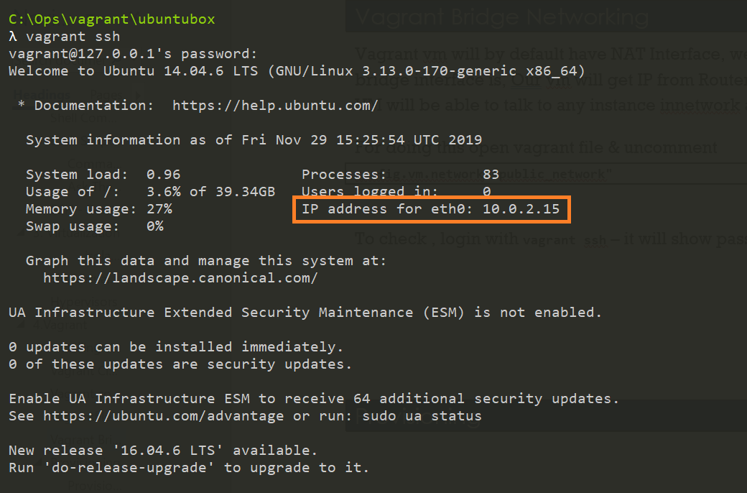

## Provisioning

### Provisioning Server

A Provisioning Server is any server that has many no. of Services installed. Provisioning Servers are used to stream software from vDisks, as needed, to target devices

Provisioning server sends configuration data to devices that request it. A provisioning server receives requests for configuration information from devices during the setup/bootup process or on a regular basis.

Provisioning and configuration management tools such as Terraform, AWS CloudFormation, Puppet, Chef, SaltStack, and Ansible are popular choices for standardizing software installation and management on infrastructure and environments.

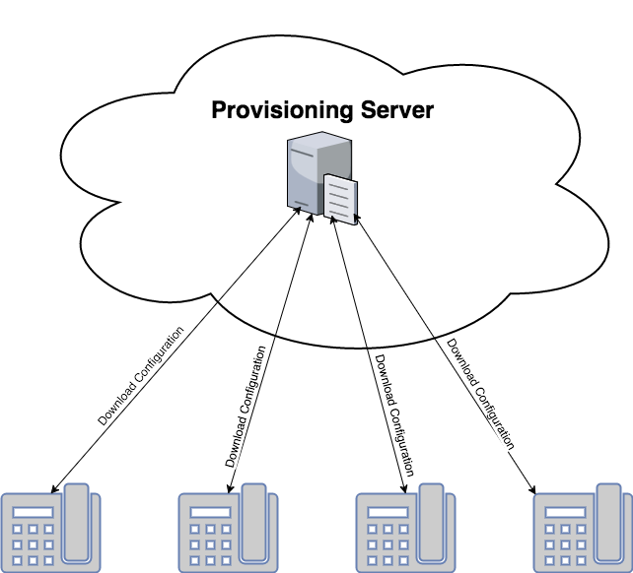

### Vagrant Provisioning

Provisioning helps execute command or script as soon as the vm comes up.  
Provisioners in Vagrant allow you to automatically install software, alter configurations, and more on the machine as part of the vagrant up process.

Vagrant gives you multiple options for provisioning the machine, from simple shell scripts to more complex, industry-standard configuration management systems.

#### Setting up apache2 Ubuntu vm

* Find config.vm.provision setting.
* Update the file with below mentioned content.

config.vm.provision "shell", inline: <<-SHELL

apt-get update

apt-get install -y apache2

SHELL

* Reload VM

vagrant reload --provision

* Verify apache default page by providing vm’s bridge ip in browser.

<http://192.168.0.106/>

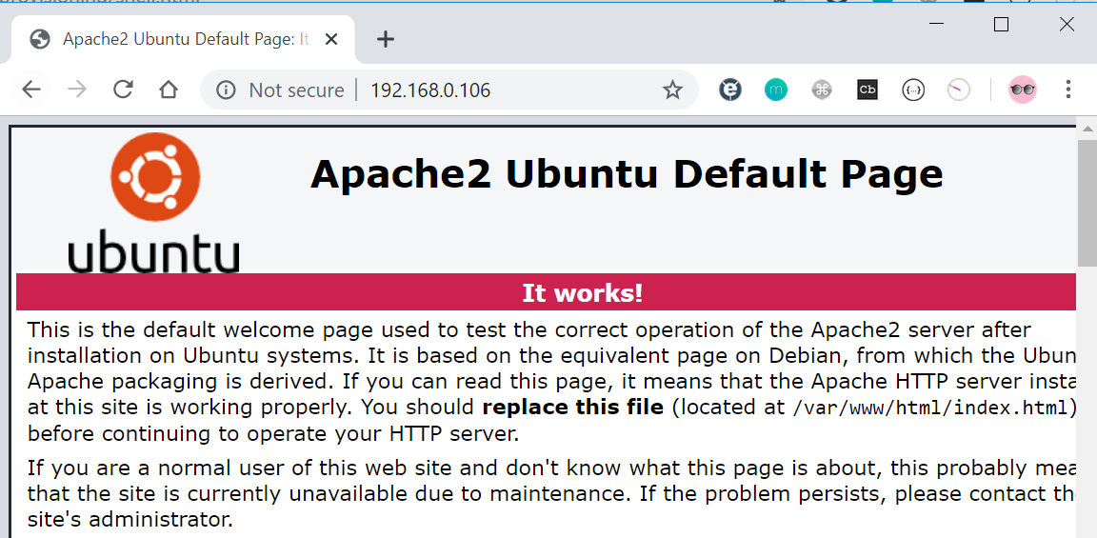

**External Script**

The shell provisioner can also take an option specifying a path to a shell script on the host machine. Vagrant will then upload this script into the guest and execute it. An example:

Vagrant.configure("2") do |config|  
config.vm.provision "shell", path: "script.sh"  
end

## Summary

**Summary:**

* Virtualization gave us the power of deploying multiple app in one physical server each having their own OS.
* Hypervisor gives us power and interface to create multiple virtual server also known as VM on one physical machine.
* There are two types of hypervisor, type1 which is installed directly on Hardware and type 2 which gets installed on a host OS.
* Virtualbox is type 2 hypervisor which can be installed on Linux and windows machine's.
* We can create & manage VM’s and their resources like virtual hard disk, Memory, Vcpu, network etc through virtualbox interface.
* Creating &Managing lot vm from virtualbox interface is time consuming and mundane task.
* Vagrant is a command line tool that helps us create & manage virtual machine lifecycle automatically.
* Vagrantcloud hosts many of vm images AKA boxes which can be used by anyone using Vagrant tool. We don’t do OS installation anymore with Vagrant, we just pull vagrant box images and run them.
* Vagrantfile is the single source of truth for your VM’s in Vagrant. We can mention box name, its memory, network and other settings while spinning a VM in the Vagrantfile.
* Vagrantfile gives us the feature of provisioning by which we can run any automation script to configure VM after vm comes up.
* Multiple VM’s can be managed by a single Vagrantfile.

**Conclusion:**

Vagrant is a great tool for our day to day DevOps tasks Maybe you have written a script for deployment or maybe you are learning any new devops tool, to test all these things you need VM’s. With Vagrant, we can quickly set up multiplevm’s and start practicing. It’s part of our daily toolkit.  
We can also use Ansible, Chef or Puppet code in provisioning part of the Vagrantfile, once we learn these tools in later chapters you can go ahead and try those. Vagrant can also be used to provision instances on AWS cloud. If you are working in DevOps you will encounter with local virtual machines, always use Vagrant to maintain your local vmsetup.

# Jenkins – vagrant setup

<https://searchcode.com/codesearch/view/95629147/>

# [Access web server on VirtualBox/Vagrant machine from host browser?](https://stackoverflow.com/questions/33129651/access-web-server-on-virtualbox-vagrant-machine-from-host-browser)

1. Open the vagrant file (should be in the directory where you specified to create a new vagrant machine).
2. Search for config.vm.network. If you didn't setup the file earlier, it should be commented.
3. Change it to look something like this config.vm.network "private_network", ip: "55.55.55.5". Here ip address (55.55.55.5) can be any ip address you want.
4. Now logout from the vagrant machine and reload your vagrant machine by this command vagrant reload.
5. After that, in your browser, enter the following address 55.55.55.5, and hopefully you should see your webapp.

Now if you would like to go further, you can edit your host file, and add this line

55.55.55.5 mynewdomain.com

Then in your browser, enter the follow address,

Then in your browser, enter the follow address,

mynewdomain.com

And you should see your web app. Note that, www is not added in the domain name inside the host file, so only mynewdomain.com can be accessed. You can however add it.

Hope this helps. Cheers.

## Errors

Stderr: VBoxManage.exe: error: (VERR_NEM_MISSING_KERNEL_API).

VBoxManage.exe: error: VT-x is not available (VERR_VMX_NO_VMX)

VBoxManage.exe: error: Details: code E_FAIL (0x80004005), component ConsoleWrap, interface IConsole

go to BIOS enable VT-x

I just solved this problem by disabling(uncheck) Hyper-V. Seems Hyper-V was enabled when I installed Docker

Control Panel -> Program And Features -> Turn Windows Features on or off.

You may need to reboot afterwords.

**Warning**: **Vagrant with VirtualBox cannot work with Docker at the same time.**

**apache2: Could not reliably determine the server's fully qualified domain name, using 10.0.2.15. Set the 'ServerName'**

This is just a friendly warning and not really a problem (as in that something does not work).

If you go to:

/etc/apache2/apache2.conf

and insert:

ServerName localhost

and then restart apache by typing into the terminal:

sudo systemctl reload apache2

the notice will disappear.

If you have a name inside /etc/hostname you can also use that name instead of localhost.

And it uses 127.0.1.1 if it is inside your /etc/hosts:

127.0.0.1 localhost

127.0.1.1 myhostname

[**Preferred method**](https://help.ubuntu.com/community/ApacheMySQLPHP#Troubleshooting_Apache)

Troubleshooting Apache

If you get this error:

apache2: Could not determine the server's fully qualified domain name,

using 127.0.0.1 for ServerName

then use a text editor such as "sudo nano" at the command line or "gksudo gedit" on the desktop to create a new file,

sudo nano /etc/apache2/conf.d/fqdn

or

gksu "gedit /etc/apache2/conf.d/fqdn"

then add

ServerName localhost

to the file and save. This can all be done in a single command with the following:

echo "ServerName localhost" | sudo tee /etc/apache2/conf.d/fqdn

But on Ubuntu 14.04:

echo "ServerName localhost" | sudo tee /etc/apache2/conf-available/fqdn.conf

sudo a2enconf fqdn

Don't forget the ".conf" (without will not work).