# Introduction

Jenkins is an open source automation tool written in Java programming language that allows continuous integration.

### What Is Continuous Integration.

Developers will push their code several times in a day to a central repository, every time there is code change it should be pulled, built, tested and notify to the user. **No deployment involved here**

## how Jenkins works

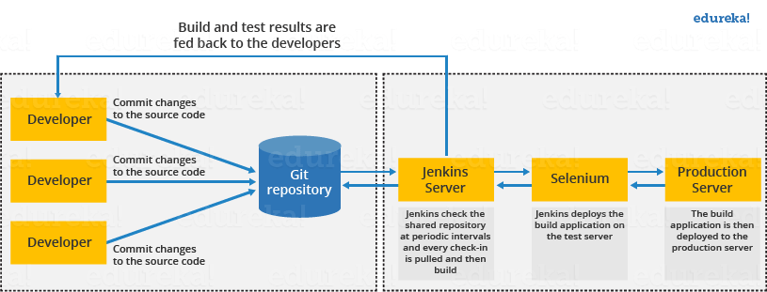

* developer commits the code to the source code repository. Meanwhile, the Jenkins checks the repository at regular intervals for changes.
* Soon after a commit occurs, the Jenkins server finds the changes that have occurred in the source code repository. Jenkins will draw those changes and will start preparing a new build.
* If the build fails, then the concerned team will be notified.
* If built is successful, then Jenkins server deploys the built in the test server.
* After testing, Jenkins server generates a feedback and then notifies the developers about the build and test results.
* It will continue to verify the source code repository for changes made in the source code and the whole process keeps on repeating.

## Jenkins Architecture

Jenkins architecture has two components:

* Jenkins Master/Server
* Jenkins Slave/Node

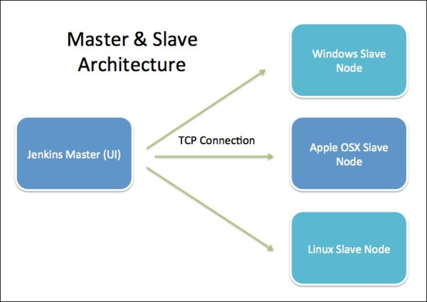

## Jenkins Installation

1.[Download & Install Java](https://www.oracle.com/technetwork/java/javase/downloads/index.html)

[2. Download Jenkins war File](https://jenkins.io/download/)

3. Open Command Line as Administrator & Run below cmd by navigate to downloaded location

# Ref.

<https://javatpoint.com/jenkins>

<https://www.edureka.co/blog/what-is-jenkins/>