## Compute

### Launch a Linux Virtual Machine with Amazon EC2

AWS Services > Amazon EC2 to open the service console.

Select Launch Instance to create and configure your virtual machine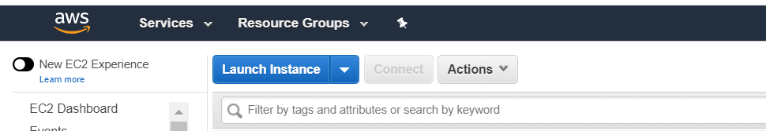

choose an **Amazon Machine Image (AMI)** > **Amazon Linux AMI** and click Select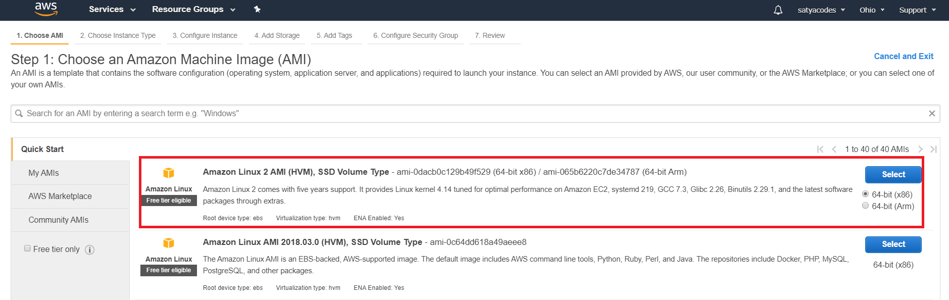

Choose an Instance type : various combinations of CPU, memory, storage, and networking capacity.default option of **t2.micro** 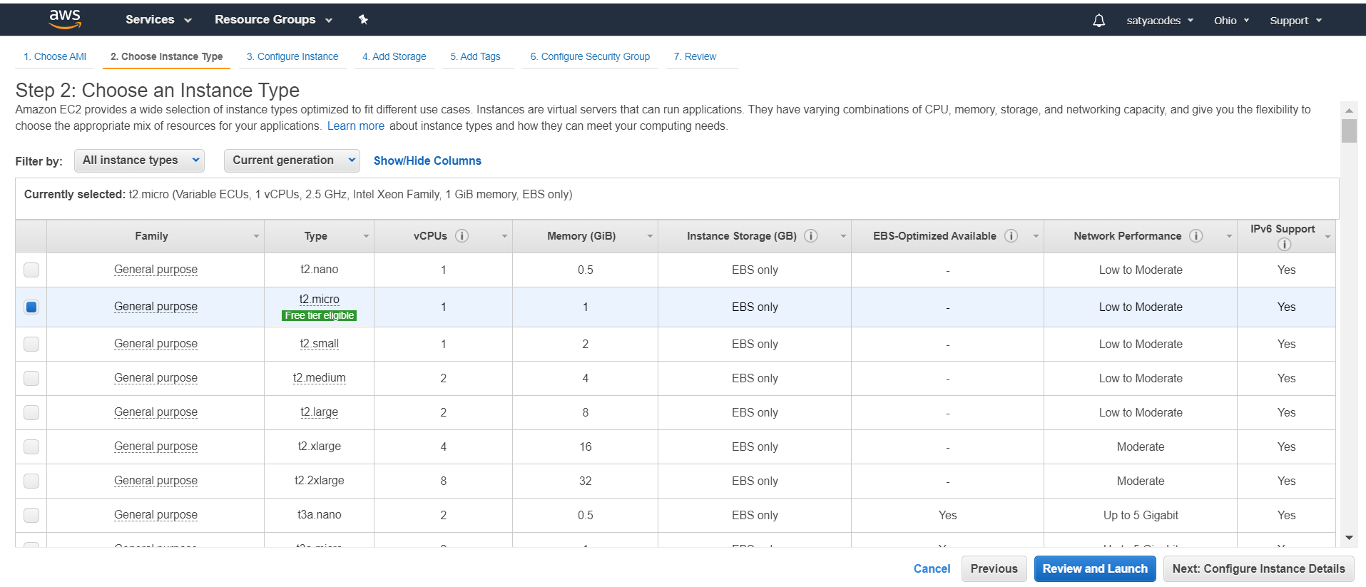

Configure Instance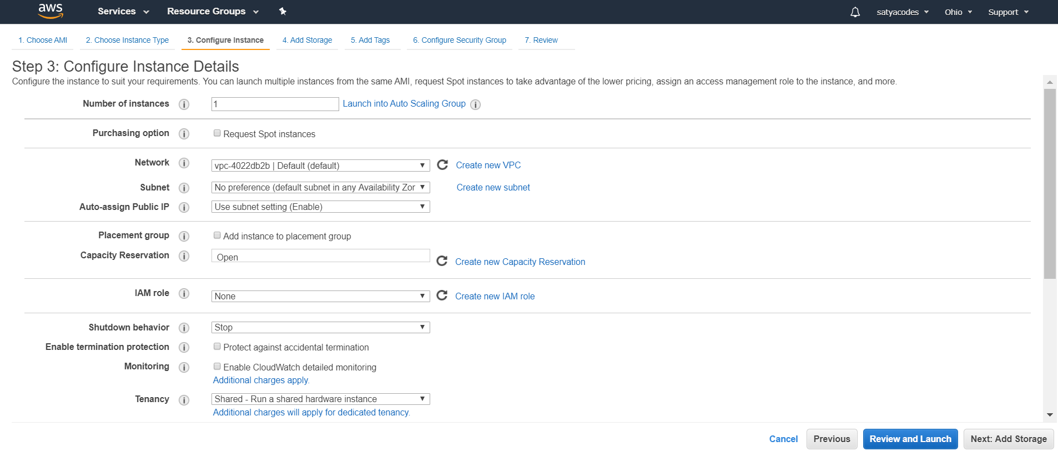

Add Storage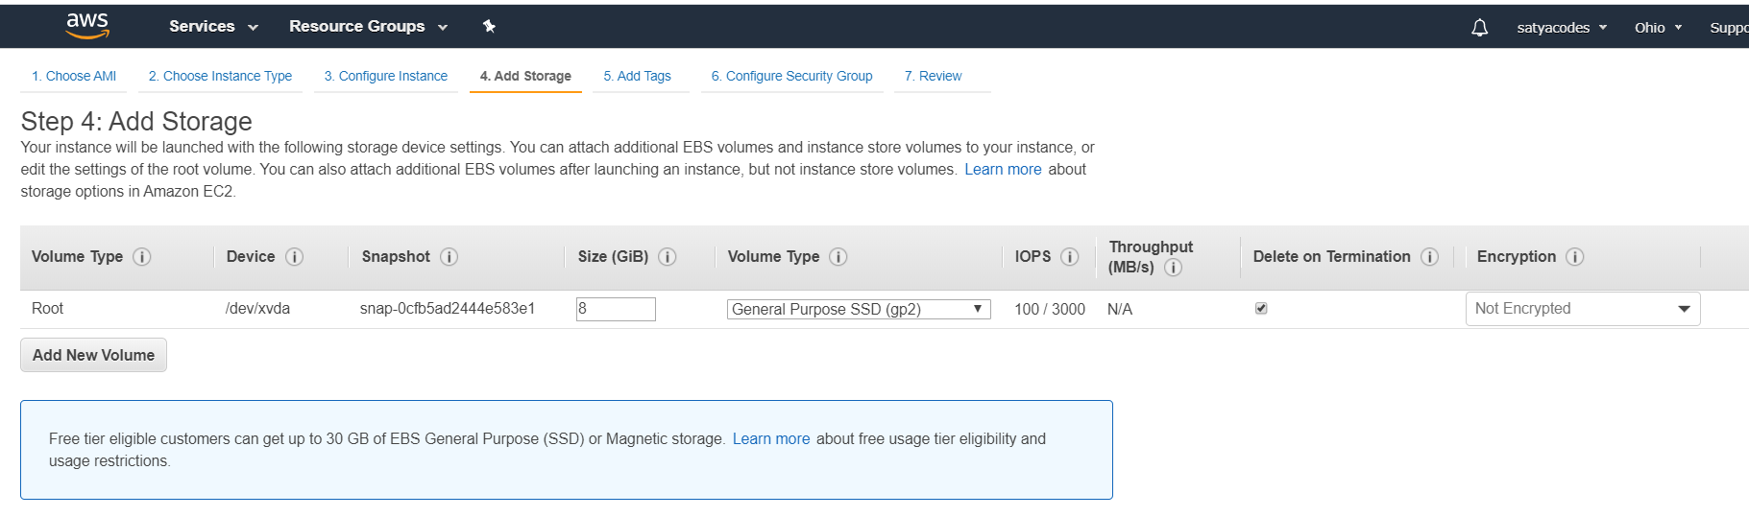

Add Tags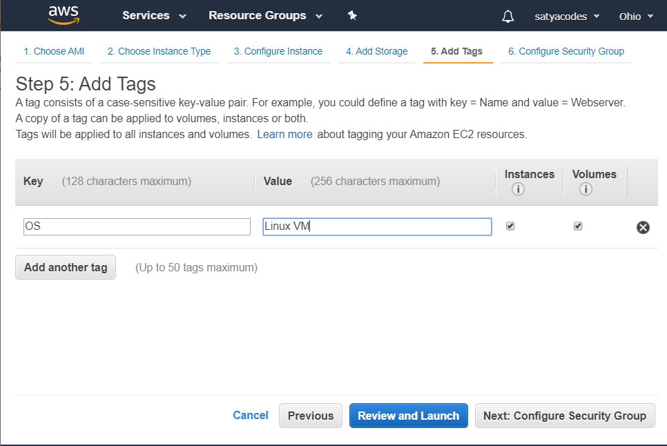

Configure Security Groups & SSH connection details - Click Review and Launch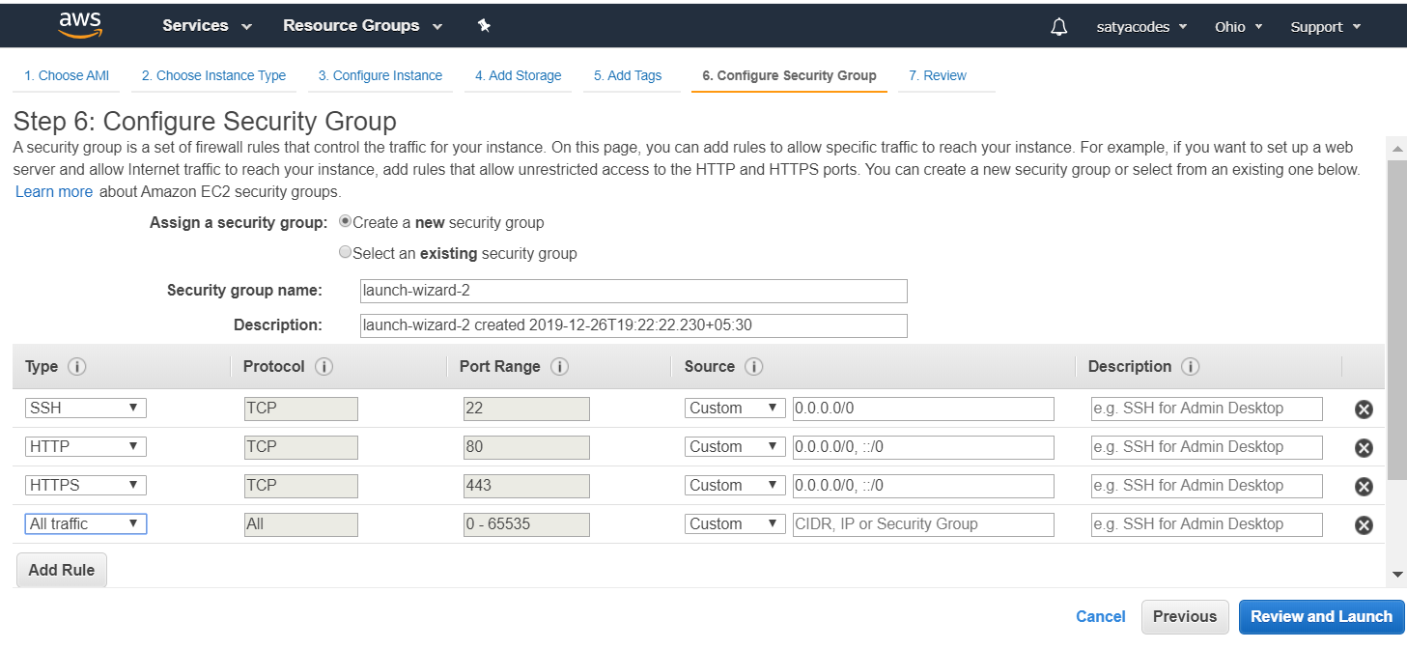

On the next screen you will be asked to choose an existing key pair or create a new key pair. A key pair is used to securely access your Linux instance using SSH

- Select Create a new key pair and give it the name LinuxVM. Next click the Download Key Pair button. 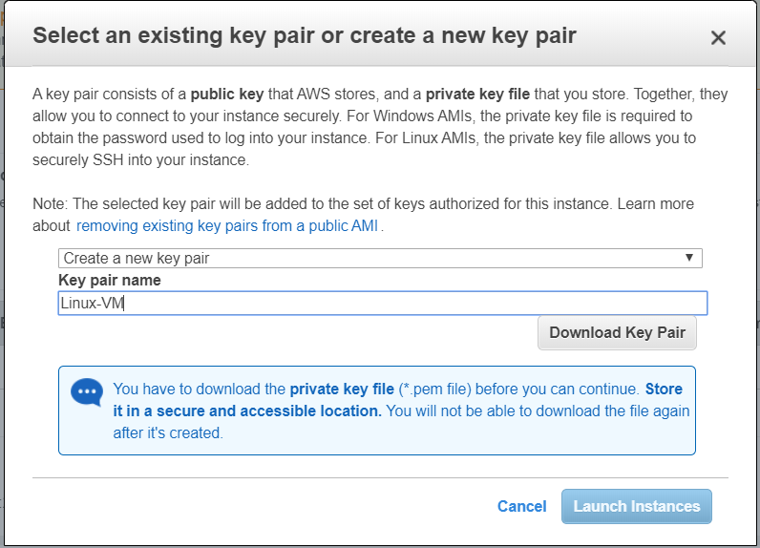

saving your key pair in your user directory in a sub-directory called .ssh (ex. C:\user\{yourusername}\.ssh\Linux-VM.pem).

Click View Instances- Copy the Public IP address of your AWS instance, so you can use it when we connect to the instance using SSH

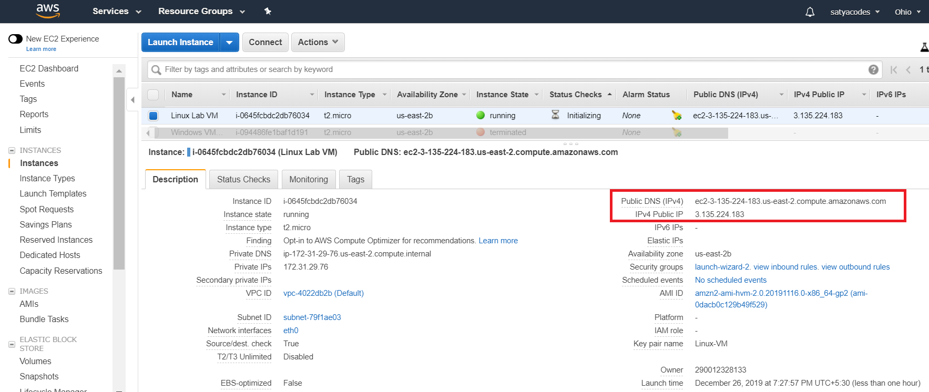

#### Login to VM

**Login Using Git**

* Download & Install Git
* Open Git Bash > Run

ssh -i {full path of your .pem file} ec2-user@{instance IP address}

ssh -i 'C:\Users\Kavetis\.ssh\Linux-VM.pem' ec2-user@3.135.224.183

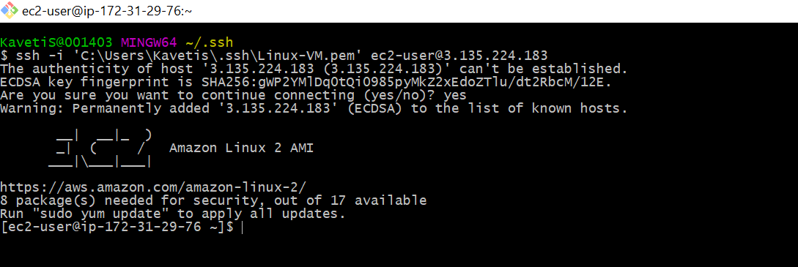

**Login Using Putty**

1.Open Downloaded .pem file

* If we are using Linux system, we can directly use .pem file for connection.
* If we are using Windows System, we don’t have SSH directly.

we use PuttY for SSH connections. but Putty doesn't support .pem file it only supports .ppk file. for that we need to convert .pem file to .ppk file

2.Covert .pem to .ppk using Putty

* Launch PuttyGen
* Load .pem file
* Save Private Key: Linux-VM.ppk

3.Open Putty

* Enter Ip : 18.216.255.66
* Connection Type : SSH
* Left Menu > SSH >+AUTH : Browse saved Linux-VM.ppk file

Remember : Default user for EC2 Instance is : "ec2-user"

### Launch a Windows Virtual Machine

Amazon EC2 > Click Launch Instance 

Amazon Machine Image (AMI) > Microsoft Windows Server 2012 R2 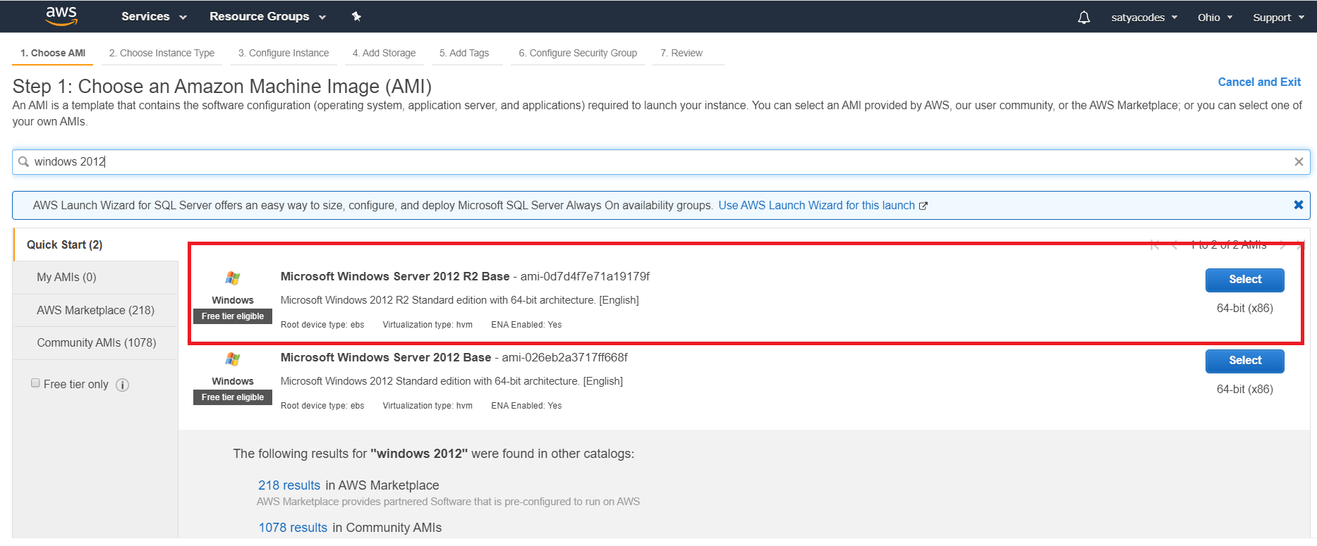

instance type - select the default option of **t2.micro**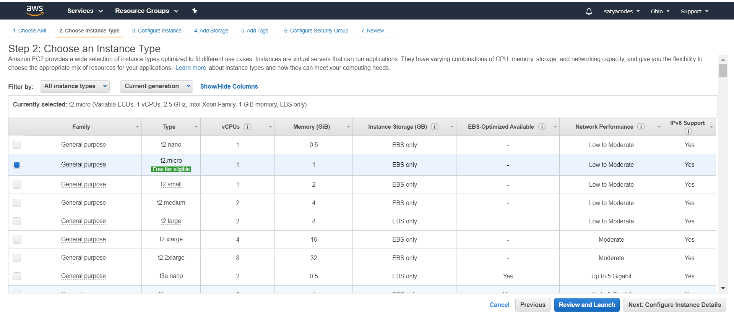

Then click Review and Launch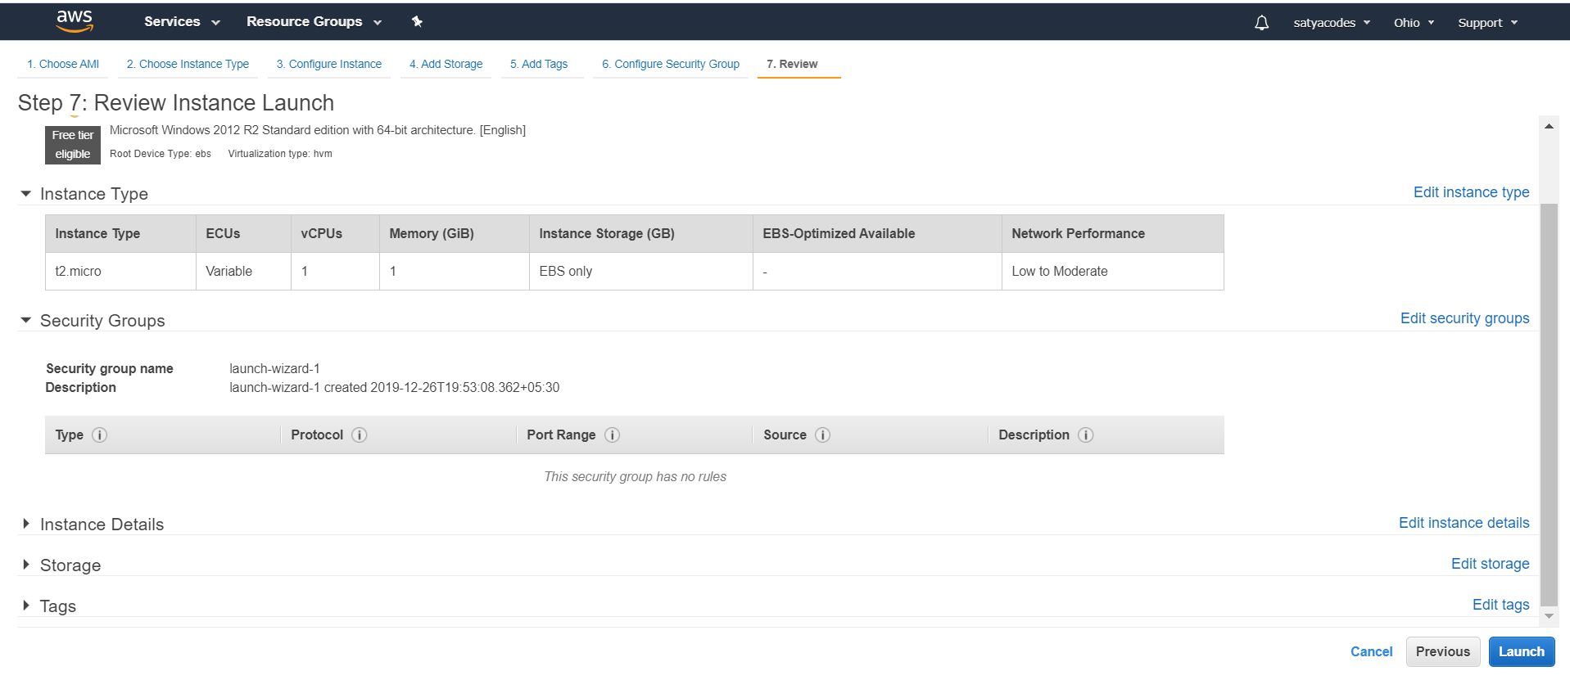

Create a Key Pair and Launch Your Instance – We already created Key Pair, we use the same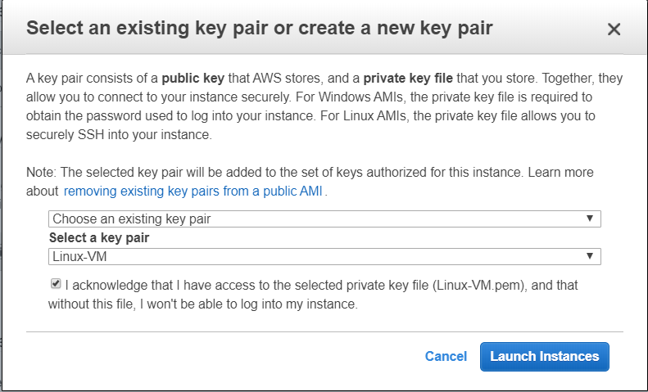

Select the Windows Server instance you just created and click Connect. 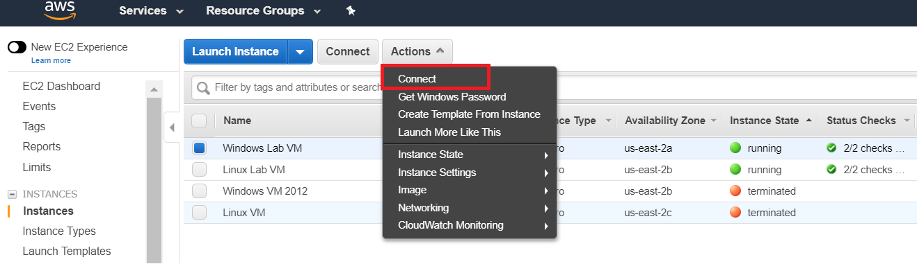

In order to connect to your Windows Instance via RDP, you will need a user name and password:

The User name defaults to Administrator & To receive your password, click Get Password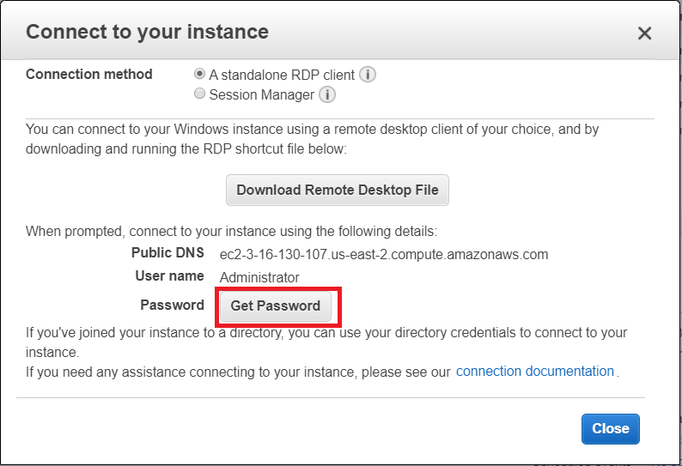

to retrieve the password, you will need to locate the Key Pair you created in before & Click Decrypt Password. Copy/save that Password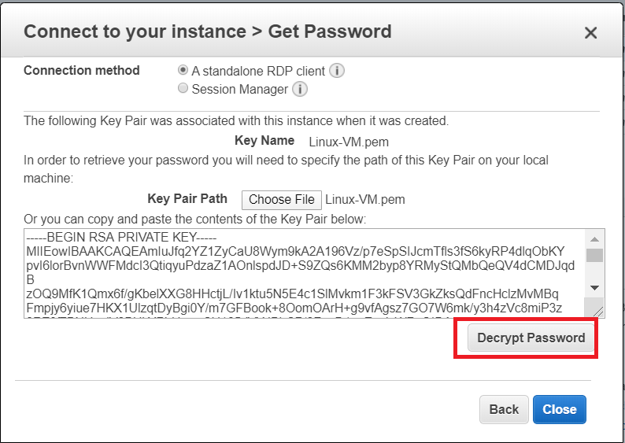

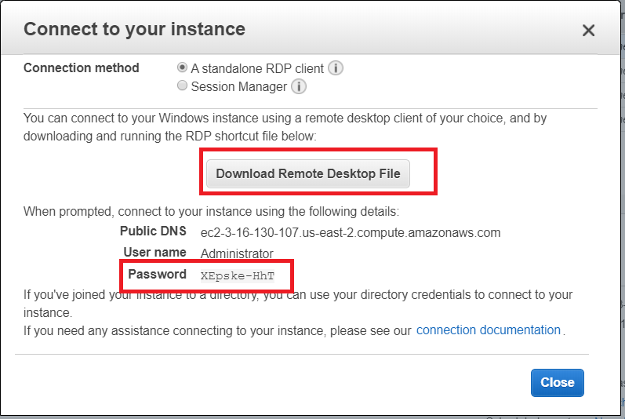

Click Download Remote Desktop File and open the file to connect via RDP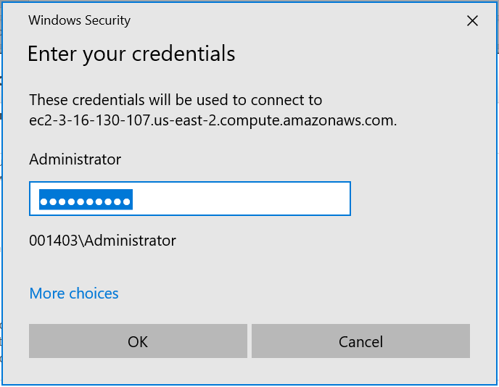

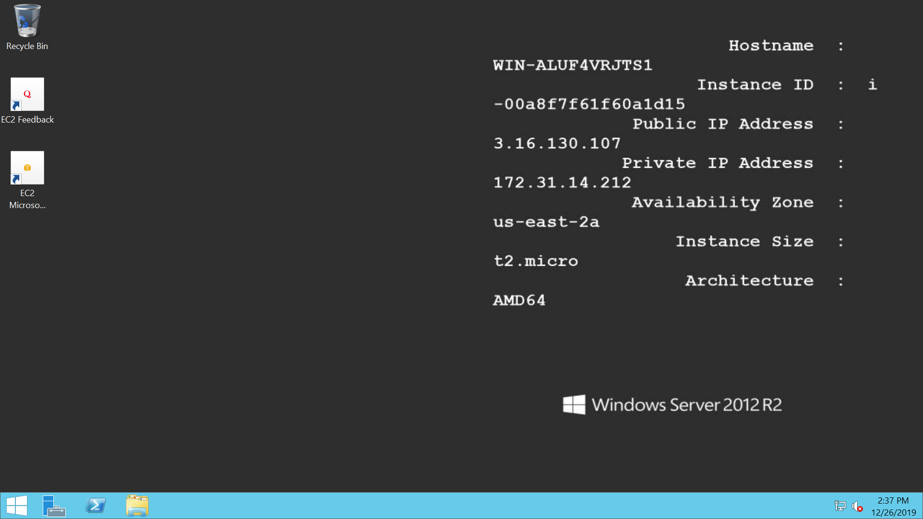

### Deploy and host WordPress website on AWS

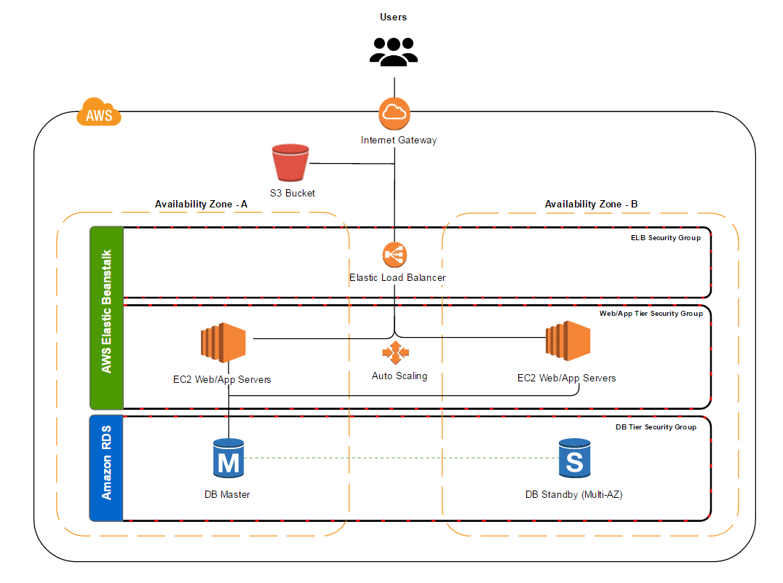

<https://docs.aws.amazon.com/elasticbeanstalk/latest/dg/php-hawordpress-tutorial.html>

* Elastic Beanstalk with PHP Environment
* Amazon Elastic File System (Amazon EFS) as shared storage for uploaded files.
* RDS DB instance – MySQL

#### Launch a DB Instance in Amazon RDS

Use the Amazon RDS console to launch a **MySQL** DB instance.

Open the [RDS console](https://console.aws.amazon.com/rds/home). : AWS services > Databases > RDS : Choose **Create database**. 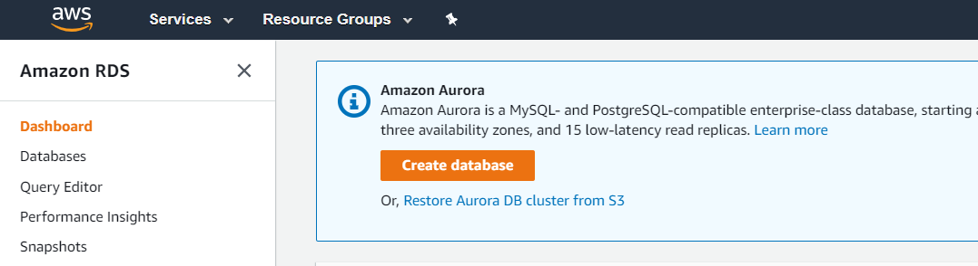

Choose a database engine. Choose **Next**.

Choose a use case, if prompted.

Under **Specify DB details**, review the default settings and adjust as necessary. Pay attention to the following options:

**DB instance class** – Choose an instance size that has an appropriate amount of memory and CPU power for your workload.

**Multi-AZ deployment** – For high availability, set to **Create replica in different zone**.

**Master username** and **Master password** – The database username and password. Make a note of these settings because you'll use them later.

Choose **Next**.

Under **Database options**, for **Database name**, type **ebdb**. Make a note of the **Database port** value for use later.

Verify the default settings for the remaining options, and choose **Create database**

#### Download WordPress

#### Launch an Elastic Beanstalk Environment

#### Configure Security Groups and Environment Properties

#### Configure and Deploy Your Application

#### Install WordPress

#### Update Keys and Salts

#### Remove Access Restrictions

#### Configure Your Auto Scaling Group

#### Upgrade WordPress