# Introduction

Kubernetes is an open-source container management (orchestration) tool. It’s container management responsibilities include container deployment, scaling & descaling of containers & container load balancing.

* Kubernetes is an open-source system for automating deployment, scaling, and management of containerized applications.
* Kubernetes is originally developed by Google; it is open sourced since its launch and managed by a large community of contributors
* Kubernetes (commonly referred to as K8s) is an orchestration engine for container technologies such as Docker and rkt that is taking over the DevOps scene in the last couple of years. It is already available on Azure and Google Cloud as a managed service.
* Kubernetes can speed up the development process by making easy, automated deployments, updates (rolling-update) and by managing our apps and services with almost zero downtime.
* It also provides self-healing. Kubernetes can detect and restart services when a process crashes inside the container.

Before Kubernetes

before containers came into existence, the developers and the testers always had a tiff between them. This usually, happened because what worked on the dev side, would not work on the testing side. Both of them existed in different environments. Now, to avoid such scenarios containers were introduced so that both the Developers and Testers were on the same page.

Handling a large number of containers all together was also a problem. Sometimes while running containers, on the product side, few issues were raised, which were not present at the development stage. This kind of scenarios introduced the Container Orchestration System.

**Challenges Without Container Orchestration**

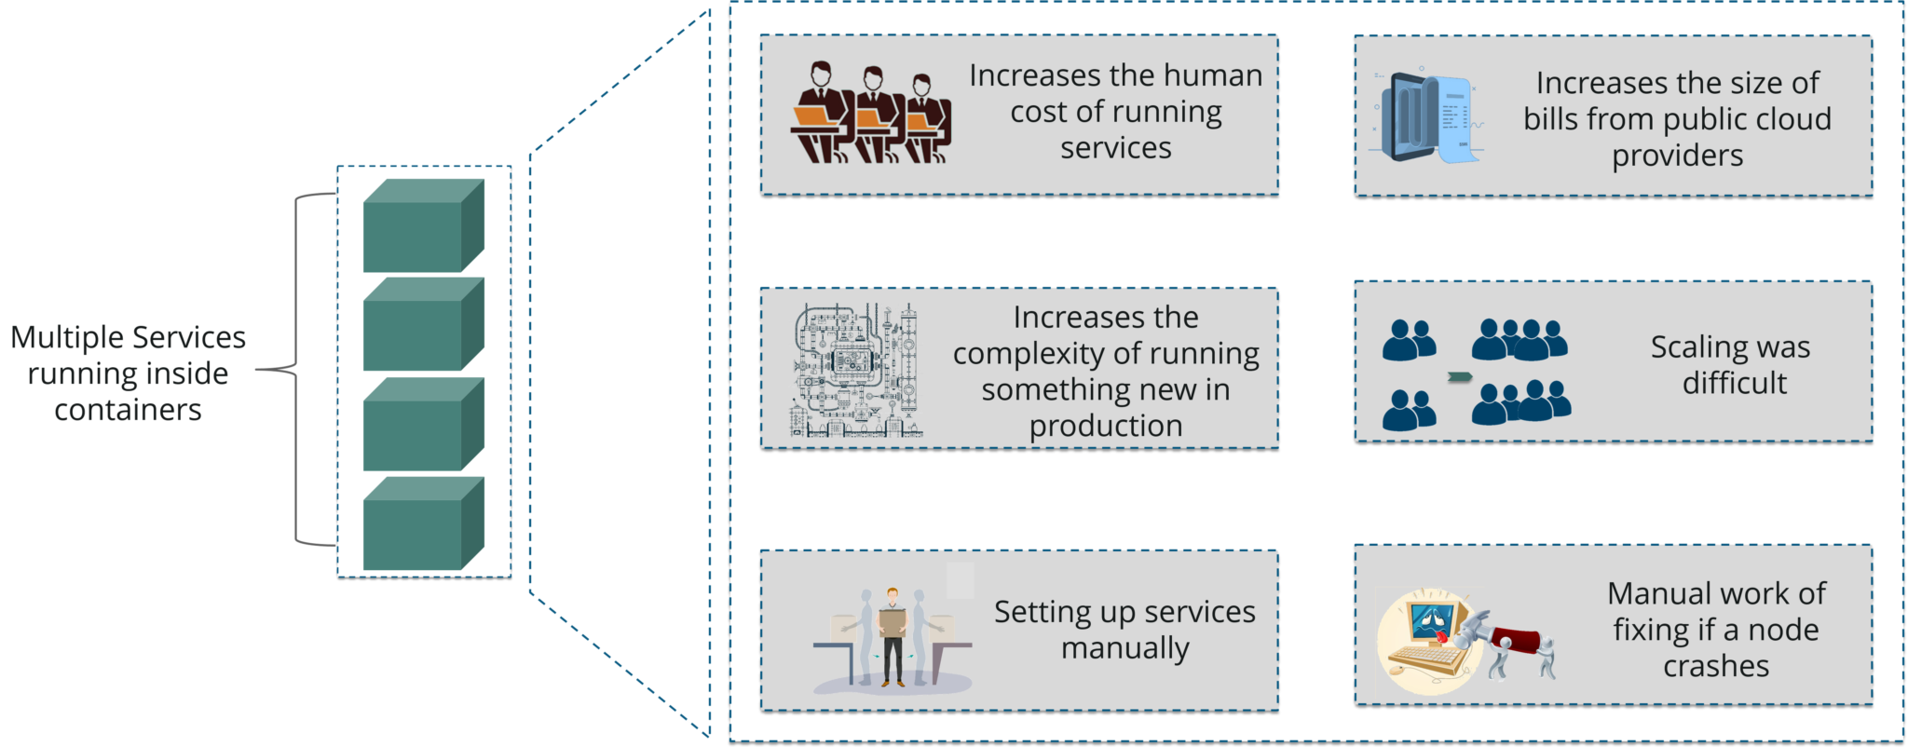

Why Kubernetes

If your application is in Container form, then we won’t use only 1 or 2 containers in Prod. But rather, **10’s or 100’s** of containers for load balancing the traffic and ensuring high availability.

Keep in mind that, as the traffic increases, they even have to scale up the number of containers to service the ‘n’ no of requests that come in every second. And, they have to also scale down the containers when the demand is less.

That is why, the need for container management tools is imminent. Both **Docker Swarm** and **Kubernetes** are popular tools for Container management and orchestration.

## Features

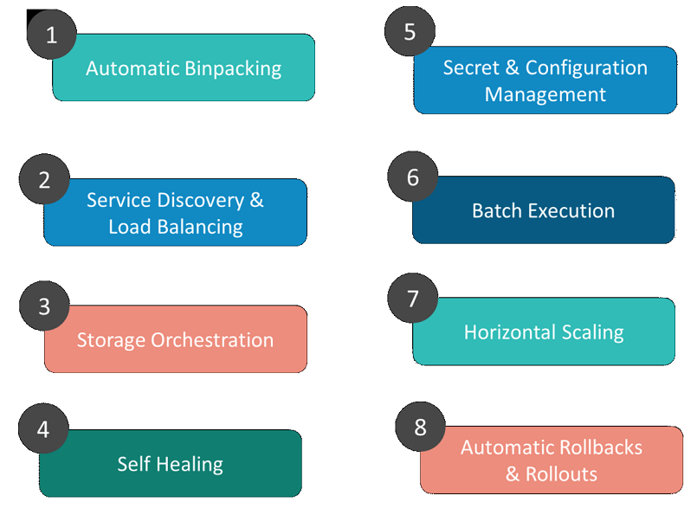

**1. Automatic Binpacking**

Kubernetes automatically packages your application and schedules the containers based on their requirements and available resources while not sacrificing availability. To ensure complete utilization and save unused resources, Kubernetes balances between critical and best-effort workloads.

**2. Service Discovery & Load balancing**

With Kubernetes, there is no need to worry about networking and communication because Kubernetes will automatically assign IP addresses to containers and a single DNS name for a set of containers, that can load-balance traffic inside the cluster.

**3. Storage Orchestration**

With Kubernetes, you can mount the storage system of your choice. You can either opt for local storage, or choose a public cloud provider such as GCP or AWS, or perhaps use a shared network storage system such as NFS, iSCSI, etc.

**4. Self-Healing**

Personally, this is my favorite feature. Kubernetes can automatically restart containers that fail during execution and kills those containers that don’t respond to user-defined health checks. But if nodes itself die, then it replaces and reschedules those failed containers on other available nodes.

**5. Secret & Configuration Management**

Kubernetes can help you deploy and update secrets and application configuration without rebuilding your image and without exposing secrets in your stack configuration.

**6. Batch Execution**

In addition to managing services, Kubernetes can also manage your batch and CI workloads, thus replacing containers that fail, if desired.

**7. Horizontal Scaling**

Kubernetes needs only 1 command to scale up the containers, or to scale them down when using the CLI. Else, scaling can also be done via the Dashboard (kubernetes UI).

**8. Automatic Rollbacks & Rollouts**

Kubernetes progressively rolls out changes and updates to your application or its configuration, by ensuring that not all instances are worked at the same instance. Even if something goes wrong, Kubernetes will rollback the change for you.

## Architecture

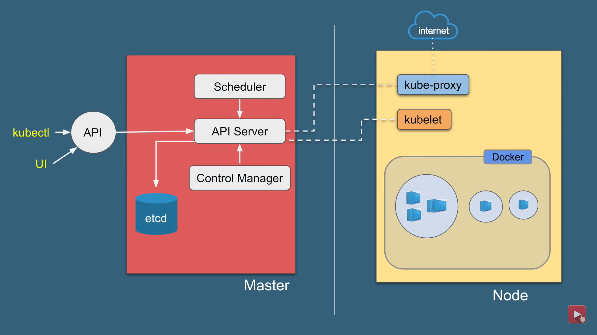

Kubernetes Architecture has the 3 main components:

* Master nodes
* Worker/Slave nodes
* Distributed key-value store(etcd.)

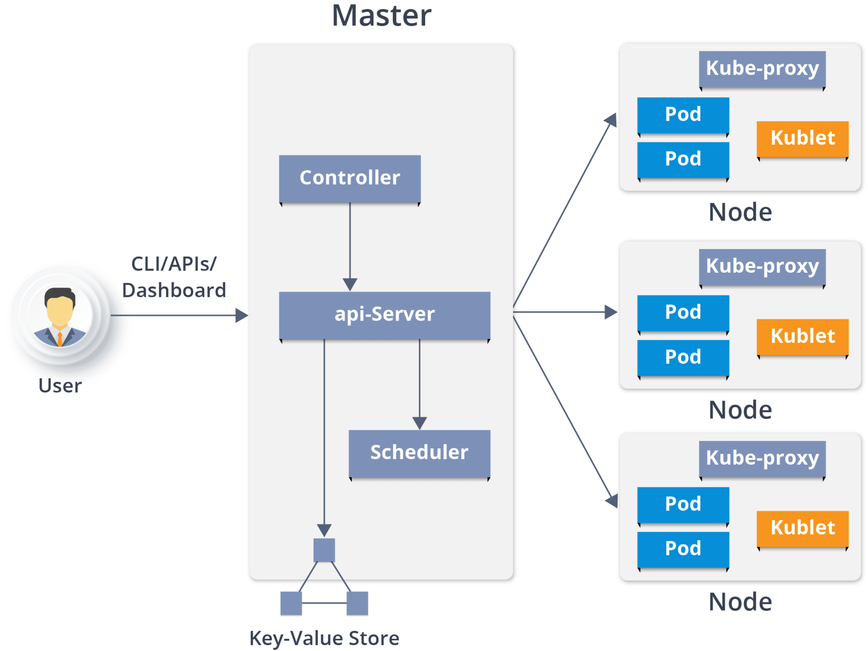

Kubernetes Cluster

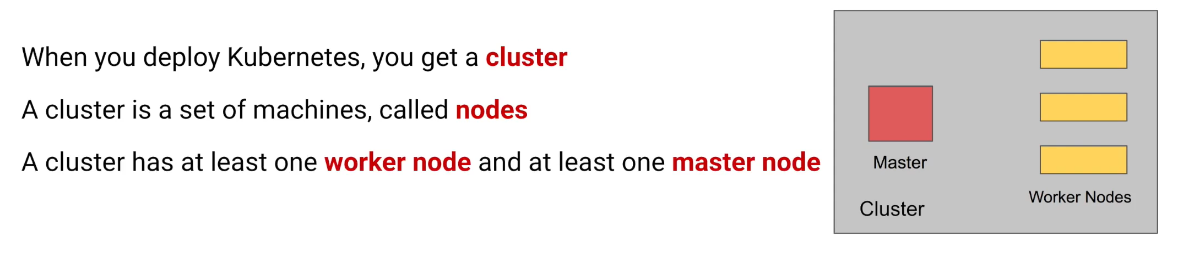

Kubernetes Cluster is primarily made up of following components

* Master:
  + Kube API Server
  + Control Plane (kube-scheduler + kube-controller-manager + Cloud-controller Manager)
  + Etcd
* Node:
  + Kubelet
  + Kube-proxy
  + Container Runtime
* Addons:
  + DNS
  + WebUI
  + Container Resource Monitoring
  + Cluster Level Logging

Master Node

It is the entry point for all administrative tasks which is responsible for managing the Kubernetes cluster. There can be more than one master node. If more than one master node, one master node acts as a main master node other node will just follows.

* The main machine that controls the nodes
* Main entry point for all administrative tasks
* It handles the orchestration of the worker nodes

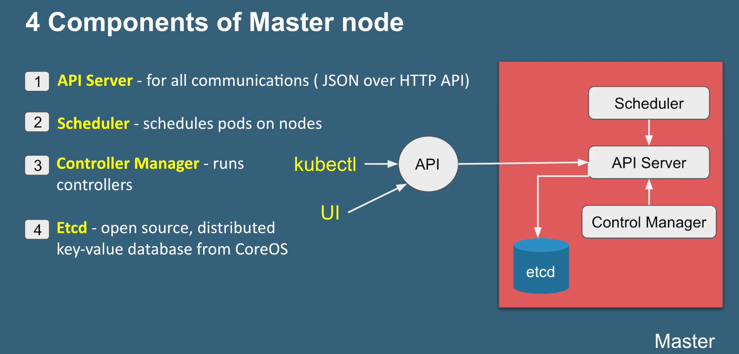

**API server:**

* Performs all the administrative tasks through the API server within the master node.
* In this REST commands are sent to the API server which validates and processes the requests.
* After requesting, the resulting state of the cluster is stored in the distributed key-value store.

**Scheduler:**

* The scheduler schedules the tasks to slave nodes. It stores the resource usage information for each slave node.
* It schedules the work in the form of Pods and Services.

**Controller manager**

* Basically, a controller watches the desired state of the objects it manages and watches their current state through the API server.
* If the current state of the objects it manages does not meet the desired state, then the control loop takes corrective steps to make sure that the current state is the same as the desired state

**ETCD**

* etcd is a distributed key-value store which stores the cluster state.
* It can be part of the Kubernetes Master, or, it can be configured externally.
* it is also used to store configuration details such as subnets, ConfigMaps, Secrets, etc.

Worker Node

It is a physical server or you can say a VM which runs the applications using Pods (**a pod scheduling unit**) which is controlled by the master node. On a physical server (worker/slave node), pods are scheduled. For accessing the applications from the external world, we connect to nodes.

* It is a worker machine in Kubernetes (used to be known as minion)
* This machine performs the requested tasks. Each Node is controlled by the Master Node
* Runs containers inside pods
* This is where the Docker engine runs and takes care of downloading images and starting containers

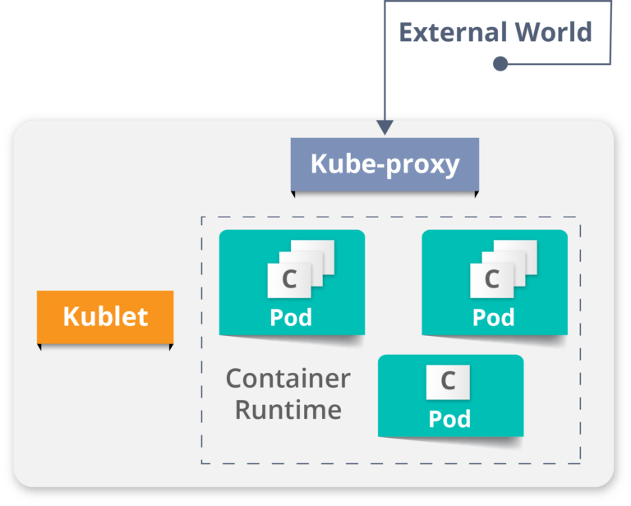

**Container runtime:**

* To run and manage a container’s lifecycle, we need a **container runtime**on the worker node.
* Sometimes, Docker is also referred to as a container runtime, but to be precise, Docker is a platform which uses **containers**as a container runtime.

**Kubelet:**

* It is an agent which communicates with the Master node and executes on nodes or the worker nodes. It gets the Pod specifications through the API server and executes the containers associated with the Pod and ensures that the containers described in those Pod are running and healthy.

**Kube-proxy:**

* Kube-proxy runs on each node to deal with individual host sub-netting and ensure that the services are available to external parties.
* It serves as a network proxy and a load balancer for a service on a single worker node and manages the network routing for TCP and UDP packets.
* It is the network proxy which runs on each worker node and listens to the API server for each Service endpoint creation/deletion.
* For each Service endpoint, kube-proxy sets up the routes so that it can reach to it.

**Pods**

* A pod is one or more containers that logically go together. Pods run on nodes. Pods run together as a logical unit. So they have the same shared content.
* They all share the same IP address but can reach other Pods via localhost, as well as shared storage. Pods don’t need to all run on the same machine as containers can span more than one machine. One node can run multiple pods.

## Kubernetes vs Docker Swarm

**Kubernetes** and **Docker Swarm** are leading container orchestration tools in today’s market.

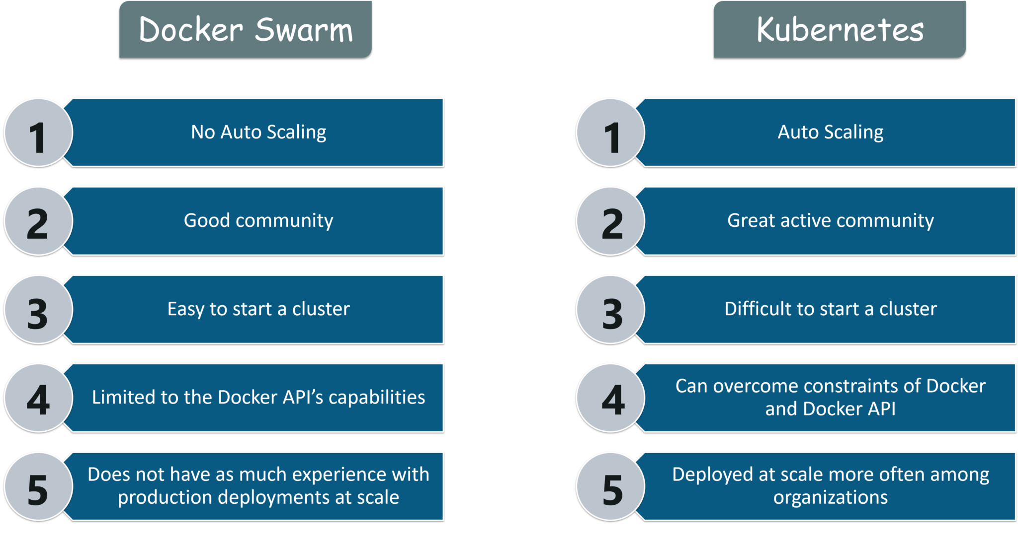

## Use Case

**Use Case: How Luminis Technologies used Kubernetes in production**

**Problem:** Luminis, a software technology company used AWS for deploying their applications. For deploying the applications, it required custom scripts and tools to automate which was not easy for teams other than operations. Their small teams didn’t have the resources to learn all of the details about the scripts and tools.

**Main Issue:** There was no **unit-of-deployment** which created a gap between the development and the operations teams.

**Solution:**

**How did they Deploy in Kubernetes:**

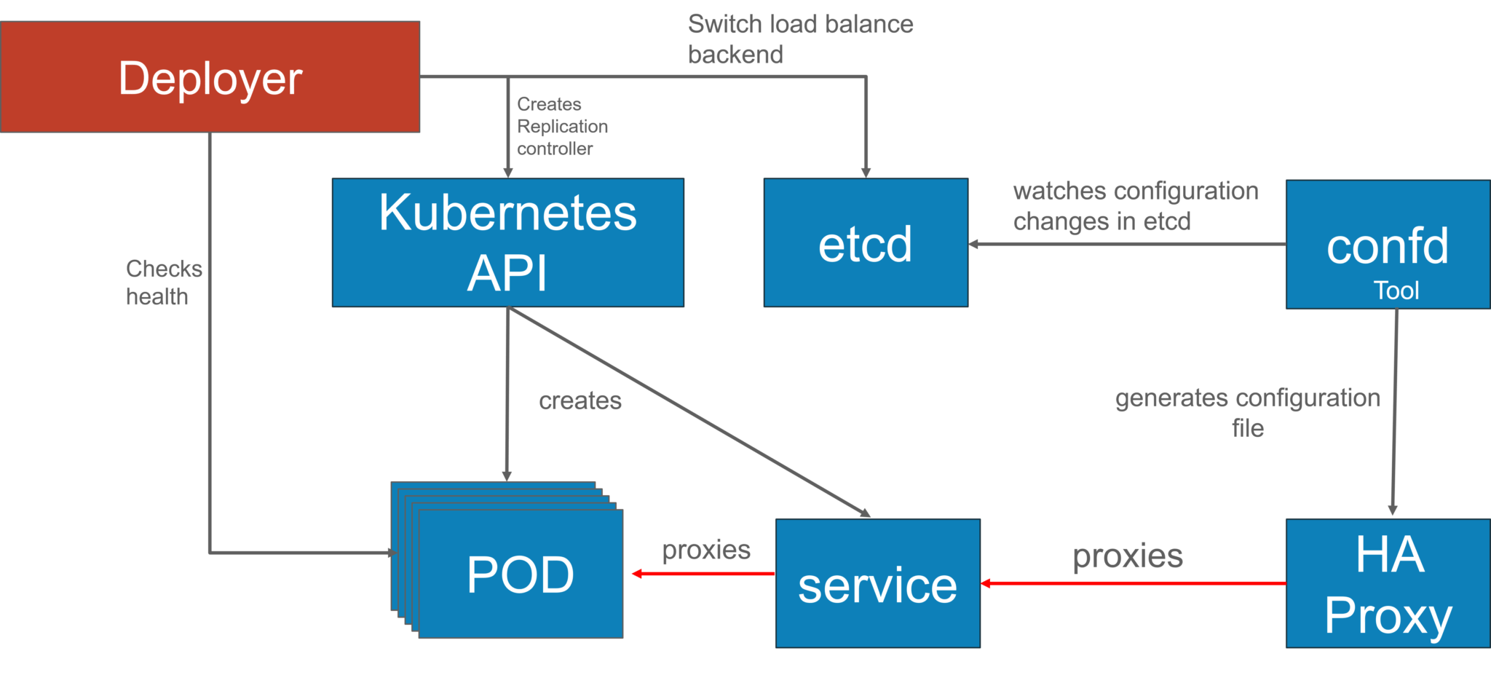They used a [blue-green deployment](https://martinfowler.com/bliki/BlueGreenDeployment.html) mechanism to reduce the complexity of handling multiple concurrent versions. (As there’s always only one version of the application running in the background)

In this, a component called “**Deployer**” that orchestrated the deployment was created by their team by open sourcing their implementation under the Apache License as part of the Amdatu umbrella project. This mechanism performed the health checking on the pods before re-configuring the load balancer because they wanted each component that was deployed to provide a health check.

**How did they Automate Deployments?**

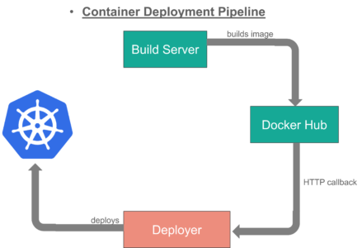With the **Deployer**in place, they were able to engage up deployments to a build pipeline. After a successful build,  their build server pushed a new Docker image to a registry on Docker Hub. Then the build server invoked the **Deployer** to automatically deploy the new version to a test environment. That same image was promoted to production by triggering the **Deployer** on the production environment.

## Use case -2

**Kubernetes Case-Study**

* **Yahoo! JAPAN** is a web services provider headquartered in Sunnyvale, California. As the company aimed to virtualize the hardware, company started using **OpenStack** in 2012. Their internal environment changed very quickly. However, due to the progress of cloud and container technology, the company wanted the capability to launch services on various platforms.
* **Problem:** How to create images for all required platforms from one application code, and deploy those images onto each platform?
* For your better understanding, refer to the below image. When the code is changed at the code registry, then bare metal images, Docker containers, and VM images are created by continuous integration tools, pushed into the image registry, and then deployed to each infrastructure platform.
* 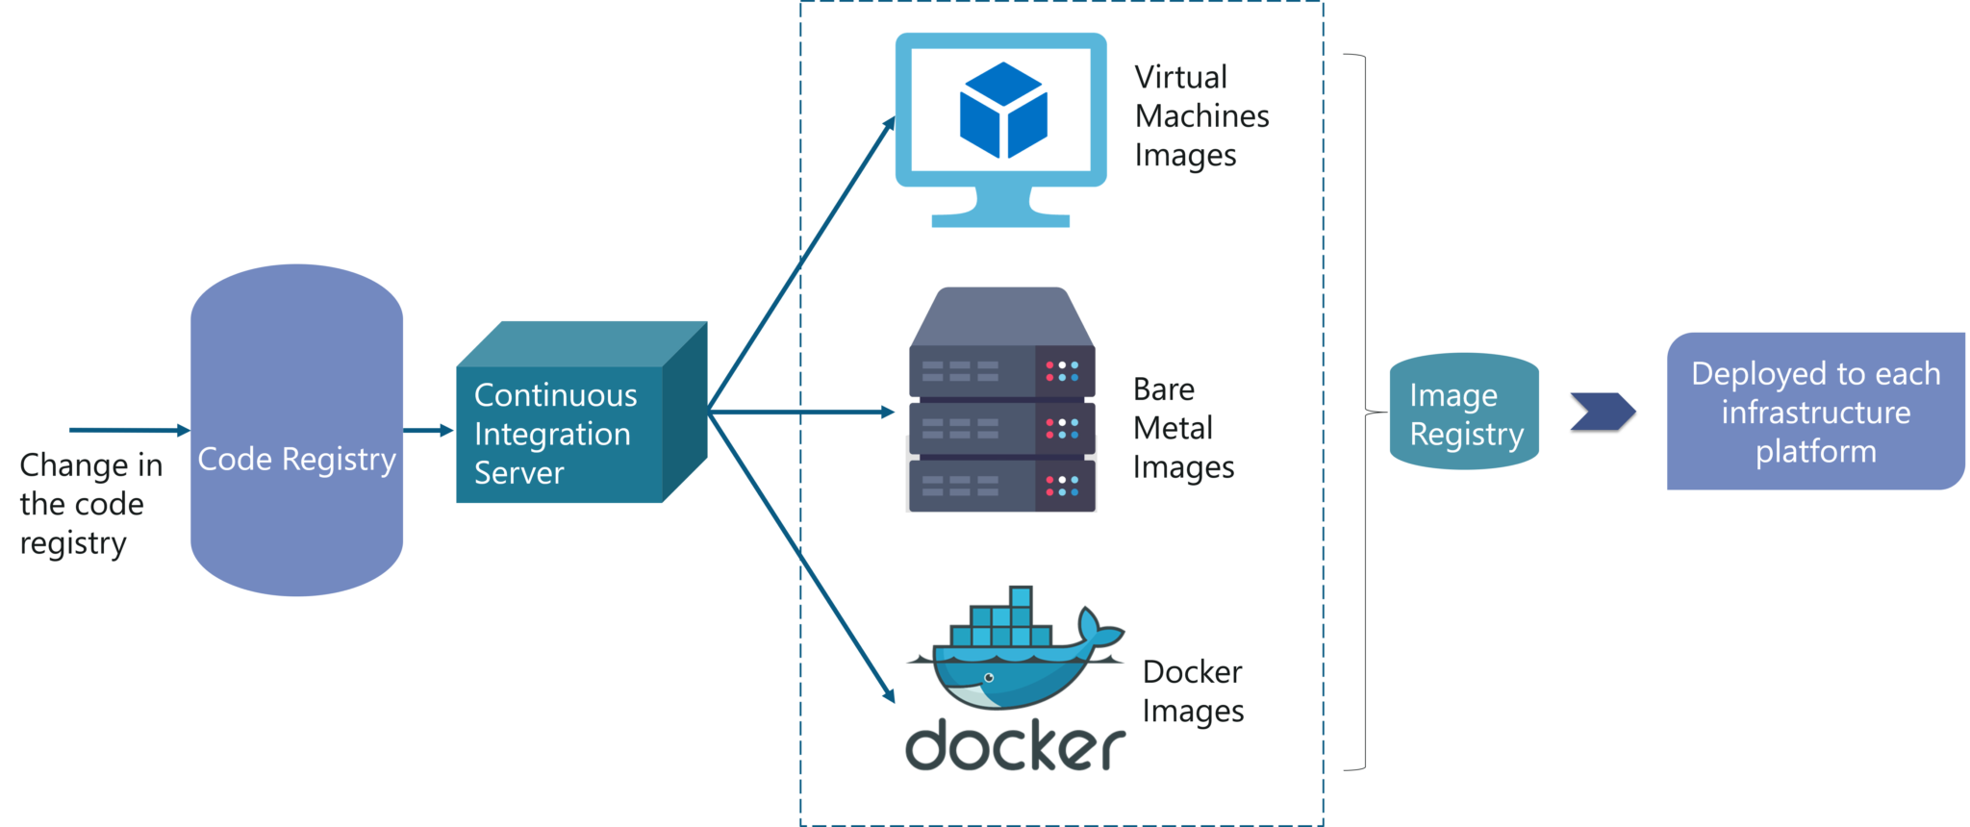
* Now, let us focus on container workflow to understand how they used Kubernetes as a deployment platform. Refer to the below image to sneak peek into platform architecture.

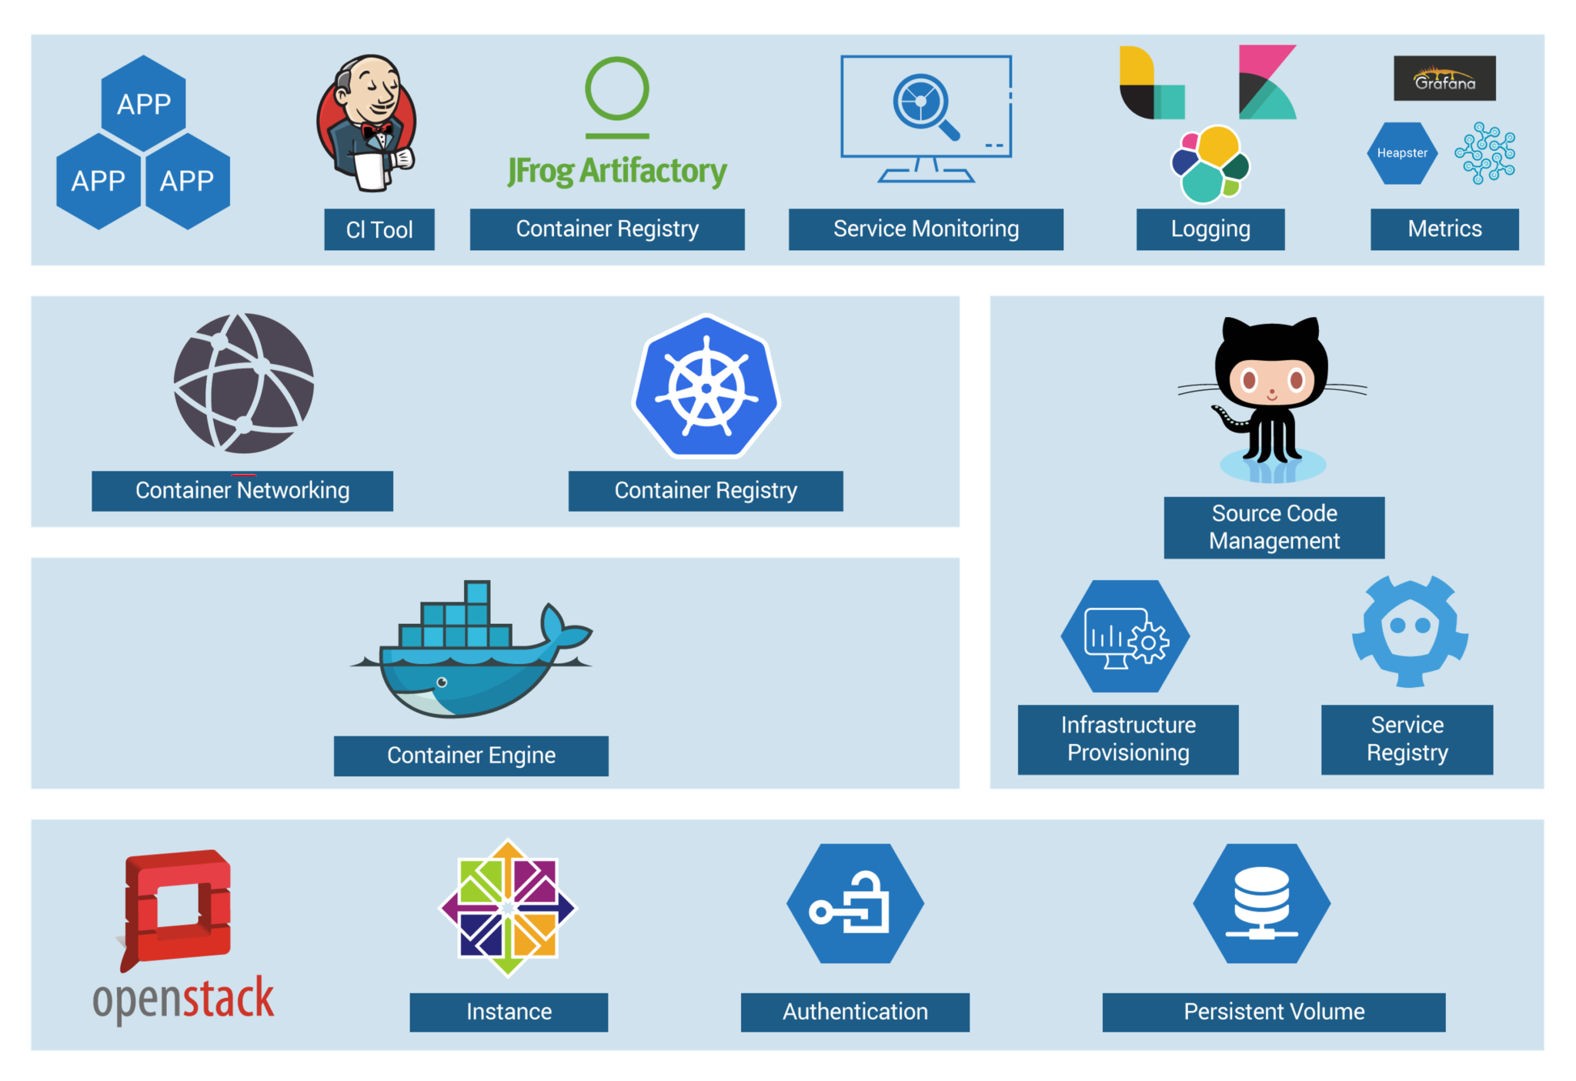

* OpenStack instances are used, with Docker, Kubernetes, Calico, etcd on top of it to perform various operations like Container Networking, Container Registry, and so on.

**DevOps Training**

* When you have a number of clusters, then it becomes hard to manage them right?
* So, they just wanted to create a simple, base OpenStack cluster to provide the basic functionality needed for Kubernetes and make the OpenStack environment easier to manage.
* By the combination of Image creation workflow and Kubernetes, they built the below toolchain which makes it easy from code push to deployment.

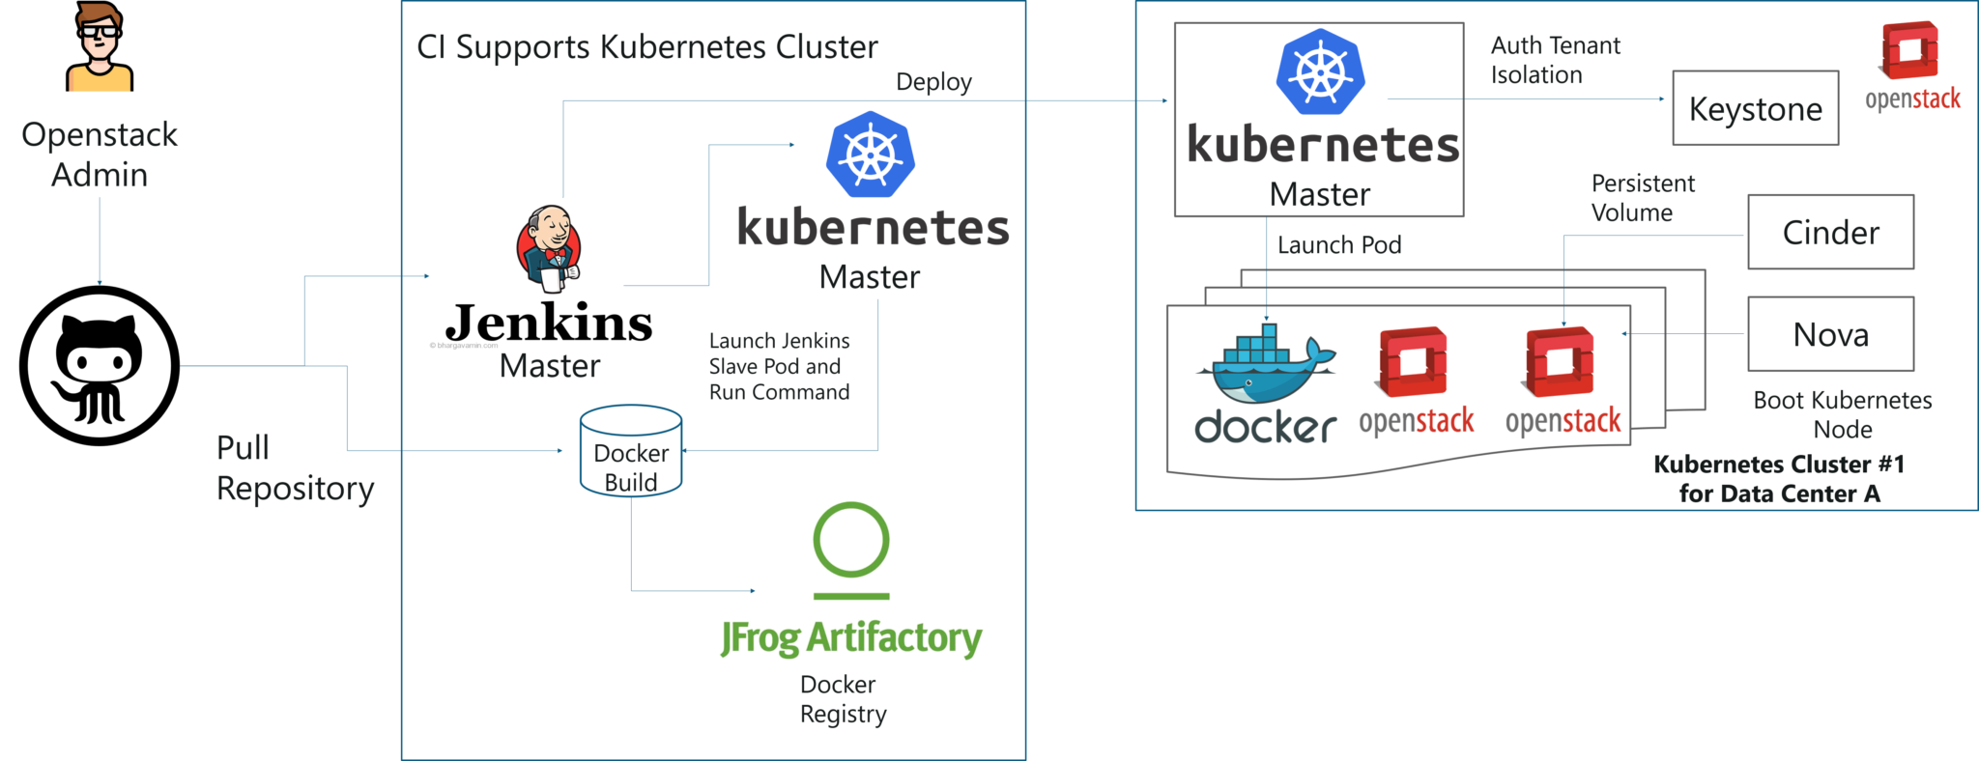

This kind of toolchain made sure that all factors for production deployment such as multi-tenancy, authentication, storage, networking, service discovery were considered.

* That’s how folks, **Yahoo! JAPAN** built an automation toolchain for “one-click” code deployment to Kubernetes running on OpenStack, with help from **Google** and **Solinea**.

## Installation

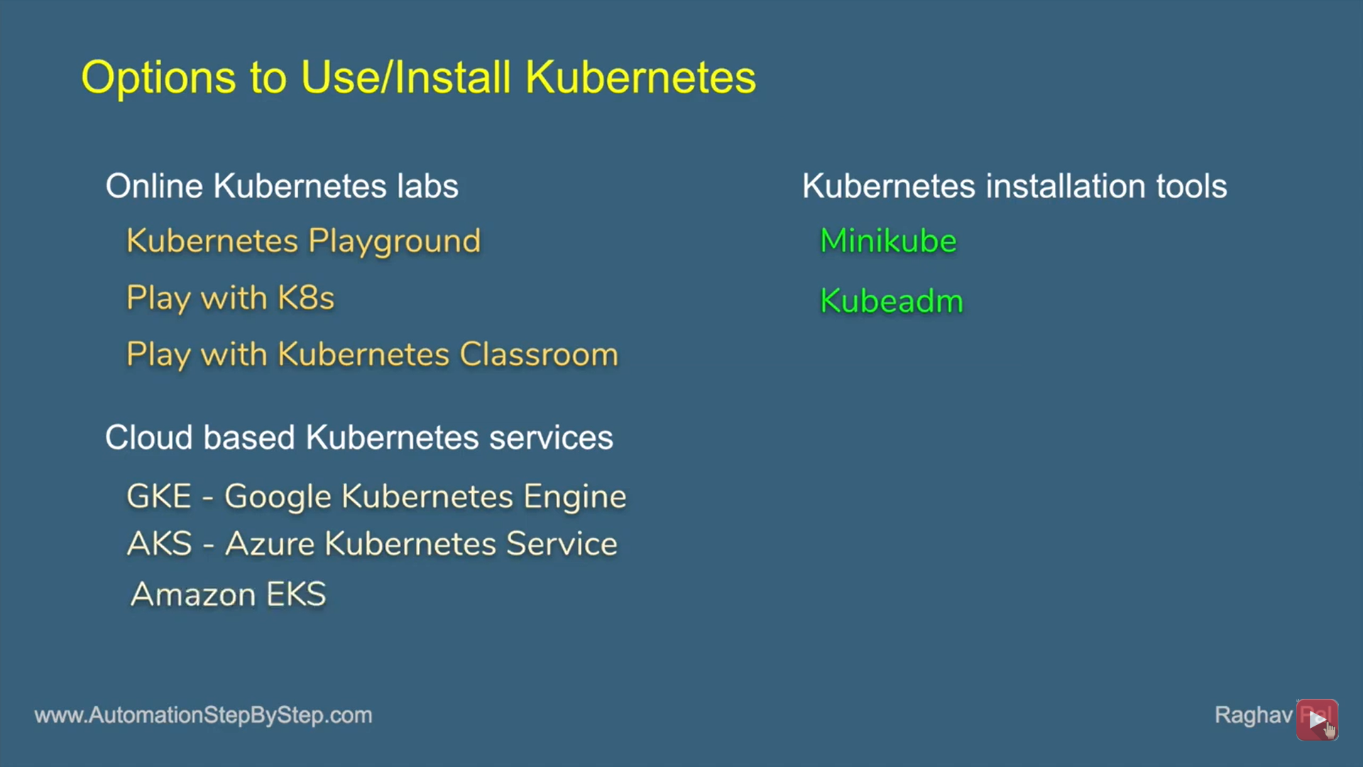

# Ref.

<http://dockerlabs.collabnix.com/>

<https://collabnix.github.io/kubelabs/>