Please follow the below steps to setup for windows environment.

1. Extract ZipCodeMinimization.zip in to your preferred location.
2. Navigate to project folder ZipCodeMinimization in command line.
3. Execute the following gradle command, which will build the project for eclipse envornoment for import and code review.

**gradlew eclipse**

1. Execute the following gradle command in command line for build and run test cases present in code base.

**gradlew clean build**

1. Navigate to /build\reports\tests\test and open index.hmtl, where we can verify the test results summary, after successful build.
2. Similarly navigate to \build\jacocoHtml and open index.html for code coverage.

The following are the test screens after code run.

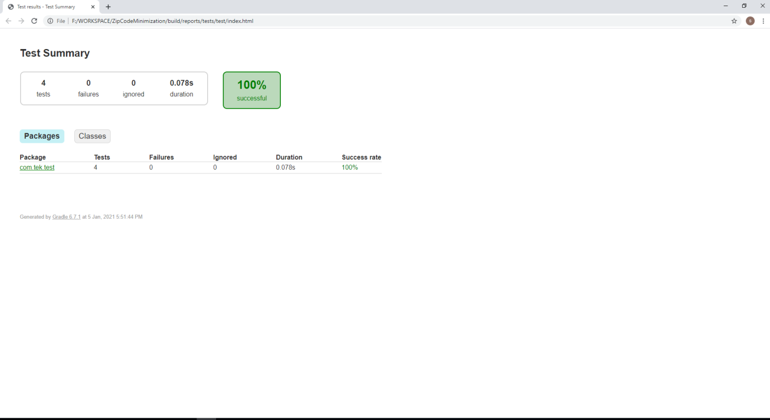

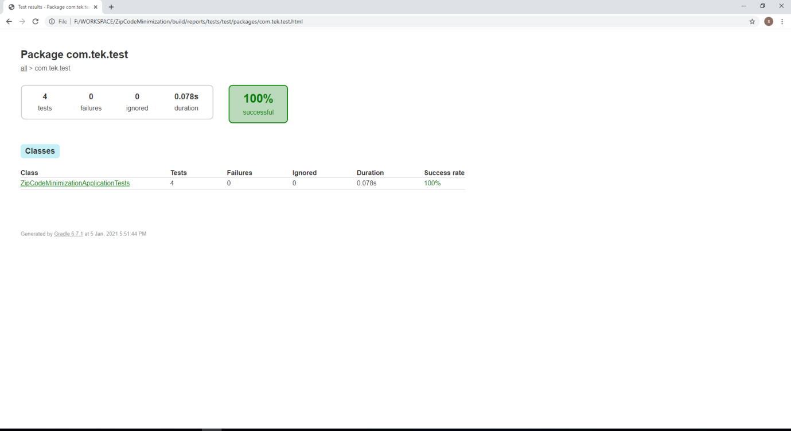 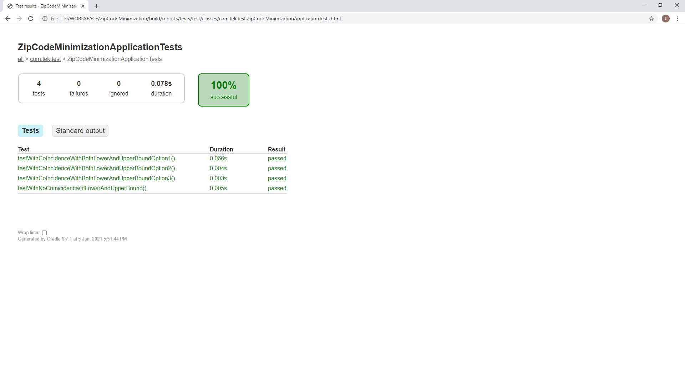 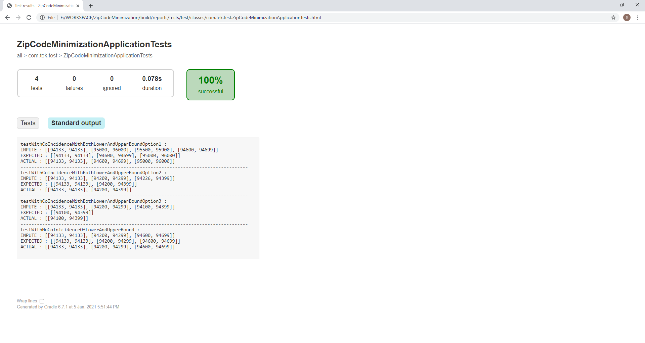

The following are the code coverage screens after code run.

