Part 2)

Task a)
Following we can see max temperature distribution in years 2000 and 2015. My understanding from this chart is that temperature in countries, specially Russia has risen during these 15 years.

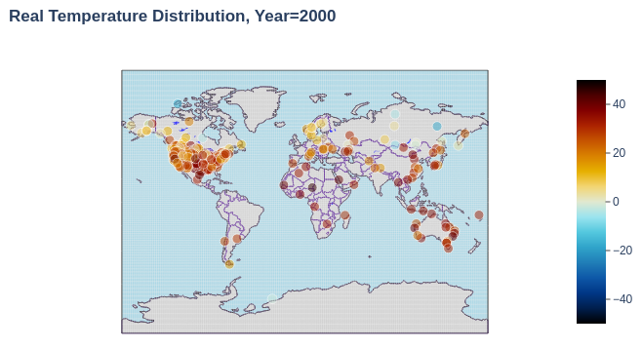
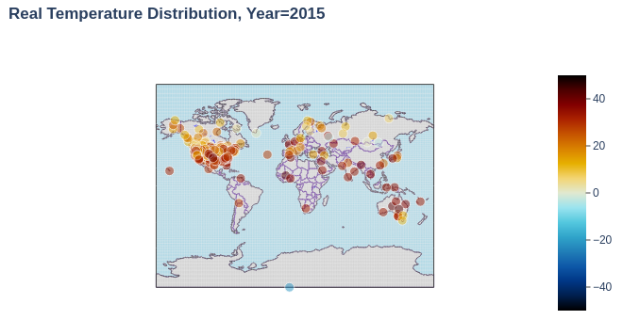

Task b)
I used my pre-trained model to predict temperature for years 2010 and 2015 again. Following is the diagrams:
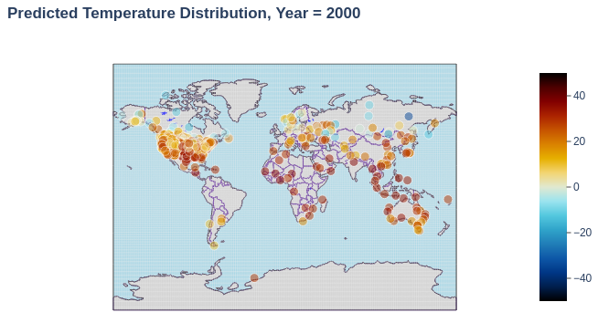
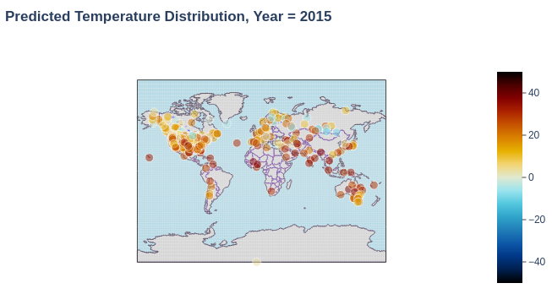
The understading is the same is previous diagram.

Task b1)
I didn’t manage to show density on this map, however, the points show that areas toward the north and south pole, Russia, and Canada show blue colors which is a sign of cold weather, and areas near equator show red color which has hot temperature.
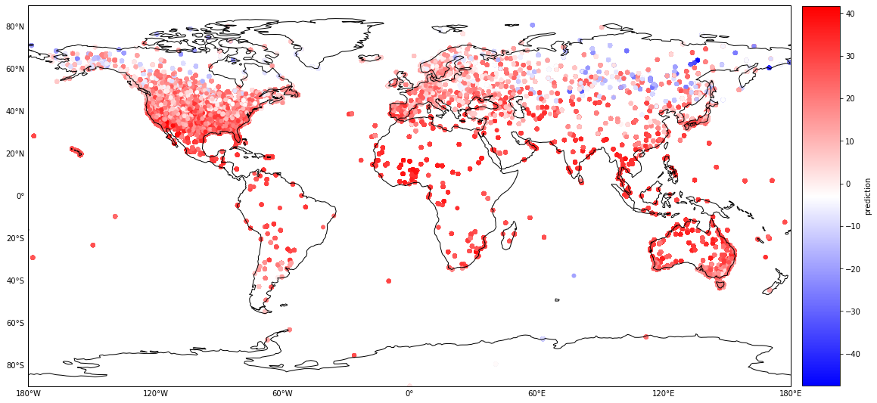

Task b2) Provided is the error rate of my model. From this map, we can understand that errors are very large in cold areas of the earth, i.e. north and south pole, Russia and some northern Europe countries.
