Hotel room reservation web application

**Full Name**: Panagiotis Sakellaropoulos

In this project, the development of a full stack web application is implemented, which is about the hotel room reservation. The main goal of the application is the user-friendliness and the optimal user experience, who would be able to complete their task easily and at the same time with the less possible cognitive process. For this reason, special emphasis is placed on the responsiveness of the application, as well as on the flow of screens through which users are required to pass in order to complete their task successfully. The tools that are used are the back-end JavaScript runtime environment "Node.js", the "Express.js" framework, the NoSQL "MongoDB", the front-end design tools "CSS", "vanilla JavaScript" and "pug" template engine for the html page rendering, as well as the “Bootstrap” framework, which was very helpful for the responsiveness of the application.

Initially, after being on the home page of the website, user can proceed by pressing the "BOOKNOW" button at the top right of the page (Image 1). It is worth noting that this button is separated from the menu with background color, to pique the user's interest and make it noticeable.

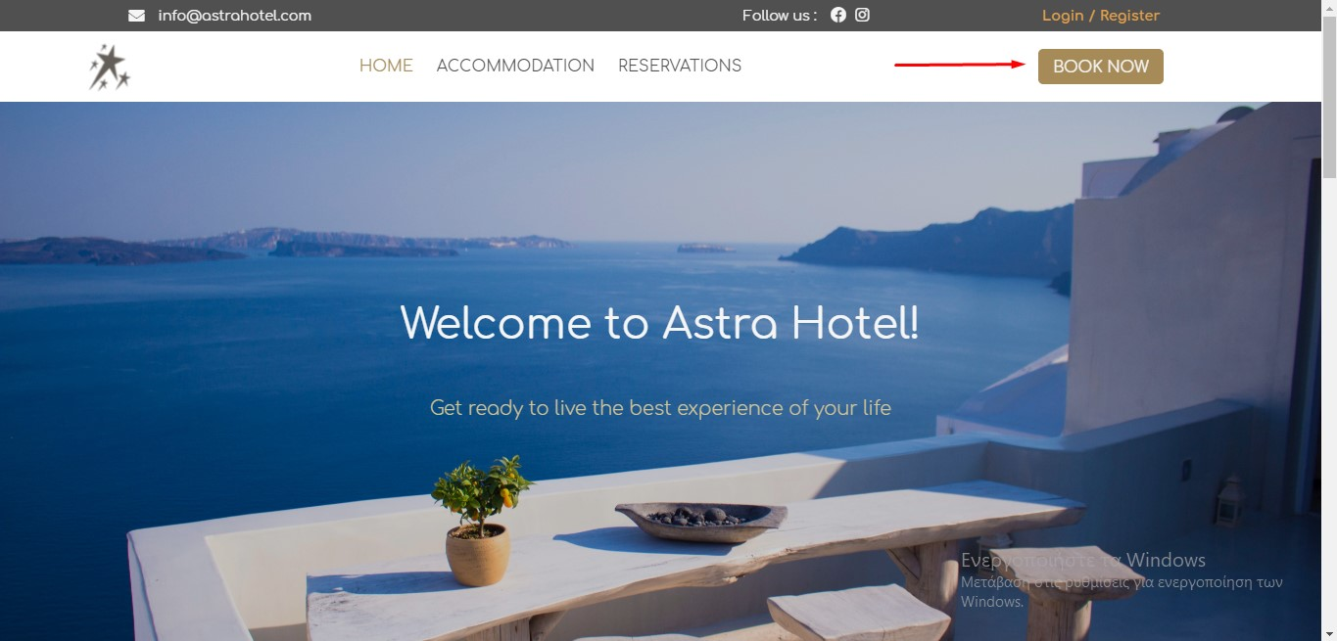Image 1

User is then taken to the rooms page (Image 2.1) where she/he can read more information about each room, via a pop-up by clicking the "View Details" button (Image 2.2), while at the top of the page there is a "Search Bar". With this, the user can select the desired arrival and departure date, as well as two optional filters related to the number of people in each room and whether she/he wants to be deluxe or not.

Εικόνα που περιέχει κείμενο

Περιγραφή που δημιουργήθηκε αυτόματαImage 2.1

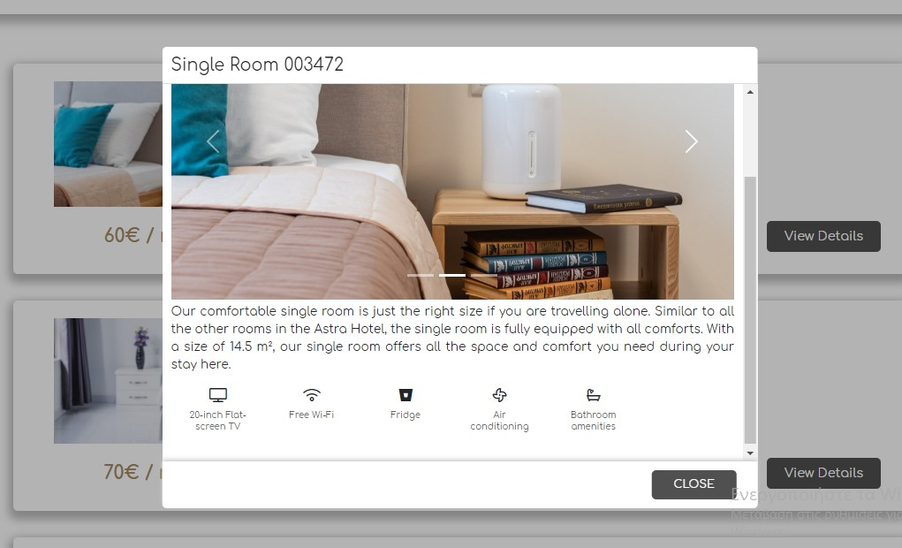Image 2.2

Then, by pressing the "Search" button, the application can find all the accommodations that meet the above conditions and are available during the period which is determined by the arrival date and departure date submitted by the user (Image 3). For arrival and departure dates, there is a check that the arrival date is always shorter than the departure date. If a room is already booked at that time, it cannot be found through the search. In addition, the user at this stage, can see the prices of each available room for each night - which vary according to the dates she/he wishes to make his reservation - and to proceed to the reservation of the room she/he wishes through the “Book” button. Finally, she/he can remove the filters by pressing "Clear" under the "Search" button.

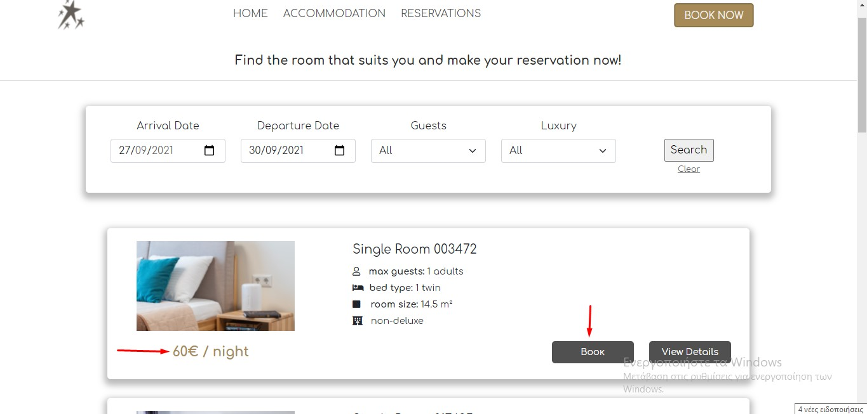Image 3

By pressing the "Book" button, the user goes to the next page (Image 4) where she/he can get informed about the details of the room she/he wants to book. These included the desired arrival and departure dates assigned by the previous step, as well as the total cost of the room he must pay to complete her/his booking. Finally, with the "Confirm" button the user goes to the last step of her/his reservation.

Εικόνα που περιέχει κείμενο

Περιγραφή που δημιουργήθηκε αυτόματαImage 4

This page (Image 5) contains a form with the details that user must fill and submit to complete the booking. For the submission of the form, there are various constraints which concern that all the fields of the form are required. In addition, the users are not allowed to have the same username as a previous user, and the verification codes he provides must be the same and contain from 8-20 characters.

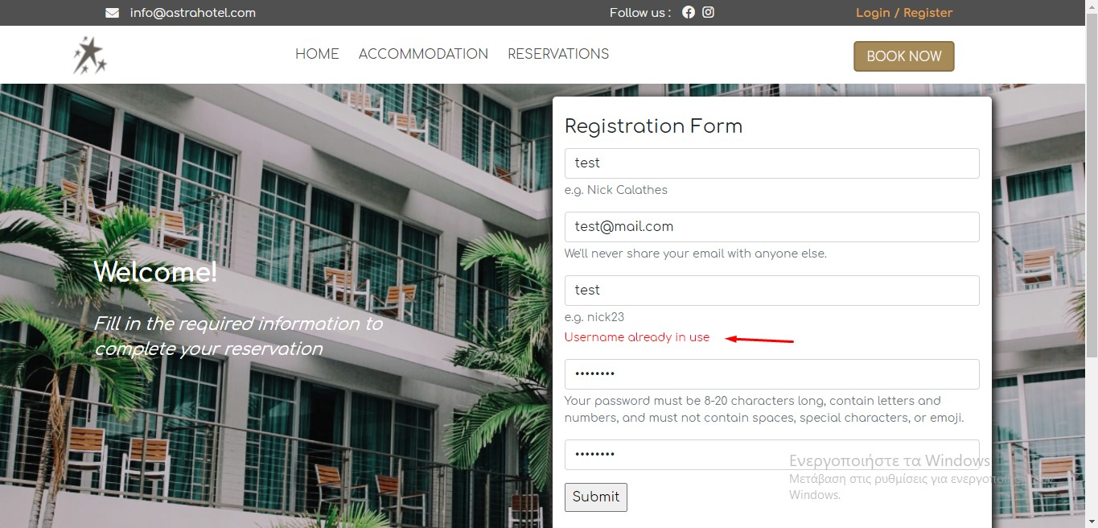Image 5

Pressing the "Submit" button, use successfully completes her/his task, and the reservation is confirmed via an informative pop-up message (Image 6).

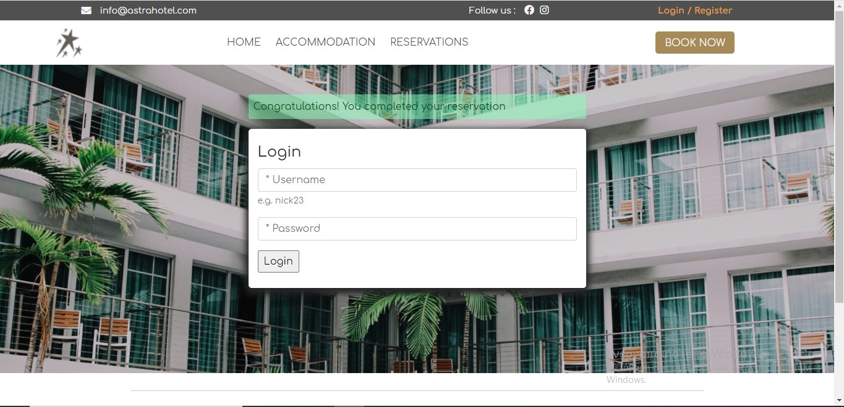Image 6

In addition to the task of booking a room, the user has the opportunity to check for the availability of accommodation by selecting from the menu "RESERVATIONS". This page (Image 7) lists for each room all the dates that have already been booked and are not available.

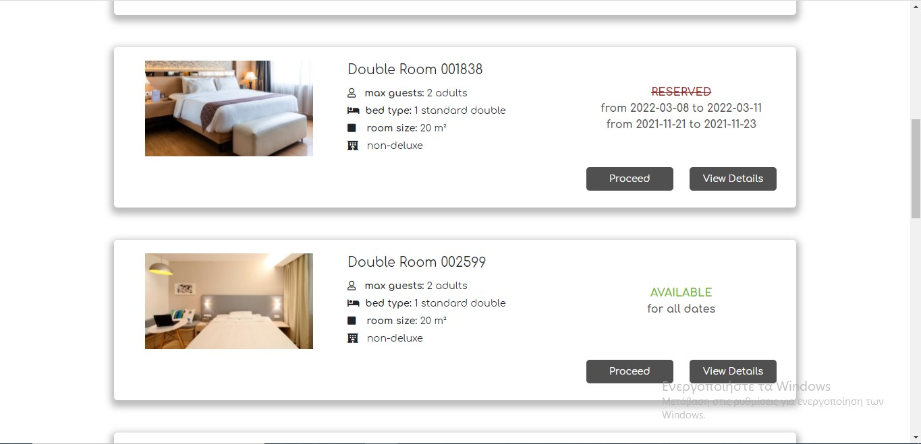Image 7

**Technical parts of the project**

The technical parts of this project will be briefly explained below.

Firstly, it is worth mentioning that all the pages have been created using the Bootstrap’s front end framework grid-system. In addition, this framework has been used for the carousels that exist both on the home page and in the pop-up with the photos for each room. The pop-ups are made with css and vanilla javascript.

The design of the database has been implemented with four models.

The first model is about the collection "**rooms**", which includes all the information about each room as shown on the booking page (including different prices per night for different months of the year for each room), to which the user first goes after clicking on the "**BOOK NOW**" button, as described above. In addition, this model includes some variables, which are "**updated**" with the "**set**" command of mongo. Specifically, "**pricePerNight**" and "**totalPrice**" are referred to the variables in which the average price of each room for each night and the total price of each room are stored, respectively. In addition, the boolean variable “**available**” is also "**updated**" and is false if the corresponding room is reserved for the dates submitted by the user. When the user presses the “**Search**” button, the variables “**possibleArrivalDates**” and “**possibleDepartureDates**” which are part of the “**temporaryBooking**” collection are updated too.

In addition, when the user selects the desired room and goes from the “**booking**” page to the “**booking/:id**” page, where the selected **arrival** and **departure** dates are displayed as well as the room **name** she/he wishes to reserve, the “**temporaryBooking**” collection is updated. This collection concerns the temporary reservations and includes 3 values ​​regarding the possible **arrival** and **departure** dates of the room, as well as the **name** of the room. This temporary storage is necessary so that as soon as the user fills the final “**booking form**”, the room **name**, **arrival** date and **departure** date are updated and stored.

Once the user chooses to submit her/his details in order to complete the booking, the room **name**, the **arrival** and **departure** dates, which are taken from the collection "**temporaryBooking**", as well as the **username** of the user, which is taken from the form submission (with the “POST” request) are stored in the “**booking**” collection.

Finally, there is the model of the collection "**users**", which allows to check some of the form inputs. More specifically, the "**username**" variable for the user's username has the property of “**unique”**, so that no one user can have the same username. In addition, the variables "**password**" and "**passwordConfirmation**" check if the passwords submitted by users are the same.

Log in functionality hasn’t implemented yet.

It is worth mentioning that for the page "**reservations**", where users can be informed about the availability of accommodation, a new object has been created in the reservation route, which has the following structure:

{

room_name1: [

{ arrivalDate: arrivalDate1, departureDate: departureDate1 },

{arrivalDate: arrivalDate2, departureDate: departureDate2 }, …

],

room_name2: [

{ arrivalDate: arrivalDate1, departureDate: departureDate1 },

{arrivalDate: arrivalDate2, departureDate: departureDate2 }, …

],

…

}

This object thus informs us about each room in a list of objects for the **arrival** and **departure** dates of each saved booking. This information is taken from the collection "**bookings**" and "**rooms**".

A lot of “**Promises”** are used in the route files, so that the collections of the database are updated before the pages are rendering through the pug template.

Finally, all the photos used are free and come from the website "unsplash.com".

Tutorial has followed for the app set up is from the below link: <https://www.youtube.com/watch?v=k_0ZzvHbNBQ>