
User Interface Design
CODE: 23CSE113 LAB

Submitted by
Name | Saket.S
Roll Number | AV.SC.U4CSE25049
Year/Sem/Section | 1st YEAR / SEM-2 / CSE-A
Credits | 03

Submitted to | DR .RAJ KUMAR BATCHU
Designation | ASST.PROFFESSOR (Sl. Grade)
Department | SCHOOL OF COMPUTING

ZEPTO Website clone

ZEPTO Website clone

AIM :- The aim of this project is to design and develop a modern, responsive, and user-friendly grocery delivery website inspired by Zepto using HTML and CSS. The website provides an intuitive interface for users to browse product categories, view offers, explore grocery items, and experience a clean e-commerce layout while demonstrating frontend web development skills.

About the Project:
Project Title: ZEPTO Clone – Grocery Delivery Website
The ZEPTO Clone is a frontend web development project designed to replicate the interface of a modern online grocery delivery platform. The website allows users to browse grocery categories, explore products, view special offers, and navigate through a clean and responsive user interface.
This project was developed using HTML5 and CSS3 to strengthen frontend development skills and understand the structure and design principles of modern e-commerce websites.

PROGRAM:
<!DOCTYPE html>
<html lang="en">
<head>
<meta charset="UTF-8">
<meta name="viewport" content="width=device-width, initial-scale=1.0">
<title>Zepto Clone</title>

<link href="https://fonts.googleapis.com/css2?family=Poppins:wght@300;400;500;600;700&display=swap" rel="stylesheet">

<style>

*{
margin:0;
padding:0;
box-sizing:border-box;
font-family:'Poppins',sans-serif;
}

body{
background:#f5f5f7;
}

/* NAVBAR */

nav{
position:sticky;
top:0;
z-index:1000;
display:flex;
justify-content:space-between;
align-items:center;
padding:18px 8%;
background:white;
box-shadow:0 2px 15px rgba(0,0,0,.08);
}

.logo{
color:#6f2cff;
font-size:2rem;
font-weight:700;
}

.search{
width:40%;
}

.search input{
width:100%;
padding:12px 18px;
border:none;
background:#f3f3f3;
border-radius:10px;
outline:none;
}

.nav-btn{
padding:10px 20px;
background:#6f2cff;
color:white;
text-decoration:none;
border-radius:10px;
}

/* HERO */

.hero{
display:flex;
justify-content:space-between;
align-items:center;
min-height:500px;
padding:50px 8%;
background:linear-gradient(135deg,#6f2cff,#4a00e0);
color:white;
}

.hero-content{
max-width:500px;
}

.hero-content h1{
font-size:3.5rem;
line-height:1.2;
}

.hero-content p{
margin:20px 0;
font-size:1rem;
}

.shop-btn{
display:inline-block;
background:white;
color:#6f2cff;
padding:12px 25px;
border-radius:10px;
text-decoration:none;
font-weight:600;
}

.hero-image{
font-size:12rem;
}

/* SECTION */

.section{
padding:60px 8%;
}

.section-title{
font-size:2rem;
margin-bottom:30px;
}

/* CATEGORIES */

.categories{
display:grid;
grid-template-columns:repeat(auto-fit,minmax(150px,1fr));
gap:20px;
}

.category{
background:white;
padding:25px;
text-align:center;
border-radius:18px;
box-shadow:0 5px 15px rgba(0,0,0,.08);
transition:.3s;
}

.category:hover{
transform:translateY(-8px);
}

.category .icon{
font-size:3rem;
}

.category p{
margin-top:10px;
font-weight:600;
}

/* OFFERS */

.offers{
display:grid;
grid-template-columns:repeat(auto-fit,minmax(280px,1fr));
gap:20px;
}

.offer{
color:white;
padding:35px;
border-radius:20px;
}

.offer:nth-child(1){
background:linear-gradient(135deg,#ff4d4d,#ff0066);
}

.offer:nth-child(2){
background:linear-gradient(135deg,#ffb703,#fb8500);
}

.offer:nth-child(3){
background:linear-gradient(135deg,#06d6a0,#118ab2);
}

.offer h2{
margin-bottom:10px;
}

/* PRODUCTS */

.products{
display:grid;
grid-template-columns:repeat(auto-fit,minmax(220px,1fr));
gap:25px;
}

.product-card{
background:white;
border-radius:20px;
overflow:hidden;
box-shadow:0 5px 20px rgba(0,0,0,.08);
transition:.3s;
}

.product-card:hover{
transform:translateY(-8px);
}

.product-image{
height:180px;
display:flex;
justify-content:center;
align-items:center;
background:#f8f8f8;
font-size:5rem;
}

.product-details{
padding:18px;
}

.delivery{
background:#f0f0f0;
padding:5px 10px;
border-radius:20px;
font-size:.75rem;
}

.product-details h3{
margin:12px 0 5px;
}

.price-row{
display:flex;
justify-content:space-between;
align-items:center;
margin-top:15px;
}

.price{
font-size:1.2rem;
font-weight:700;
}

.add-btn{
padding:8px 18px;
border:none;
background:#6f2cff;
color:white;
border-radius:8px;
cursor:pointer;
}

/* APP BANNER */

.app-banner{
margin:60px 8%;
padding:50px;
border-radius:20px;
color:white;
background:linear-gradient(135deg,#6f2cff,#a855f7);
text-align:center;
}

.app-banner h2{
font-size:2rem;
}

.app-banner p{
margin:15px 0;
}

.download-btn{
display:inline-block;
background:white;
color:#6f2cff;
padding:12px 25px;
border-radius:10px;
text-decoration:none;
font-weight:600;
}

/* FOOTER */

footer{
background:#111827;
color:white;
padding:50px 8%;
}

.footer-grid{
display:grid;
grid-template-columns:repeat(auto-fit,minmax(200px,1fr));
gap:30px;
}

footer h3{
margin-bottom:15px;
}

footer ul{
list-style:none;
}

footer ul li{
margin-bottom:10px;
}

footer ul li a{
color:#d1d5db;
text-decoration:none;
}

.copy{
text-align:center;
margin-top:30px;
color:#9ca3af;
}

@media(max-width:768px){

.hero{
flex-direction:column;
text-align:center;
}

.hero-content h1{
font-size:2.5rem;
}

.hero-image{
font-size:8rem;
margin-top:30px;
}

.search{
display:none;
}

}

</style>
</head>

<body>

<nav>
<div class="logo">⚡ zepto</div>

<div class="search">
<input type="text" placeholder="Search for groceries...">
</div>

<a href="#" class="nav-btn">Login</a>
</nav>

<section class="hero">

<div class="hero-content">
<h1>Groceries Delivered in 10 Minutes</h1>
<p>
Fresh fruits, vegetables, snacks, beverages,
dairy products and more delivered to your doorstep.
</p>

<a href="#" class="shop-btn">Shop Now</a>
</div>

<div class="hero-image">
🛒
</div>

</section>

<section class="section">

<h2 class="section-title">Shop By Category</h2>

<div class="categories">

<div class="category">
<div class="icon">🥦</div>
<p>Vegetables</p>
</div>

<div class="category">
<div class="icon">🍎</div>
<p>Fruits</p>
</div>

<div class="category">
<div class="icon">🥛</div>
<p>Dairy</p>
</div>

<div class="category">
<div class="icon">🍪</div>
<p>Snacks</p>
</div>

<div class="category">
<div class="icon">🥤</div>
<p>Beverages</p>
</div>

<div class="category">
<div class="icon">🧴</div>
<p>Beauty</p>
</div>

</div>
</section>
<section class="section">
<h2 class="section-title">Today's Offers</h2>
<div class="offers">
<div class="offer">
<h2>40% OFF</h2>
<p>Fresh Fruits & Vegetables</p>
</div>
<div class="offer">
<h2>Buy 2 Get 1</h2>
<p>On Soft Drinks</p>
</div>
<div class="offer">
<h2>60% OFF</h2>
<p>First Order Special</p>
</div>
</div>
</section>
<section class="section">
<h2 class="section-title">Popular Products</h2>
<div class="products">
<div class="product-card">
<div class="product-image">🥛</div>
<div class="product-details">
<span class="delivery">⚡ 10 min</span>
<h3>Amul Milk</h3>
<p>500 ml</p>
<div class="price-row">
<span class="price">₹28</span>
<button class="add-btn">ADD</button>
</div>
</div>
</div>
<div class="product-card">
<div class="product-image">🍞</div>
<div class="product-details">
<span class="delivery">⚡ 10 min</span>
<h3>Brown Bread</h3>
<p>400 g</p>
<div class="price-row">
<span class="price">₹40</span>
<button class="add-btn">ADD</button>
</div>
</div>
</div>
<div class="product-card">
<div class="product-image">🥚</div>
<div class="product-details">
<span class="delivery">⚡ 10 min</span>
<h3>Fresh Eggs</h3>
<p>6 Pieces</p>
<div class="price-row">
<span class="price">₹55</span>
<button class="add-btn">ADD</button>
</div>
</div>
</div>
<div class="product-card">
<div class="product-image">🍅</div>
<div class="product-details">
<span class="delivery">⚡ 10 min</span>
<h3>Tomatoes</h3>
<p>500 g</p>
<div class="price-row">
<span class="price">₹22</span>
<button class="add-btn">ADD</button>
</div>
</div>
</div>
</div>
</section>
<div class="app-banner">
<h2>Download The Zepto App</h2>
<p>Get exclusive offers and faster delivery.</p>
<a href="#" class="download-btn">Download Now</a>
</div>
<footer>
<div class="footer-grid">
<div>
<h3>Zepto</h3>
<p>Groceries delivered in 10 minutes.</p>
</div>
<div>
<h3>Company</h3>
<ul>
<li><a href="#">About</a></li>
<li><a href="#">Careers</a></li>
<li><a href="#">Blog</a></li>
</ul>
</div>
<div>
<h3>Support</h3>
<ul>
<li><a href="#">Help</a></li>
<li><a href="#">Contact</a></li>
<li><a href="#">Privacy</a></li>
</ul>
</div>
<div>
<h3>Follow Us</h3>
<ul>
<li><a href="#">Instagram</a></li>
<li><a href="#">Facebook</a></li>
<li><a href="#">Twitter</a></li>
</ul>
</div>
</div>
<div class="copy">
© 2025 Zepto Clone. All Rights Reserved.
</div>
</footer>
</body>
</html>
Output :
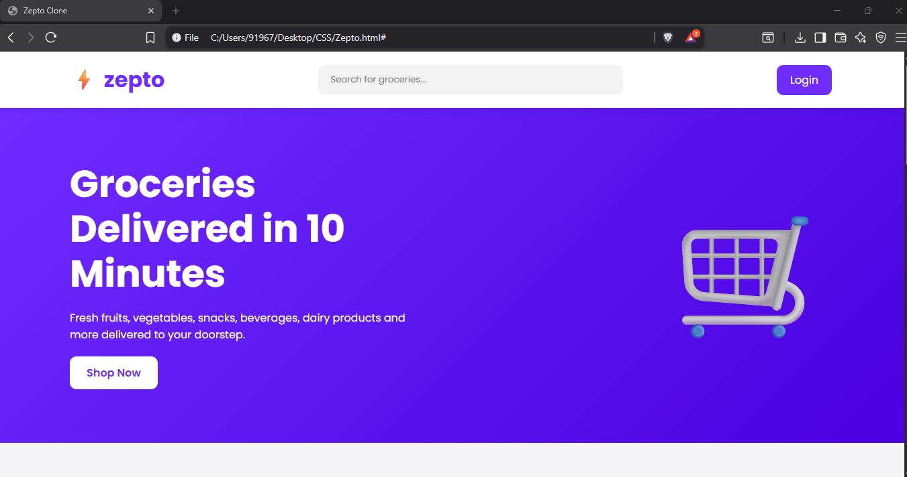
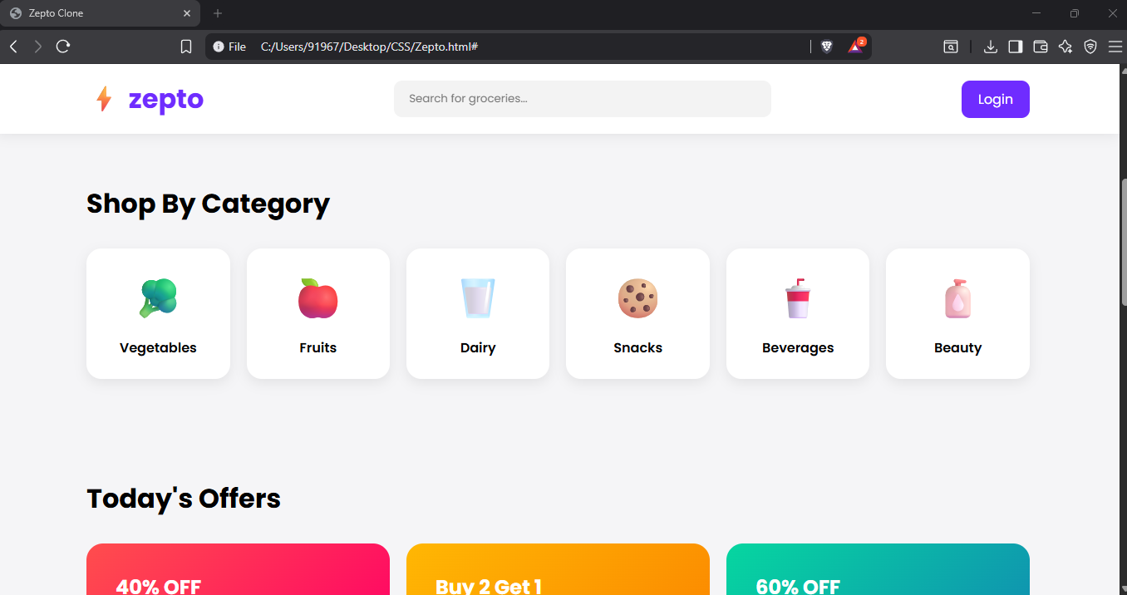
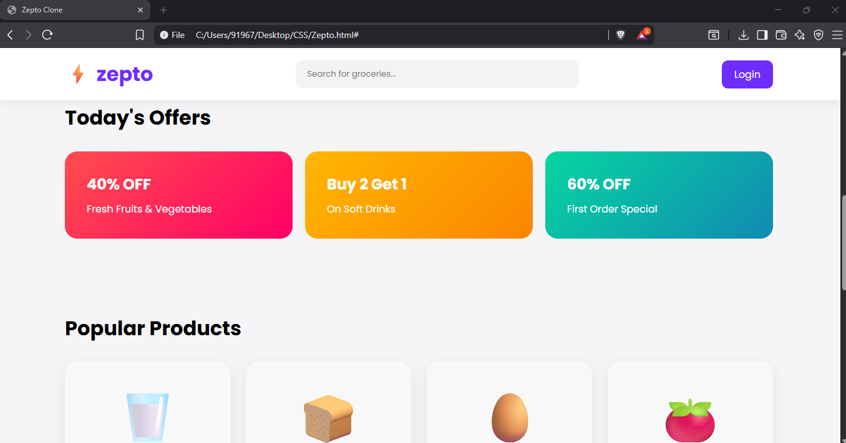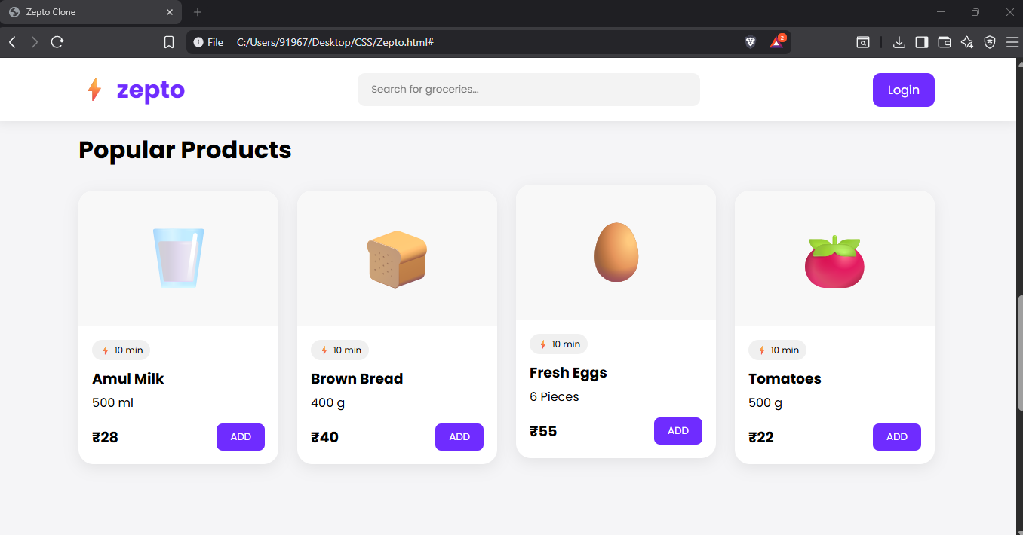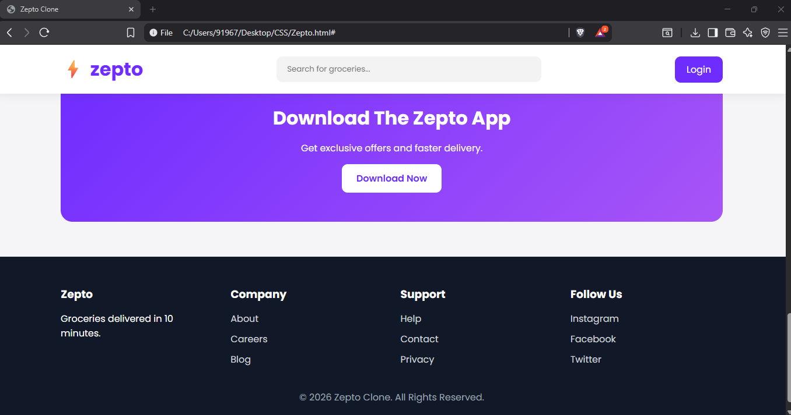
Explanation of tags:
<html> | Root element that contains the entire webpage | Wraps the whole website
<head> | Stores metadata and resources | Contains title, fonts, CSS, and meta tags
<meta> | Provides page information to browser | Character encoding and responsive design
<title> | Sets the browser tab name | Displays "Zepto Clone" on the tab
<link> | Connects external resources | Google Fonts integration
<style> | Contains CSS styling | Used for all website design and layout
<body> | Contains all visible webpage content | Entire website content
<nav> | Defines the navigation bar | Logo, search bar, and login button
<div> | Generic container used for grouping elements | Used throughout the website for layout and structure
<input> | Creates user input fields | Search bar
<a> | Creates hyperlinks | Login button, Shop Now button, Download button, Footer links
<section> | Defines logical sections of a webpage | Hero, Categories, Offers, Products sections
<h1> | Main heading of the page | Hero section heading
<h2> | Section headings | Categories, Offers, Products, App Banner
<h3> | Sub-headings | Product names and Footer titles
<p> | Displays paragraph text | Product descriptions, Hero text, Footer text
<span> | Inline text container | Prices, delivery badges, labels
<button> | Creates clickable buttons | ADD button, Download button
<footer> | Defines the footer area | Company information and links
<ul> | Creates an unordered list | Footer navigation links
<li> | Represents individual list items | About, Contact, Privacy, etc.

Explanation
I used semantic HTML tags such as <nav>, <section>, and <footer> to organize the website structure, along with content tags like headings and paragraphs, interactive elements like buttons and links, and container elements like <div> to create a responsive Zepto-inspired grocery delivery website.
Media Query
@media (max-width: 768px) { ... }
Adjusts layout for mobile: stacks flex rows vertically, reduces font sizes, and adjusts padding.
Class Selectors & Modifiers Classes like .btn, .btn-green, .btn-lg follow a modifier pattern — a base class sets shared styles and modifier classes layer on specifics. This keeps the CSS DRY (Don't Repeat Yourself).
The HTML tags used in my project are: <html>, <head>, <meta>, <title>, <link>, <style>, <body>, <nav>, <div>, <input>, <a>, <section>, <h1>, <h2>, <h3>, <p>, <span>, <button>, <footer>, <ul>, and <li>.

Final Thought :
In conclusion, this project helped me apply HTML and CSS concepts to build a responsive and visually appealing grocery delivery website. It enhanced my understanding of frontend development, website layout design, and user experience, while also providing a foundation for future full-stack development features

