1. Download the code to your local machine.
2. Please make sure that you have Python installed on your machine, by running the command Python –version, from your Command Line Prompt or Terminal.’

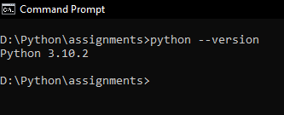

1. Run the Code by the command, Python Full-Path-Where-Your-Code-Is/count_of_words.py

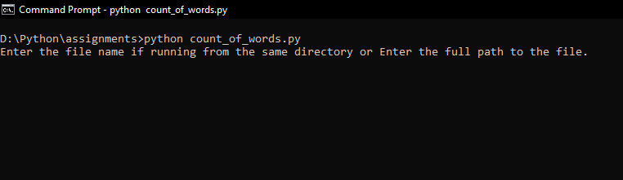

1. Enter the path to the file or the filename if already in the directory.

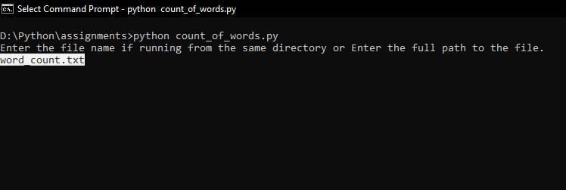

1. The system should display count of the individual words in a descending order of frequency they appear in.