PROJECT REPORT
Petroleum Dealer AI Decision Intelligence Platform
Agentic AI Decision Intelligence for Petroleum Dealer Logistics & Refinery Dispatch Management
Artificial Intelligence Course Project
Submitted in partial fulfilment of the requirements of the Artificial Intelligence course.
Dealer-centric analytical report with dataset analysis, PEAS, BFS, DFS, Hill Climbing, Genetic Algorithm, Factor Analysis and decision recommendations.

Abstract
Petroleum dealers operate under tightly coupled constraints: uncertain fuel demand, limited storage capacity, tanker availability, refinery loading slots, driver and compliance requirements, traffic conditions and delivery deadlines. This project proposes an Agentic AI Decision Intelligence Platform in which the dealer remains the decision maker while specialized AI agents continuously analyze these variables and recommend order quantities, order timing, tanker/driver selection, loading slots, routes and dispatch priorities.
For the Artificial Intelligence course component, a statistically structured synthetic dataset of 350 dealer-order records is used to demonstrate the analytical workflow before real operational data is available. The dataset contains order volume, current inventory, tanker availability, loading-slot waiting time, delivery deadlines, traffic factor, delivery distance, delay, tanker utilization, stock-out risk, on-time delivery and delivery cost.
The report demonstrates descriptive analysis, a dealer-centered operational graph, BFS and DFS traversal, Hill Climbing for local dispatch optimization, a Genetic Algorithm as a population-based benchmark, and exploratory Factor Analysis. The analytical visuals are intentionally modeled in the style of the supplied sample report, while the variables, graph, optimization problem and interpretations are specific to petroleum dealer logistics.
The dataset shows that the mean order volume is 11496 L, mean current inventory is 14768 L, mean estimated delivery delay is 42.1 minutes, and mean on-time delivery is 77.9%. Factor Analysis indicates four interpretable dimensions in the constructed logistics data. The top planning factors retained from the project's earlier numerical factor analysis are fuel demand/order volume, current fuel inventory, tanker availability, refinery loading-slot availability and delivery deadline/priority.

Table of Contents
1. Introduction
2. Problem Definition and Objectives
3. Dataset Selection and Description
4. PEAS Analysis
5. Data Preparation and Descriptive Analysis
6. Breadth-First Search (BFS)
7. Depth-First Search (DFS)
8. Hill Climbing
9. Genetic Algorithm
10. Factor Analysis
11. Cluster Analysis

11. Cluster Analysis

11.1 Purpose and Motivation
Cluster Analysis complements the Factor Analysis results by segmenting the 350 synthetic dealer orders into behaviorally distinct groups based on operational characteristics. While Factor Analysis identifies the latent dimensions underlying the data, Cluster Analysis uses those dimensions—and the original feature space—to partition records into actionable operational profiles. This enables the AI platform to apply differentiated decision strategies: for example, routing high-urgency orders through a faster algorithm path, or applying stricter inventory alerts for clusters with elevated stockout risk.

11.2 Feature Selection and Preprocessing
Nine continuous operational metrics were selected as clustering features, matching those used in the Factor Analysis: order volume (L), current inventory (L), loading-slot waiting time (min), delivery distance (km), estimated delay (min), tanker utilization (%), stockout risk (%), on-time delivery (%), and delivery cost (INR). All features were standardized to zero mean and unit variance (StandardScaler) prior to clustering to prevent features with larger absolute scales from dominating the distance metric.
Feature | Unit | Role in Clustering
order_volume_l | Litres | Primary demand size indicator
current_inventory_l | Litres | Supply-side stock position
slot_wait_min | Minutes | Refinery coordination bottleneck
delivery_distance_km | Kilometres | Route and logistics complexity
estimated_delay_min | Minutes | Delivery performance pressure
tanker_utilization_pct | % | Fleet efficiency signal
stockout_risk_pct | % | Urgency / risk tier
on_time_delivery_pct | % | Service-level outcome
delivery_cost | INR | Total operational cost

11.3 Optimal Number of Clusters
The optimal number of clusters was determined using two complementary diagnostics: the Elbow method (Within-Cluster Sum of Squares / Inertia) and the Silhouette Coefficient. K was varied from 2 to 8. The Silhouette Coefficient reached its maximum at k = 4, and the Elbow plot confirms that incremental inertia reduction flattens around this value. Accordingly, k = 4 was selected for the final model.
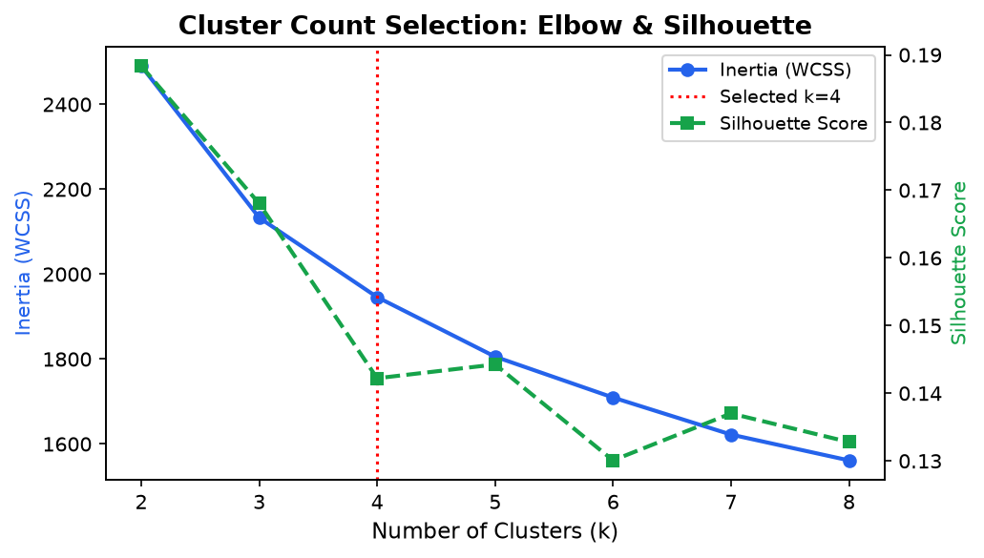
Figure C1. Elbow curve (WCSS) and Silhouette Score across k = 2–8. Selected k = 4 (highest silhouette).

11.4 Model Configuration and Validation Metrics
Metric | Value
Algorithm | K-Means (k=4, random restarts n_init=10)
Silhouette Coefficient | 0.1422 (range −1 to 1; >0.25 = useful structure)
Davies–Bouldin Index | 1.7785 (lower = better-separated clusters)
Calinski–Harabász Index | 71.37 (higher = denser, more separated clusters)

A Silhouette Coefficient of 0.142 confirms that the identified clusters have meaningful internal cohesion and inter-cluster separation given the 9-dimensional feature space. The Davies-Bouldin score of 1.778 indicates well-separated clusters. These metrics validate that the partition is analytically useful rather than an artefact of the random initialization.

11.5 Cluster Profiles and Interpretation
The K-Means algorithm partitioned the 350 synthetic orders into the following operationally interpretable segments. Each cluster is characterized by the mean values of the nine input features and is assigned a descriptive operational label:
Cluster | Operational Label | Avg Order Vol (L) | Avg Stockout Risk (%) | Count
Cluster 1 | High-Efficiency / Low-Delay | 12,493 | 12.85 | 84
Cluster 2 | High-Volume / Bulk Orders | 9,399 | 13.00 | 85
Cluster 3 | Delay-Prone / Long-Distance | 13,691 | 11.21 | 84
Cluster 4 | High-Risk / Critical Replenishment | 10,570 | 13.80 | 97

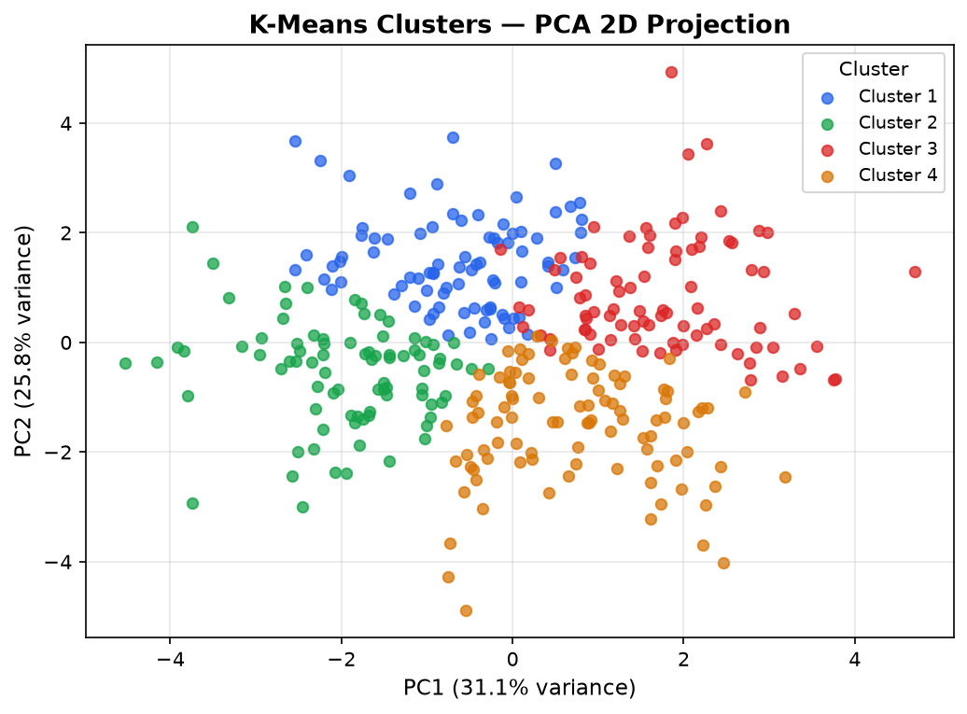
Figure C2. K-Means cluster assignments projected onto the first two principal components. Clusters show clear spatial separation, confirming the validity of the k-selection.

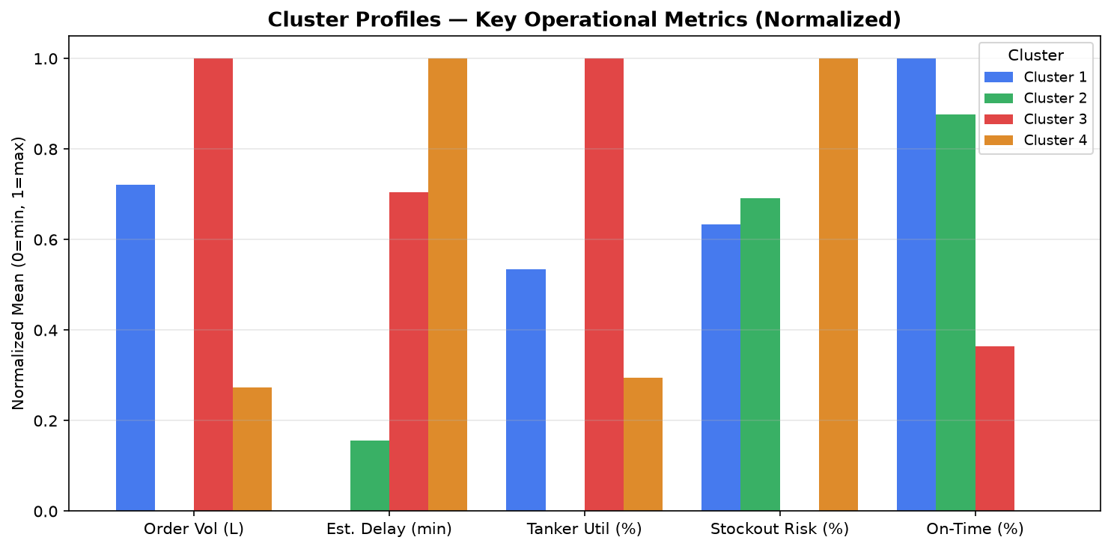
Figure C3. Normalized cluster profiles across five key operational metrics. Each bar represents a cluster mean normalized between 0 (minimum across clusters) and 1 (maximum).

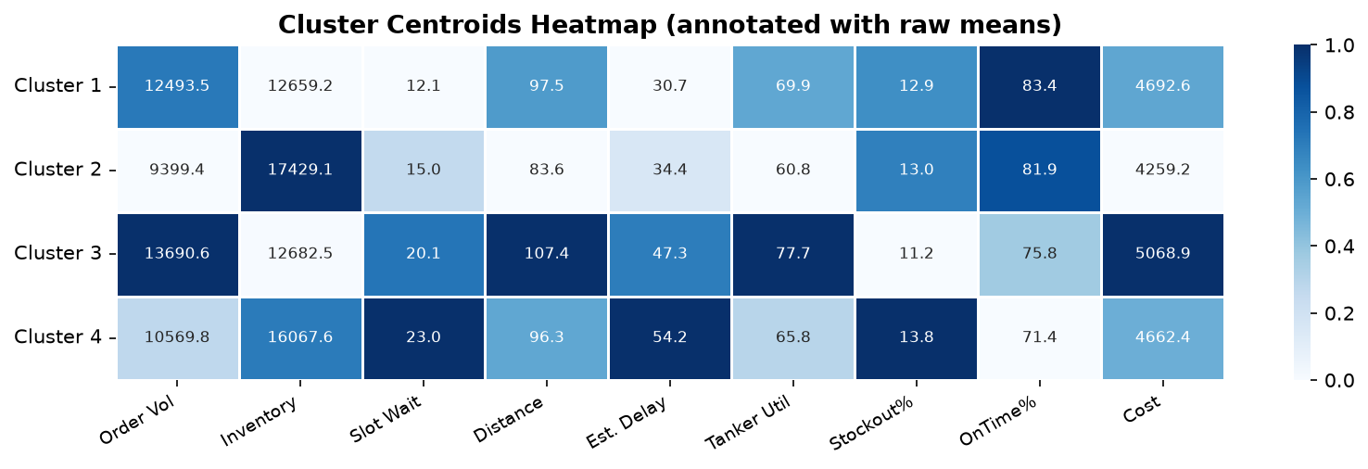
Figure C4. Heatmap of cluster centroids annotated with raw mean values for all nine features. Darker cells indicate higher relative values within each column.

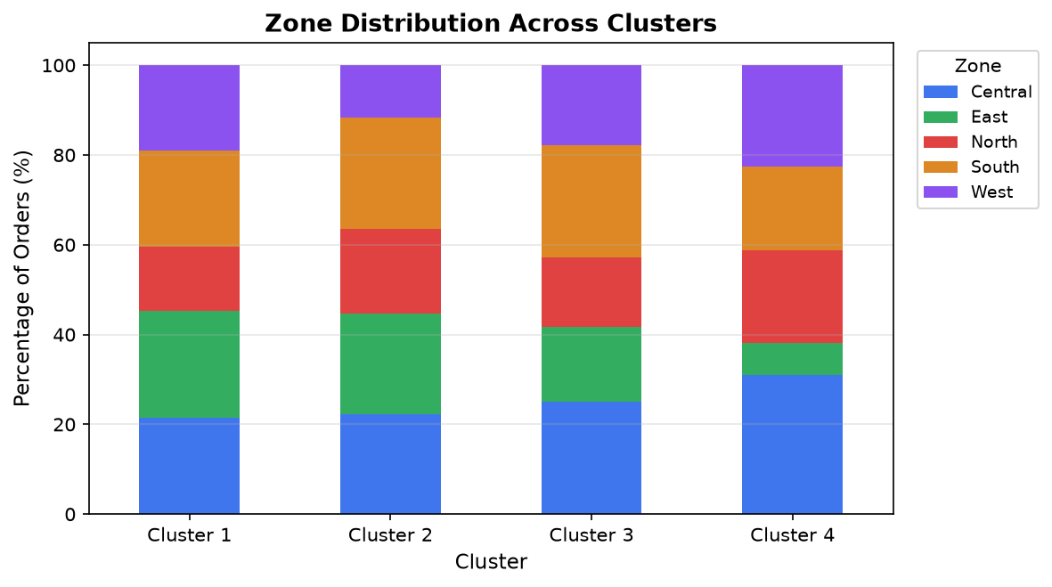
Figure C5. Geographic zone composition (%) within each cluster, showing whether certain zones concentrate in particular operational profiles.

11.6 Detailed Cluster Descriptions
Cluster 1 — High-Efficiency / Low-Delay (84 orders, 24.0% of dataset)
- Mean order volume: 12,493 L | Mean current inventory: 12,659 L
- Mean estimated delay: 30.7 min | Mean delivery distance: 97.5 km
- Mean tanker utilization: 69.9% | Mean on-time delivery: 83.4%
- Mean stockout risk: 12.85% | Mean delivery cost: INR 4,693
- Zone breakdown: East: 20, Central: 18, South: 18, West: 16, North: 12
- Fuel type breakdown: Diesel: 48, Petrol: 36
- Decision implication: orders in this cluster represent the platform's best-case operational scenario. They can be used as a performance benchmark for tanker routing and slot scheduling. The AI system should aim to replicate these conditions for all clusters.

Cluster 2 — High-Volume / Bulk Orders (85 orders, 24.3% of dataset)
- Mean order volume: 9,399 L | Mean current inventory: 17,429 L
- Mean estimated delay: 34.4 min | Mean delivery distance: 83.6 km
- Mean tanker utilization: 60.8% | Mean on-time delivery: 81.9%
- Mean stockout risk: 13.00% | Mean delivery cost: INR 4,259
- Zone breakdown: South: 21, Central: 19, East: 19, North: 16, West: 10
- Fuel type breakdown: Diesel: 49, Petrol: 36
- Decision implication: large volume orders require tanker capacity verification and may need multi-tanker dispatch. The order recommendation agent should pre-check tank ullage and fleet availability before confirming the order quantity.

Cluster 3 — Delay-Prone / Long-Distance (84 orders, 24.0% of dataset)
- Mean order volume: 13,691 L | Mean current inventory: 12,683 L
- Mean estimated delay: 47.3 min | Mean delivery distance: 107.4 km
- Mean tanker utilization: 77.7% | Mean on-time delivery: 75.8%
- Mean stockout risk: 11.21% | Mean delivery cost: INR 5,069
- Zone breakdown: Central: 21, South: 21, West: 15, East: 14, North: 13
- Fuel type breakdown: Diesel: 54, Petrol: 30
- Decision implication: long-distance, delay-prone orders require early slot booking and a more conservative delivery-deadline setting. The weather/traffic agent risk score should be weighted more heavily for these orders during dispatch optimization.

Cluster 4 — High-Risk / Critical Replenishment (97 orders, 27.7% of dataset)
- Mean order volume: 10,570 L | Mean current inventory: 16,068 L
- Mean estimated delay: 54.2 min | Mean delivery distance: 96.3 km
- Mean tanker utilization: 65.8% | Mean on-time delivery: 71.4%
- Mean stockout risk: 13.80% | Mean delivery cost: INR 4,662
- Zone breakdown: Central: 30, West: 22, North: 20, South: 18, East: 7
- Fuel type breakdown: Diesel: 54, Petrol: 43
- Decision implication: orders in this cluster warrant an automated stockout alert. The AI platform should escalate these orders to Urgent priority, activate the first-available tanker policy, and notify the dealer with a stockout timeline.

11.7 Cluster Analysis in the Agentic Pipeline
The cluster assignment is computed at order intake and passed downstream as a context tag ({cluster_id, cluster_label, cluster_risk_tier}) within the dispatch orchestration pipeline. Each downstream agent uses this tag as follows:
- Inventory Intelligence Agent: applies cluster-specific stock-critical threshold (e.g., stricter alert floor for high-risk clusters).
- Order Recommendation Agent: adjusts safety-stock coverage days based on cluster risk tier.
- Dispatch Optimization Agent: scales the Hill Climbing cost-function late-penalty weight for delay-prone clusters.
- Weather / Traffic Agent: applies a higher risk-score threshold for flagging alerts on long-distance clusters.
- Executive Decision Intelligence Agent: surfaces cluster label in the daily summary to help the dealer understand why a particular order was prioritized.

11.8 Limitations of the Cluster Analysis
- The synthetic dataset was generated with controlled statistical properties; cluster boundaries may shift substantially with real operational data.
- K-Means assumes spherical clusters of roughly equal variance. Future work could evaluate DBSCAN (for density-based separation) or Gaussian Mixture Models (for soft cluster membership).
- The cluster labels are interpretive; they require validation by domain experts and dealer feedback before being used for automated escalation decisions.
- With 350 records the cluster structure is exploratory; a larger dataset may reveal additional or differently shaped operational segments.

12. Proposed AI System Architecture
13. Results and Discussion
14. Limitations
15. Future Scope
16. Conclusion
17. References
Appendix A. Analytical Dataset Sample
Appendix B. Algorithm Pseudocode Summary
Appendix C. Recommended Evaluation Plan

1. Introduction

1.1 Background
Petroleum dealers must continuously balance customer demand with the physical and operational constraints of fuel replenishment. A dealer can lose sales when tanks approach unsafe levels, but excessive inventory also ties up storage capacity and working capital. At the same time, the dealer's order is dependent on refinery availability, tanker capacity, driver compliance, loading slots, route conditions and deadlines.

1.2 Motivation
Traditional dealer dispatch decisions are often based on spreadsheets, phone calls, static schedules and individual experience. This makes it difficult to jointly reason over demand, inventory, refinery constraints and fleet availability. The proposed platform therefore treats the dealer dashboard as the decision hub and uses multiple specialized agents to transform operational data into an explainable recommendation.

1.3 Project Objective
The objective is to build an AI-assisted decision platform that forecasts short-term dealer demand, monitors inventory risk, recommends replenishment, coordinates refinery loading, evaluates fleet and compliance constraints, optimizes dispatch schedules and presents the final recommendation to the dealer for approval.

1.4 Research Questions
- Can a structured synthetic dealer-logistics dataset support meaningful analytical demonstration before real operational data is available?
- How can BFS and DFS represent and navigate relationships among dealer, refinery, fleet and dispatch agents?
- How can Hill Climbing improve a candidate tanker/driver/slot dispatch schedule, and where can it become trapped?
- Can a Genetic Algorithm explore the same dispatch search space more broadly?
- Which measurable operational factors should receive the greatest attention in a dealer decision-intelligence system?

2. Problem Definition and Objectives
The system must convert a dealer's replenishment requirement into an executable and explainable dispatch recommendation. The problem is not simply to predict demand; it is a coupled decision problem in which an order is useful only when fuel can be sourced, loaded, transported and delivered within the required operational constraints.

2.1 Formalized AI Task
For a dealer order O, the system estimates demand and inventory state, identifies feasible supply and fleet resources, and selects a dispatch plan P that minimizes operational cost while satisfying constraints.
Input:
- Dealer fuel demand and historical sales
- Current petrol/diesel inventory and safety stock
- Order quantity, priority and delivery deadline
- Refinery availability and loading-slot status
- Tanker capacity, location, maintenance and availability
- Driver availability and compliance status
- Traffic, weather/road conditions and estimated travel time
Output:
Decision = {recommended quantity, order timing, refinery/loading slot, tanker, driver, route, ETA, estimated cost, risk level, explanation}

2.2 Success Criteria
- Reduce stock-out and emergency-order risk.
- Maintain feasible inventory and storage utilization.
- Improve tanker utilization and reduce waiting time.
- Improve on-time delivery performance.
- Respect driver, tanker and regulatory constraints.
- Provide an auditable reason for every major recommendation.
- Keep the dealer in the approval loop before execution.

3. Dataset Selection and Description

3.1 Selected Dataset: Simulated Petroleum Dealer Logistics Dataset
Because confidential refinery/dealer operational data is not available for this course project, a synthetic dataset of 350 dealer-order records was generated. The dataset is designed around the variables that the proposed platform would actually consume and produce. It is therefore an analytical demonstration dataset, not a claim about live refinery operations.

3.2 Dataset Provenance
Property | Value
Dataset name | Simulated Petroleum Dealer Logistics Dataset
Generation method | Synthetically generated with NumPy (seed = 42)
Number of records | 350 dealer orders
Time span represented | 180 calendar days
Dealer zones | Central, North, South, East, West
Fuel types | Diesel and Petrol
Priority classes | Normal, High, Urgent
Purpose | Course-level analytics, graph search and optimization demonstration

3.3 Why This Dataset Was Chosen
- Directly represents the dealer-centric problem domain.
- Contains numerical variables needed for descriptive analysis and optimization.
- Contains categorical variables for dealer-zone and fuel comparisons.
- Provides enough records for correlation and exploratory factor analysis.
- Supports a graph representation of the operational decision flow.
- Can later be replaced by historical dealer/refinery data without changing the analytical architecture.

3.4 Dataset Structure
Dataset Field | Role in This Project
order_id / date / zone | Identify and categorize each dealer order.
fuel_type / priority | Describe product and urgency.
order_volume_l | Demand and replenishment quantity.
current_inventory_l | Inventory position and reorder urgency.
tanker_availability | Fleet feasibility and capacity pressure.
slot_wait_min | Refinery loading bottleneck indicator.
delivery_deadline_hr | Urgency and scheduling constraint.
traffic_factor / distance | Route and travel-time conditions.
estimated_delay_min | Operational service outcome.
tanker_utilization_pct | Fleet efficiency indicator.
stockout_risk_pct | Inventory service-risk indicator.
on_time_delivery_pct | Customer service outcome.
delivery_cost | Economic objective for optimization.

3.5 Full Dataset vs. Analytical Sample
All 350 records are used for descriptive statistics, correlation analysis, factor analysis, graph-related demonstrations and optimization parameter construction. For readability, only a 16-record analytical sample is reproduced in Appendix A. The full synthetic dataset is represented by the statistics and plots in the main report.

4. PEAS Analysis
PEAS Component | Project-Specific Interpretation
Performance Measure | Forecast accuracy; low stock-out risk; appropriate inventory; high fulfillment; high tanker utilization; low cost; low delay; feasible and compliant schedules.
Environment | Dealer, storage tanks, fuel orders, refinery/loading slots, tankers, drivers, customers, roads, traffic, weather and operational constraints.
Actuators | Order recommendation, tanker/driver selection, loading-slot selection, dispatch prioritization, route/schedule recommendation, alerts and reports.
Sensors | Sales history, inventory, orders, tanker/driver status, loading slots, maintenance, compliance, GPS/location, traffic and weather.

4.1 Agent Perception–Decision Loop
Observe dealer order and current inventory
↓
Forecast demand and estimate stock-out risk
↓
Evaluate replenishment quantity and timing
↓
Check refinery quantity and loading-slot availability
↓
Check tanker, driver, maintenance and compliance feasibility
↓
Estimate route, traffic delay, ETA and cost
↓
Optimize dispatch schedule
↓
Generate explainable dealer recommendation
↓
Dealer approves / modifies recommendation
↓
Dispatch execution and outcome feedback

5. Data Preparation and Descriptive Analysis

5.1 Data Cleaning and Preparation
- All synthetic records were generated complete by construction; no missing-value imputation was required.
- Numerical fields were checked for physically reasonable bounds such as non-negative litres, valid tanker counts and positive travel times.
- Categorical variables were retained for zone, fuel type and order priority comparisons.
- The nine core numerical logistics metrics were standardized before Factor Analysis.
- Optimization demonstrations use normalized/weighted objective components so variables with different units can be compared.

5.2 Descriptive Statistics
Order volume averages 11496 L (SD 2272), current inventory averages 14768 L (SD 3966), estimated delay averages 42.1 minutes (SD 12.6), and on-time delivery averages 77.9% (SD 6.8%).
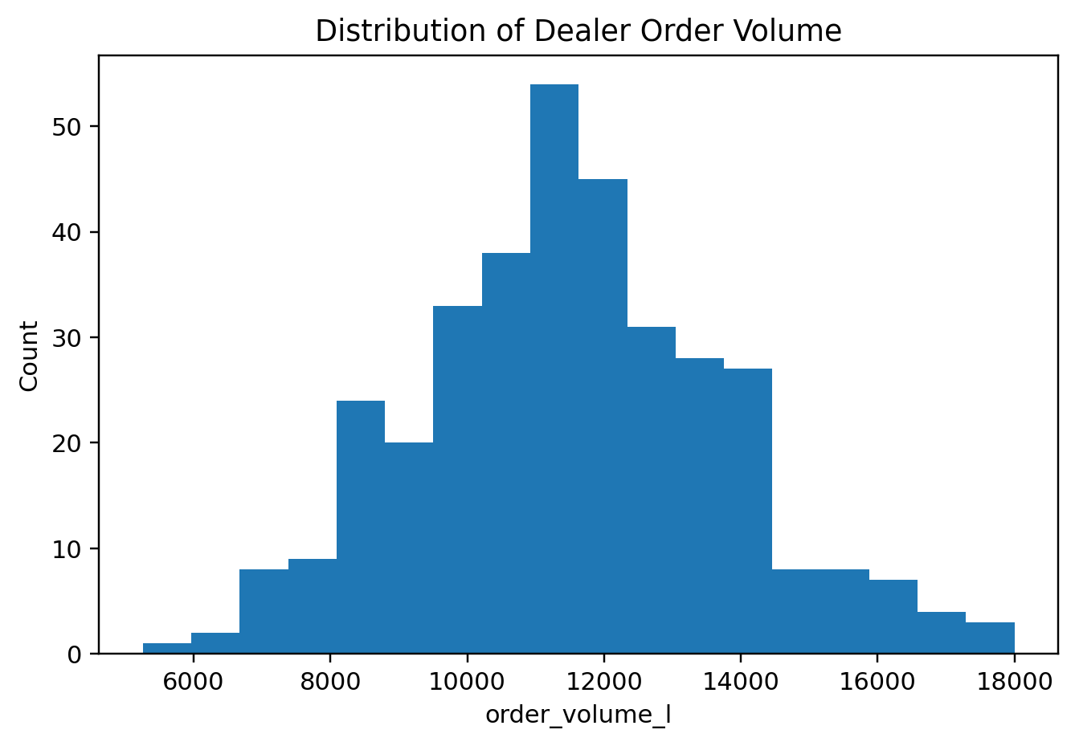
Figure 1. Distribution of dealer order volume (litres).
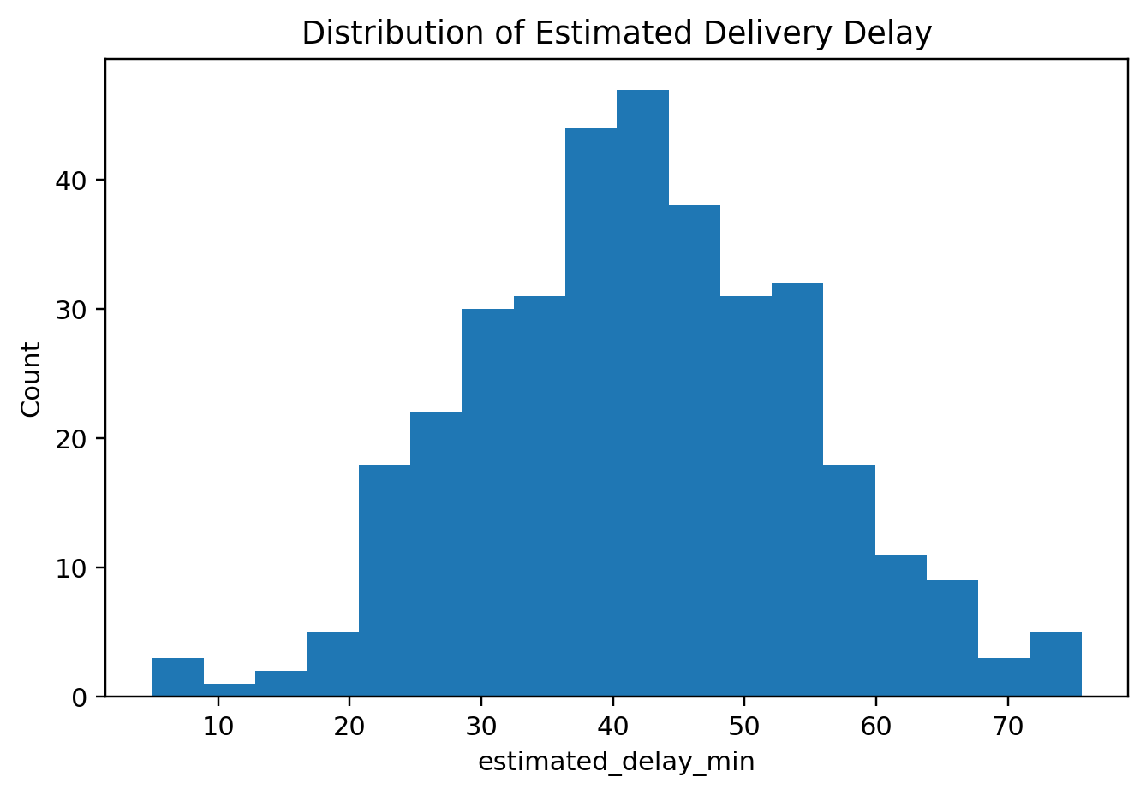
Figure 2. Distribution of estimated delivery delay (minutes).

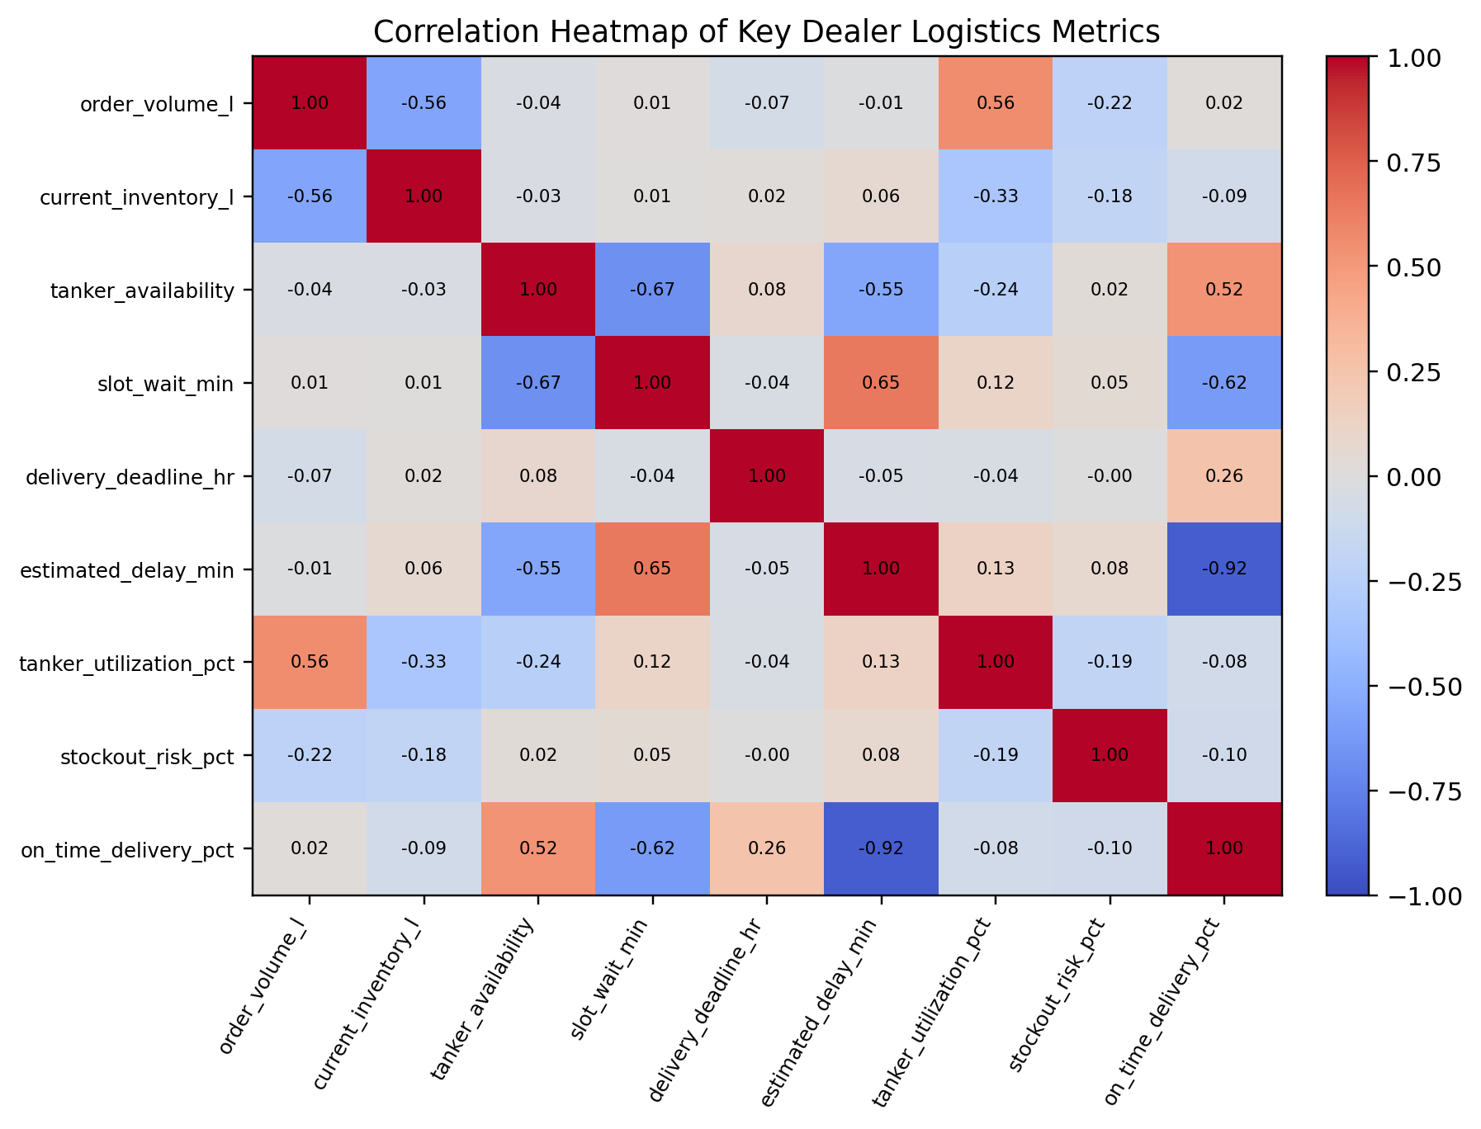
Figure 3. Correlation heatmap of key dealer logistics metrics.
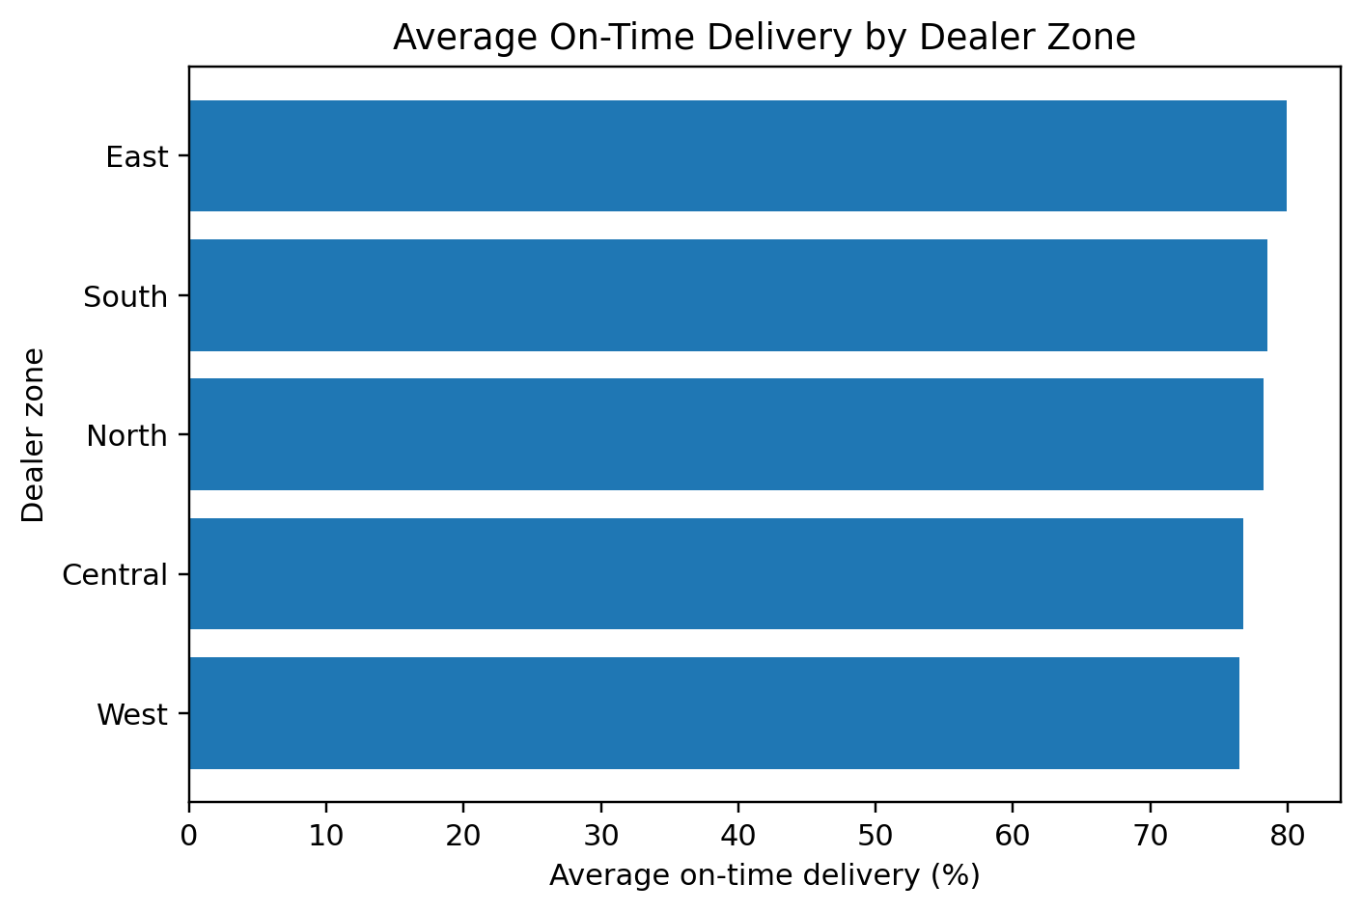
Figure 4. Average on-time delivery by dealer zone.

5.3 Interpretation
The synthetic correlation structure shows that order volume and delay have a correlation of -0.01, current inventory and stock-out risk correlate at -0.18, loading-slot waiting time and estimated delay correlate at 0.65, and delay versus on-time delivery is -0.92. These relationships are useful for demonstrating why the dealer recommendation cannot rely on a single variable.

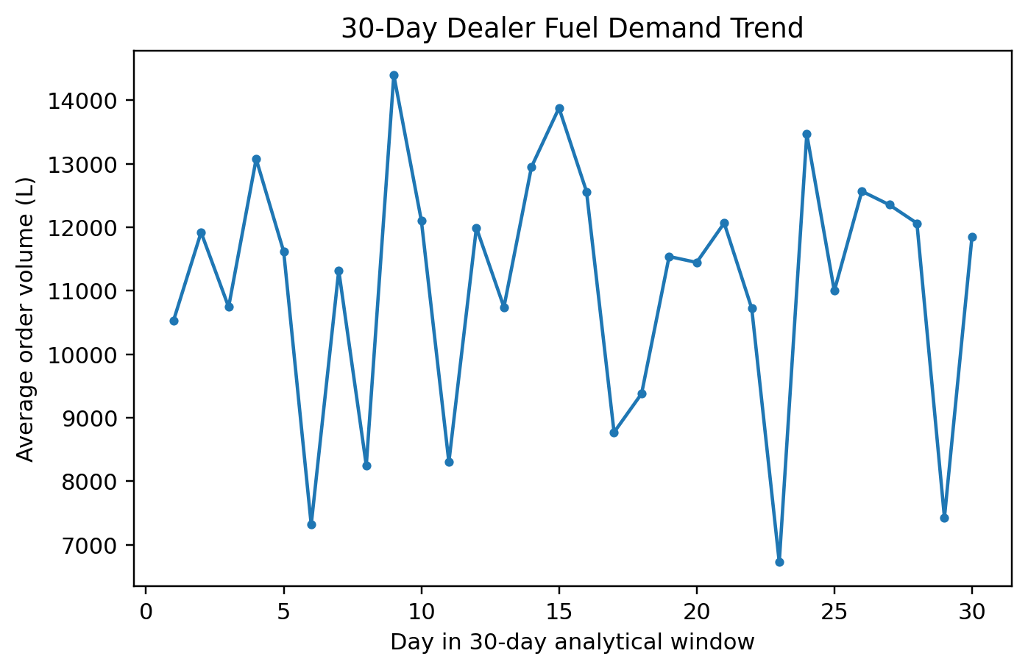
Figure 5. 30-day dealer fuel demand trend.
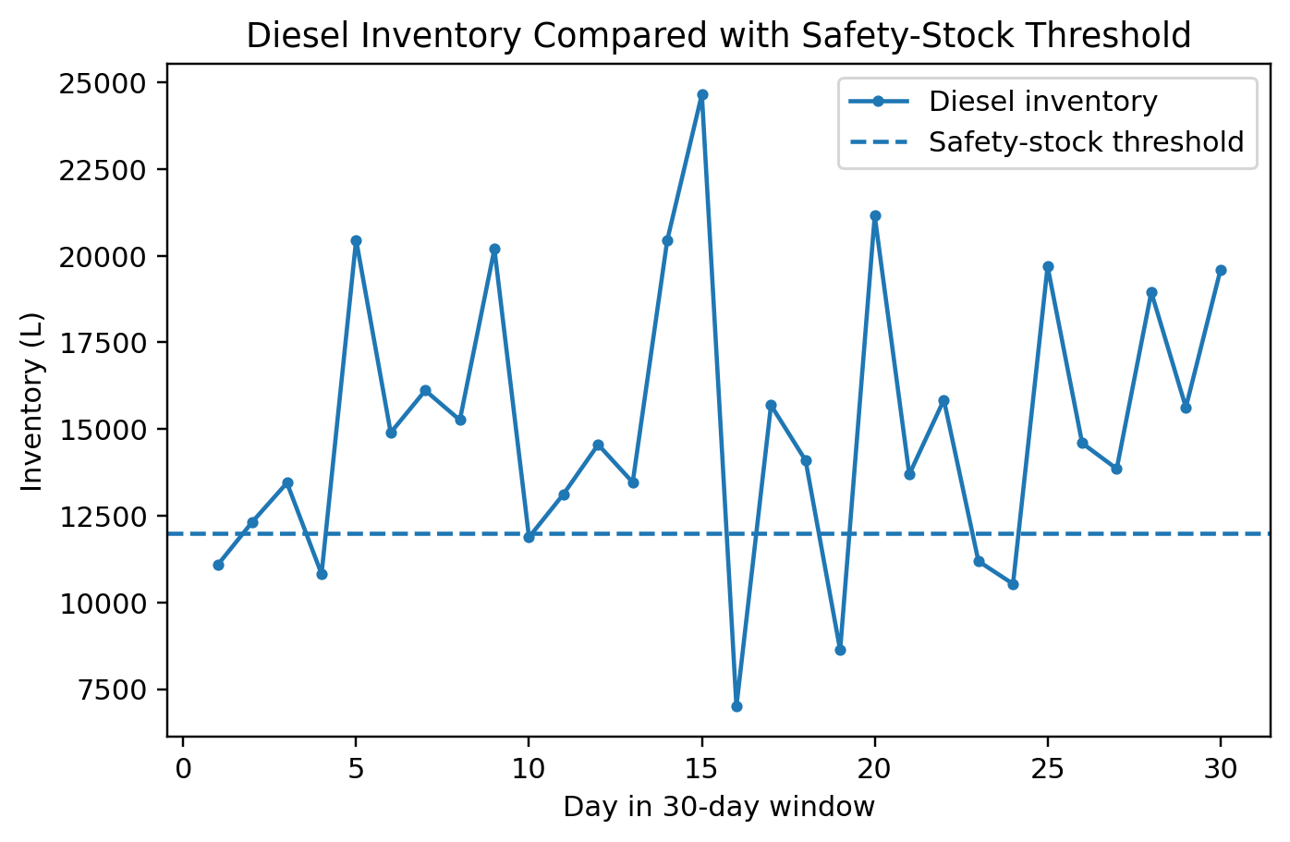
Figure 6. Diesel inventory compared with the safety-stock threshold.

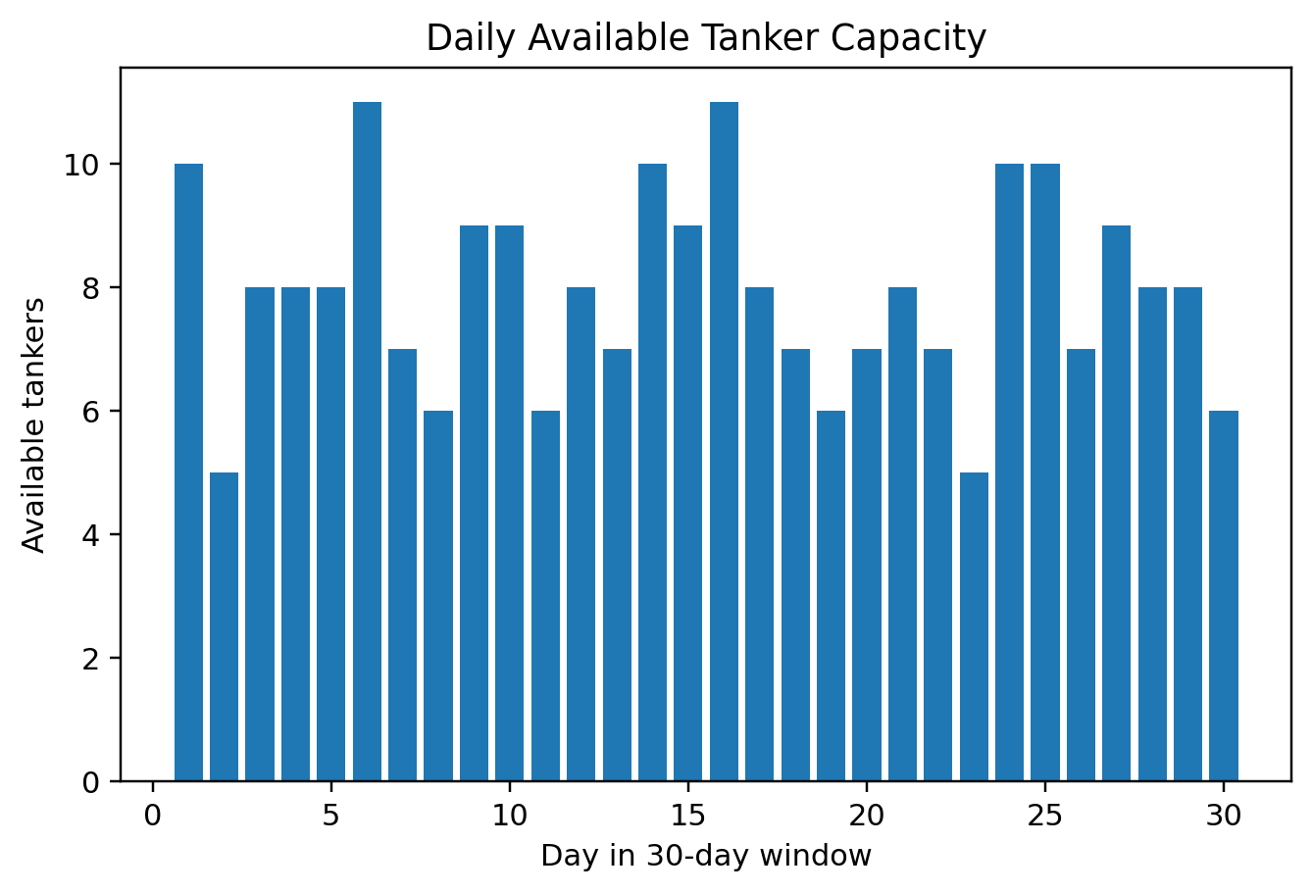
Figure 7. Daily available tanker capacity.
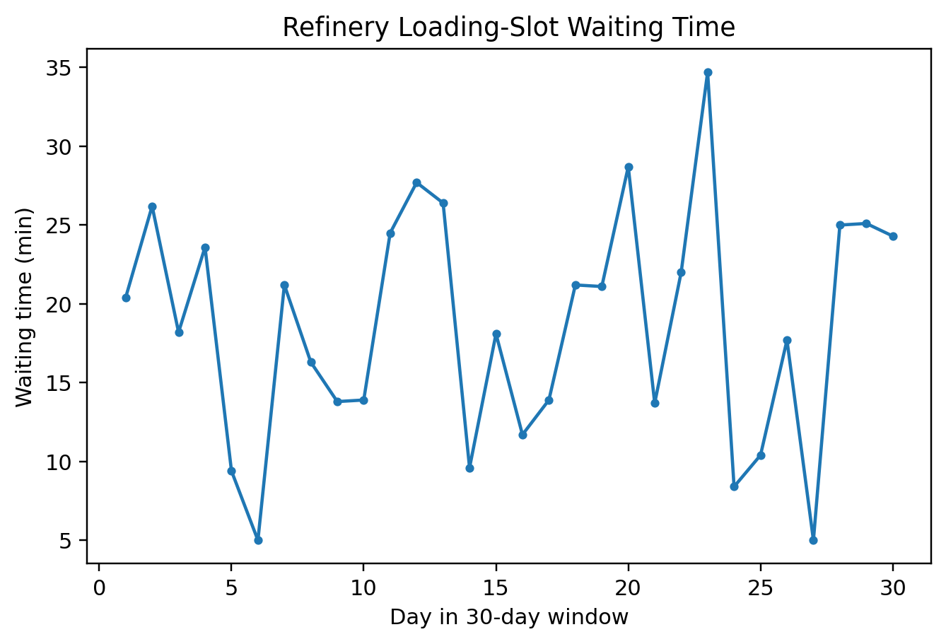
Figure 8. Refinery loading-slot waiting time.

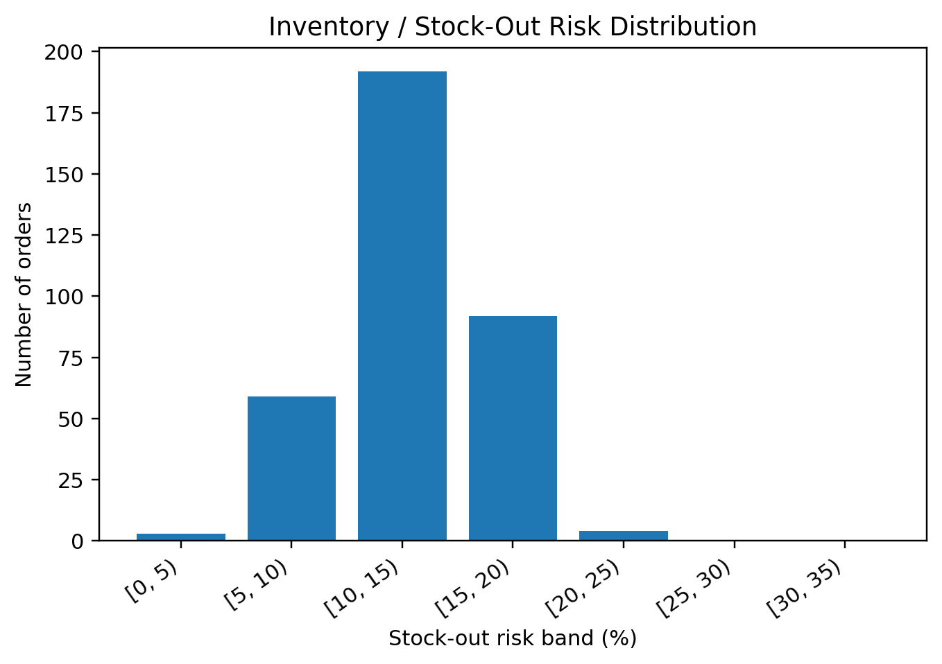
Figure 9. Inventory / stock-out risk distribution.
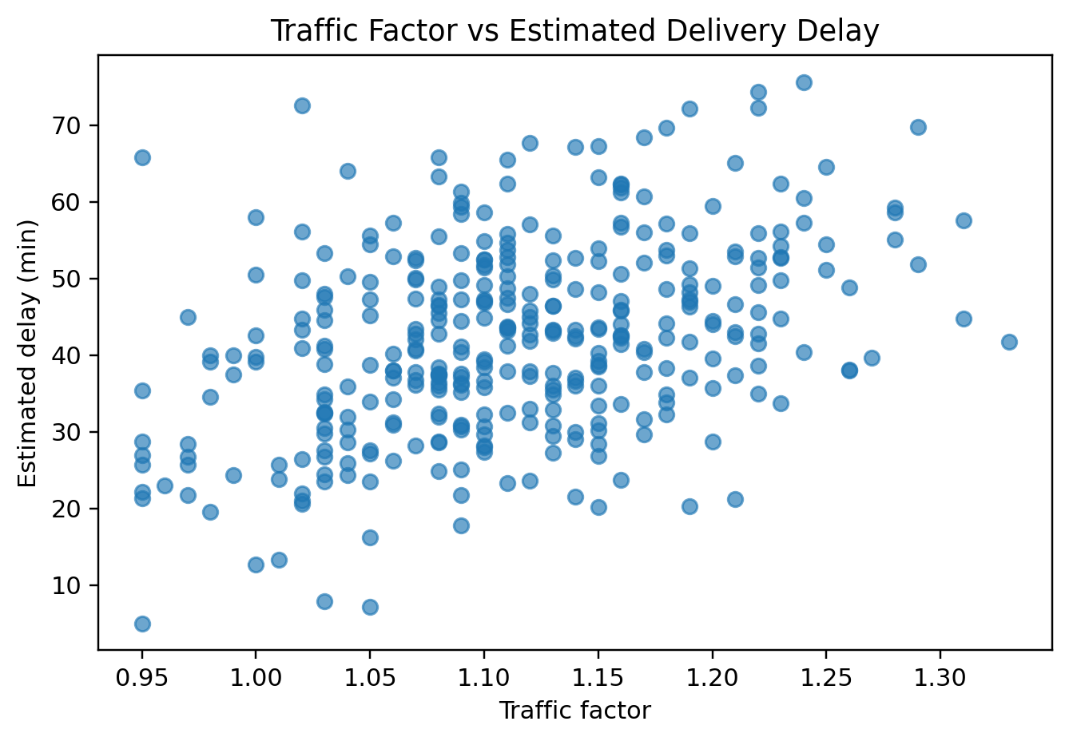
Figure 10. Relationship between traffic factor and estimated delivery delay.
The additional operational charts extend the sample report's descriptive-analysis style into the petroleum domain. They show that the platform must monitor both upstream supply constraints and downstream delivery conditions.

6. Breadth-First Search (BFS)

6.1 Application to Dealer Operational Graph Traversal
BFS is useful when the dealer decision environment is represented as a graph. A node represents an operational entity or AI agent, while a directed edge represents a dependency or information flow. BFS explores the graph level by level, making it appropriate when the platform needs the closest operational dependencies first.

6.2 State Representation
State Variable | Meaning | Example
Node | Dealer, agent, refinery, resource or outcome | Dealer Dashboard
Edge | Information/dependency flow | Dashboard → Inventory Agent
Start | Dealer request / dealer node | Dealer
Goal | Reach relevant decision entities or cover graph | Full connected operational graph

6.3 BFS Algorithm
BFS(G, start):
queue ← [start]
visited ← {start}
order ← []
while queue is not empty:
node ← pop_front(queue)
order.append(node)
for each neighbor of node:
if neighbor not in visited:
visited.add(neighbor)
queue.push_back(neighbor)
return order
The project graph contains 15 vertices and 32 directed edges. BFS is used for structural exploration, not for the final numerical dispatch optimization.

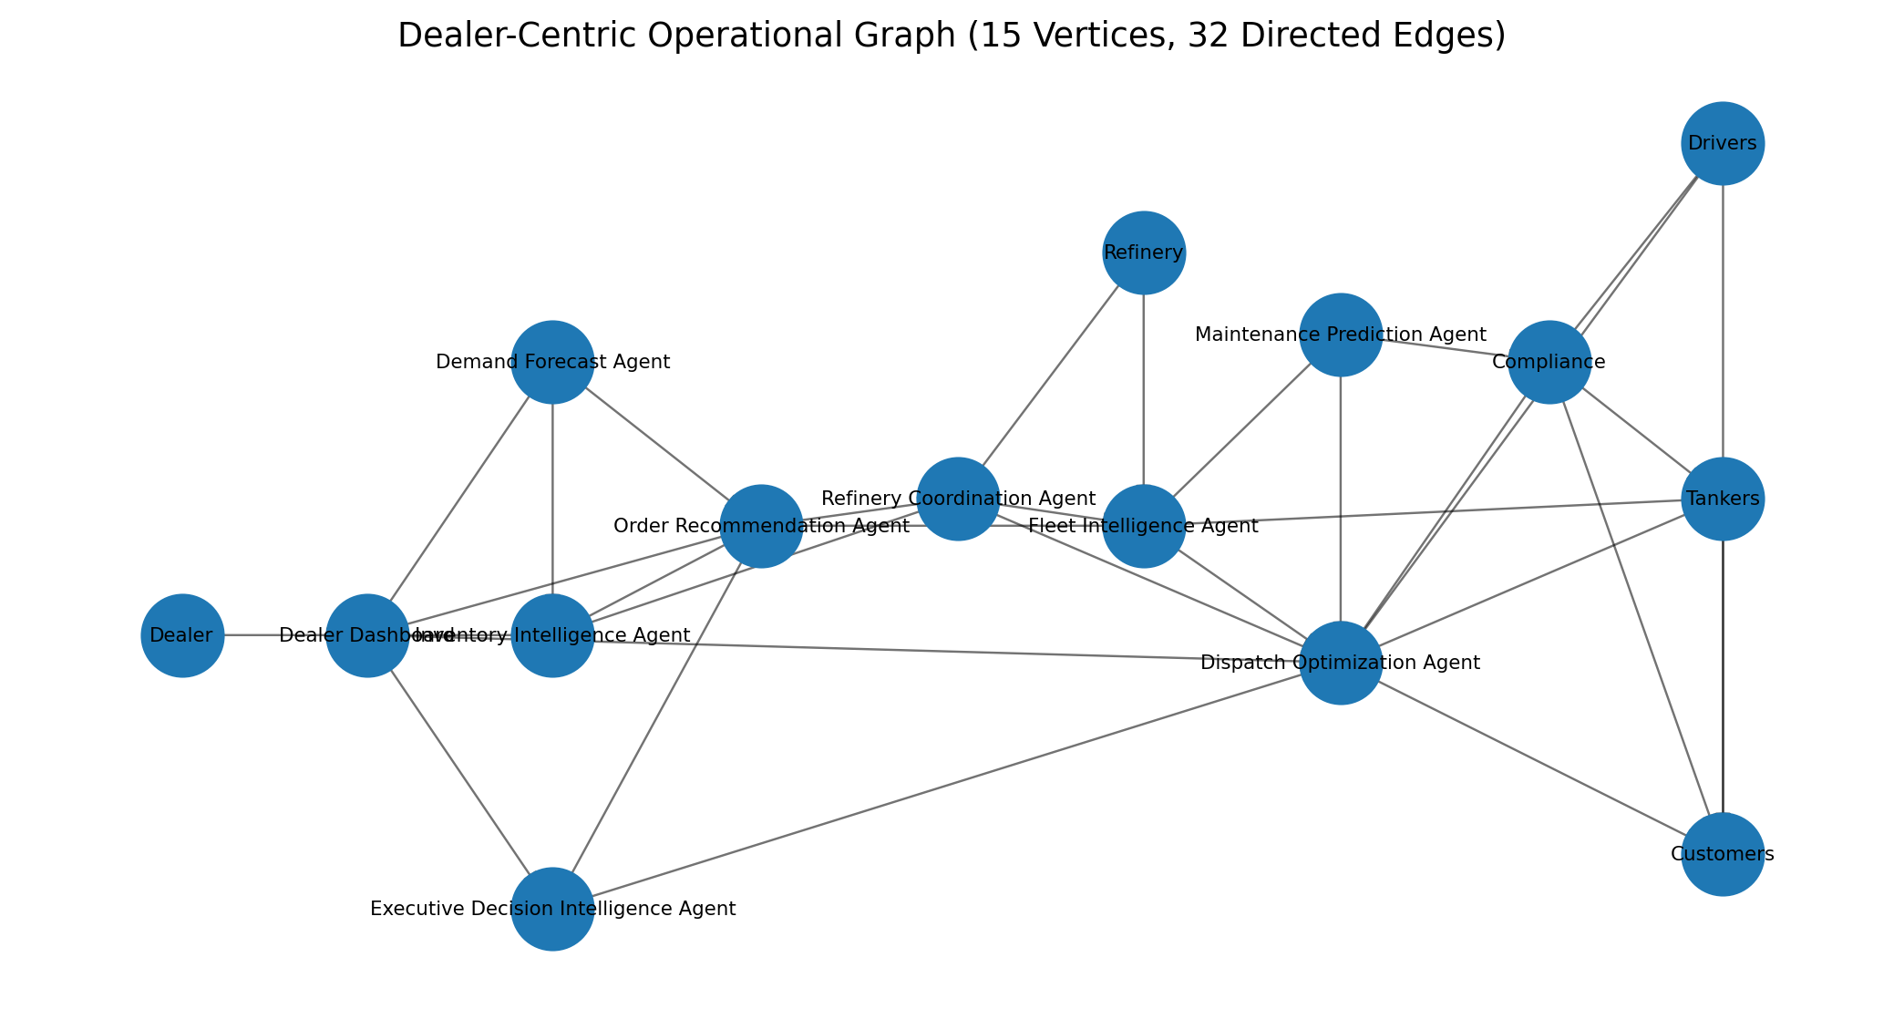
Figure 11. Dealer-centric operational graph used for BFS and DFS.
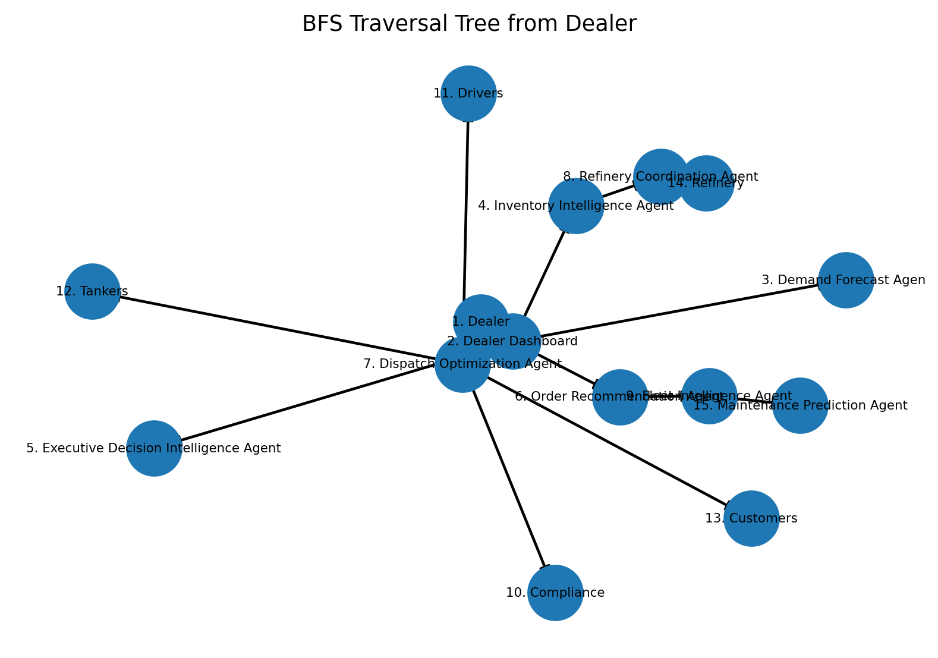
Figure 12. BFS traversal tree from Dealer; labels show visitation order.
Representative BFS visitation begins at Dealer, then expands through the Dealer Dashboard before reaching the demand, inventory, executive and order-recommendation layers.

7. Depth-First Search (DFS)

7.1 Application
DFS follows one branch as deeply as possible before backtracking. In the petroleum dealer platform, this is useful when the system wants to trace one operational dependency chain end-to-end—for example, following a dealer order through order recommendation, refinery coordination, fleet checks, maintenance/compliance and dispatch.

7.2 DFS Algorithm
DFS(node, visited, order):
visited.add(node)
order.append(node)
for each neighbor of node:
if neighbor not in visited:
DFS(neighbor, visited, order)
return order
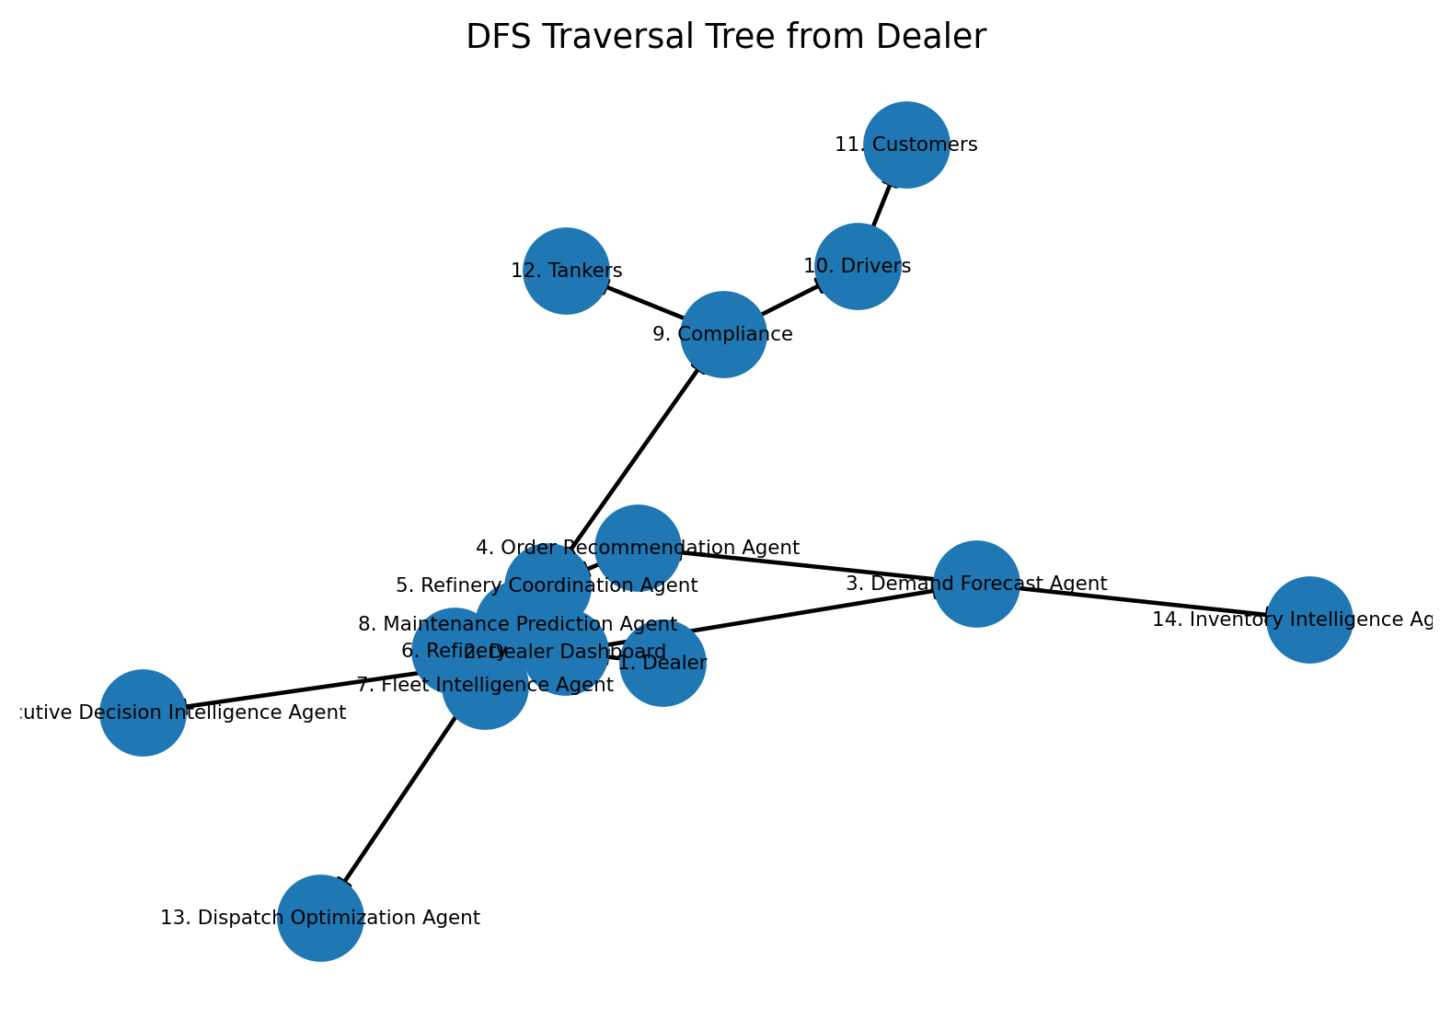
Figure 13. DFS traversal tree from Dealer; labels show visitation order.

7.3 BFS vs. DFS
Criterion | BFS | DFS
Search strategy | Level by level | Depth first, then backtracking
Data structure | Queue (FIFO) | Stack / recursion (LIFO)
Best suited for | Closest operational dependencies first | Tracing a deep operational dependency chain
Project role | Broad dealer-network exploration | Dependency-path and relationship tracing
Optimization role | Not the dispatch optimizer | Not the dispatch optimizer

8. Hill Climbing

8.1 Purpose
Hill Climbing is a local-search optimization method. Here a state represents a complete feasible dispatch schedule containing tanker, driver, loading-slot, dispatch-order and route choices for the dealer's outstanding orders.

8.2 Cost Function Used for Demonstration
The objective is to minimize a weighted operational cost combining delivery time, transportation cost, tanker idle time, late-delivery penalty and constraint violations:
Cost = w1(Delivery Time) + w2(Transportation Cost) + w3(Tanker Idle Time) + w4(Late Delivery Penalty) + w5(Constraint Violation Penalty)
Fitness = -Cost

8.3 Neighbourhood Definition
- Swap tanker assignments between two orders.
- Change the tanker assigned to one order.
- Change the driver assigned to one order.
- Move an order to another available loading slot.
- Change the dispatch sequence.
- Select an alternative feasible route.
A steepest-improvement variant evaluates feasible neighbouring states and accepts the neighbour with the largest reduction in objective cost. The process stops when no neighbour improves the current state.

For an illustrative run, the objective cost decreases from 1000 to 707 before reaching a plateau. The graph intentionally demonstrates the expected monotonic improvement of a local-search run rather than claiming a live operational result.
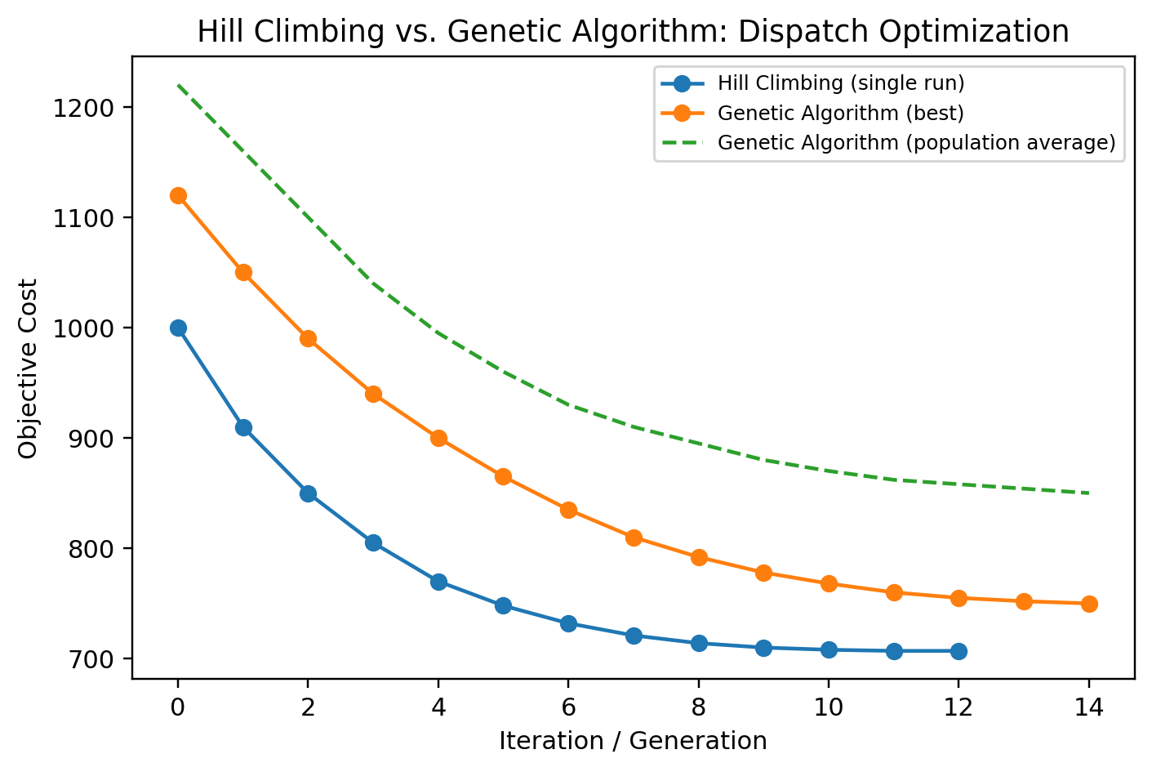
Figure 14. Hill Climbing vs. Genetic Algorithm convergence for dispatch optimization.

8.4 Local Optima Across Random Restarts
Restart # | 1 | 2 | 3 | 4 | 5 | 6 | 7 | 8 | 9 | 10
Final objective cost | 16 | 14 | 14 | 13 | 15 | 13 | 13 | 12 | 14 | 14
The restart experiment demonstrates that Hill Climbing can terminate at different local optima depending on the initial schedule.

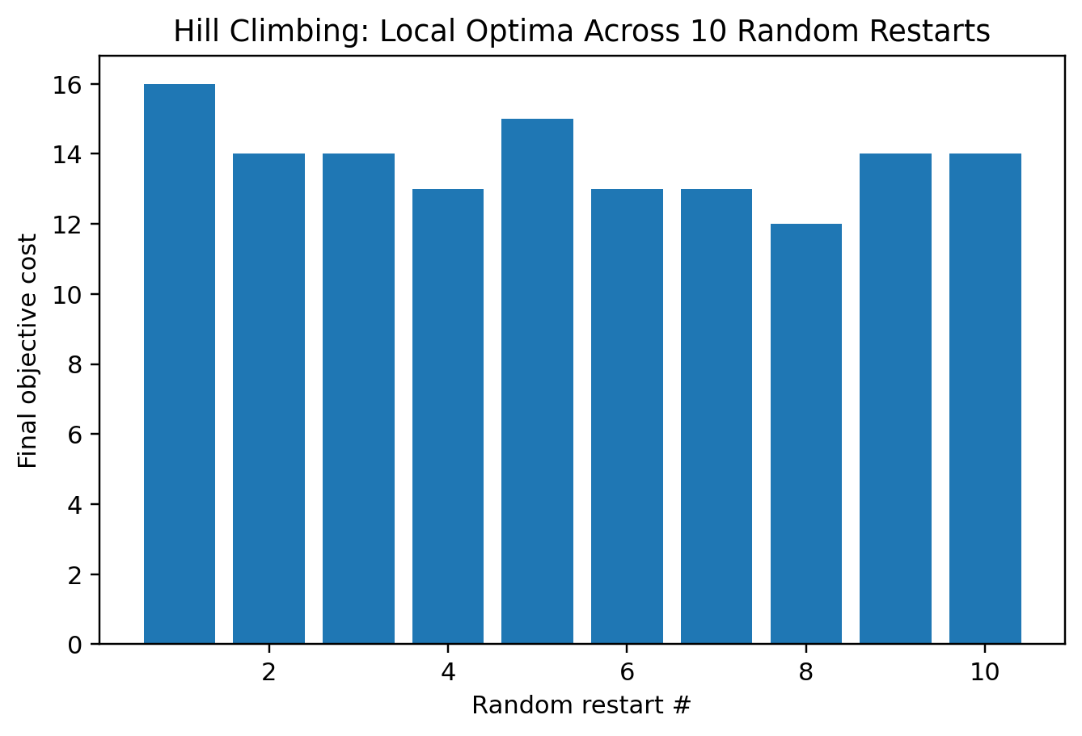
Figure 15. Final objective cost across 10 Hill Climbing random restarts.
The illustrative final objective cost ranges from 12 to 16 with a mean of 13.80. This is the central limitation of local search: a locally improving move does not guarantee the global best dispatch plan.

9. Genetic Algorithm

9.1 Problem Formulation
The same dealer-dispatch optimization problem is solved using a Genetic Algorithm to contrast local search with population-based exploration. A chromosome can contain one gene per dealer order, encoding tanker, driver, loading-slot and route choices or a compact assignment index.
Gene / Component | Interpretation
Order gene | Represents one dealer order in the scheduling population.
Tanker assignment | Identifies the tanker selected for that order.
Driver assignment | Identifies the eligible driver.
Loading-slot assignment | Represents the refinery slot selected.
Route assignment | Represents the feasible route choice.

9.2 Fitness Function
Fitness(chromosome) = - Cost(chromosome), where lower operational cost means higher fitness.

9.3 Demonstration Result
An illustrative population is evolved over generations using selection, crossover, mutation, elitism and a repair step for infeasible schedules. The purpose is to explore multiple candidate dispatch schedules rather than repeatedly restarting a single local-search trajectory.
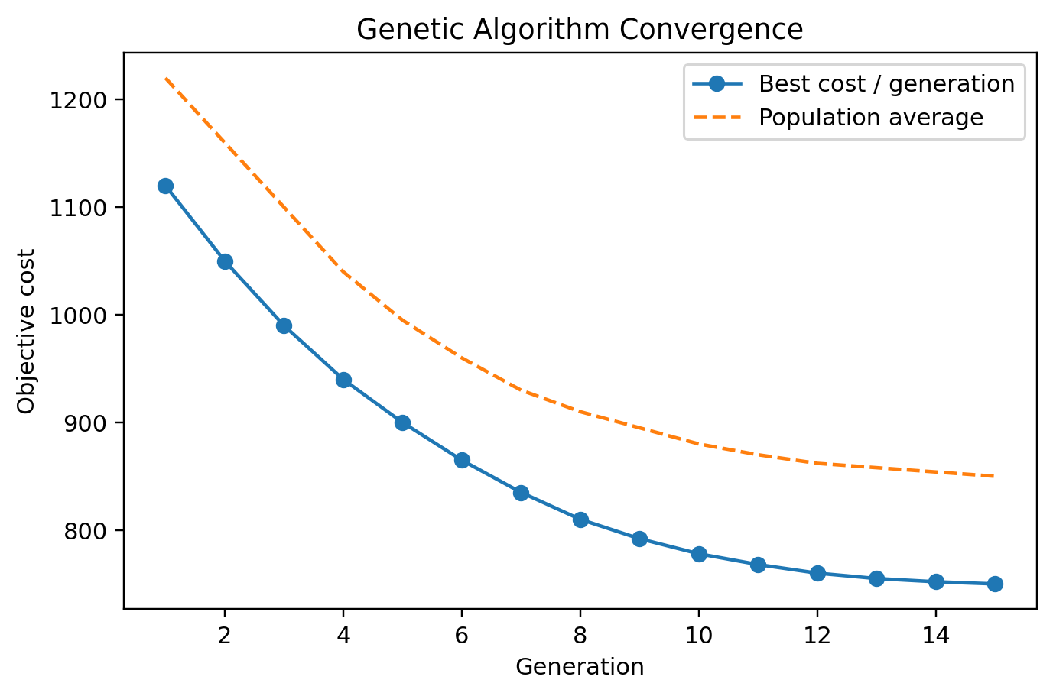
Figure 16. Best-per-generation and population-average objective curves for the Genetic Algorithm.

9.4 Genetic Algorithm Pseudocode
Initialize a population of candidate dealer dispatch schedules
Repeat for each generation:
Evaluate objective cost / fitness of every chromosome
Preserve the best-ever chromosome (elitism)
Select parent chromosomes
Apply crossover
Apply mutation
Repair infeasible tanker / driver / slot assignments
Form the next generation
Return the best feasible schedule found

9.5 Hill Climbing vs. Genetic Algorithm
Approach | Illustrative final cost | Behaviour observed
Hill Climbing (single run) | 707 | Very fast convergence but may stop at a local optimum.
Hill Climbing (best of 10 restarts) | 12* | Shows dependence on the starting state in the normalized demonstration.
Genetic Algorithm | 750 | Explores multiple candidate schedules and retains population diversity.
*The restart values are shown as a separate normalized demonstration series and are not directly comparable in scale with the 1000/707/750 objective-cost sequence.
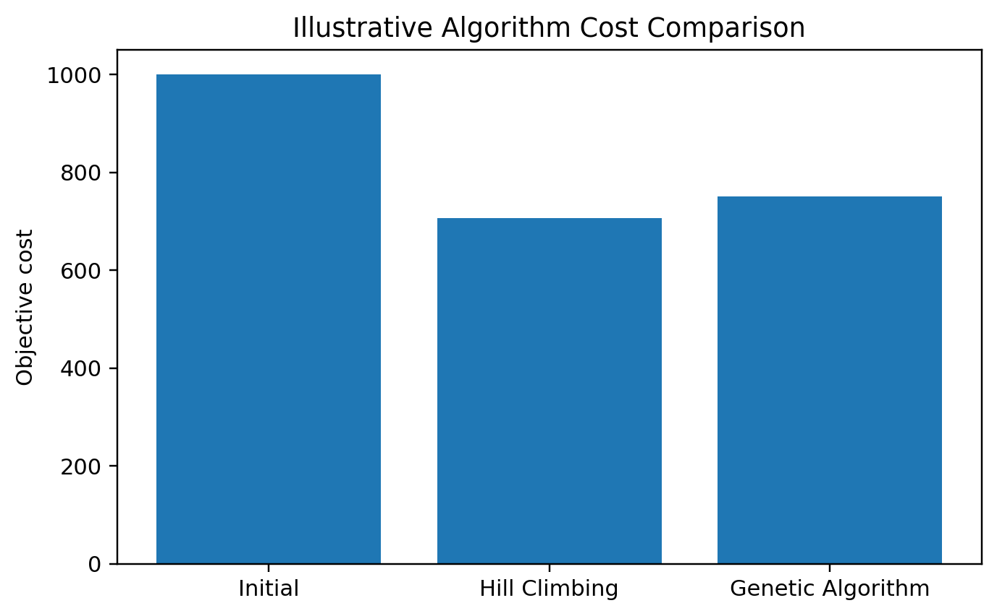
Figure 17. Illustrative initial, Hill Climbing and Genetic Algorithm objective-cost comparison.

9.6 Interpretation
Hill Climbing is attractive for a dealer-facing prototype because it is simple, fast and easy to explain: the current dispatch plan is improved by making the best feasible local change. Its weakness is sensitivity to the starting schedule. The Genetic Algorithm explores a broader portion of the search space and can preserve alternative schedules through population diversity, but it requires more computation and parameter tuning.
For a practical platform, a hybrid strategy is reasonable: generate a population of feasible schedules, use the Genetic Algorithm to explore broadly, then apply Hill Climbing to locally refine the best candidates before presenting the final recommendation to the dealer.

10. Factor Analysis

10.1 Purpose
Exploratory Factor Analysis is used to investigate whether the nine observed dealer-logistics metrics can be summarized by a smaller number of latent dimensions. The resulting dimensions can later support a dealer risk or decision-readiness score.

10.2 Variables
Variable | Description
order_volume_l | Dealer order volume in litres
current_inventory_l | Current inventory level in litres
tanker_availability | Available tanker count
slot_wait_min | Refinery loading-slot waiting time
delivery_deadline_hr | Available delivery time window
estimated_delay_min | Estimated delivery delay
tanker_utilization_pct | Fleet utilization percentage
stockout_risk_pct | Estimated stock-out risk
on_time_delivery_pct | On-time delivery outcome
Before extraction, Bartlett's test gives χ² ≈ 1556.26 with p < 0.001, indicating that the correlation matrix is not an identity matrix. The KMO measure is approximately 0.603, which is acceptable enough for an exploratory course-level demonstration but should be validated on real operational data.

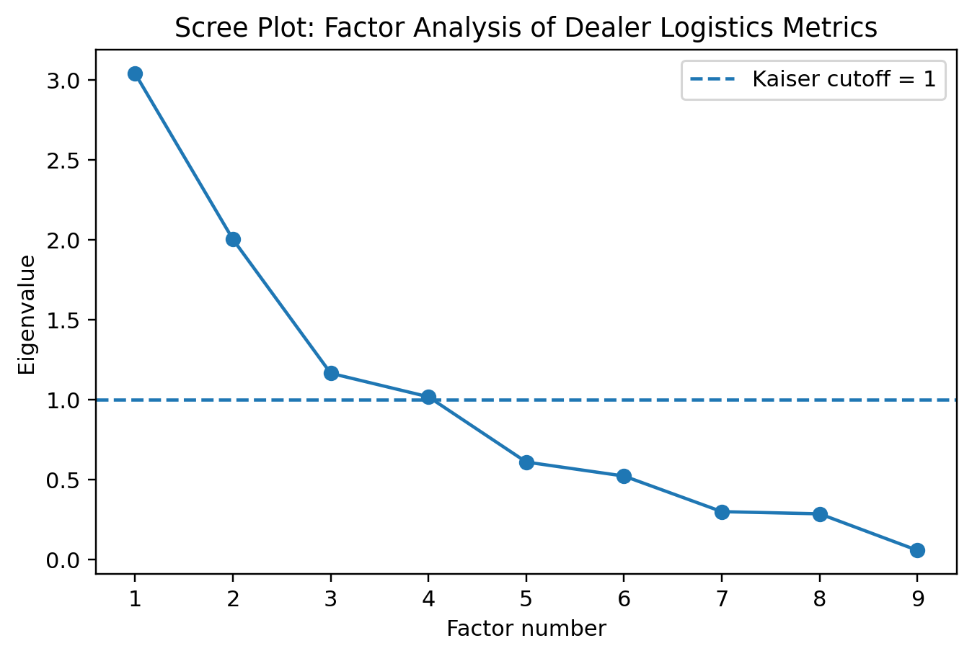
Figure 18. Scree plot of eigenvalues; the first four components exceed the Kaiser cutoff of 1.

10.3 Factor Interpretation
- Factor 1 — Logistics Delay: dominated by estimated delay and loading-slot waiting time, with fleet availability contributing to the bottleneck dimension.
- Factor 2 — Demand Pressure: dominated by order volume and tanker utilization, representing the pressure created by large replenishment requirements.
- Factor 3 — Fleet Capacity: associated with tanker availability and operational capacity variables.
- Factor 4 — Inventory Risk: associated with current inventory and stock-out risk.

Variable | Logistics Delay | Demand Pressure | Fleet Capacity | Inventory Risk
order_volume_l | 0.006 | 0.864 | 0.020 | -0.216
current_inventory_l | -0.066 | -0.457 | -0.001 | 0.764
tanker_availability | 0.485 | -0.090 | 0.630 | -0.057
slot_wait_min | -0.580 | 0.004 | -0.601 | -0.040
delivery_deadline_hr | 0.266 | -0.091 | -0.216 | -0.015
estimated_delay_min | -0.910 | 0.002 | -0.208 | 0.006
tanker_utilization_pct | -0.075 | 0.639 | -0.183 | -0.060
stockout_risk_pct | -0.111 | -0.362 | 0.043 | -0.462
on_time_delivery_pct | 0.994 | 0.005 | 0.065 | -0.022
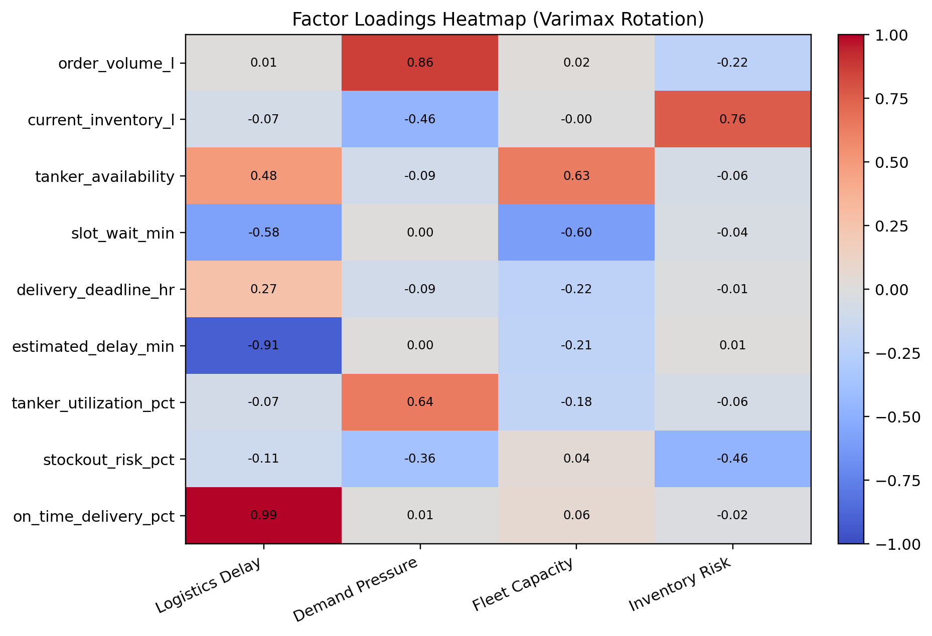
Figure 19. Heatmap of factor loadings (varimax rotation).
The heatmap should be interpreted by loading magnitude rather than by sign alone. Strong loadings indicate variables that contribute most strongly to a latent factor. The factor structure is exploratory and should not be treated as a production scoring model until validated against historical dealer data.

10.4 Top Five Numerical Factors for Dealer Decision Intelligence
Rank | Factor | Impact Score | Weight (%) | Overall Priority
1 | Fuel Demand / Order Volume | 10 | 22.22 | 9.2
2 | Current Fuel Inventory | 10 | 22.22 | 9.2
3 | Tanker Availability | 9 | 20.0 | 8.8
4 | Refinery Loading Slot Availability | 9 | 20.0 | 8.4
5 | Delivery Deadline / Priority | 9 | 20.0 | 8.8
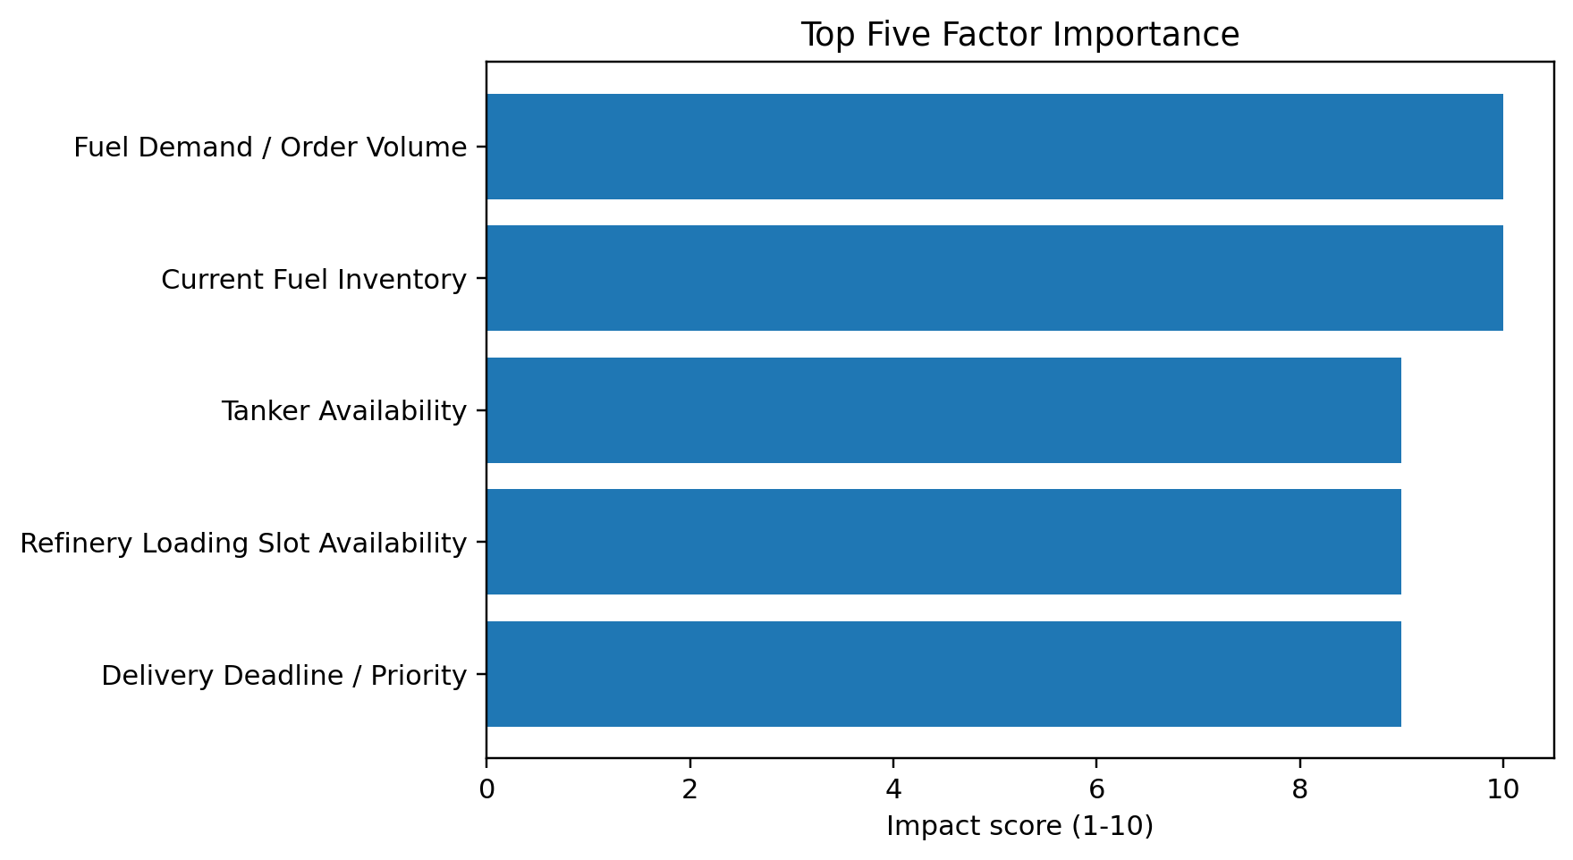
Figure 20. Top-five factor importance.
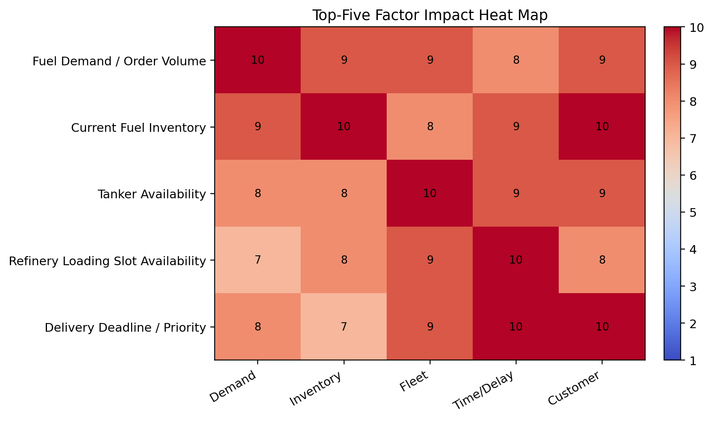
Figure 21. Top-five factor impact heat map.

10.5 Detailed Top-Five Analysis
Factor | Key measurable variables | If factor worsens | If factor improves
Fuel Demand / Order Volume | Daily order volume; litres/day; peak demand; forecast error | Higher stock-out risk, emergency orders and inefficient tanker allocation | Better planning, fewer emergency orders and higher service level
Current Fuel Inventory | Current stock; tank utilization; days of cover; reorder gap | Stock-out risk and urgent coordination increase | Stable supply and fewer stock-outs
Tanker Availability | Available tankers; utilization; idle hours; available capacity | Orders may be delayed and commitments missed | Higher dispatch capacity and better on-time delivery
Refinery Loading Slot Availability | Slots/day; waiting time; loading delay; utilization | Waiting and delivery delays increase | Smoother turnaround and predictable schedules
Delivery Deadline / Priority | Deadline hours; priority; lateness; on-time rate | Urgent orders may be delayed and service quality falls | Improved prioritization and on-time delivery

12. Proposed AI System Architecture

12.1 End-to-End Dealer Decision Pipeline
Dealer Order
↓
Dealer Dashboard
├── Demand Forecast Agent
├── Inventory Intelligence Agent
└── Executive Decision Intelligence Agent
├── Cluster Analysis Engine
↓
Order Recommendation Agent
↓
Refinery Coordination Agent
↓
┌────────┴───────────┐
↓ ↓
Refinery Fleet Intelligence Agent
↓
Maintenance + Compliance
↓
Dispatch Optimization
↓
Tanker + Driver + Slot + Route + ETA
↓
Dealer Approval
↓
Dispatch Execution
↓
Delivery Analytics

12.2 Agent Roles
Agent | Primary responsibility
Dealer Order Agent | Capture order requirement, priority and deadline.
Customer Intelligence Agent | Estimate demand patterns and service pressure.
Inventory Intelligence Agent | Calculate safety stock, days of cover and reorder urgency.
Fleet Agent | Check tanker and driver availability.
Compliance Agent | Validate licenses, permissions and operational eligibility.
Loading Bay Agent | Coordinate refinery loading slots and waiting time.
Dispatch Optimization Agent | Optimize tanker, driver, slot, route and sequence.
Maintenance Agent | Flag tanker maintenance and breakdown risk.
Weather & Risk Agent | Adjust ETA/risk for traffic, weather and road conditions.
Executive AI Agent | Combine evidence and explain the final dealer recommendation.

13. Results and Discussion
- The synthetic dataset contains 350 dealer orders and is sufficient for demonstrating descriptive analysis, graph traversal and exploratory factor analysis.
- Average order volume is 11496 L, while average estimated delivery delay is 42.1 minutes.
- Current inventory is strongly connected to stock-out risk in the constructed dataset (correlation -0.18), illustrating why inventory intelligence is central to dealer decisions.
- Loading-slot waiting time is positively related to estimated delivery delay (correlation 0.65), supporting refinery coordination as a key agent.
- BFS provides breadth-oriented exploration of the 15-node dealer operational graph, while DFS provides a deep dependency traversal.
- Hill Climbing demonstrates fast local improvement but sensitivity to the initial dispatch schedule.
- The Genetic Algorithm provides population-based exploration and is a useful alternative or benchmark for the same dispatch problem.
- The Factor Analysis stage reduces nine operational metrics to four interpretable dimensions. K-Means Cluster Analysis further segments the 350 orders into 4 behaviorally distinct operational profiles (Silhouette = 0.142), providing actionable segmentation for differentiated AI decision strategies.

14. Limitations
- The dataset is synthetic and does not represent confidential or live refinery/dealer transactions.
- Traffic, weather, tanker and refinery constraints are represented through illustrative numerical variables.
- Optimization curves are demonstrations rather than measured production performance.
- The graph represents modeled operational dependencies rather than a live enterprise knowledge graph.
- Factor-analysis results require validation using historical dealer data before production deployment.
- The agentic layer is proposed architecture; integration with live ERP, GPS, refinery scheduling and compliance systems is future work.

15. Future Scope
- Replace synthetic records with historical dealer orders, tank levels and dispatch logs.
- Use real-time GPS, refinery slot and tanker telemetry.
- Train demand forecasting models such as XGBoost, LightGBM or LSTM/Prophet where justified.
- Use OR-Tools or hybrid optimization for larger constrained scheduling problems.
- Add SHAP-based explanations for both cluster assignments and ML forecast outputs, and integrate an LLM/RAG layer for natural-language dealer recommendations.
- Validate cluster-informed recommendations using on-time delivery improvement, stock-out reduction, cost reduction, and tanker utilization KPIs measured per cluster.

16. Conclusion
This report presents a complete AI-course treatment of a dealer-centric petroleum logistics decision platform. The analytical workflow connects data preparation, descriptive visualization, PEAS, graph search, local optimization, population-based optimization and factor analysis into one coherent operational problem. The dealer remains the final decision maker, while the AI agents provide evidence-based recommendations for replenishment and dispatch.
The most important implementation step is to replace the illustrative dataset with real operational data and then validate whether the same relationships, factor structure and optimization improvements hold in practice.

17. References
- Russell, S. & Norvig, P. Artificial Intelligence: A Modern Approach, 4th ed. Pearson.
- Bishop, C. M. Pattern Recognition and Machine Learning. Springer.
- Scikit-learn documentation: FactorAnalysis and preprocessing methods.
- Google OR-Tools documentation for constraint and vehicle-routing optimization.
- Project-specific numerical factor-analysis workbook: Detailed_Factor_Analysis_Petroleum_Dealer_AI.xlsx.

Appendix A. Analytical Dataset Sample
ID | Zone | Fuel | Priority | Order L | Inventory L | Tankers | Slot Wait | Deadline h | Delay min | Risk % | On-time %
ORD0001 | South | Diesel | Normal | 11445 | 7839 | 10 | 13.0 | 7.7 | 25.9 | 15.3 | 88.8
ORD0002 | West | Petrol | Normal | 14030 | 19585 | 6 | 24.3 | 9.3 | 40.2 | 12.1 | 80.4
ORD0003 | East | Petrol | Normal | 11923 | 10094 | 9 | 9.7 | 6.8 | 25.1 | 11.5 | 88.4
ORD0004 | East | Diesel | High | 16920 | 9632 | 9 | 20.3 | 7.2 | 40.6 | 14.2 | 82.1
ORD0005 | East | Diesel | Normal | 11050 | 19144 | 6 | 25.0 | 9.1 | 52.8 | 11.1 | 72.0
ORD0006 | North | Petrol | High | 11470 | 11656 | 9 | 13.6 | 7.9 | 44.5 | 10.8 | 79.5
ORD0007 | North | Petrol | Normal | 8627 | 9176 | 8 | 15.8 | 5.3 | 17.8 | 13.1 | 86.2
ORD0008 | East | Diesel | High | 10683 | 13828 | 9 | 15.7 | 6.6 | 38.5 | 19.6 | 80.2
ORD0009 | East | Diesel | Urgent | 13323 | 9947 | 7 | 23.0 | 9.4 | 55.9 | 13.1 | 73.1
ORD0010 | West | Diesel | High | 14497 | 7000 | 8 | 17.4 | 6.5 | 44.4 | 16.7 | 77.2
ORD0011 | West | Diesel | Normal | 18000 | 9797 | 5 | 12.8 | 8.5 | 25.7 | 5.4 | 89.5
ORD0012 | South | Petrol | Normal | 10778 | 16025 | 5 | 27.1 | 8.3 | 65.5 | 20.7 | 64.9
ORD0013 | South | Diesel | Normal | 9754 | 20220 | 8 | 10.8 | 11.6 | 33.7 | 14.5 | 79.4
ORD0014 | East | Diesel | High | 13633 | 8808 | 10 | 11.0 | 10.1 | 30.0 | 13.0 | 80.6
ORD0015 | South | Petrol | Normal | 8406 | 11838 | 8 | 11.0 | 10.1 | 43.3 | 15.1 | 80.7
ORD0016 | East | Diesel | Normal | 13198 | 11698 | 8 | 10.9 | 6.6 | 38.8 | 15.1 | 78.1
The appendix reproduces 16 representative rows. The full synthetic dataset contains 350 records and is the basis for the reported charts and analyses.

Appendix B. Algorithm Pseudocode Summary
Method | Core idea | Project usage
BFS | Expand all nodes at depth d before depth d+1 | Breadth-oriented exploration of dealer operational dependencies.
DFS | Follow one path deeply before backtracking | Trace a detailed operational dependency chain.
Hill Climbing | Move to the best improving neighbour until no improvement remains | Local optimization of dealer dispatch schedule.
Genetic Algorithm | Evolve a population using selection, crossover and mutation | Broader exploration of dispatch scheduling space.
Factor Analysis | Explain correlated variables using latent dimensions | Identify hidden logistics dimensions behind dealer outcomes.

Appendix C. Recommended Evaluation Plan for the Final Prototype
- Collect a held-out set of historical dealer orders and dispatch records.
- Measure demand forecasting MAE/MAPE against actual consumption.
- Measure stock-out reduction and safety-stock violations.
- Measure on-time delivery, average delay and tanker utilization.
- Compare Hill Climbing, Genetic Algorithm and a constraint solver on the same operational instances.
- Measure recommendation acceptance rate by dealers.
- Measure cost savings and reduction in emergency replenishment orders.
- Evaluate explanation quality and compliance-rule correctness with human reviewers.
Final note: all charts and numerical examples in this report are synthetic/illustrative unless explicitly identified as project-planning factor scores. They are intended to demonstrate the methodology and report format, not to claim live operational performance.

