# Lab 1 : Basic ssh connectivity :

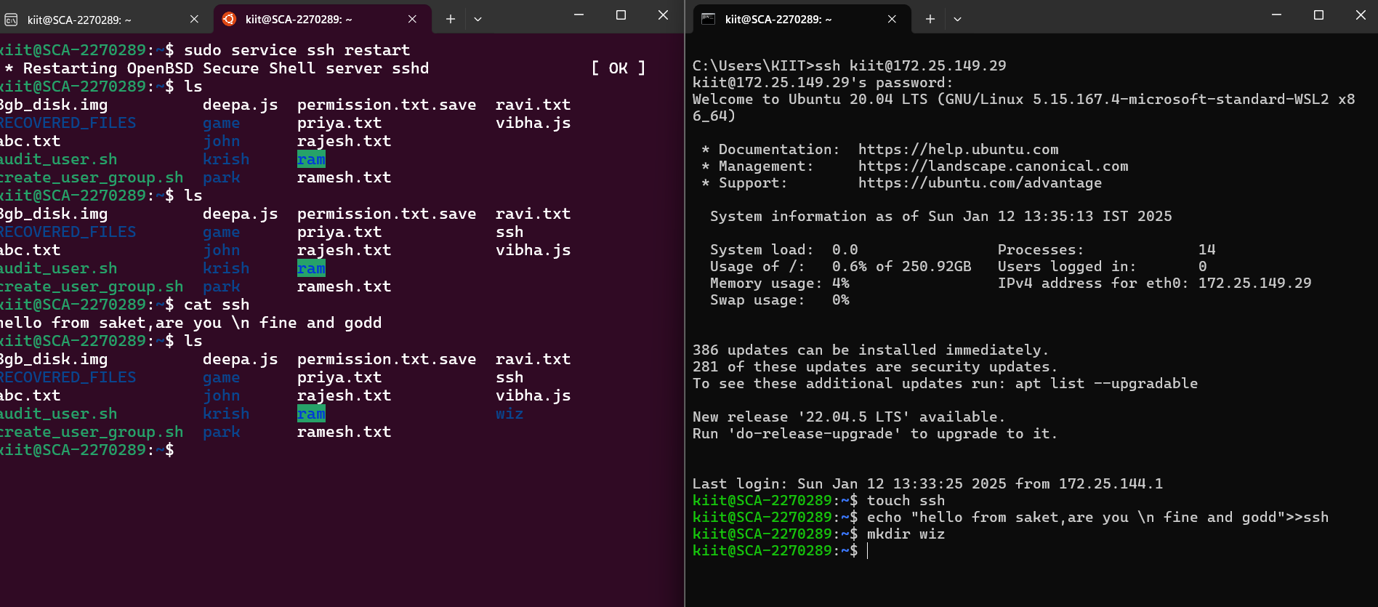

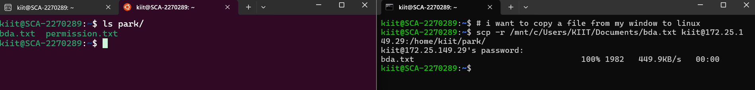

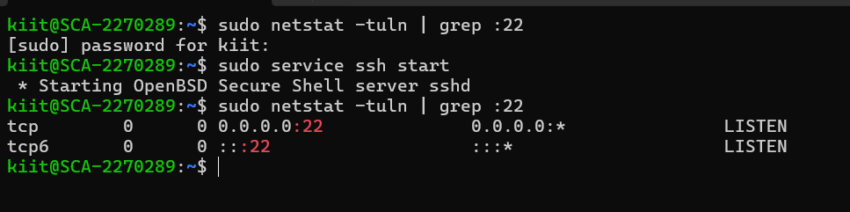

# Lab 2: SSH Key-Based Authentication :

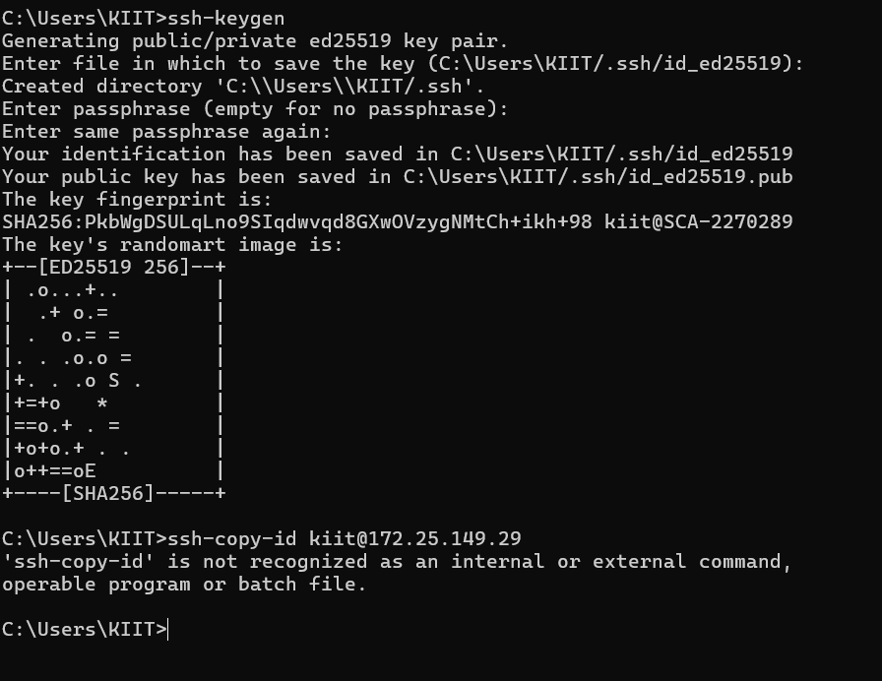

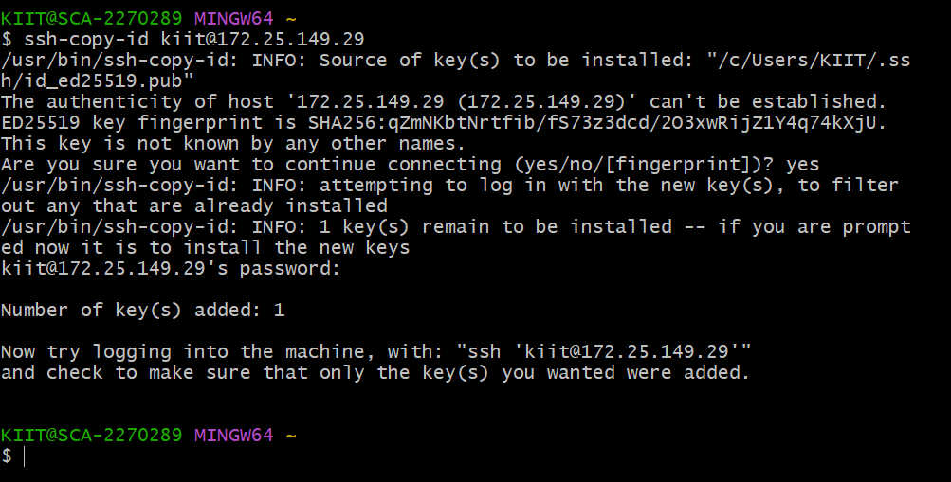

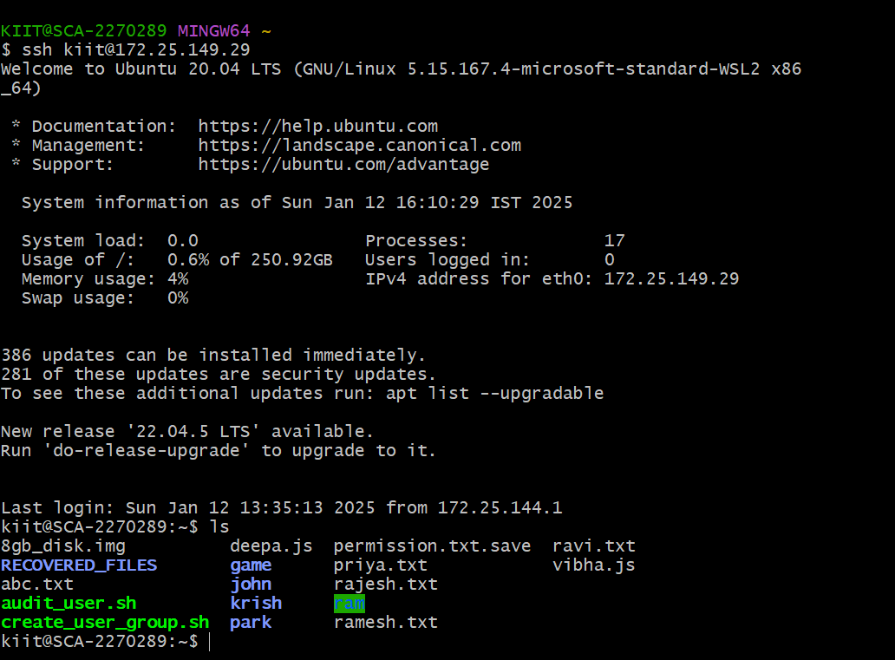

# Lab 4: SSH Tunneling and Port Forwarding :

#### Objective:

• Learn how to set up SSH tunneling for secure communication between two systems.

#### Outcome:

You will understand and be able to implement SSH tunneling to securely forward **ports** and set up a SOCKS proxy.

## Local port forwarding

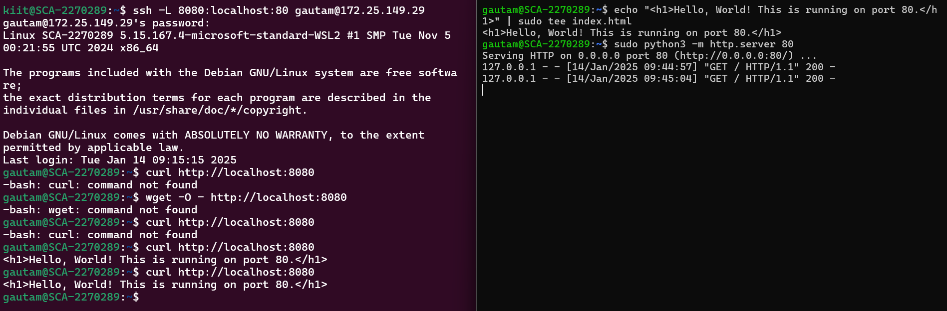

## Remote port forwarding

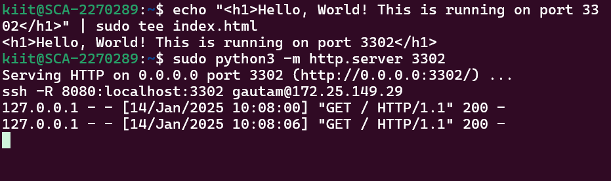

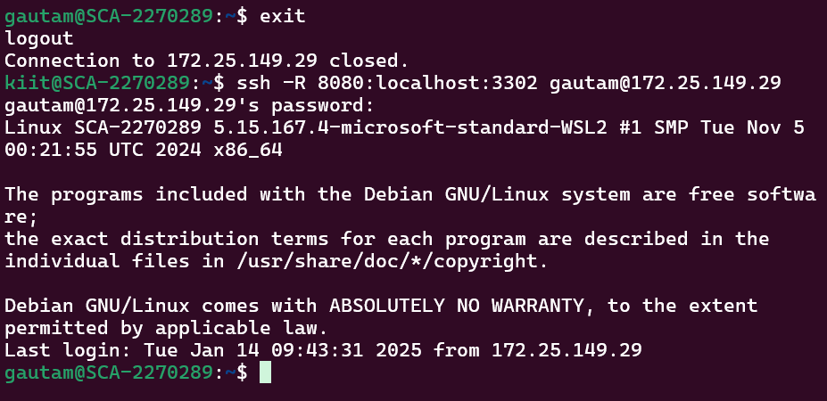

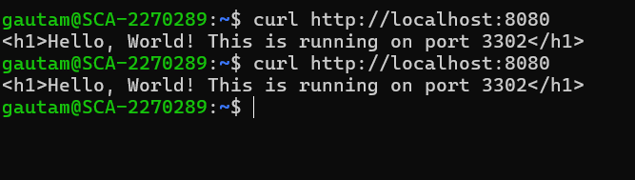

# Lab 5 : Ssh Agent And Forwarding :

## Objective :

• Learn to use SSH agent forwarding for accessing remote servers that require authentication via SSH keys.

#### Outcome:

You will understand how to use SSH agent forwarding to securely access multiple systems without copying SSH keys.

