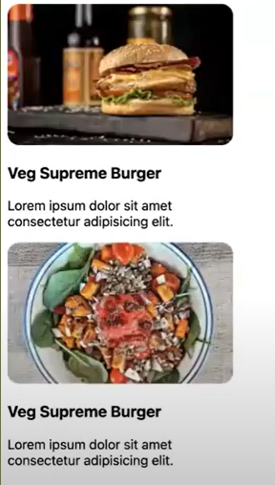**How to bring these items side by side?**

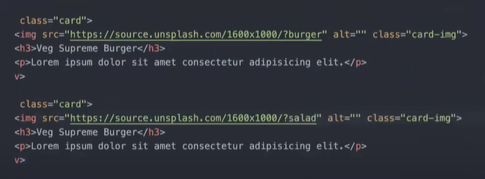**USE 🡪 Flex Box**

**Flex is much more powerful than float.**

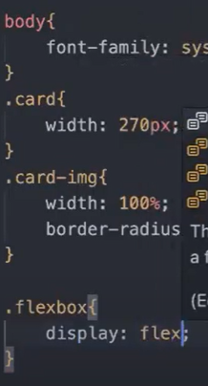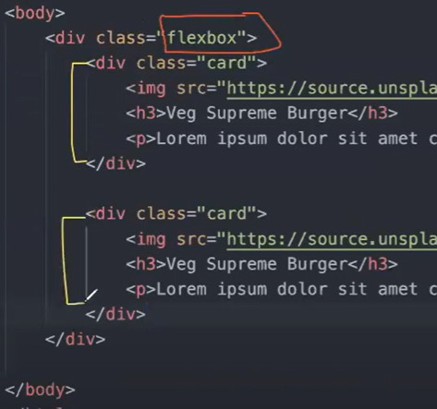

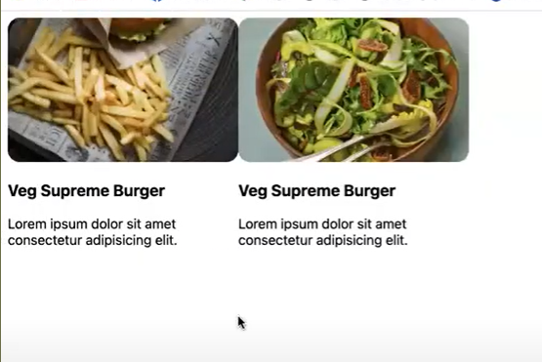Whenever you apply flexbox, all the child elements come along the horizontal axis.

Gap: 2opx

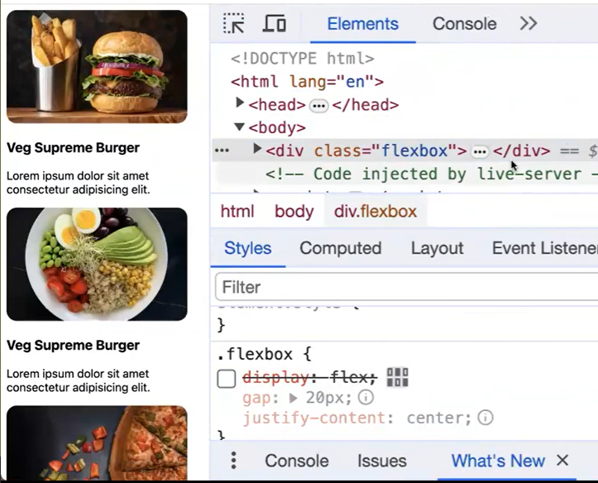How to make responsive design?

***Flex-wrap: wrap;***

Examples:

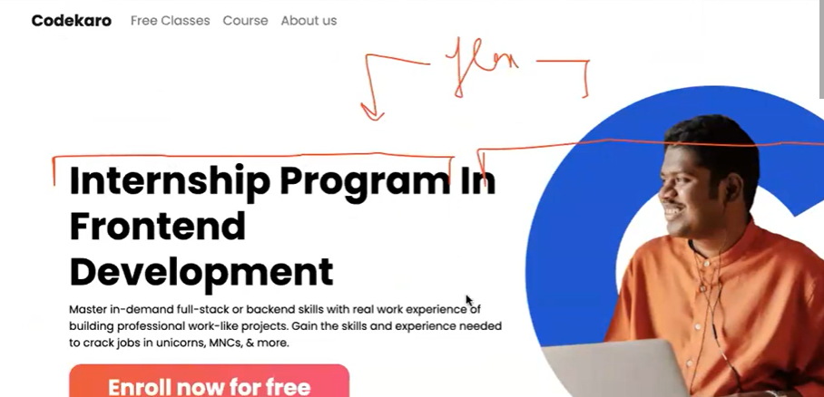

Align-items: center -> vertical alignment . ie heightwise

Justify-content: center -> horizontal alignment ie widthwise.

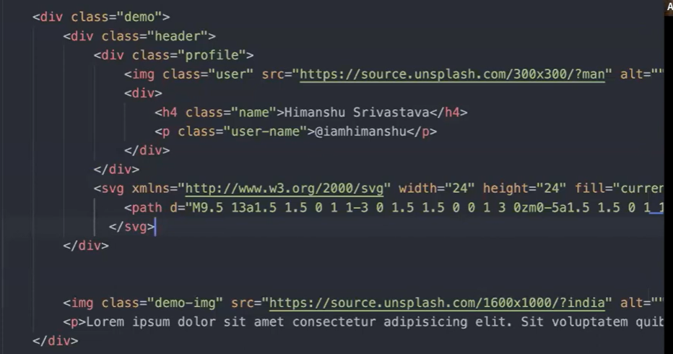

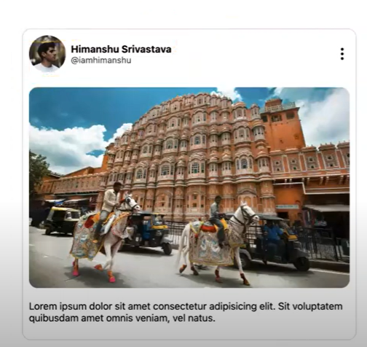

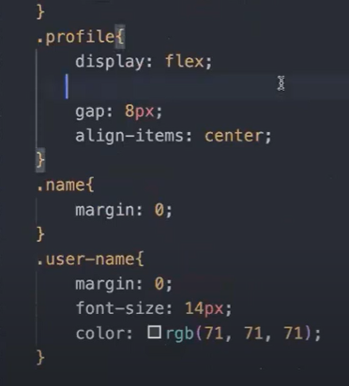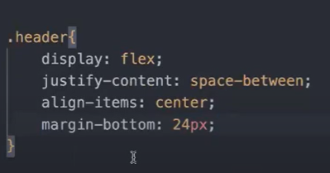

Media Queries

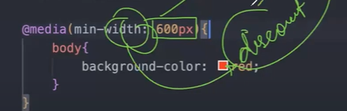

Whenver you get confused with min-width or max-width

Just think like min-discount or max-discount

Min-discount 600px, minimum 600px to hoga hi hoga, is s zada bhi kuch ho sakta h to apply hoga.

Max-discount 600px, maximum discount 600px hoga hi hoga, is s kam bhi kuch hoga to milega hi milega.

Min width = big screen

Max-width = small screen