Day 1: Margin, Borders Titles etc

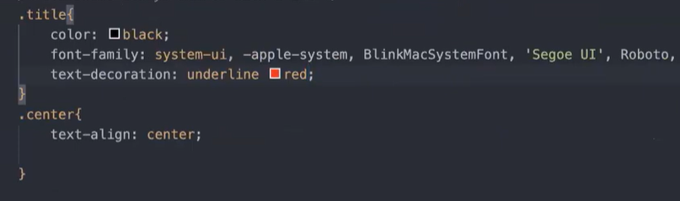

1. Border

* border: thickness, style and color  
  border: 5px solid red;  
  style --> solid, dashed, dotted.  
  border-radius: 10 px

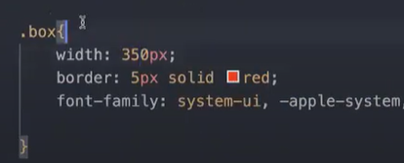

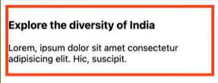

* As you can see above box has a property width, which shrinks the content to fit in the box. The border you would apply would also be applied on it.

1. Padding and Margin

Space **inside the box is padding** and outside is margin.

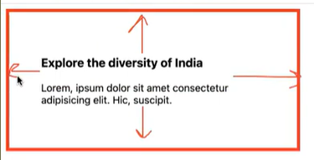Only Padding example

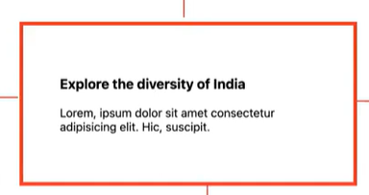

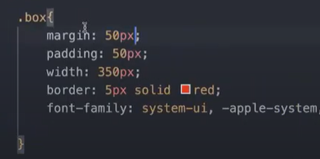Padding as well as margin->

1. Images

%age of what?

.box-img{

width:100%; // this %age is of the parent element.

}

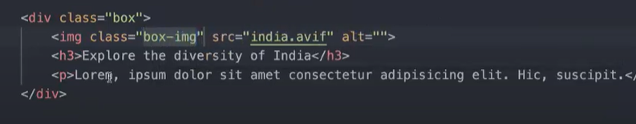border-radius: 20px, can be used in img as well.

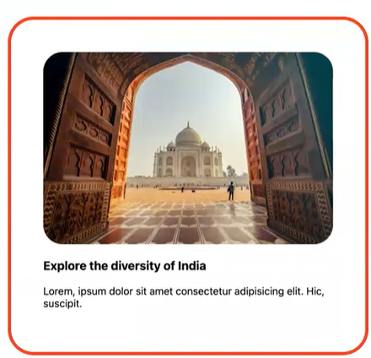

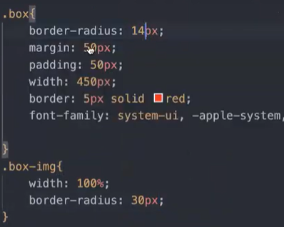

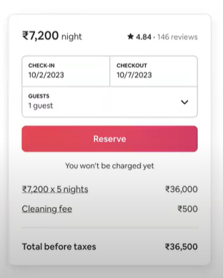Box Model examples:

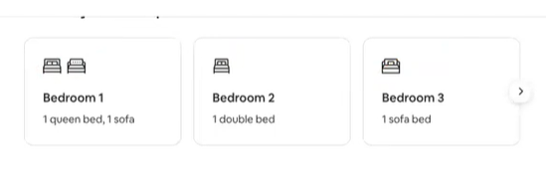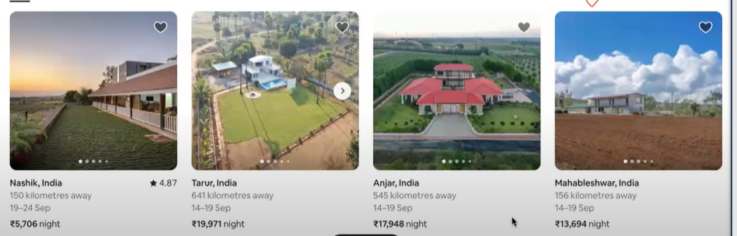



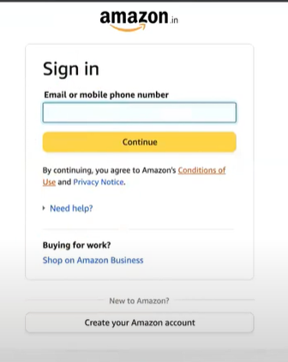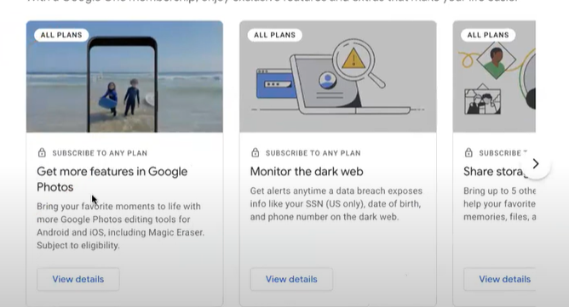

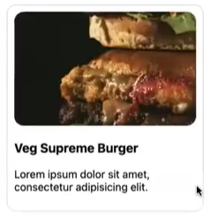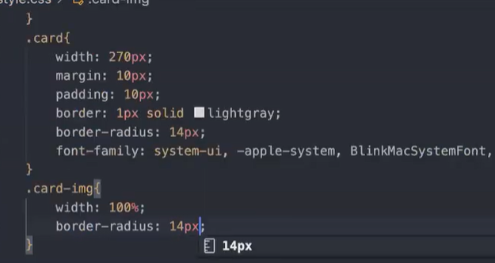Box like that:

Margin: auto works for left and right not for top and bottom.

Margin: 60px auto;

First value -> top and bottom, second for left and right

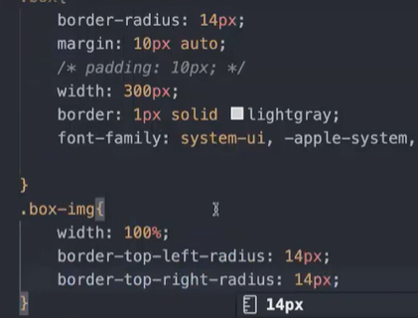



Curved only at top left and top right.

But we need to wrap paragraph text in a different div.