Day 2: Understanding positions in CSS

Fixed, Relative, absolute, sticky, static(default)  
1**. Fixed**

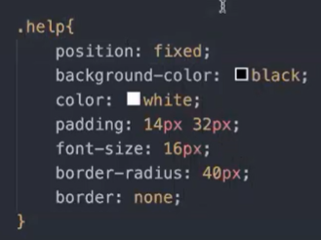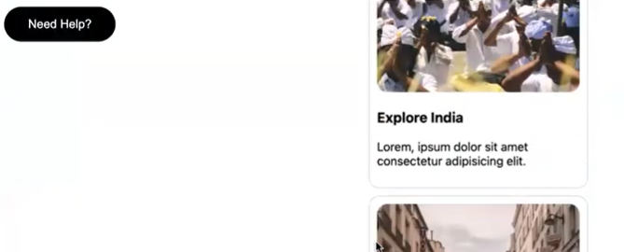Content should scroll but button should not scroll? 🡪 **fixed**

How to move that help button to one of the corners?

* Right: 0 🡪 distance from right is 0.
* Bottom: 0 🡪 distance from bottom is 0.
* Transform is used to move it relatively.

2. **Sticky:**

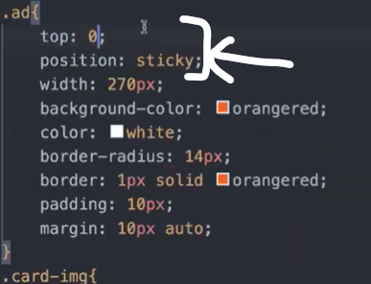

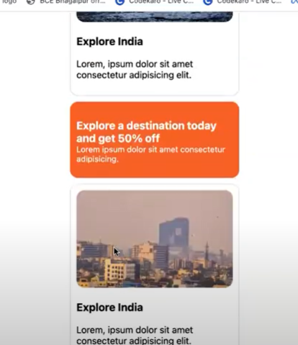

3. **Absolute:**

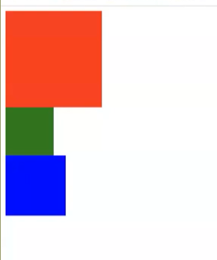

3 different cars in a parking lot.   
If green is not there, blue will go in place of green one.

If green car can float in air to park itself, that is what absolute does.

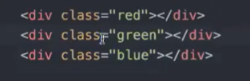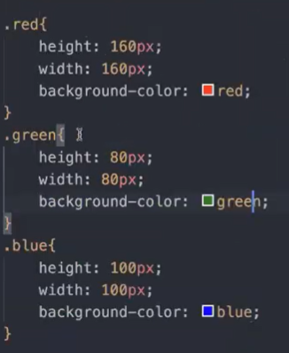



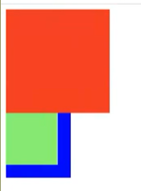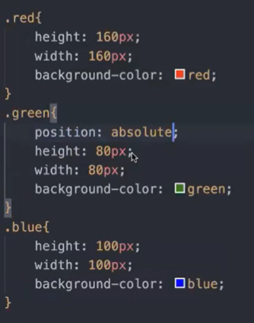

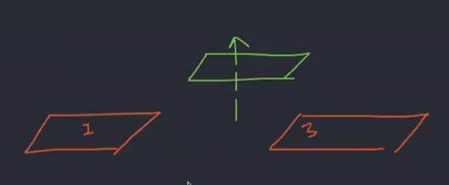

Green is made absolute.

By putting absolute: you can move the element wherever you want with respect to the screen.

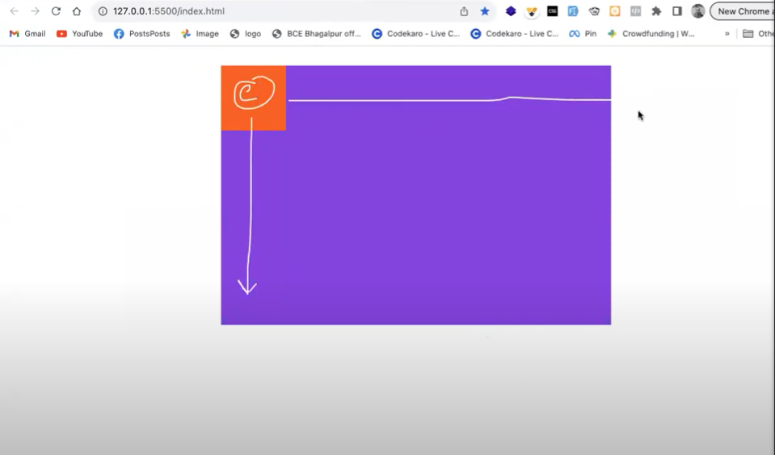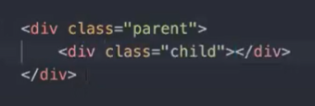4. **Relative:**

As we know, absolute moves with respect to screen size.

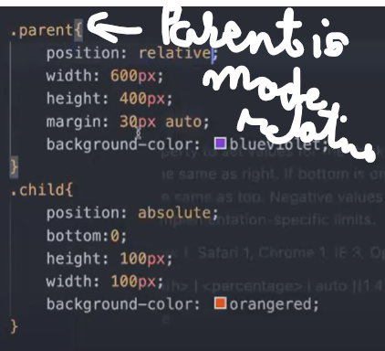**When I want to move the child with respect to parent, relative comes into place.**

