Section 6

**Topics**

1. Rendering dynamic list and conditional content
2. Just because we changed some variable, react will not render its updated version, so we need to use state to manage this.
3. && operator outputs the part written after the && operator, if the condition written before && is true. This is called a shortCircuit operator.
4. We can store jsx content in variables.

**Completed Project Structure:**

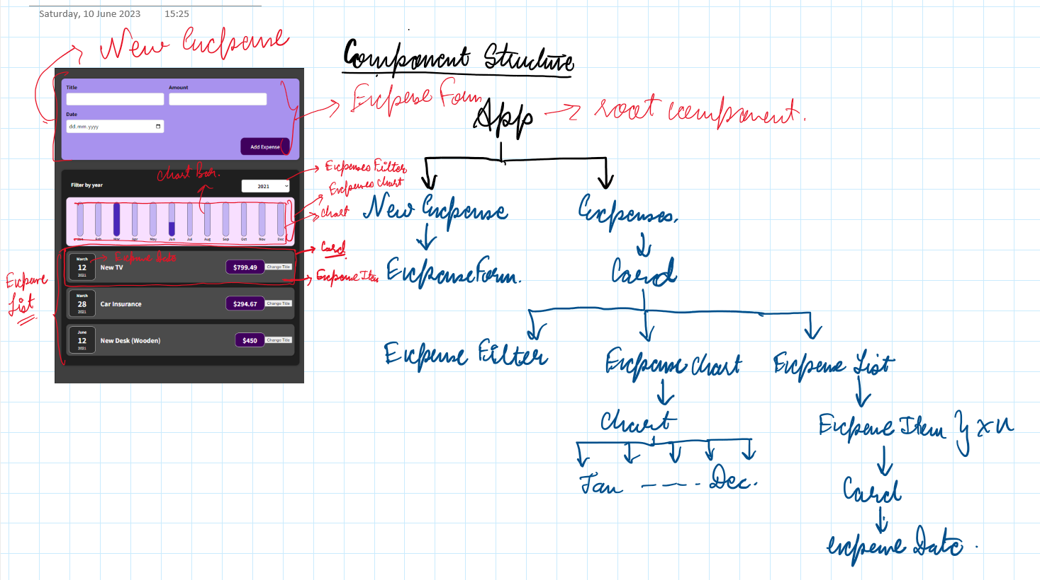

The conditional list is done with the help of the filter variable which is set in the drop down menu by user, and then that initiates an event of onChange which then filters our content to be displayed based on the prop we receive and the function we decide for it.

The process gets executed and applied even without a state, because we are only changing the data sent to it everytime the filter is changed without a state.