**Section 7 : Component Tree**

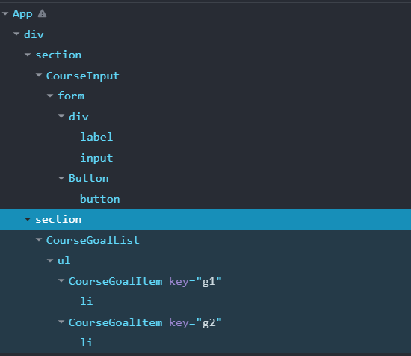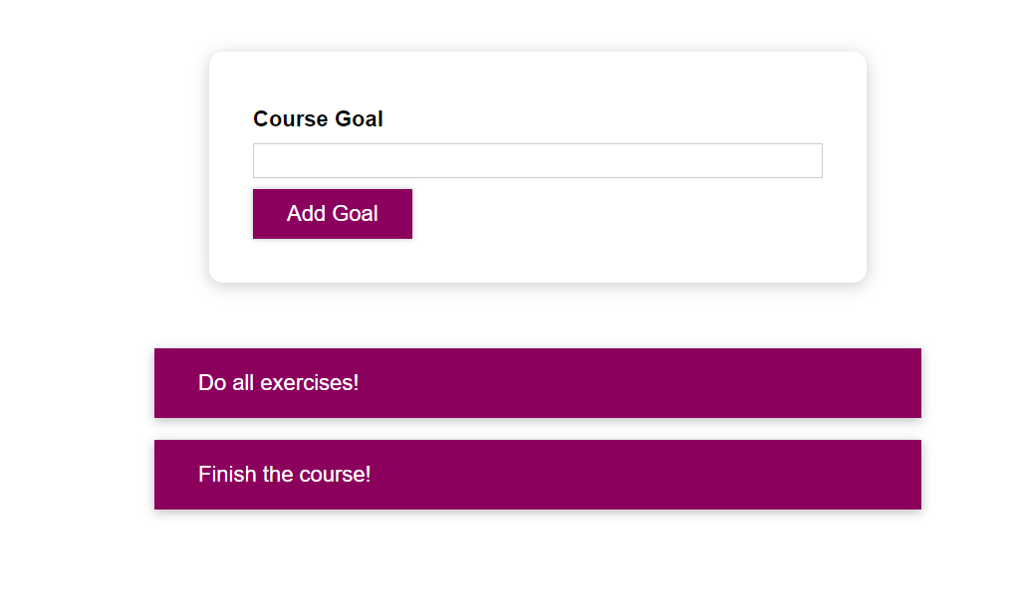

**Inline Styling**

* `` back ticks are used to create a string literal. It supports jsx. ``We can use it like a variable.
* 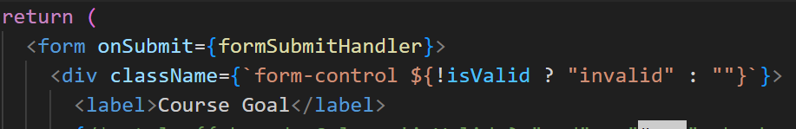Dynamic style control to add or remove class with the name invalid depending on the output of isValid state.

**CSS Module method**

import styles from './Button.module.css';

We import styles like this from the css file when we use this. And we apply it to the given element by adding it as a className to it.

We need to change the name of our css file by adding .module. in between the name and extension.

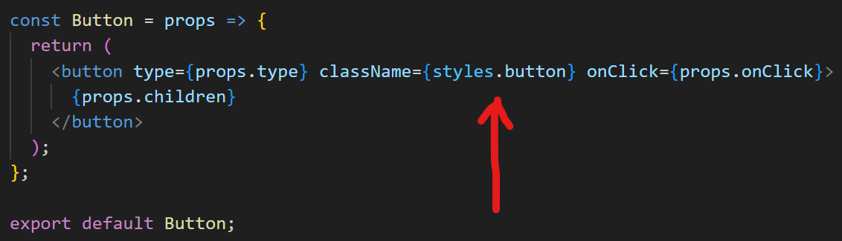

In the backend, a the class added to it is made unique, by adding a hash at the end of classname, component name etc.

**Dynamic Styling in css modules:**

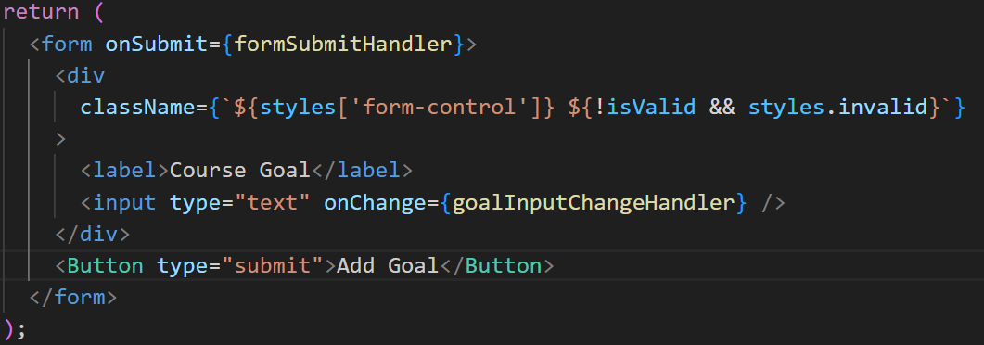



We can pick specific classs from styles module, and we can do conditional styling using the back-tick syntax as above.

Media query is used as usual in normal css file.

About value attibute of the input tag - [here](https://stackoverflow.com/questions/17633478/what-is-the-purpose-of-the-html-input-tag-value-attribute#:~:text=Given%20%3Cinput%20type%3D%22checkbox%22%20name%3D%22foo%22%20value%3D%22bar%22%3E%20the%20submitted%20data%20for%20the%20checkbox%20will%20be%20foo%3Dbar%20if%20the%20form%20it%20is%20inside%20is%20submitted%20and%20the%20checkbox%20is%20successful%20(the%20main%20additional%20criteria%20for%20which%20is%20that%20it%20is%20checked).%20The%20server%20side%20form%20handler%20can%20then%20use%20that%20information.)