Project 2 Notes

* htmlFor attribute in JSX label is used to associate input id with label. Helpful for screen readers.
* To apply the classes from component.module.css to the native JSX html elements wrapped inside a custom component, we need to accept the incoming classes in inputs as props and extend the custom wrapper component classes with our classes that we applied in new component.  
  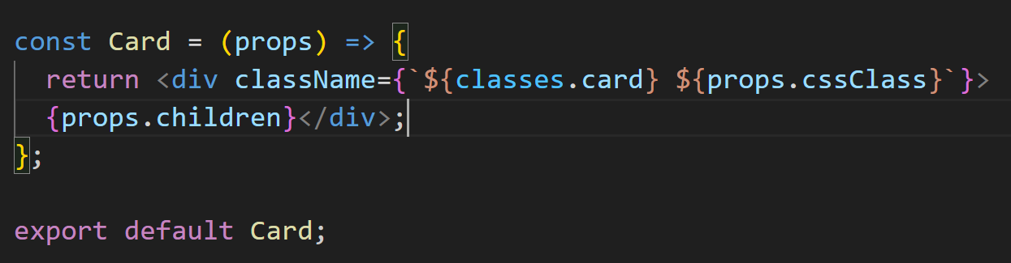 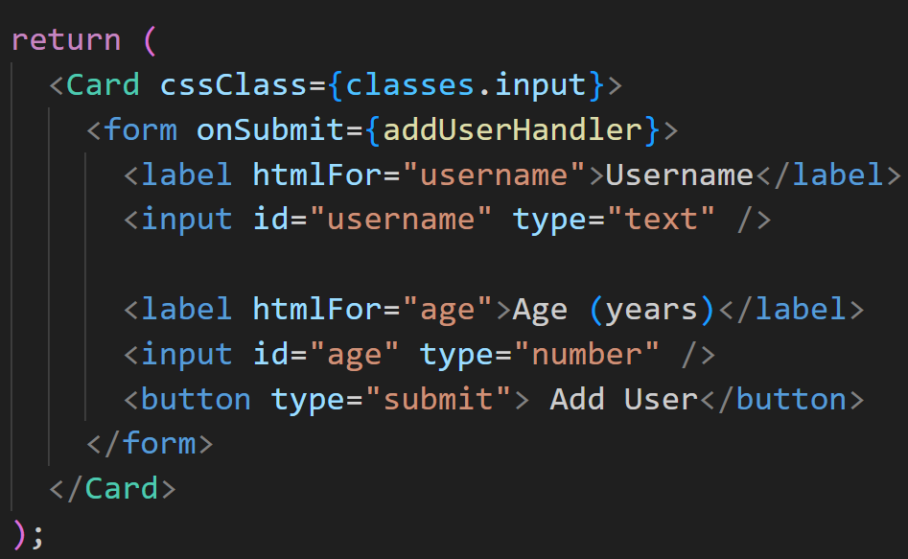



* How to add backdrop? We add an empty div which uses some styling, to dull and cover content behind it.

