What is create-react-app?

It is a pre-defined folder structure, and configuration files to build and develop production ready code. It gives a nice development environment, and allows to preview project with hot module updater. It creates a folder and puts all the necessary files. A lot of usages are going on in the background like injecting jsx and other supported files. When you do inspect element, you can find the weird static/js folder and files as source code of REACT DOM package used to render your work.  
Your written code is transformed heavily which is not easy to write, but react provides a platform to code easy and a code which works on browser.

1. [Create react app](https://youtu.be/2OTq15A5s0Y) alternatives.
   1. [Vite](https://youtu.be/89NJdbYTgJ8)-1 , [Vite-2](https://youtu.be/VAeRhmpcWEQ) – very similar to cra. Learn about rendering paradigms
   2. Nx – standalone react apps. Monorepo. Generators, graph command. [very cool]
   3. Next.JS – full fledged react website to be sent into production. So many advantages
   4. Gatsby. I do not understand much but recommended a lot.
   5. Astro.
2. **About vite:**

Create react app uses webpack in the background. It is really slow.

Vite takes advantage of import export ES module system, to make it fast.

It is a dev server and not a module bundler for production. It uses roll-up to bundle for production.

CRA- laggy as it uses Webpack for everything. It is very buggy.

How CRA works?



How Vite works?

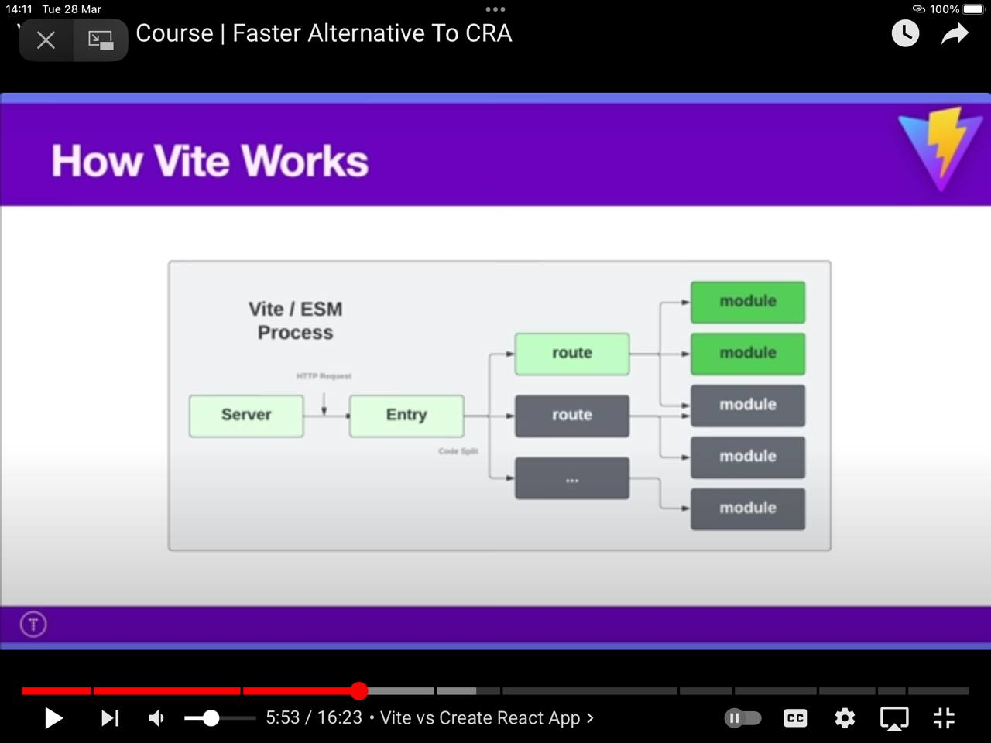  
We do not need to bundle every time and it helps to see changes immediately by ES Module technology.