REACT

React is a Js library to build front end. It simplified building the interface building, We do not need it but it is very helpful. All user interfaces are made of components as building blocks of a web page. It is all about components.

1. React components: Individual units which are usually repeated in the code.  
   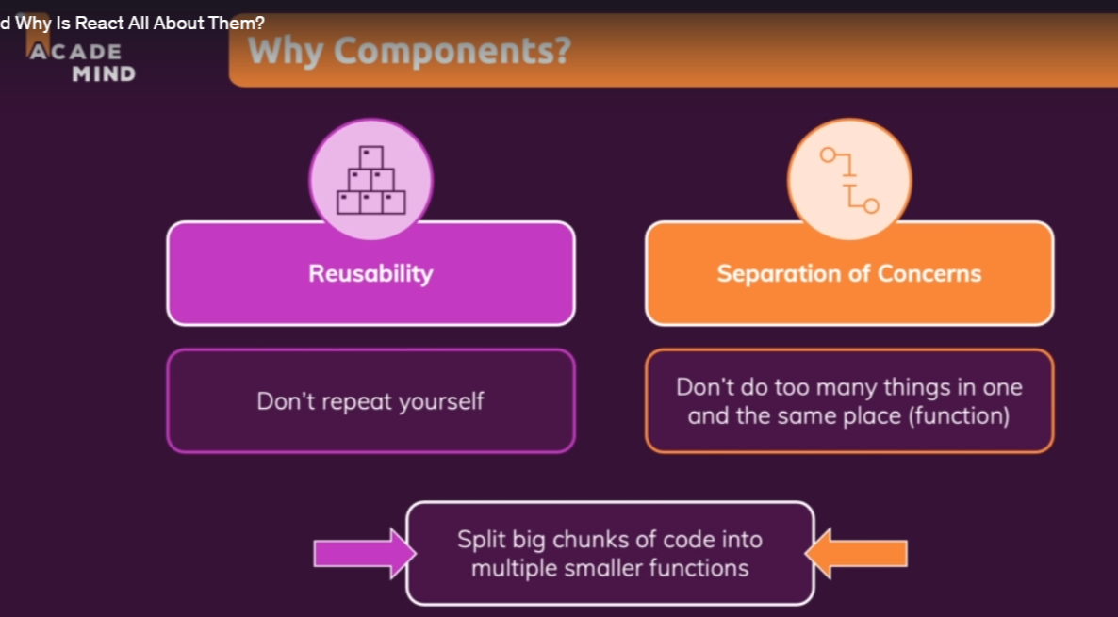
2. 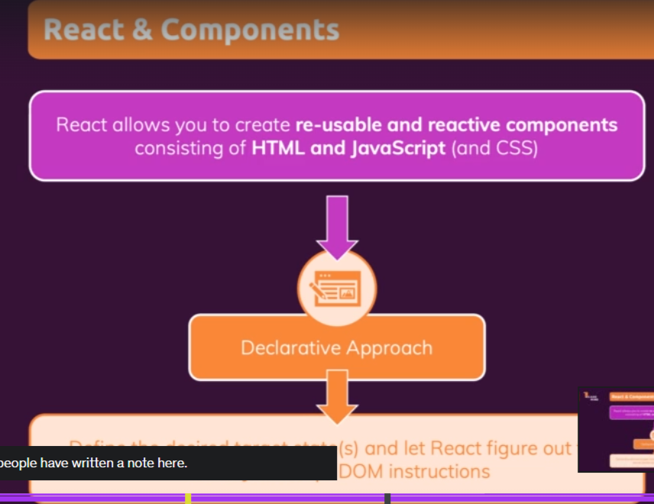REACT Declarative approach  
   Declarative programming describes **what you want the program to achieve** rather than how it should run. In other words, within the declarative paradigm, you define the results you want a program to accomplish without describing its control flow. Ultimately, it’s up to the programming language’s implementation and the compiler to determine how to achieve the results. This places emphasis not on the execution process, but on the results and their ties to your overall goal. (Injection of JSX to render html in JS, to get what you need at a high level.)  
     
   The usual imperative approach where you specify line by line what you want the control flow to be gets cumbersome. We could do getElement, createElement etc in JS to render HTML.