Class4.R
saketchodavarapu
2026-01-16
x <- 1:50
plot(x)
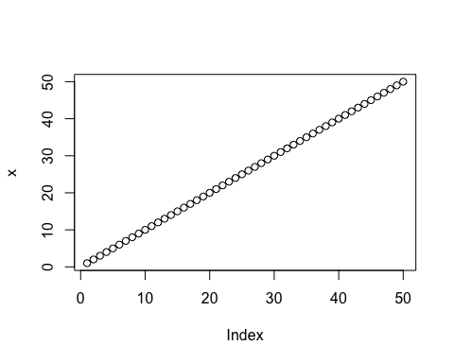
plot(x, sin(x), type="l", col="#137F53", lwd=3,
xlab="Is it lunch time yet?")
