**A**

**PROJECT REPORT**

**ON**

**“Player Application”**

**Index**

* 1. Hardware Requirement
  2. Software Requirement
  3. Synopsis
  4. Requirements
  5. Features
  6. Conclusion
  7. Use Case Diagram 0
  8. Use Case Diagram 1
  9. Class Diagram
  10. Flow Diagram

**1.1 Hardware Requirement**

Processor: - 1.2GHz and above

Hard Disk: - 10GB and more

RAM: - Minimum 1 GB

**1.2 Software Requirement**

Operating System: - All windows system supported.

Software’s: - STS, Mongo Shell, Mongo Compass, Git bash, Postman, Chrome, JDK 11, Mockito, Junit

**1.3 Synopsis:**

The Player application will be helpful for users. It gives the details about players in just one click. User can search and add their favourite players according to their choice. User can also delete the players from favourite section.

It also provides details about

1. login/registration

2. Eureka Service

3. Favourite Player

4. Player Search

5.Player Category

The user of this system should first register for any interaction with the system. Once registered, he/she will be provided with a username and password for the user to log in. User can choose their favourite player according to their choice. User can get all details about their Player after searching by Its Id.

**1.4 Requirements:**

1. **Player Category: -**

The User can choose favourite players as their own choice. User can also make changes in the favourite list they can add, remove the players from list. Also it can fetch the details by searching player by their Id.

**2. Player Search: -**

In this user can search player by its ID’s. So using this feature user can easily get that player details which they wants to see.

**1.5 Features:**

1) Registration and Login Authentication. Not only does this step help you build a strong community, but also to provide a highly personalized experience for your users.

2) Favourite Player.

3) **The files can be easily shared via the online medium.**

**User Story:-**

**Modules:**

* **Registration / Login:** User and Admin have to register first to use the application.
* **Admin login:** Admin is the one who administers the system by adding or removing list of cricketers into and from the system respectively.
* **User login:** User have to register themselves into the system to create an account. After registering successfully, they can then login into the system by entering 10 digit mobile number and their email id.
* **User** can Search player into a cricket app by using get operation.
* **Add and Update Cricketer List:** The admin can add players to the system by entering the details of the player and can even update the details.
* **Search option:** User can even search for his/her favourite player by entering the Id of the Cricketer.

**1.6 Conclusion:**

Player application provides various features like adding, deleting and fetching all details of favourite players.

**1.7 Use Case Diagram:**

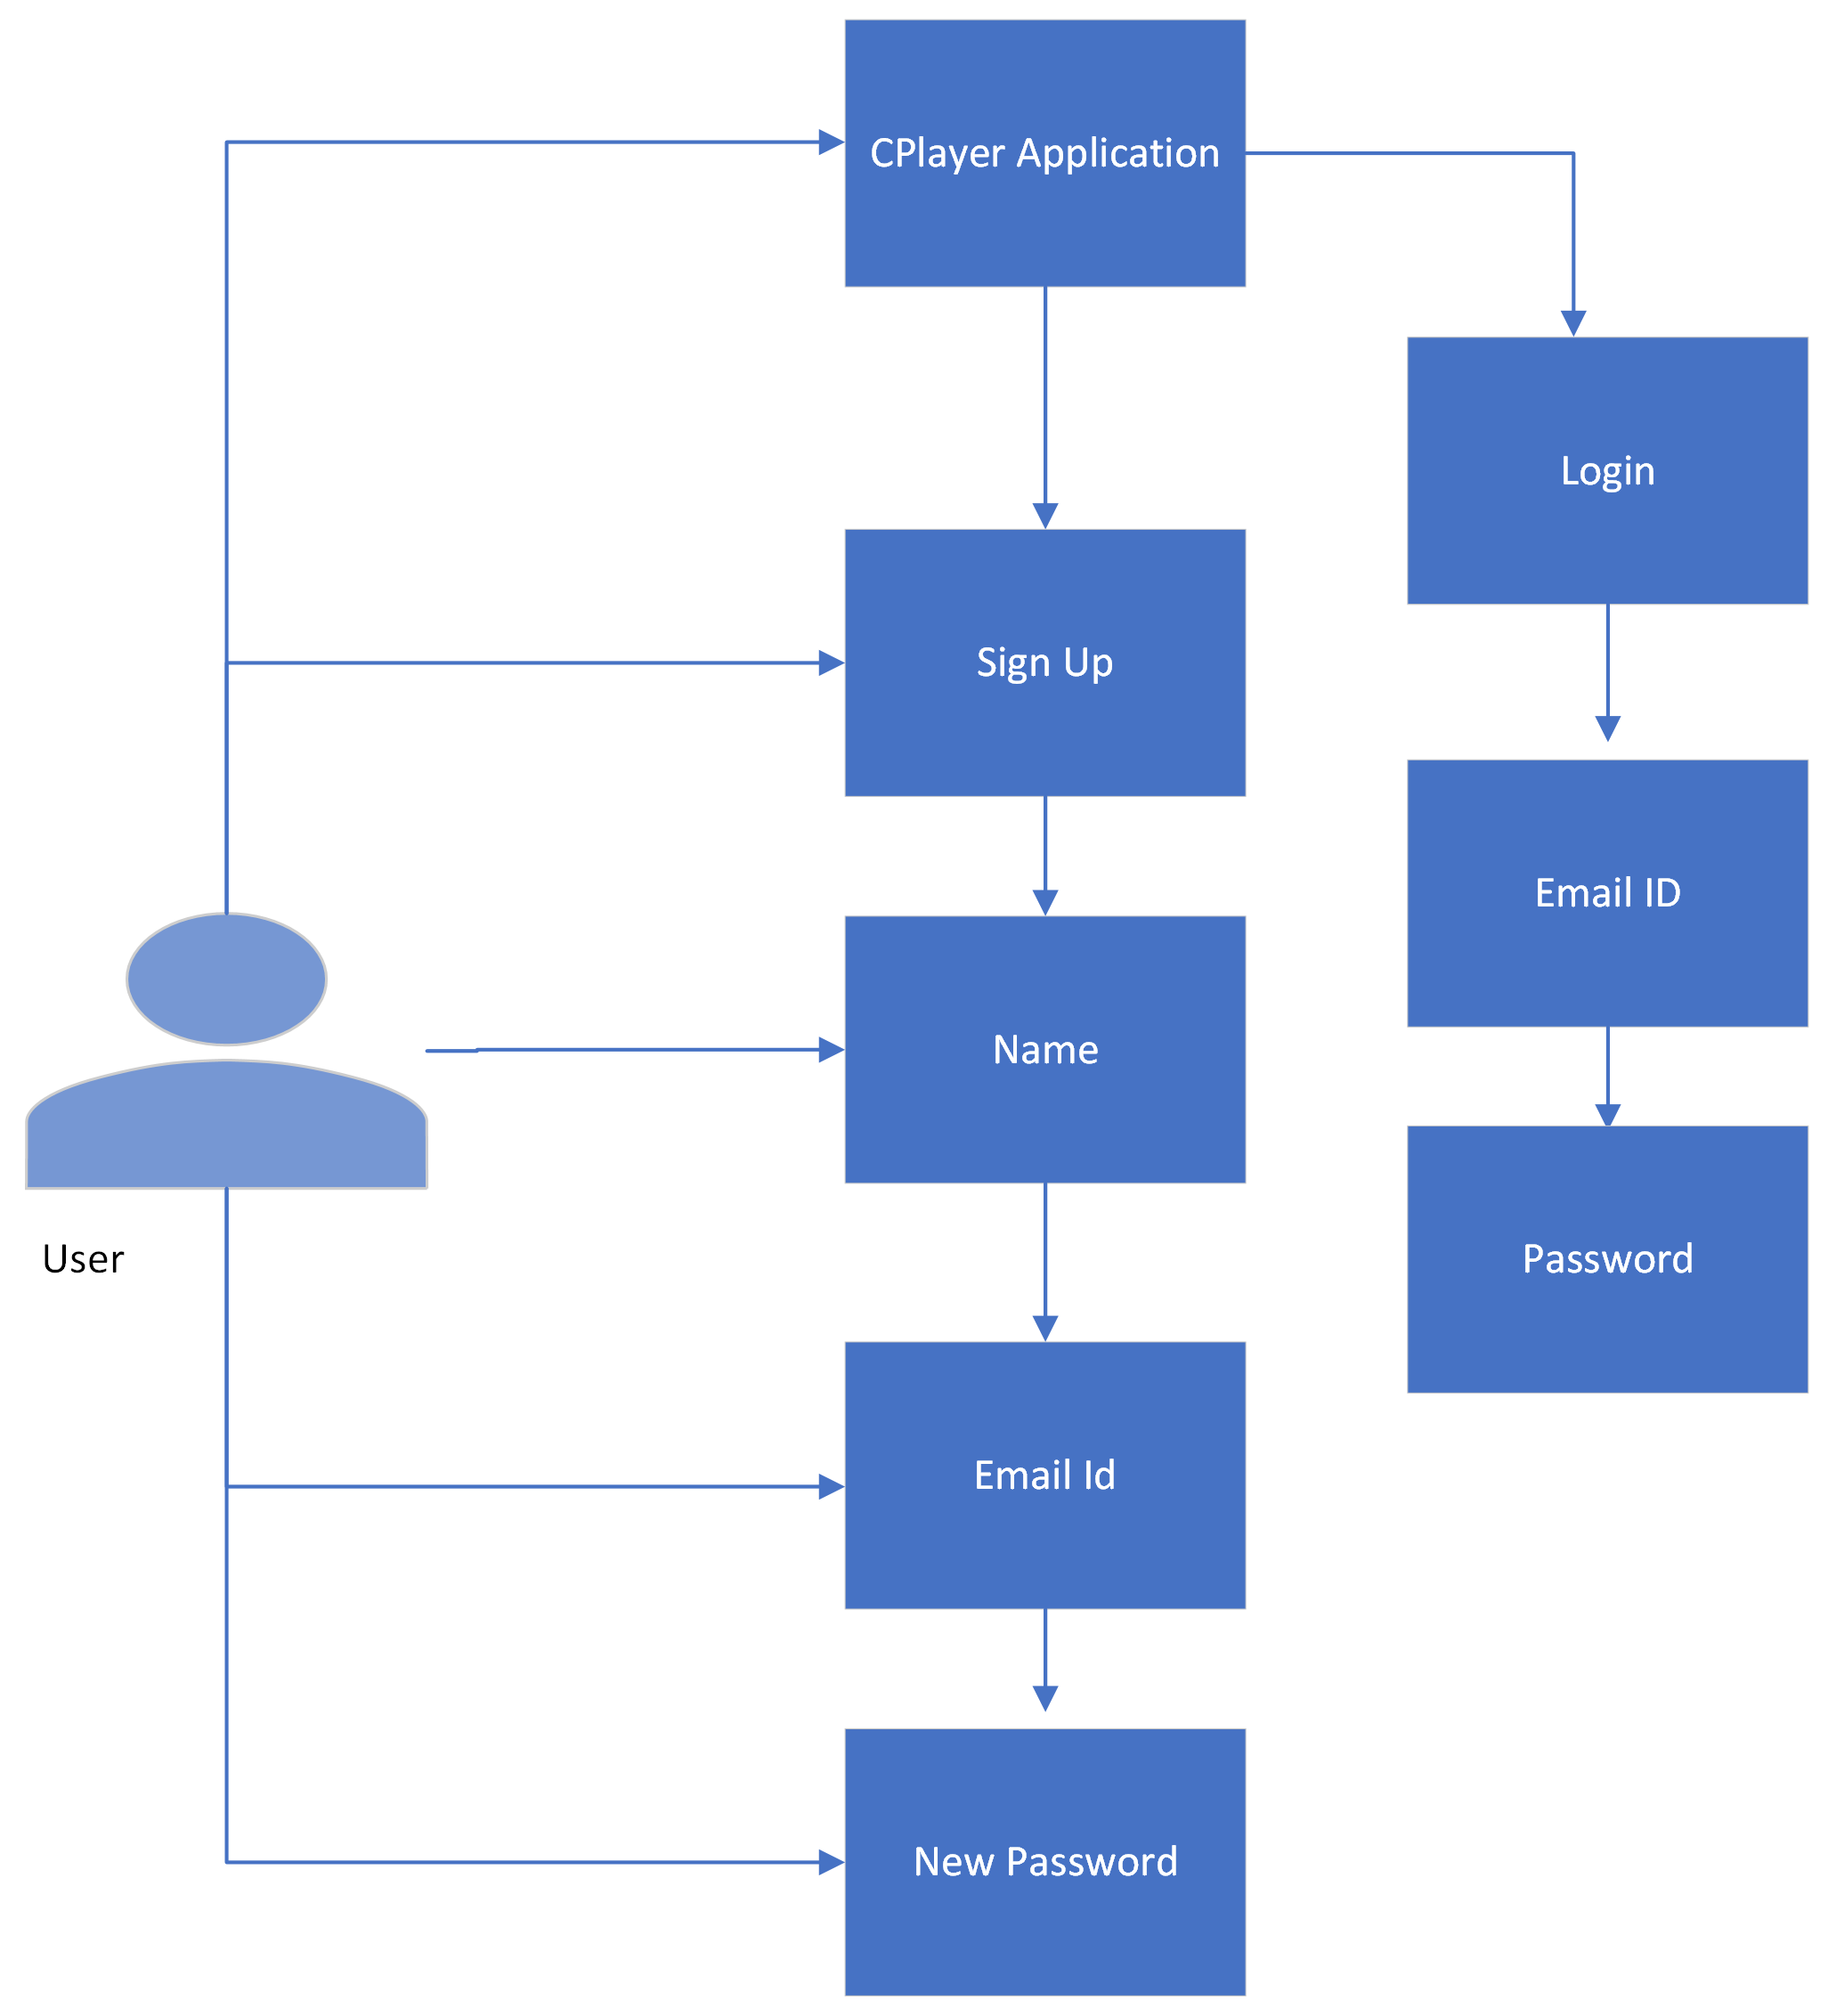

Fig: - Use Case Diagram 0

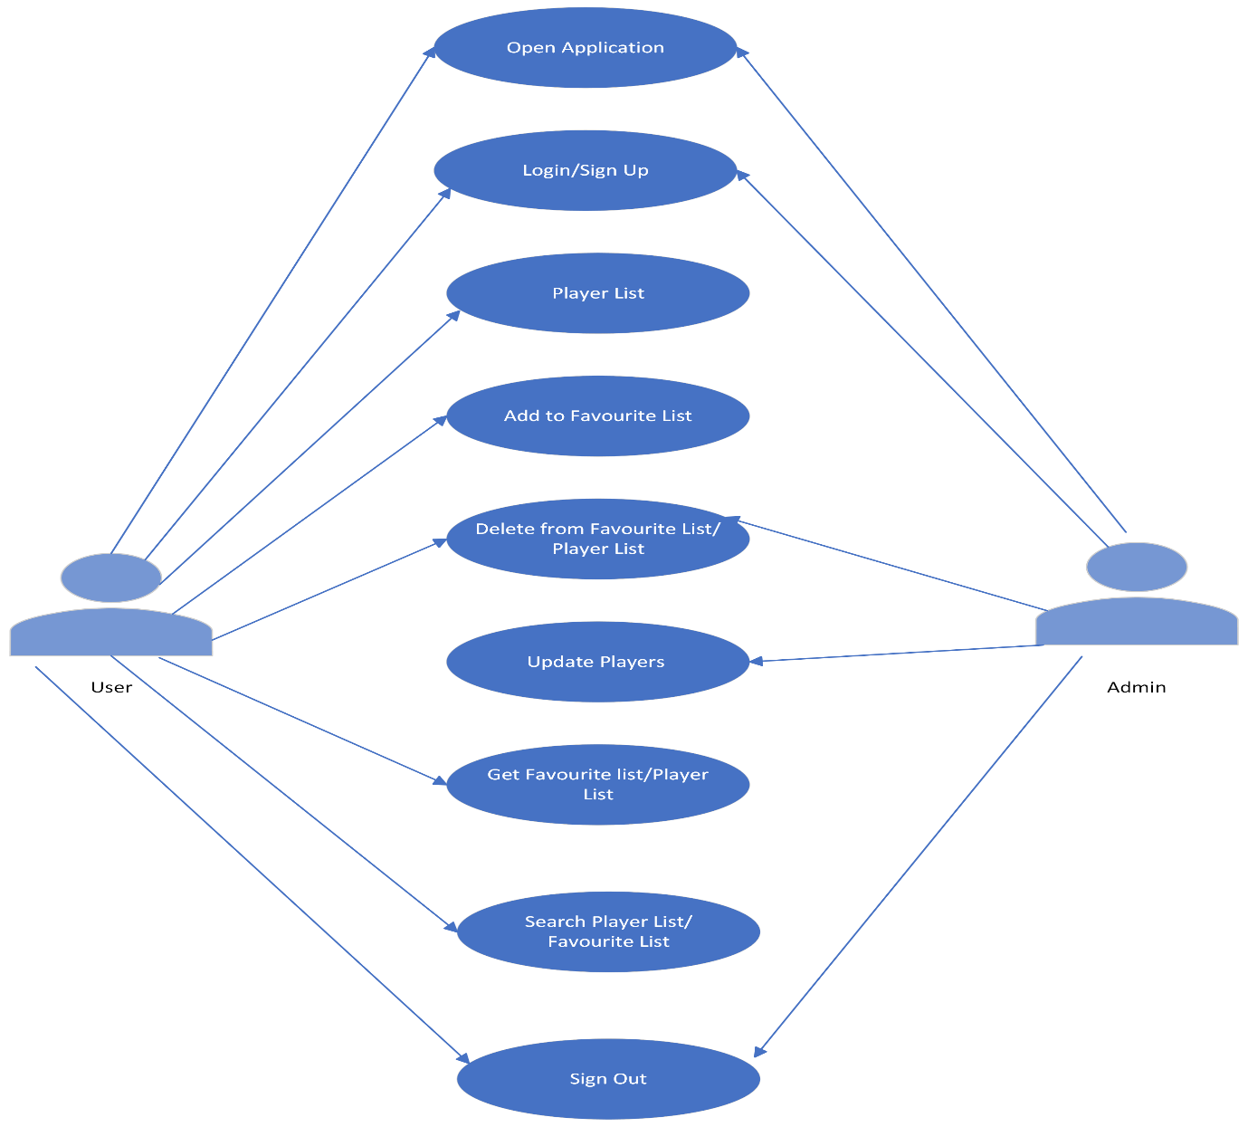

Fig: - Use Case Diagram 1

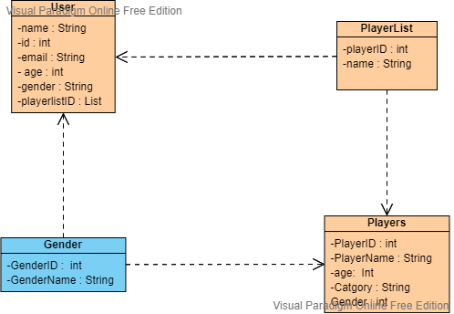

Fig: - Class Diagram

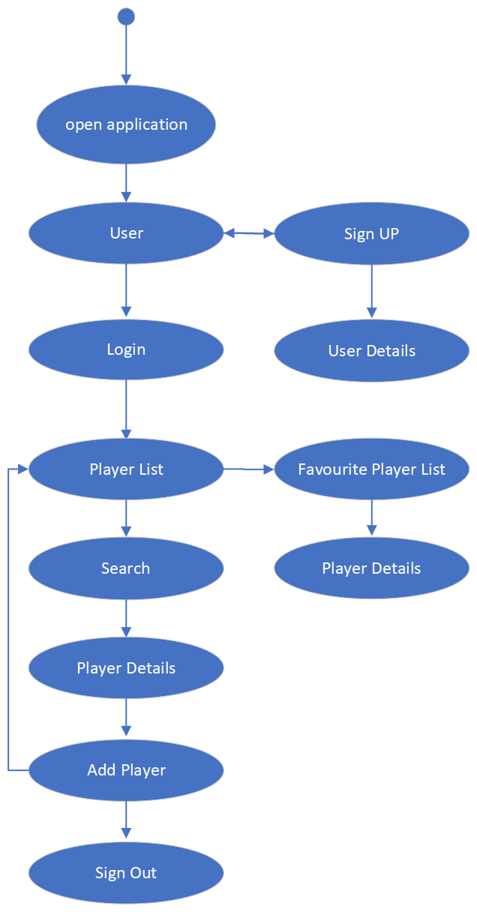

Fig: - Flow Diagram

**1.7 Cricket Player Application Admin :**

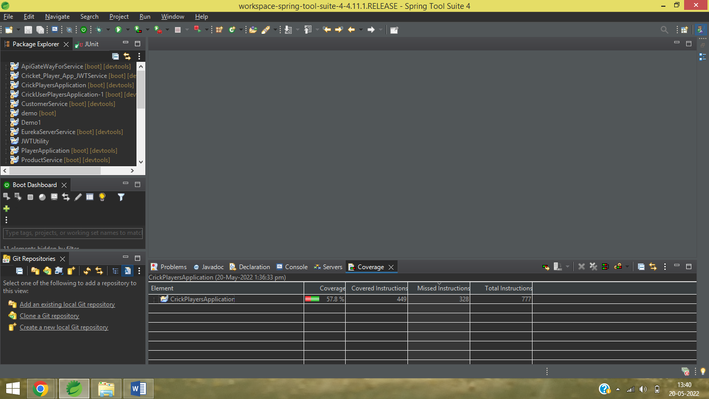

**1.8 Application Gateway API Service :**

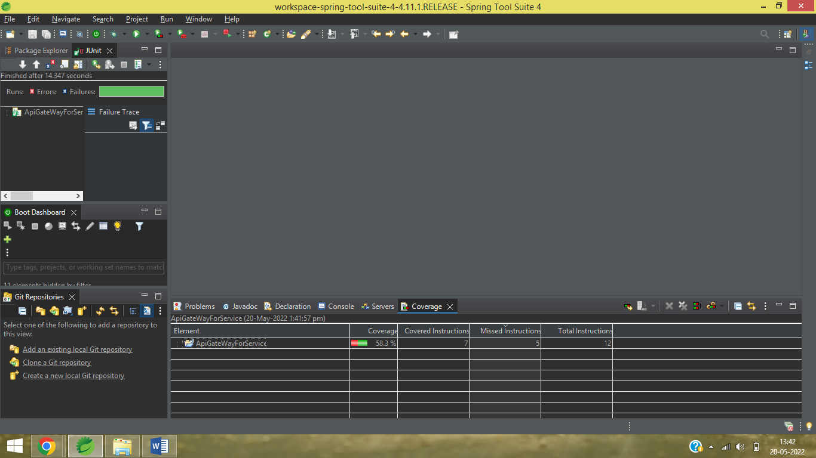

**1.9 Cricket Application User Service:**

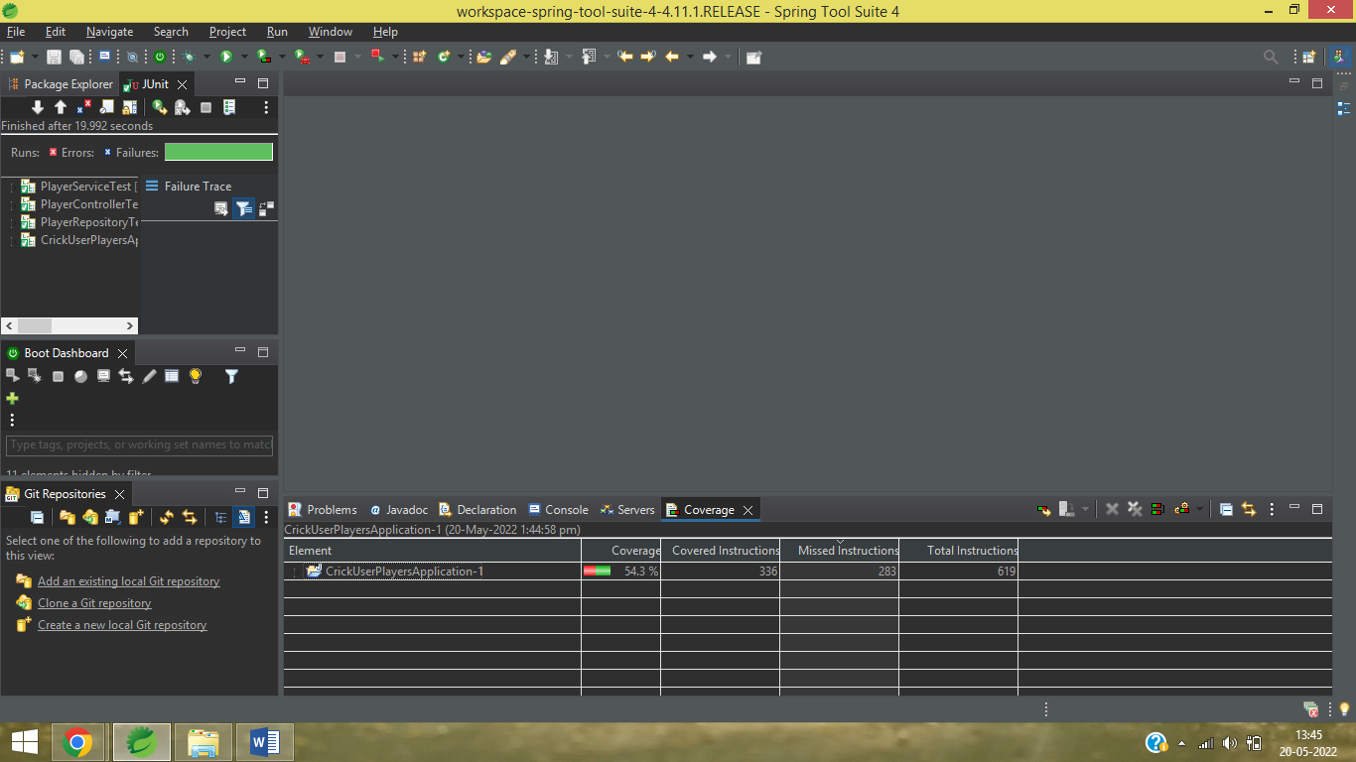

**1.10 Eureka Service Application :**

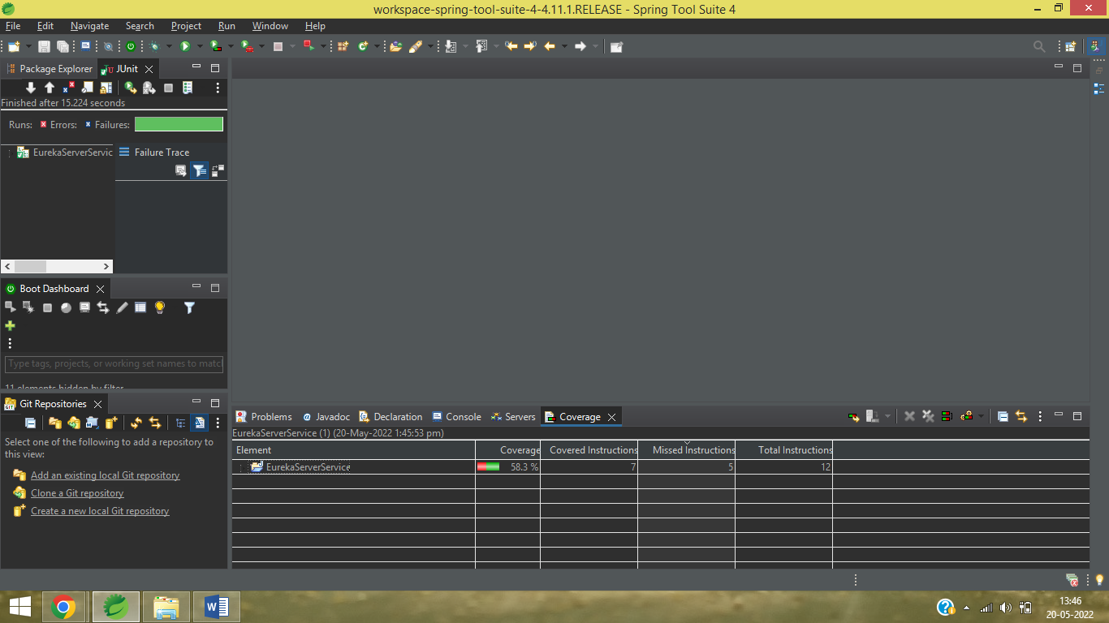

**1.11 Cricket Player JWT Application:**

