# Sample Document with Text, Tables, and Charts

Lorem ipsum dolor sit amet, consectetur adipiscing elit. Lorem ipsum dolor sit amet, consectetur adipiscing elit. Lorem ipsum dolor sit amet, consectetur adipiscing elit. Lorem ipsum dolor sit amet, consectetur adipiscing elit. Lorem ipsum dolor sit amet, consectetur adipiscing elit. Lorem ipsum dolor sit amet, consectetur adipiscing elit. Lorem ipsum dolor sit amet, consectetur adipiscing elit. Lorem ipsum dolor sit amet, consectetur adipiscing elit. Lorem ipsum dolor sit amet, consectetur adipiscing elit. Lorem ipsum dolor sit amet, consectetur adipiscing elit. Lorem ipsum dolor sit amet, consectetur adipiscing elit. Lorem ipsum dolor sit amet, consectetur adipiscing elit. Lorem ipsum dolor sit amet, consectetur adipiscing elit. Lorem ipsum dolor sit amet, consectetur adipiscing elit. Lorem ipsum dolor sit amet, consectetur adipiscing elit. Lorem ipsum dolor sit amet, consectetur adipiscing elit. Lorem ipsum dolor sit amet, consectetur adipiscing elit. Lorem ipsum dolor sit amet, consectetur adipiscing elit. Lorem ipsum dolor sit amet, consectetur adipiscing elit. Lorem ipsum dolor sit amet, consectetur adipiscing elit.

Table 1

|  |  |  |  |
| --- | --- | --- | --- |
| A | B | C | D |
| 5 | 32 | 70 | 30 |
| 28 | 95 | 55 | 65 |
| 43 | 17 | 4 | 47 |
| 94 | 88 | 33 | 55 |
| 70 | 37 | 65 | 72 |

Table 2

|  |  |  |  |
| --- | --- | --- | --- |
| A | B | C | D |
| 15 | 50 | 23 | 73 |
| 35 | 77 | 5 | 5 |
| 4 | 16 | 83 | 16 |
| 4 | 97 | 83 | 16 |
| 74 | 57 | 7 | 15 |

Table 3

|  |  |  |  |
| --- | --- | --- | --- |
| A | B | C | D |
| 3 | 32 | 52 | 88 |
| 44 | 58 | 51 | 29 |
| 49 | 37 | 3 | 23 |
| 10 | 14 | 60 | 19 |
| 35 | 12 | 66 | 46 |

Table 4

|  |  |  |  |
| --- | --- | --- | --- |
| A | B | C | D |
| 50 | 68 | 28 | 47 |
| 55 | 71 | 8 | 16 |
| 85 | 35 | 41 | 88 |
| 60 | 59 | 99 | 69 |
| 30 | 85 | 3 | 5 |

Table 5

|  |  |  |  |
| --- | --- | --- | --- |
| A | B | C | D |
| 98 | 11 | 73 | 29 |
| 35 | 26 | 16 | 60 |
| 13 | 82 | 51 | 81 |
| 45 | 5 | 47 | 81 |
| 7 | 48 | 60 | 27 |

Table 6

|  |  |  |  |
| --- | --- | --- | --- |
| A | B | C | D |
| 95 | 22 | 53 | 17 |
| 38 | 83 | 31 | 94 |
| 15 | 43 | 53 | 82 |
| 62 | 3 | 52 | 60 |
| 44 | 87 | 34 | 74 |

Table 7

|  |  |  |  |
| --- | --- | --- | --- |
| A | B | C | D |
| 68 | 53 | 89 | 46 |
| 55 | 26 | 94 | 90 |
| 65 | 9 | 59 | 57 |
| 24 | 86 | 42 | 60 |
| 27 | 97 | 99 | 25 |

Table 8

|  |  |  |  |
| --- | --- | --- | --- |
| A | B | C | D |
| 44 | 15 | 93 | 4 |
| 86 | 32 | 73 | 79 |
| 57 | 32 | 83 | 48 |
| 13 | 8 | 45 | 2 |
| 77 | 52 | 58 | 61 |

Table 9

|  |  |  |  |
| --- | --- | --- | --- |
| A | B | C | D |
| 43 | 51 | 82 | 1 |
| 49 | 57 | 61 | 52 |
| 65 | 16 | 83 | 36 |
| 84 | 54 | 92 | 45 |
| 50 | 13 | 77 | 55 |

Table 10

|  |  |  |  |
| --- | --- | --- | --- |
| A | B | C | D |
| 70 | 97 | 18 | 1 |
| 23 | 65 | 10 | 67 |
| 23 | 37 | 19 | 67 |
| 53 | 97 | 5 | 44 |
| 54 | 59 | 74 | 73 |

Chart: chart_1_bar.png

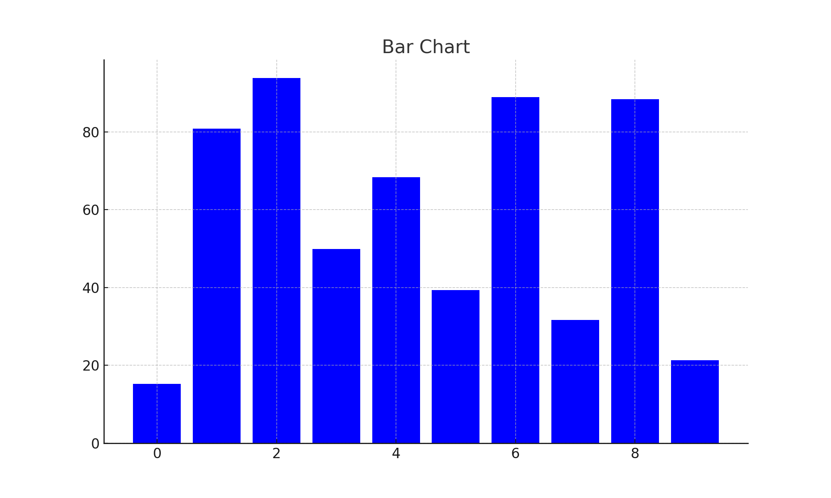

Chart: chart_2_line.png

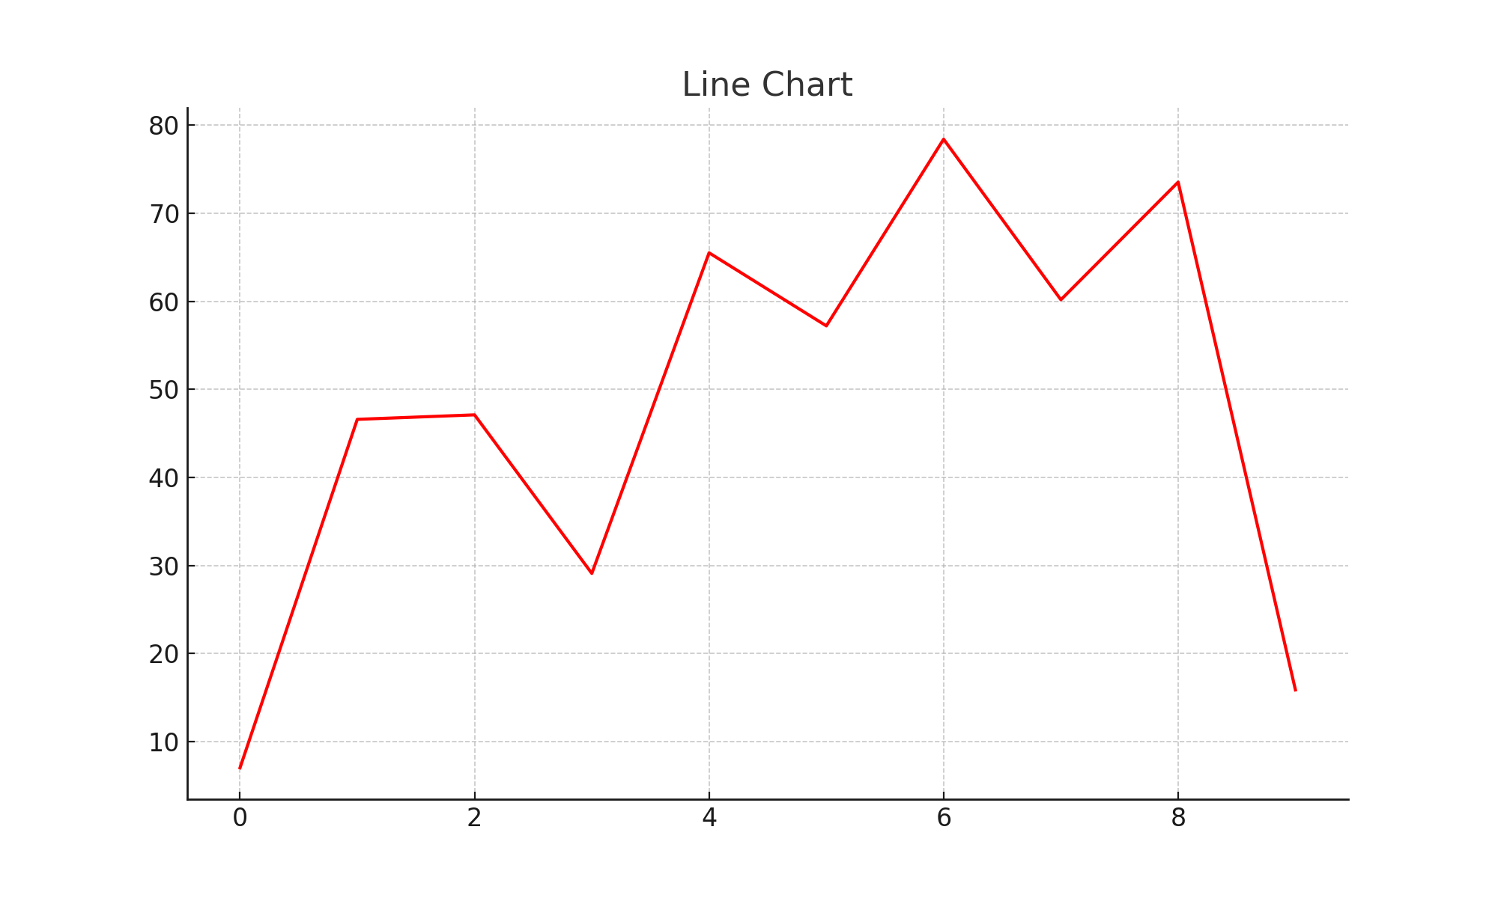

Chart: chart_3_pie.png

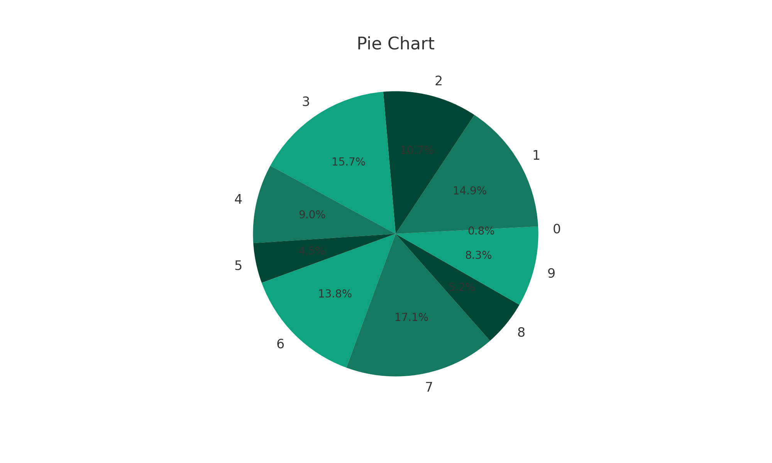

Chart: chart_4_scatter.png

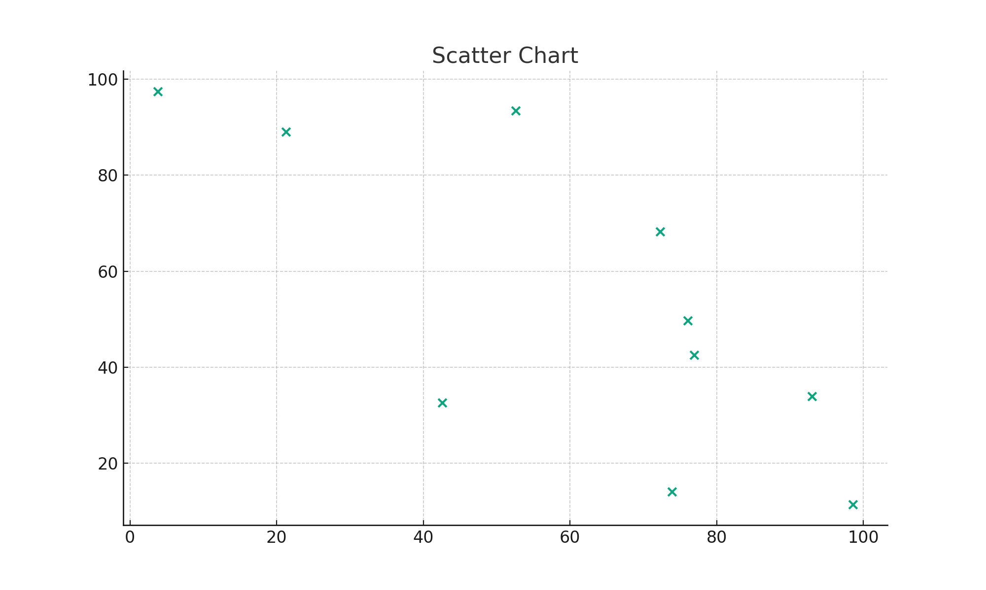

Chart: chart_5_bar.png

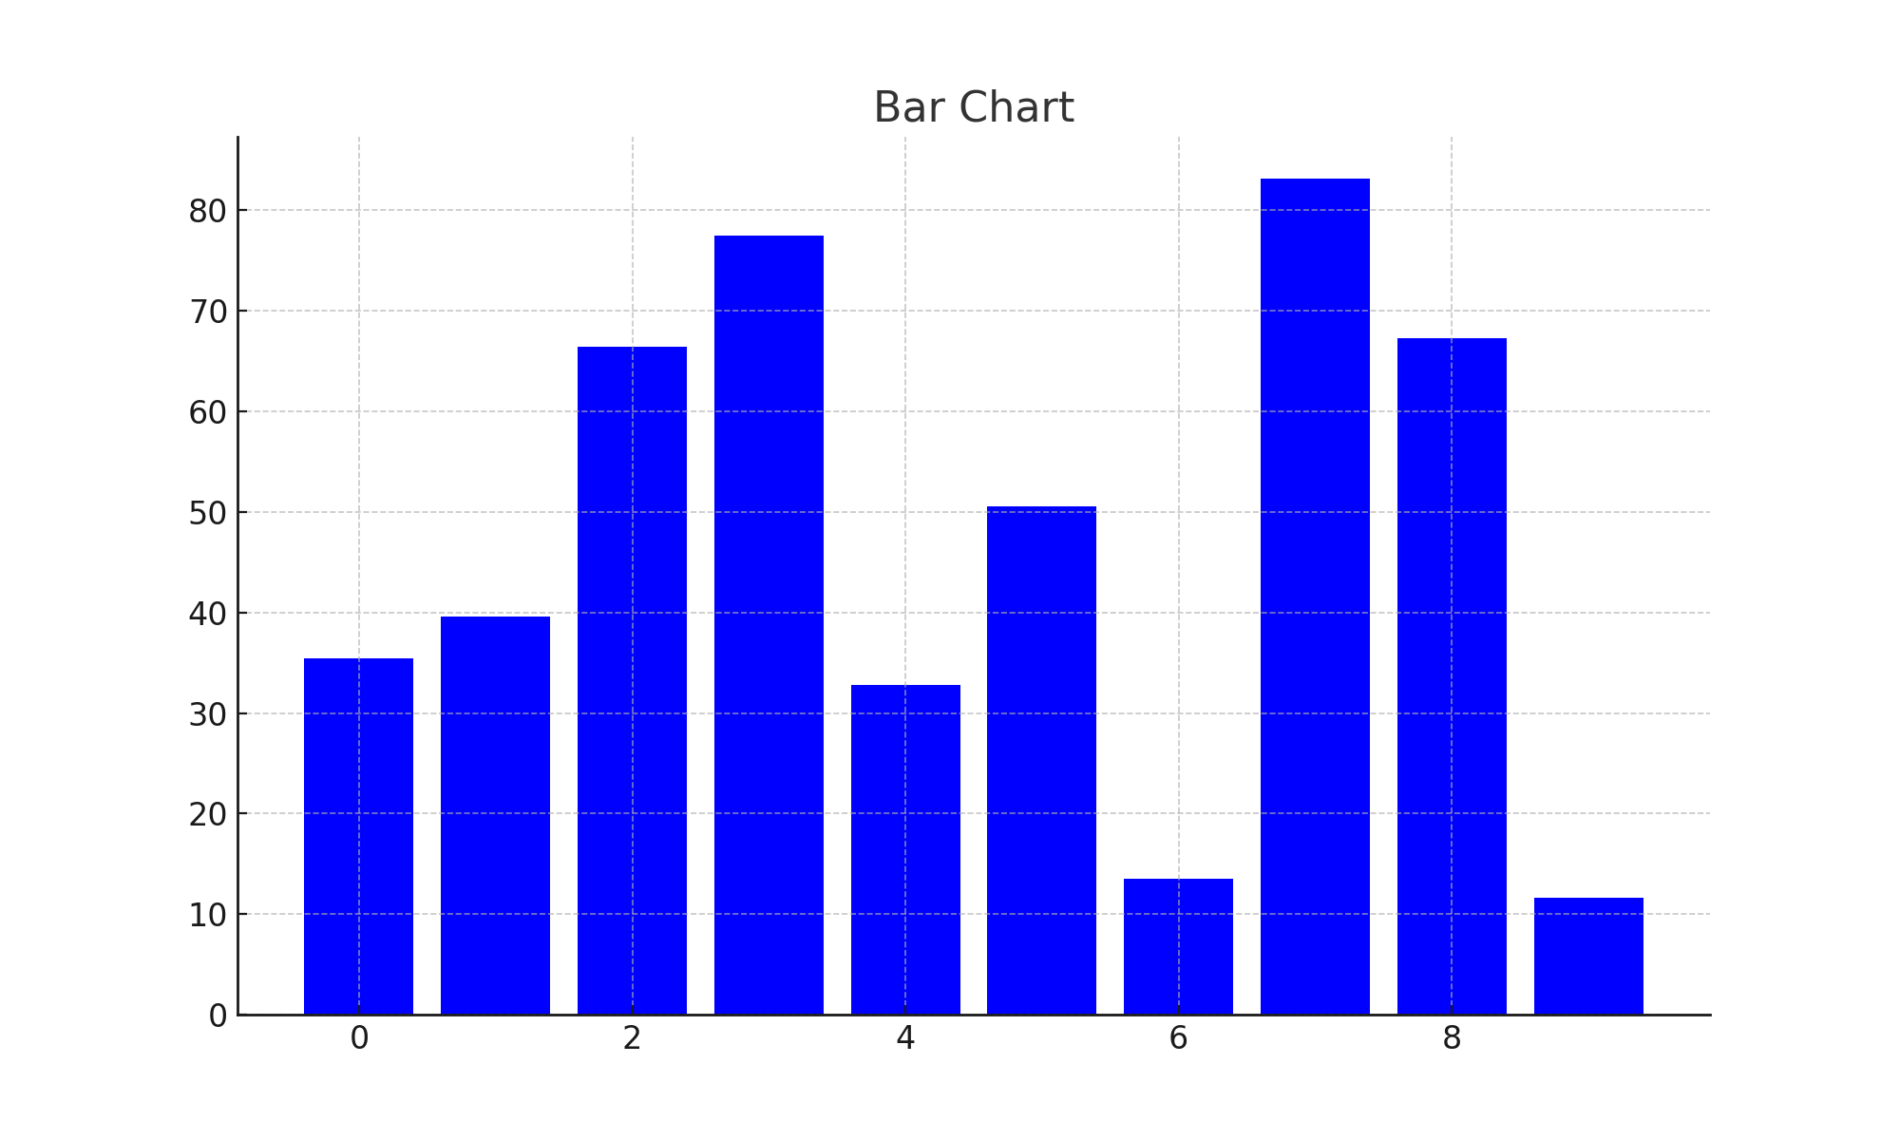

Chart: chart_6_line.png

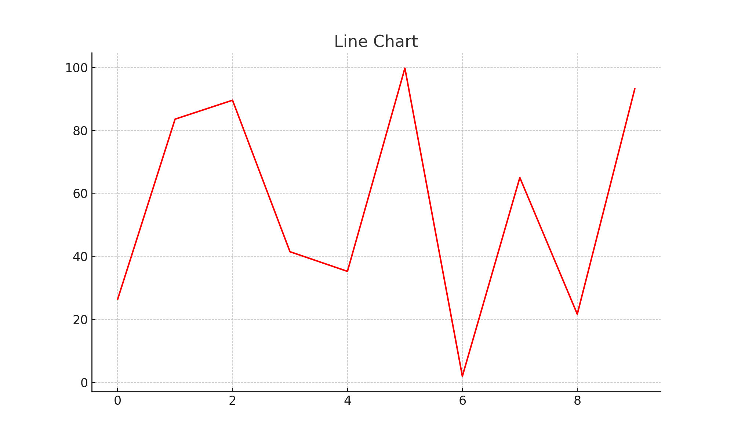

Chart: chart_7_pie.png

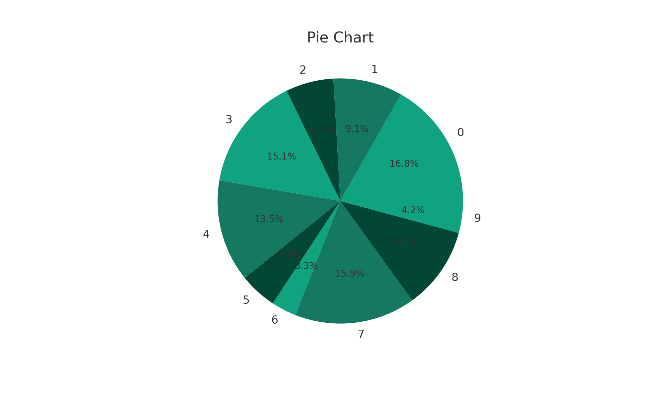

Chart: chart_8_scatter.png

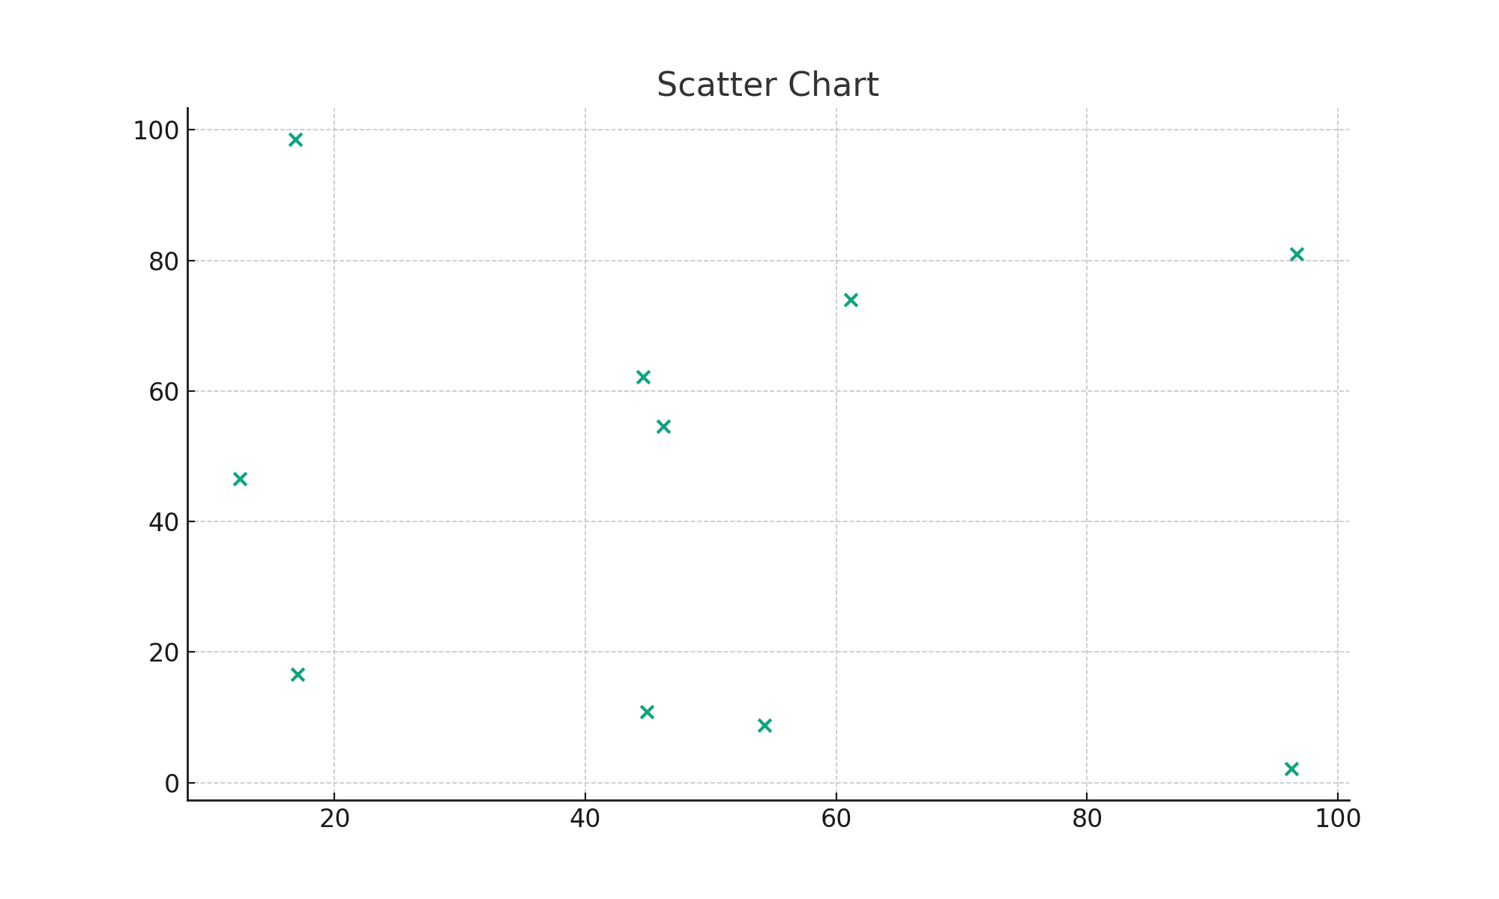

Chart: chart_9_bar.png

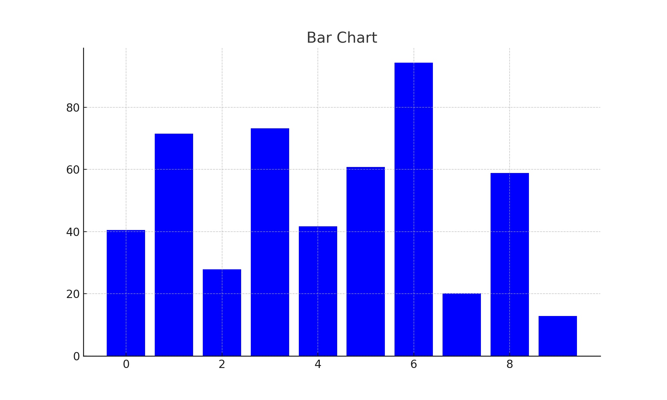

Chart: chart_10_line.png

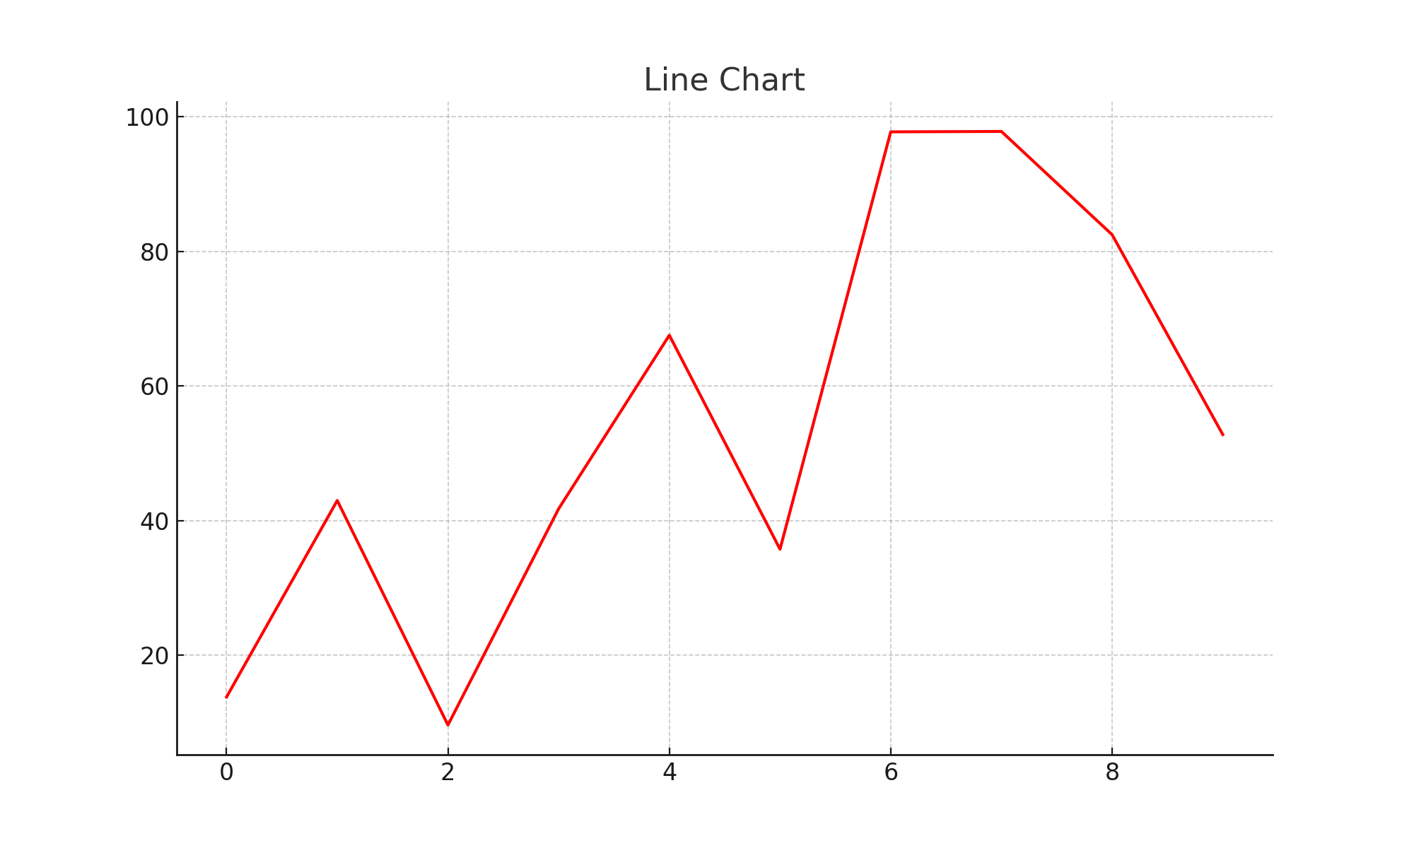

Chart: chart_11_pie.png

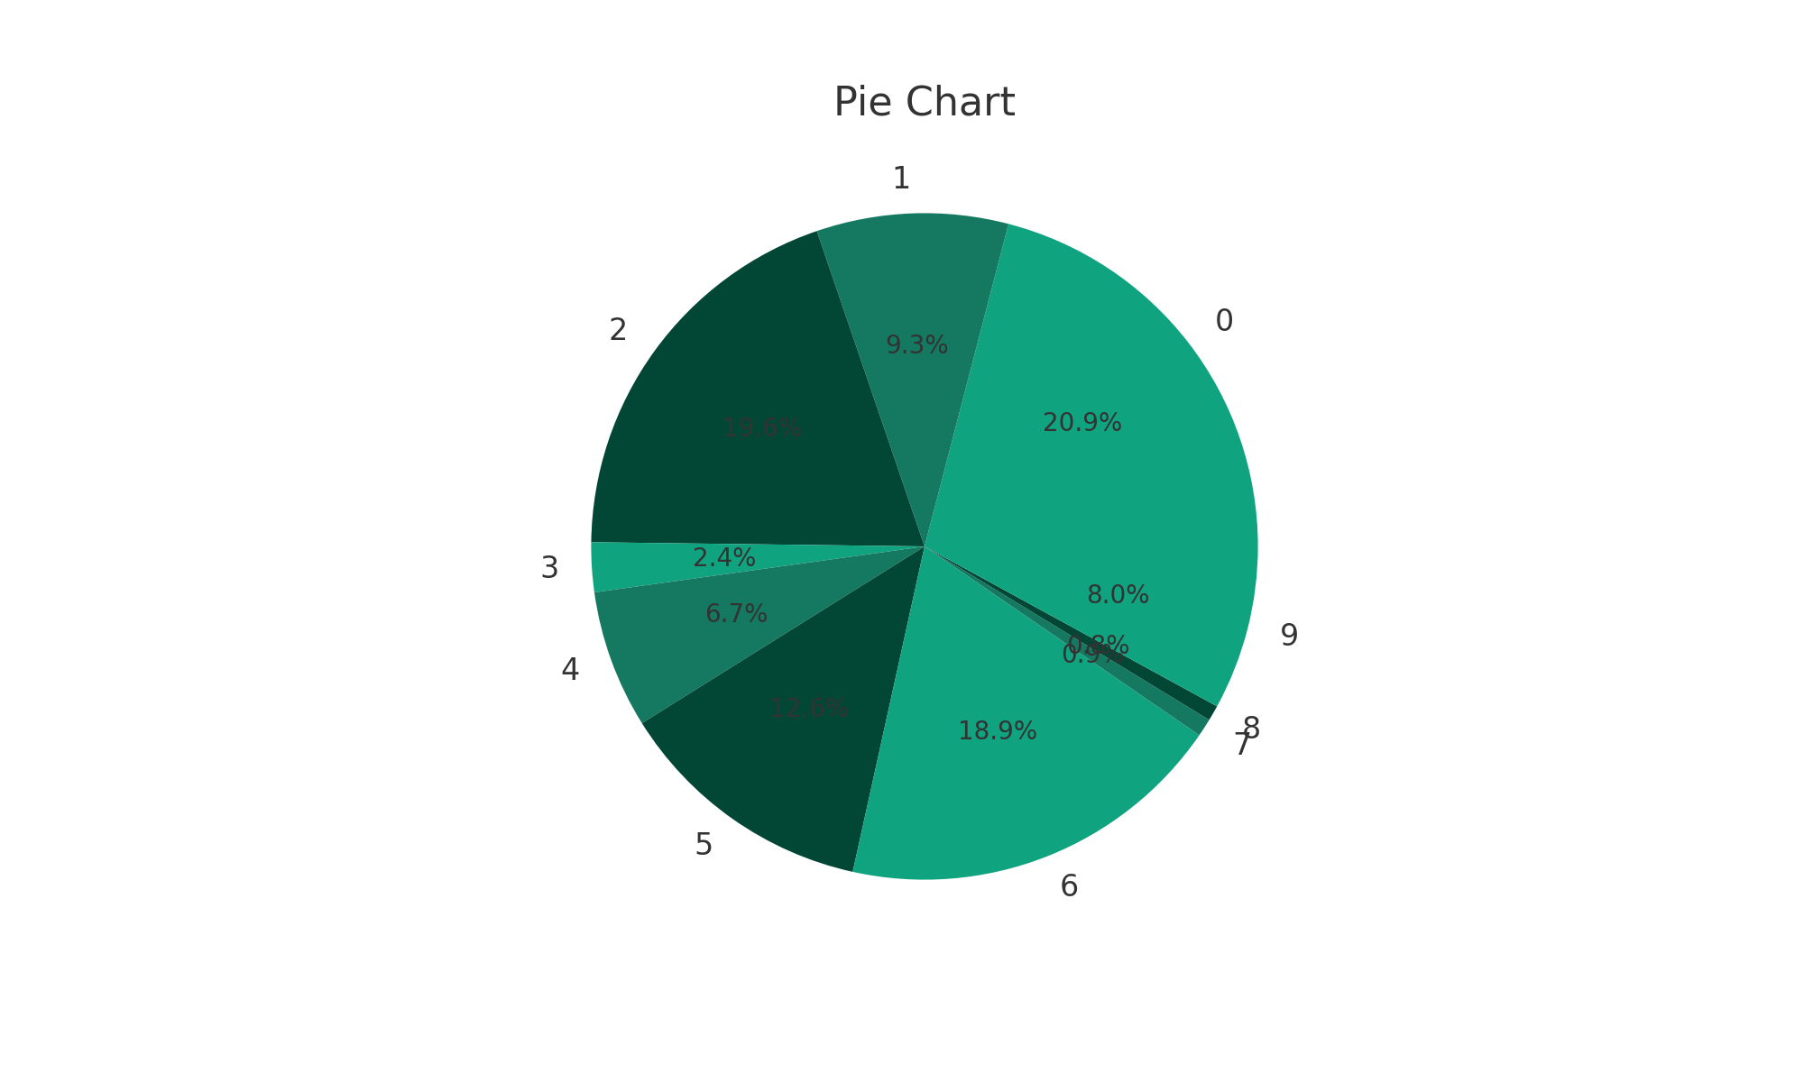

Chart: chart_12_scatter.png

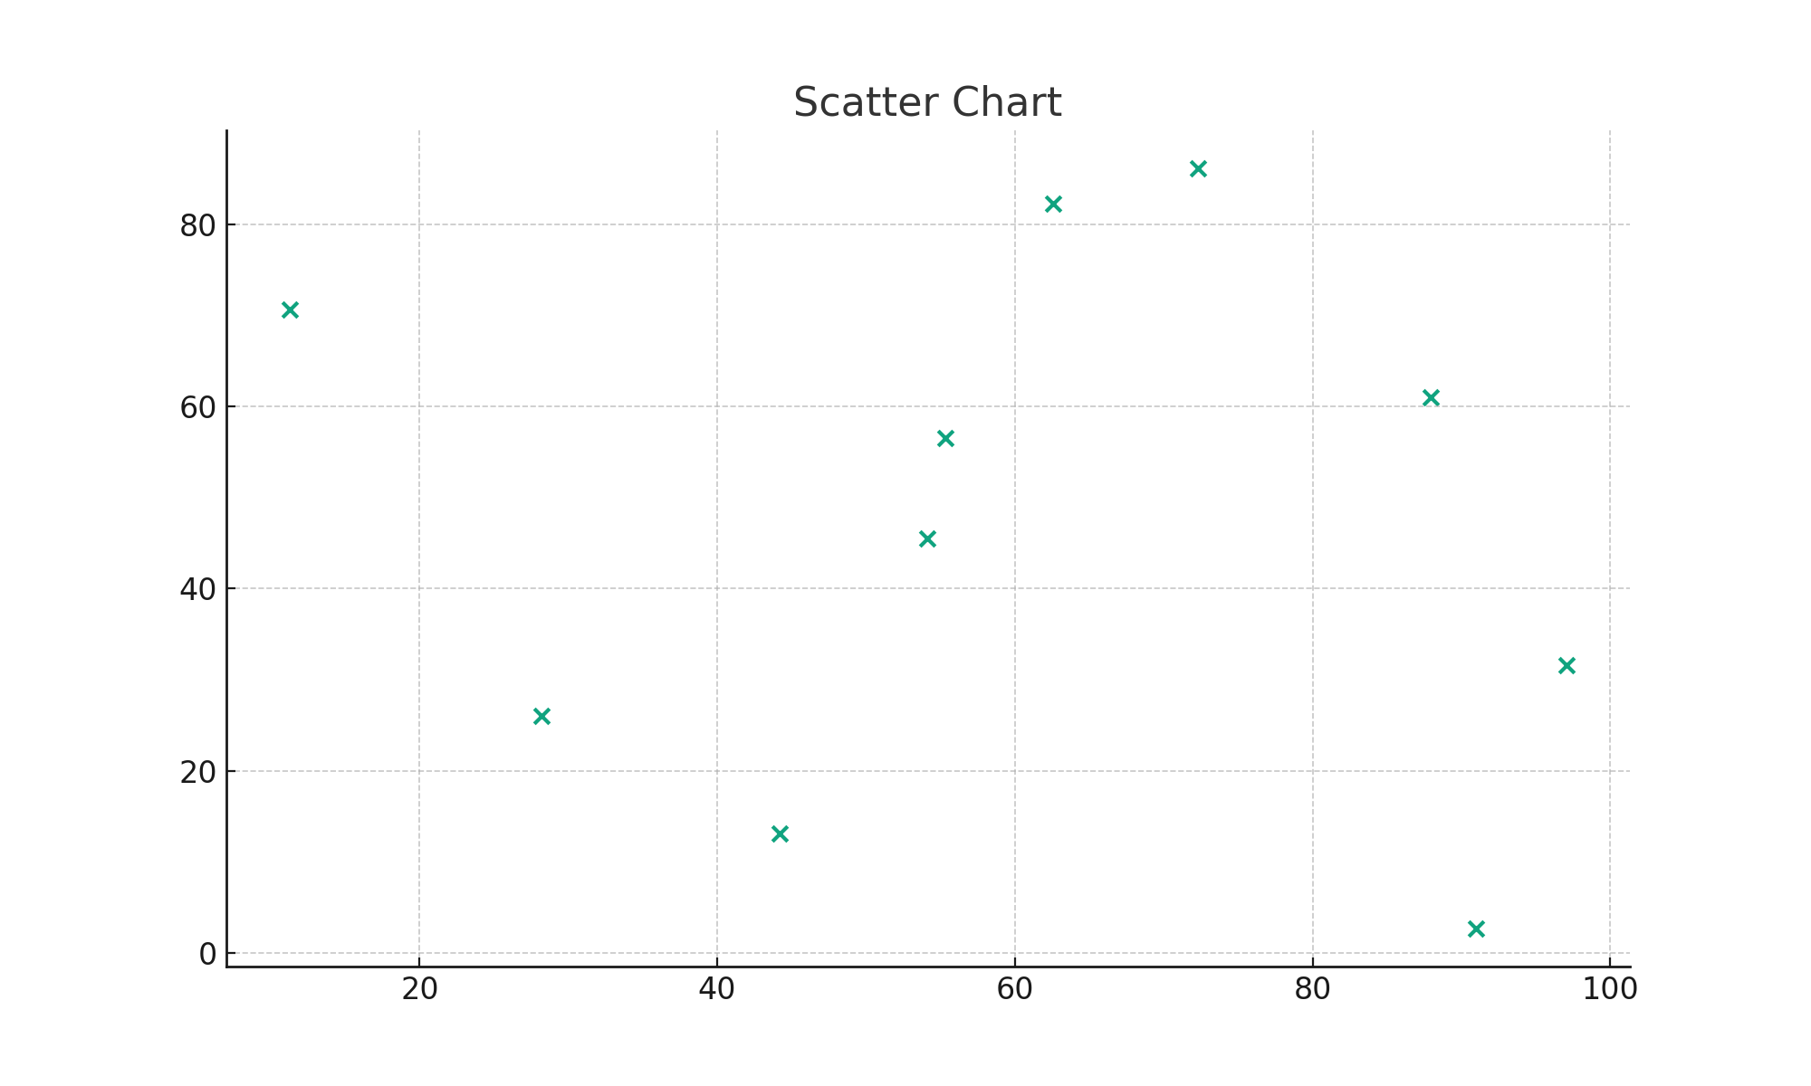

Chart: chart_13_bar.png

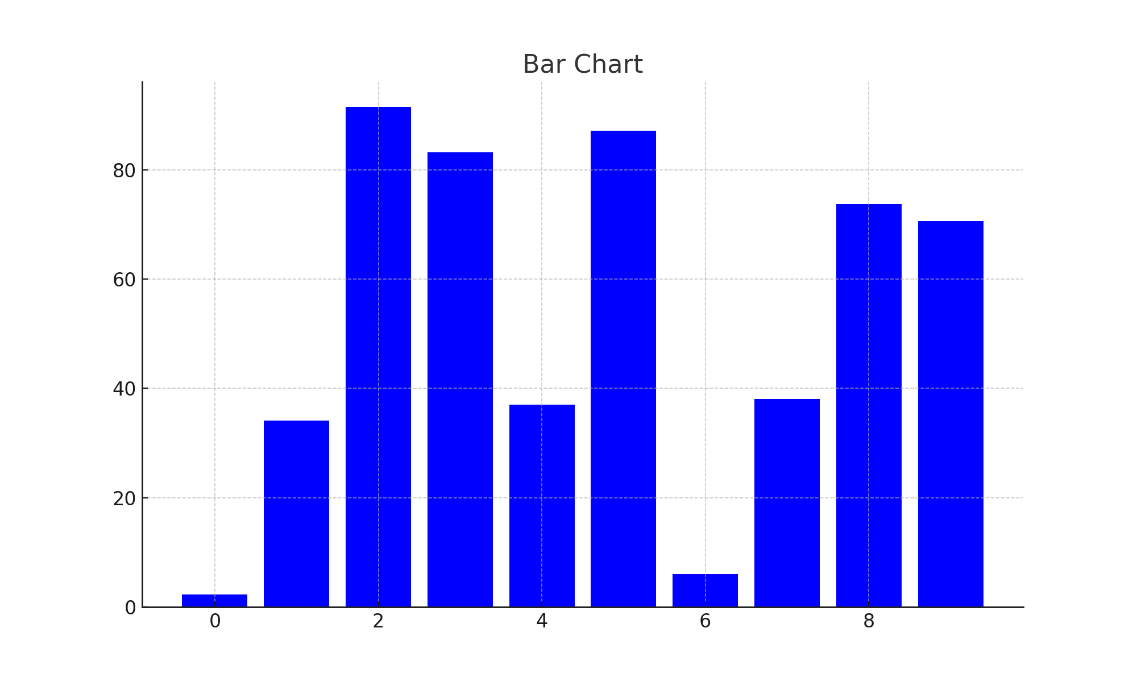

Chart: chart_14_line.png

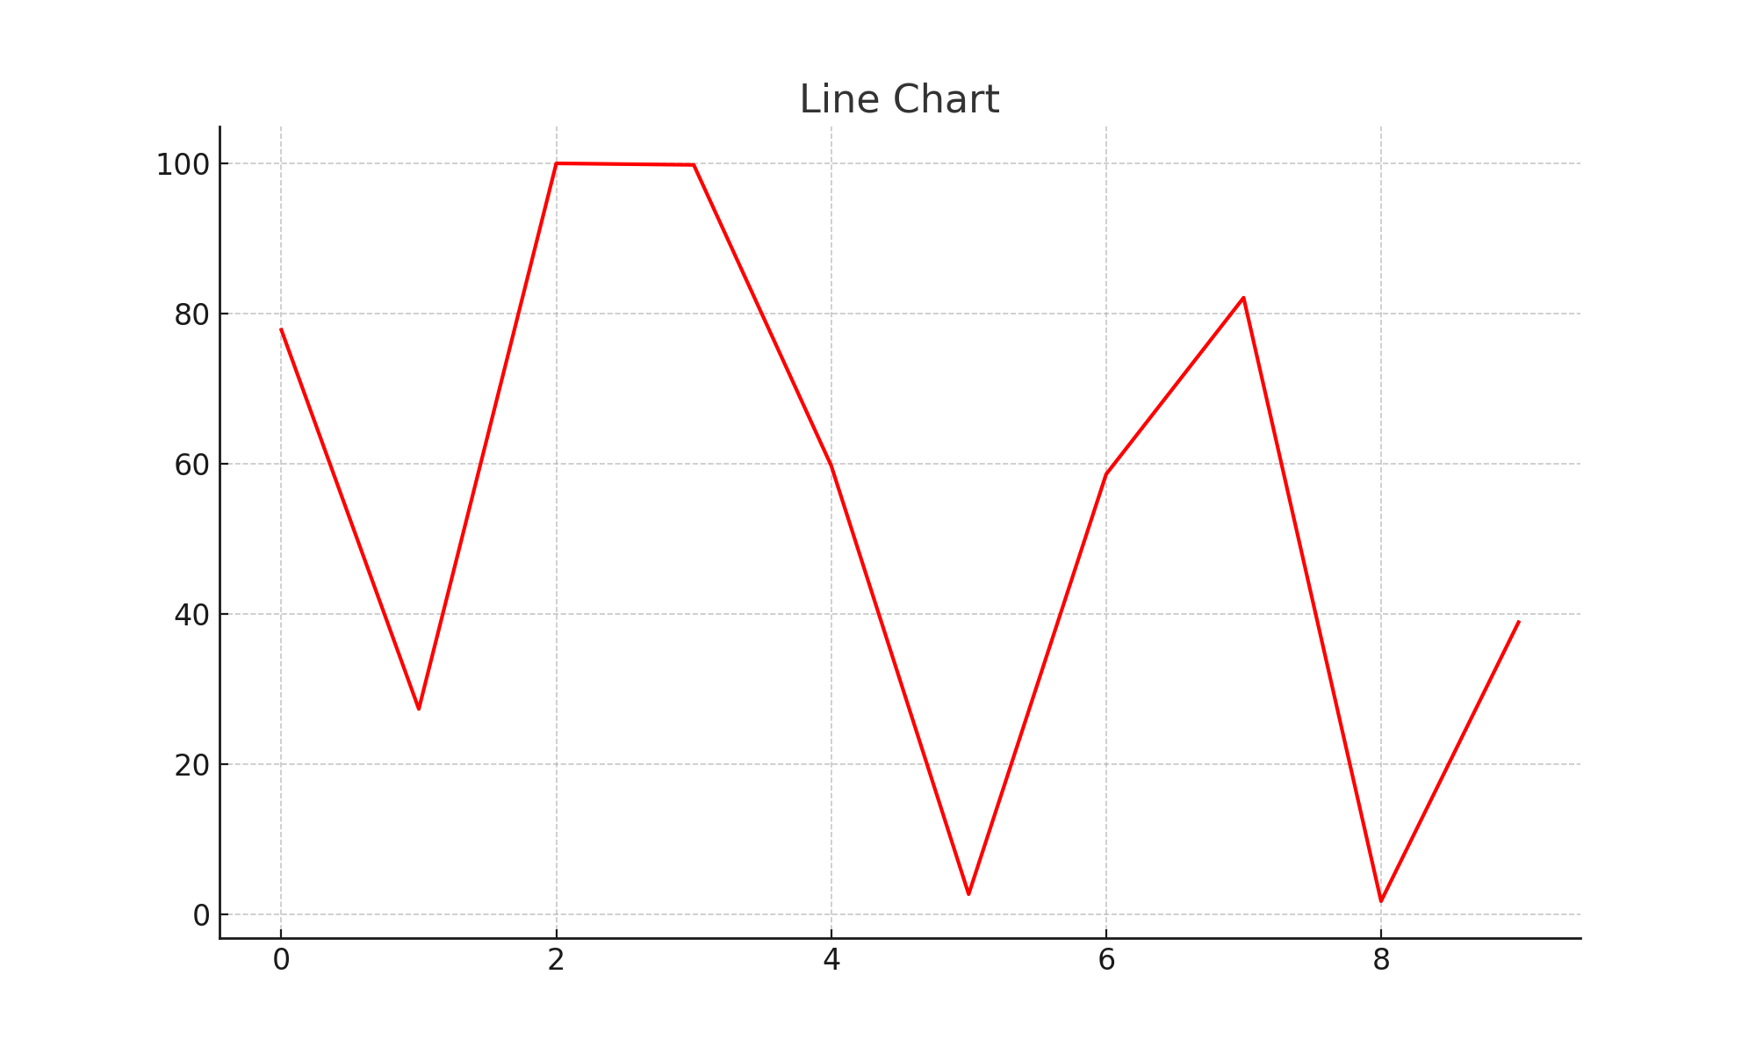

Chart: chart_15_pie.png

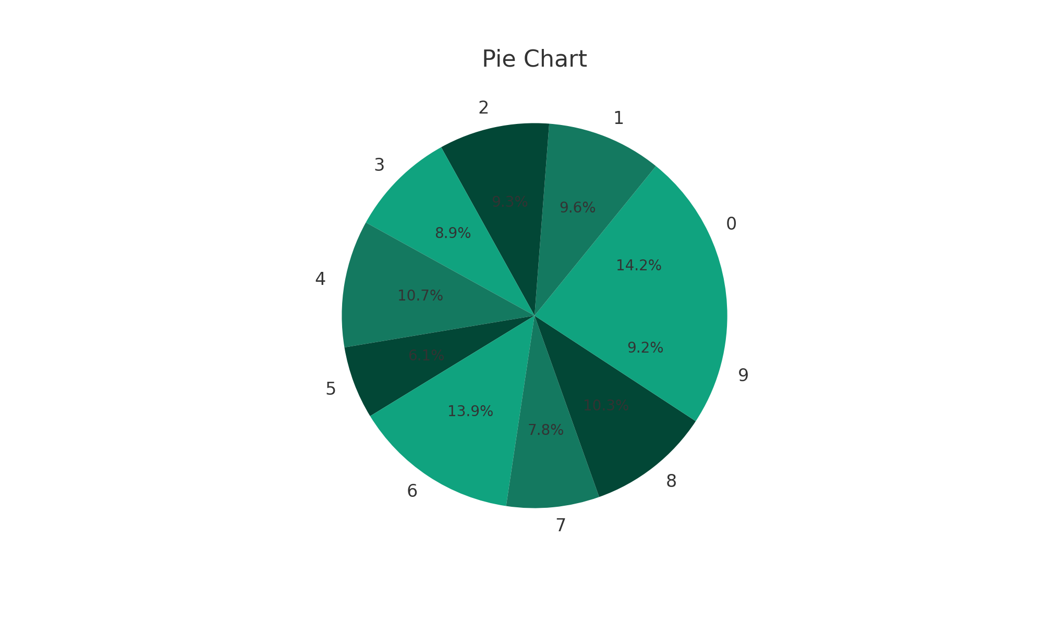

Chart: chart_16_scatter.png

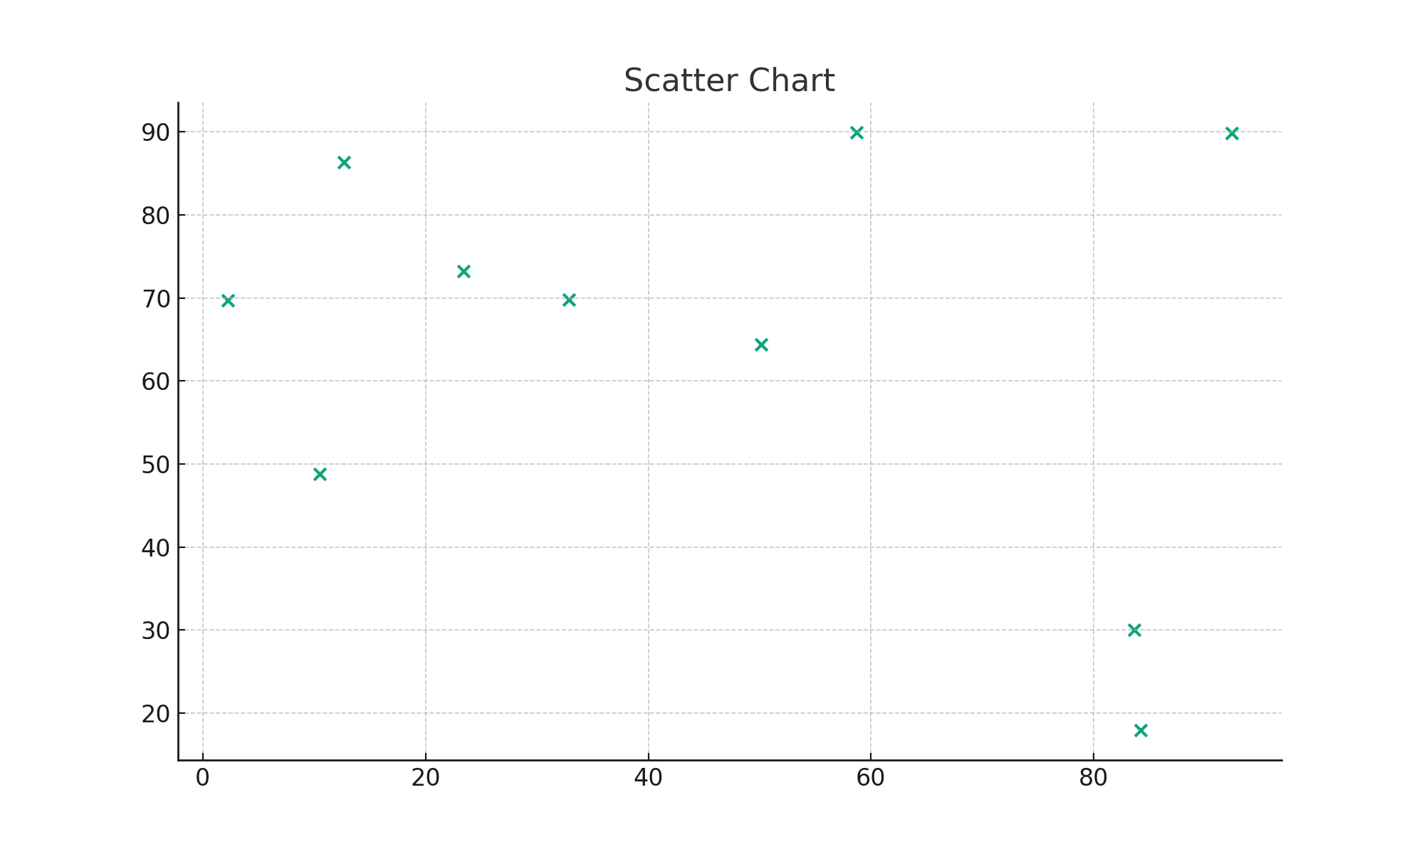

Chart: chart_17_bar.png

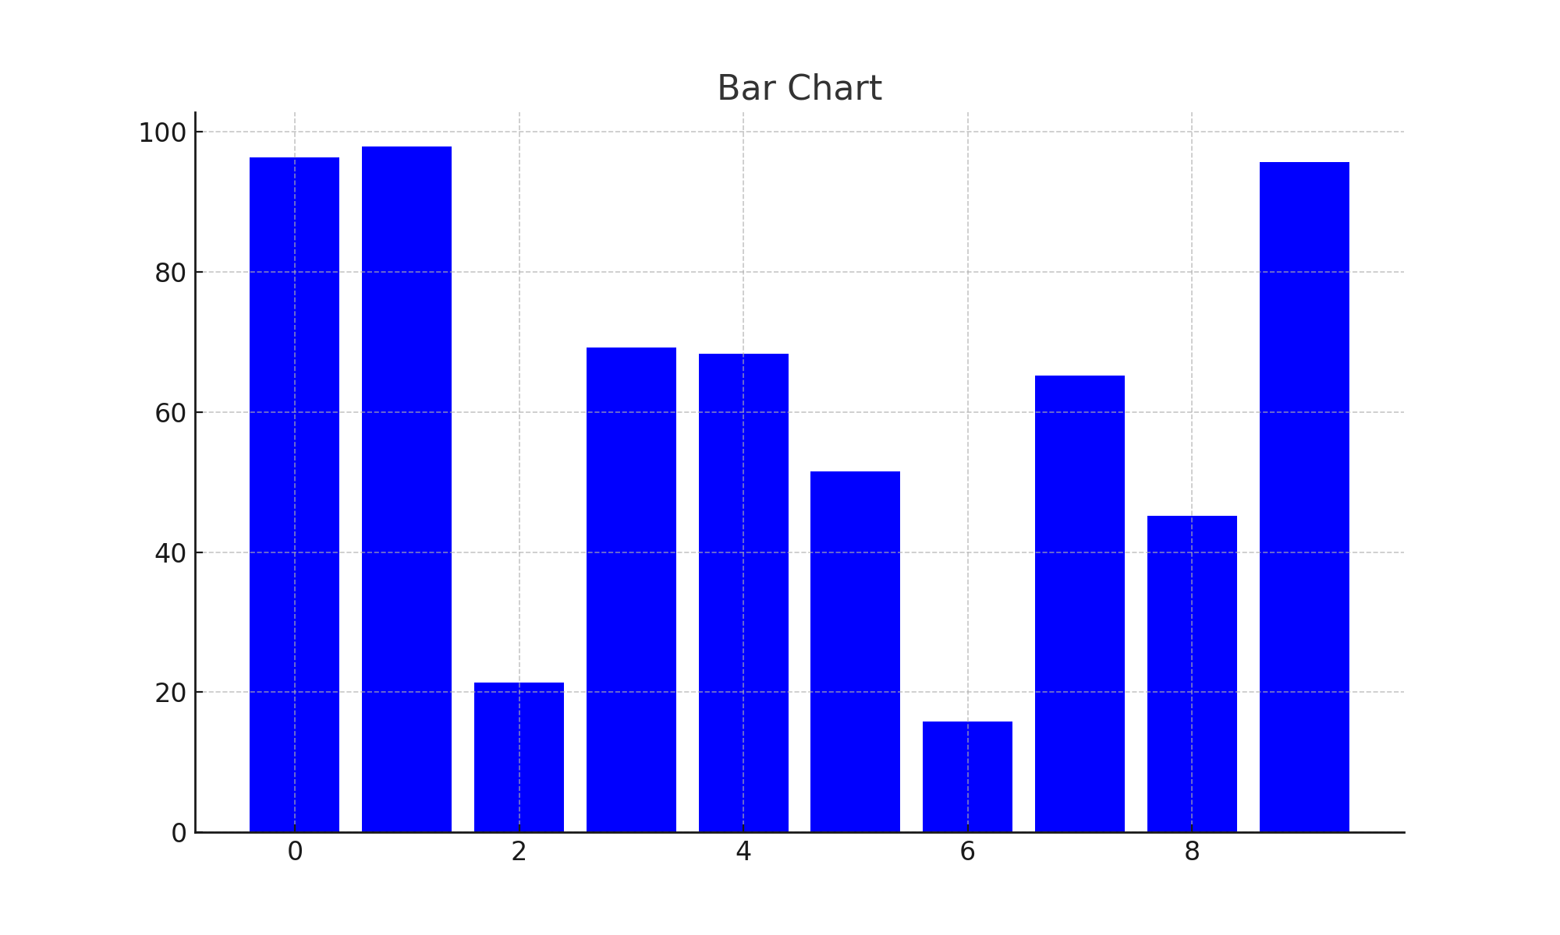

Chart: chart_18_line.png

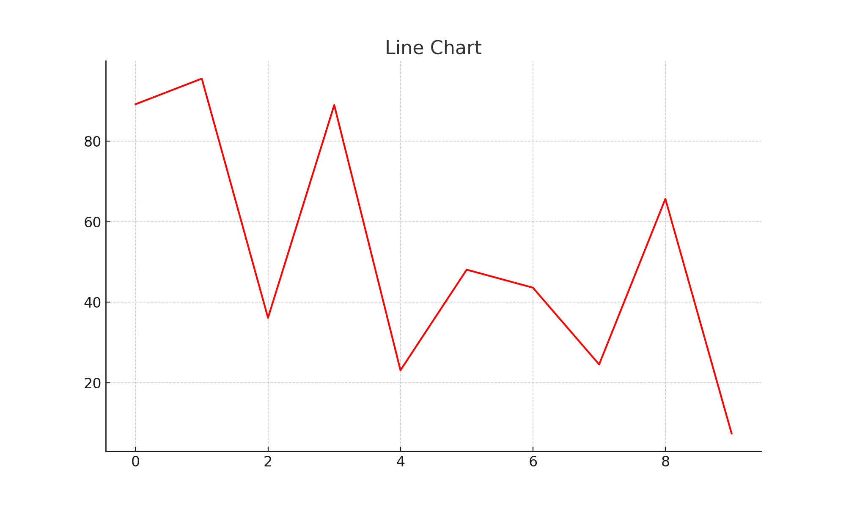

Chart: chart_19_pie.png

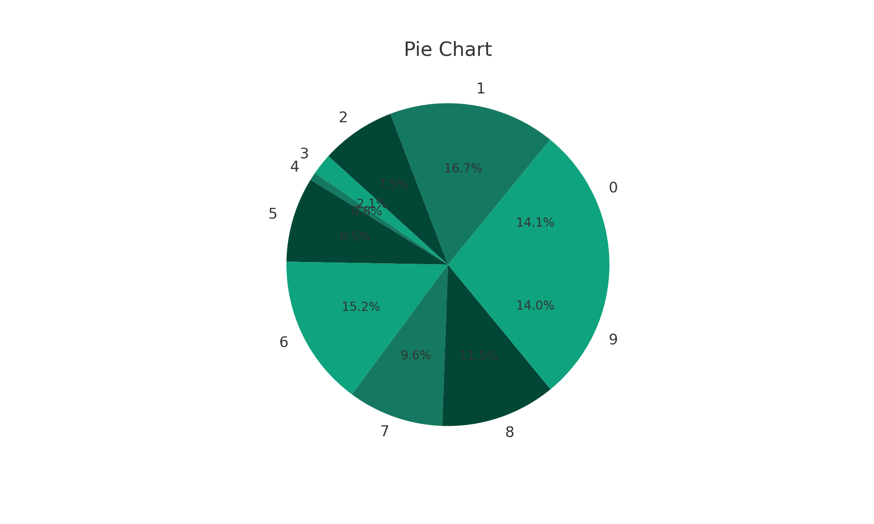

Chart: chart_20_scatter.png

