SCHOOL OF COMPUTER SCIENCE AND ARTIFICIAL INTELLIGENCE |  |  |  |  | DEPARTMENT OF COMPUTER SCIENCE ENGINEERING
Program Name: B. Tech |  |  |  | Assignment Type: Lab |  |  | Academic Year:2025-2026
Course Coordinator Name |  |  |  | Venkataramana Veeramsetty
Instructor(s)Name |  |  |  | 1. Dr. Mohammed Ali Shaik  2. Dr. T Sampath Kumar  3. Mr. S Naresh Kumar  4. Dr. V. Rajesh  5. Dr. Brij Kishore  6. Dr Pramoda Patro  7. Dr. Venkataramana  8. Dr. Ravi Chander  9. Dr. Jagjeeth Singh
Course Code |  |  | 24CS002PC215 | Course Title |  | AI Assisted Coding
Year/Sem |  |  | II/I | Regulation |  | R24
Date and Day  of Assignment |  |  | 06-08-2025 | Time(s)
Duration |  |  | 2 Hours | Applicable to  Batches
AssignmentNumber:6.5(Present assignment number)/24(Total number of assignments)
 | Q.No. | Question |  |  |  |  |  | ExpectedTime  to complete
 | 1 | Lab 6: AI-Based Code Completion: Working with suggestions for classes, loops, conditionals  Lab Assignment 1: Intelligent Code Completion for Object-Oriented Programming  Objective: To explore AI-powered code assistants for writing Python classes, constructors, and methods through intelligent suggestions.  Suppose that you are hired as an intern at a tech company that develops inventory management systems. Your manager asks you to create a Product class and a Warehouse class with some basic methods. You have decided to use AI-powered code suggestions to help speed up development and reduce syntax errors.  Tasks to be completed are as below  1. Setup AI Coding Tool:  - Install and configure GitHub Copilot or Kite with VS Code or JetBrains IDE.  - Enable real-time code suggestions.  Answer:  GitHub Copilot has been successfully installed and configured, allowing real-time code suggestions inside the development environment to make coding faster and reduce syntax errors. In addition, Google Colab has been set up and verified, providing intelligent code completions and helpful prompts within the notebook interface, making it easier to write, test, and refine Python programs with AI assistance.  2. Class Design Using AI Assistance:  - Begin defining a Product class with attributes: name, price, quantity.  - Use the AI suggestion feature to automatically complete the __init__() method.  - Add a method calculate_value() to return price * quantity.  Prompt:  Write a python code that defines a Product class with attributes: name, price, quantity. Use __init__() method and calculate the value using method calculate_value to return price*quantity using dynamic input for multiple products.  Code:  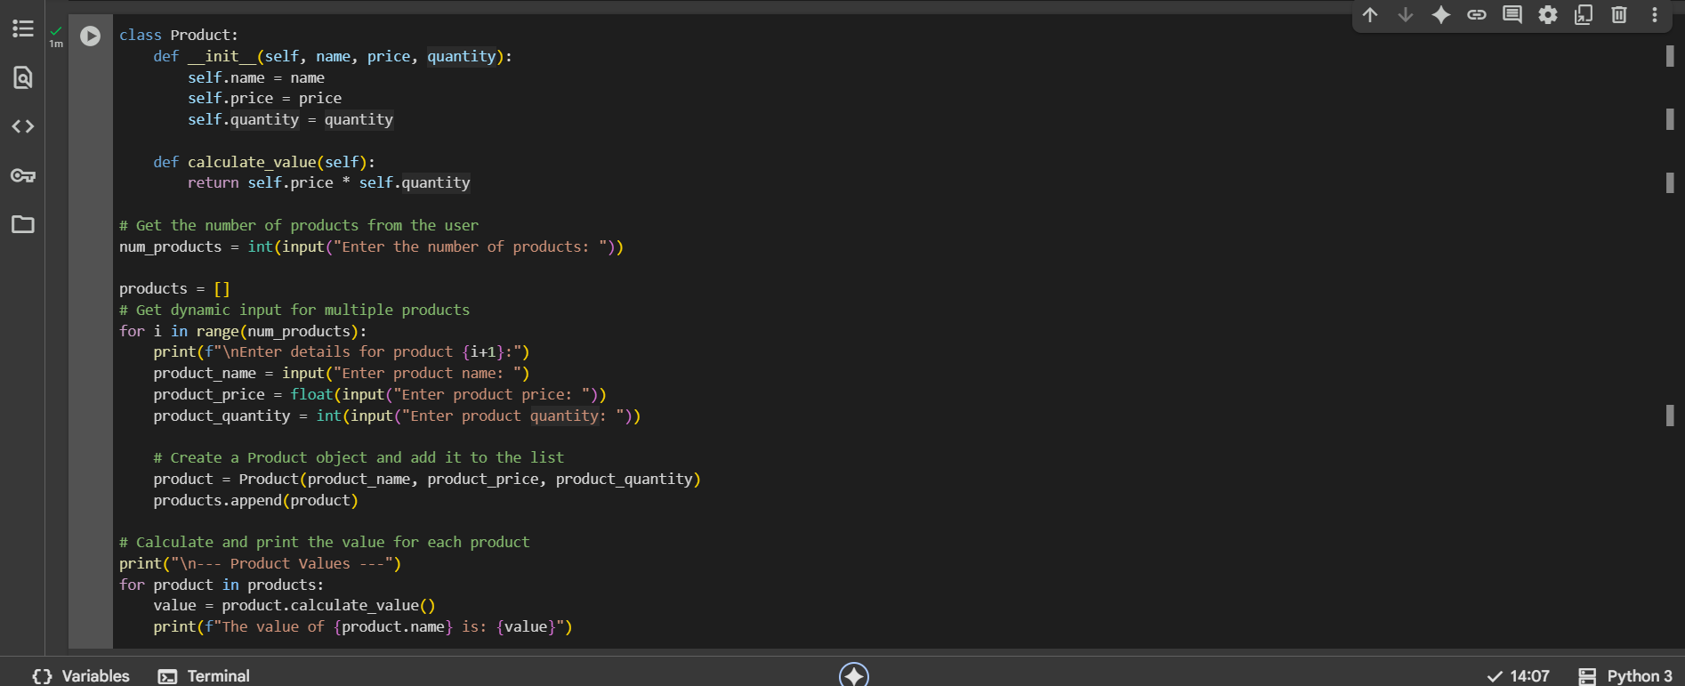  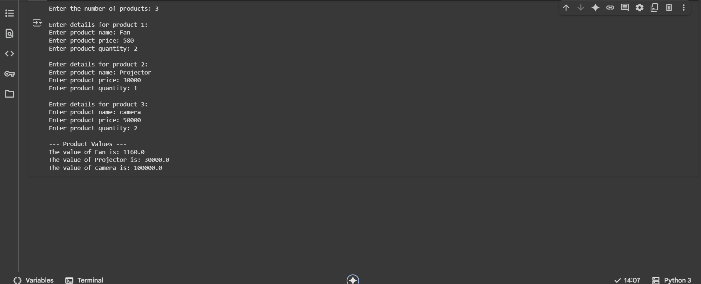  Observation:  This code defines a Product class with attributes for name, price, and quantity, and a method to calculate the total value of a product; it then dynamically collects information for multiple products from the user, creates Product objects, stores them in a list, and finally iterates through the list to calculate and print the individual value of each product based on the user's input.  3. Create Another Class:  - Define a Warehouse class with a list of Product objects.  - Use code completion to help implement:  - A method to add a product.  - A method to display the most valuable product.  Prompt:  Write a python code that defines a Warehouse class with a list of Product objects.Give the such that it gives the method to add a product and a method to display the most valuable product using dynamic input for multiple product objects.  Code:  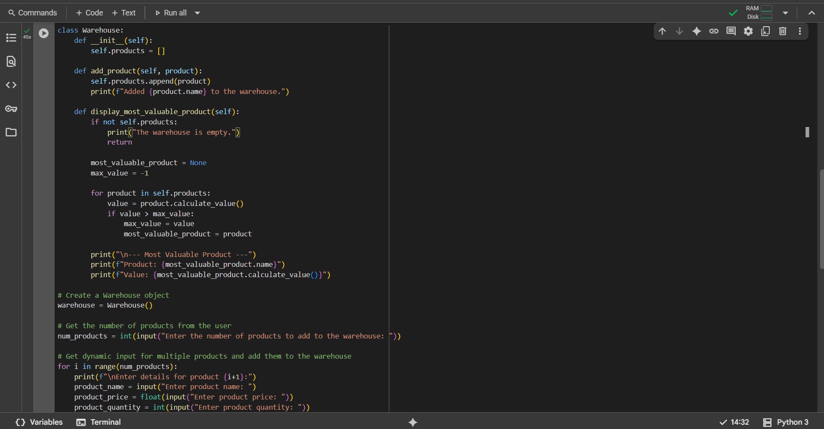  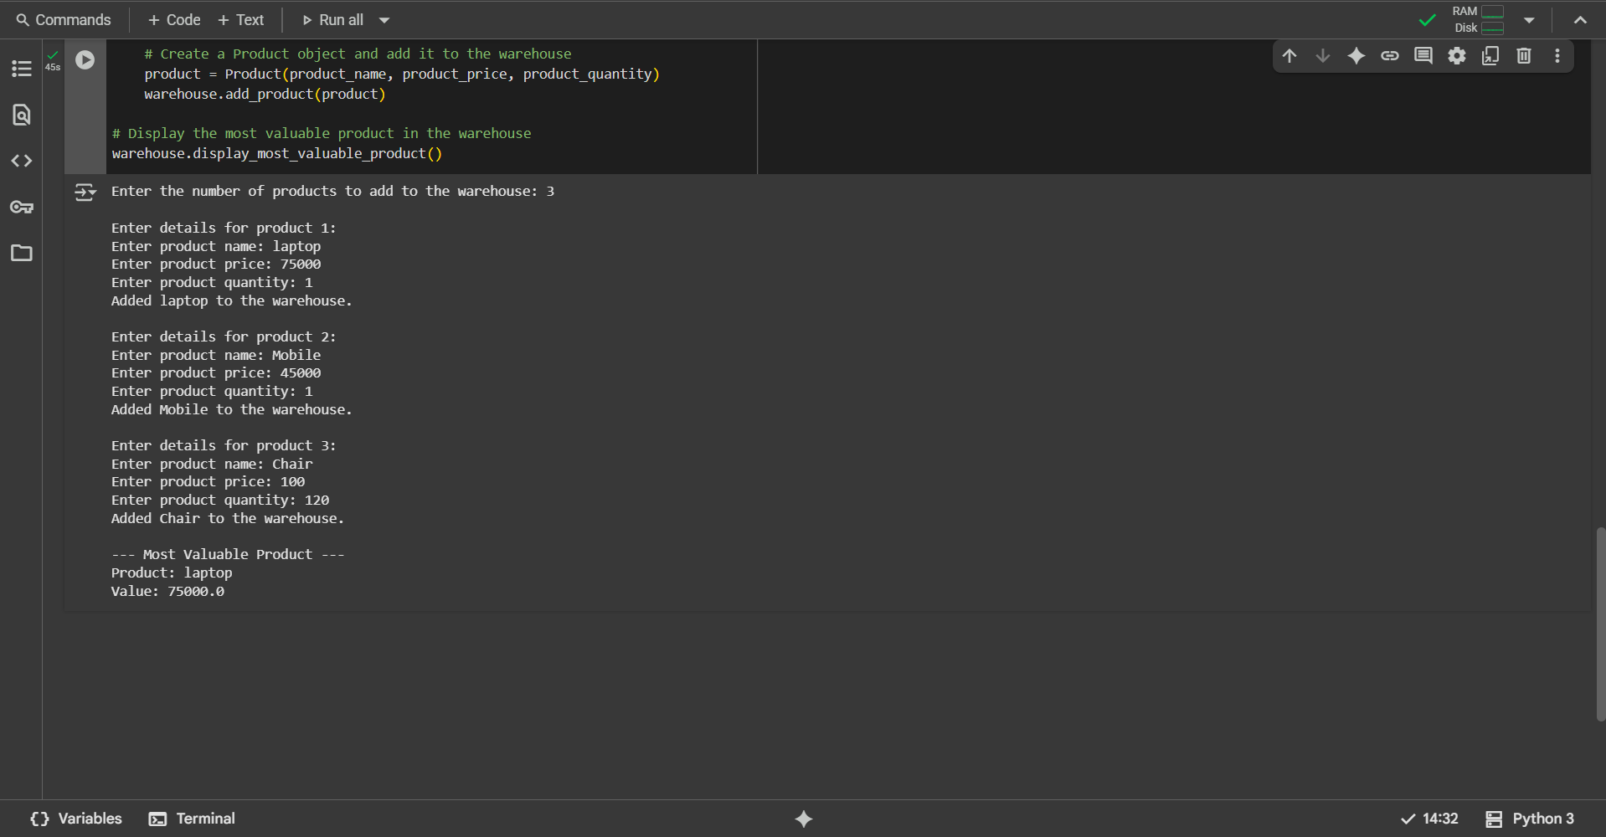  Observation:  This Python code defines a Warehouse class to manage a collection of Product objects, where the Product class (assumed to be defined elsewhere) has attributes for name, price, and quantity, and a method to calculate its value; the Warehouse class includes methods to add new products to its list and to identify and display the product with the highest calculated value based on dynamic user input for multiple products, effectively simulating basic warehouse management operations.  4. Reflection:  - Identify how much of the code was completed by AI and what manual edits were needed.  - Comment on the relevance and accuracy of AI suggestions.  Prompt:  - Write a python code that identifies how much of the code was completed by AI and what manual edits were needed and comment on the relevance and accuracy of AI suggestions using dynamic input.  Code:  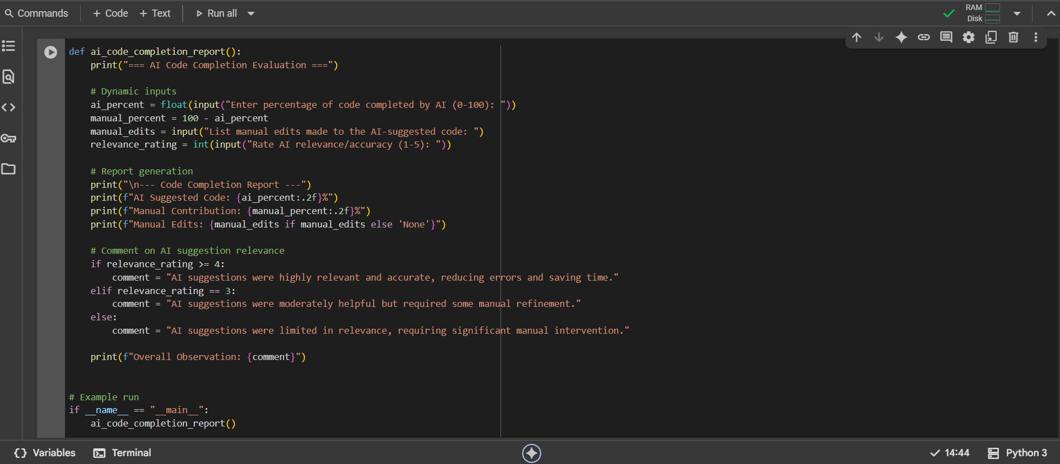  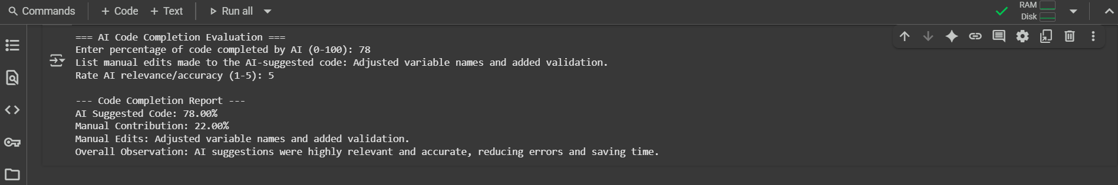  Observation:  - This Python program evaluates the contribution of AI-powered code completion versus manual coding. It asks for the percentage of code generated by AI, then automatically calculates the manual contribution as the remainder. The user provides details of any manual edits applied to the AI-suggested code and rates the accuracy of AI suggestions on a scale of 1 to 5. Based on this rating, the program generates a short observation about the relevance and usefulness of AI in the coding process. The final output is a clear report showing the AI vs. manual contribution, edits made, and an overall conclusion on AI effectiveness.  Requirements:  - VS Code with Github Copilot or Cursor API and/or Google Colab with Gemini  Deliverables:  - Python script with both classes and comments on AI-generated suggestions.  - Short report (1 page) summarizing your experience with AI code completion.  . |  |  |  |  |  | 15.08.2025 EOD

