EVENT MANAGEMENT SYSTEM
9. Software Architecture
Team E7
Saketh Narayanam – PES1UG24CS292 | Neeraj R Gowda – PES1UG24CS295 | Likhith Reddy M – PES1UG24CS282 | N. Adil Ahmed – PES1UG24CS285

Architecture Pattern
The system uses a simple layered client-server architecture. React.js handles the user interface, Node.js/Express.js handles the application and API logic, and the database stores users, events, and registrations. Keeping these parts separate makes the project easier to build and maintain.
Layer | Main Responsibility
Presentation Layer | React components, pages, forms, navigation, validation messages, and responsive user interface.
Application / API Layer | Express.js routes, authentication, authorization, business rules, registration logic, capacity checks, and notification handling.
Data Access Layer | Database queries, models, validation, and persistence of users, events, registrations, and related records.
Database Layer | Stores user accounts, roles, event information, registration records, and report-related data.

Component Diagram
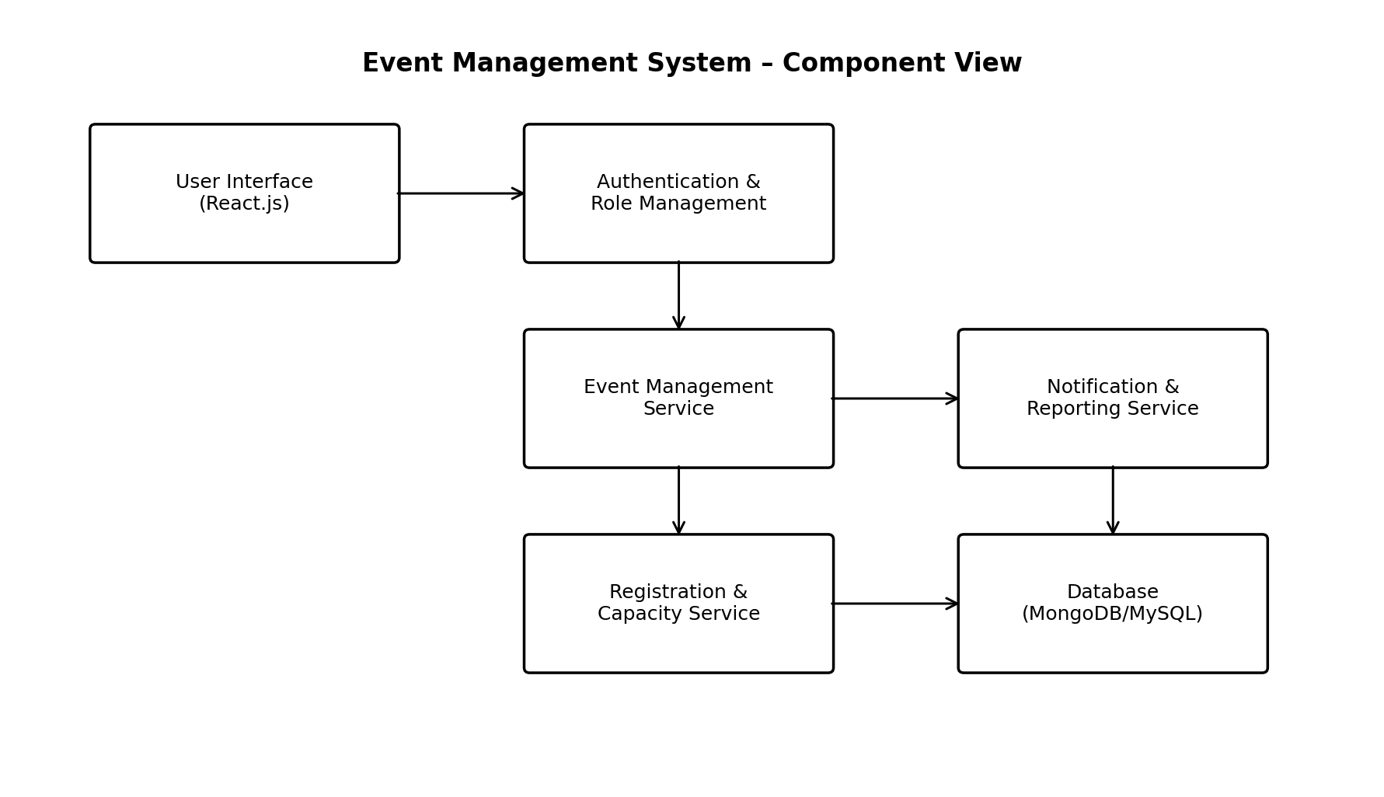
Figure: Component view of the Event Management System
Component Description
Component | Description
User Interface | Provides pages and forms for visitors, attendees, organizers, and administrators.
Authentication & Role Management | Handles login, password verification, sessions/tokens, and role-based access.
Event Management Service | Creates, edits, cancels, searches, filters, and retrieves event information.
Registration & Capacity Service | Creates registrations, checks capacity, prevents duplicates, and handles cancellation.
Notification & Reporting Service | Sends event updates, exposes registration information, and supports registration/report generation.
Database | Persists users, roles, events, registrations, and other application records.

Architecture Traceability
Requirement Area | Architecture Component
FR-01 / Authentication | Authentication & Role Management
FR-02 / FR-03 Event discovery and details | User Interface + Event Management Service
FR-04 / FR-05 Registration and capacity | Registration & Capacity Service
FR-06 Registered events | User Interface + Registration & Capacity Service
FR-07 / FR-08 Organizer management | User Interface + Event Management Service + Registration & Capacity Service
FR-09 Event updates and registration information | Notification & Reporting Service
FR-10 Registration reports | Notification & Reporting Service
FR-11 Administration | User Interface + Authentication & Role Management + Event Management Service
NFR-01 / NFR-02 Performance | Application / API Layer + Database Layer
NFR-03 / NFR-04 Security | Authentication & Role Management + Security Controls
NFR-05 / NFR-06 / NFR-07 Quality | Presentation + Application + Data Access Layers

Security Architecture
1. Authentication is handled at the API boundary before protected operations are executed.
2. Authorization checks the user's role before organizer or administrator operations are allowed.
3. Passwords are stored using secure hashing rather than readable text.
4. Input validation is applied at both the user-interface and server layers where appropriate.
5. Database access is isolated behind the application/data-access layer rather than exposed directly to the browser.
6. Sensitive operations should be logged where appropriate for accountability and troubleshooting.
The architecture separates presentation, application/API, data-access, and database responsibilities. Authentication and authorization are applied before protected organizer and administrator operations. Reporting is treated as part of the Notification & Reporting Service so that FR-09 and FR-10 have explicit architectural ownership.

