EVENT MANAGEMENT SYSTEM
10. Detailed Design
Team E7
Saketh Narayanam – PES1UG24CS292 | Neeraj R Gowda – PES1UG24CS295 | Likhith Reddy M – PES1UG24CS282 | N. Adil Ahmed – PES1UG24CS285

Design Overview
The detailed design focuses on the main interactions between the user interface, API layer, and database.
Sequence Diagram 1 – User Login
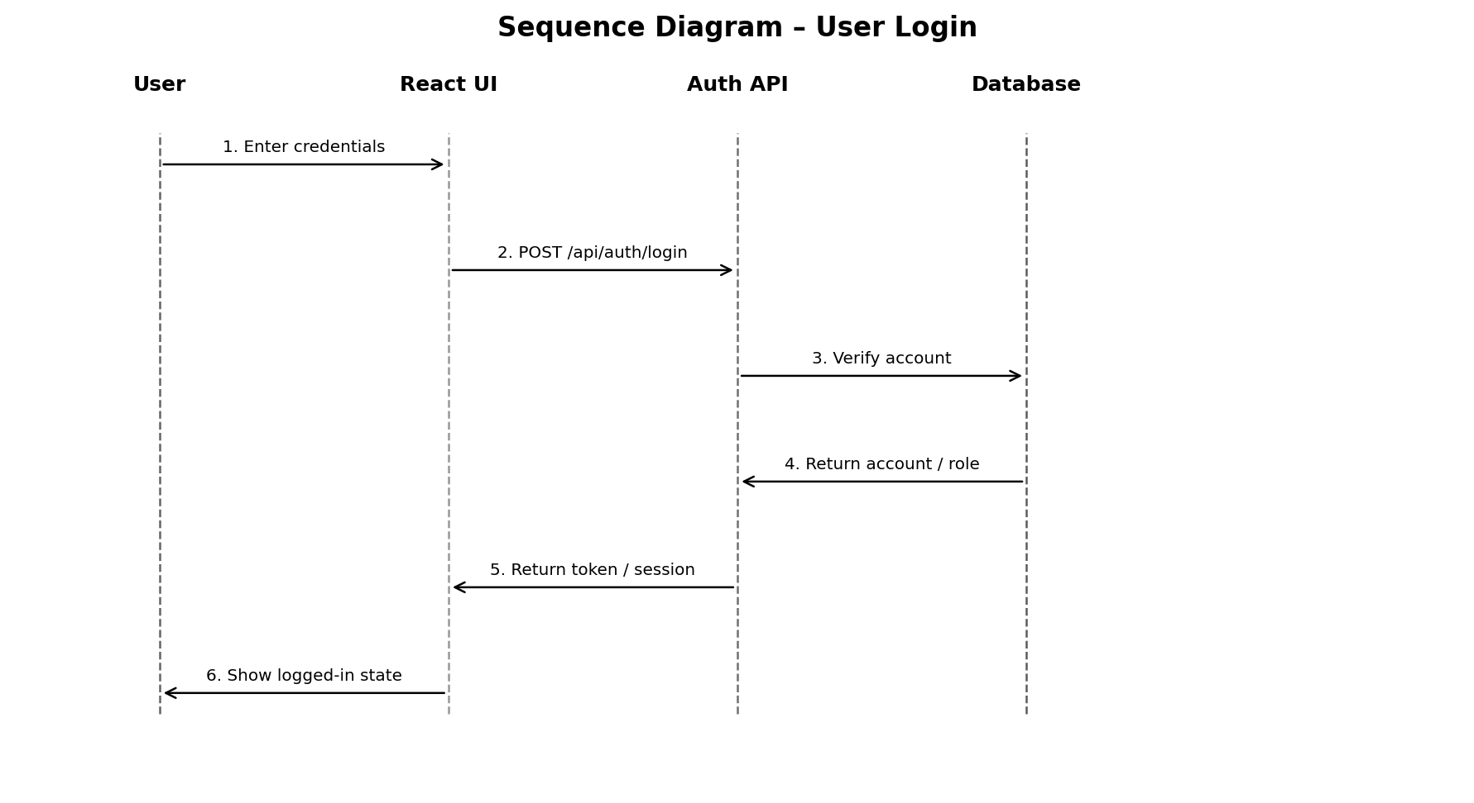
Figure: Sequence Diagram for User Login
Sequence Diagram 2 – Event Registration
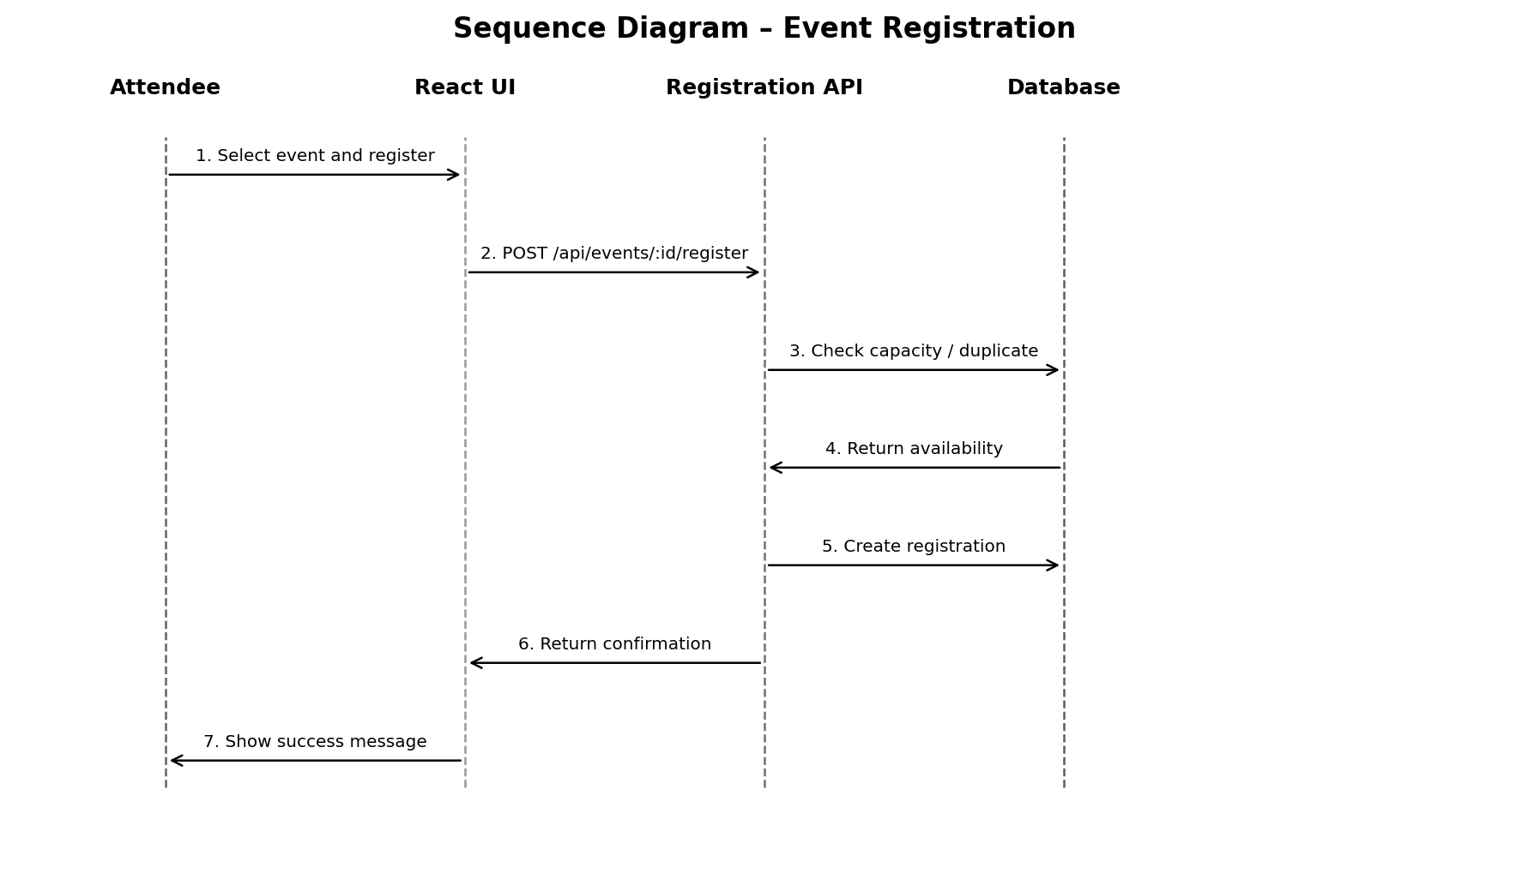
Figure: Sequence Diagram for Event Registration
Registration Sequence – Validation Conditions
• The API verifies that the user is authenticated before registration is attempted.
• The event is checked for existence and availability.
• The current registration count is compared with the configured event capacity.
• The system checks whether the user already has a registration for the event.
• Only after all checks pass is the registration created and confirmation returned.
• If any validation fails, the API returns an appropriate error and does not create an invalid registration.
The login sequence primarily supports FR-01, SEC-01, SEC-02, and SEC-04. The event-registration sequence supports FR-04, FR-05, FR-06, NFR-02, and NFR-06.

