EVENT MANAGEMENT SYSTEM
7. UML Use Case Diagram
Team E7
Saketh Narayanam – PES1UG24CS292 | Neeraj R Gowda – PES1UG24CS295 | Likhith Reddy M – PES1UG24CS282 | N. Adil Ahmed – PES1UG24CS285

UML Use Case Diagram
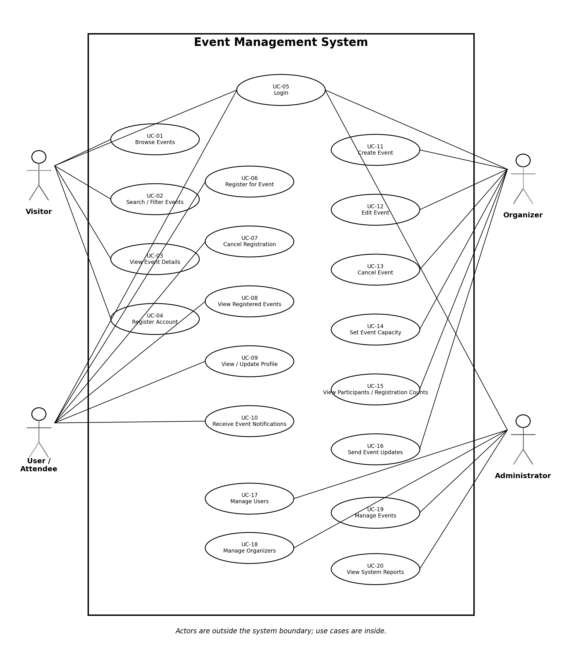
Figure: UML Use Case Diagram for the Event Management System
The diagram shows the actors outside the system boundary and the main use cases inside it. The roles are Visitor, User / Attendee, Organizer, and Administrator.

