EMBEDDED SYSTEMS CASE STUDY
STM32-Based Knock Pattern Smart Door Lock
Keyless access using accelerometer-based knock rhythm analysis
Students | V. Saketh (CB.SC.U4CSE24558)  Y. Jothi Basu (CB.SC.U4CSE24559)  T. Rohit Reddy (CB.SC.U4CSE24551)  T. Kumar (CB.SC.U4CSE24552)  Vageesh Raj V S (CB.SC.U4CSE24554)
Mentor | Dr. A. Baskar
Course | 23CSE304 – Embedded Systems
Department | Computer Science and Engineering
Institution | School of Computing, Amrita Vishwa Vidyapeetham, Coimbatore, India
1. Problem Statement
Physical keys, PINs and cards can be lost, copied or shared, and conventional locks do not alert the owner after a failed attempt. This project offers a keyless alternative: the door opens only when the owner knocks a secret rhythm on the door or a wooden pad.
2. Objectives
- Build a smart door lock on the STM32F401CCU6 (Black Pill) microcontroller.
- Detect knocks with an ADXL345 accelerometer over I²C.
- Recognise a secret pattern from the knock count and the gaps between knocks.
- Unlock a latch with an SG90 servo driven by PWM, and show the result on a 16×2 I²C LCD.
- Send status and rejection alerts to a phone through HC-05 Bluetooth.
- Provide a push button for mode toggle and manual input.
3. Proposed Solution
An STM32F401CCU6 reads an ADXL345 accelerometer, counts the knocks, measures the gaps between them with a hardware timer, and compares the sequence with the stored pattern. A 10 kΩ potentiometer on the ADC sets the knock threshold. A correct pattern moves the servo to unlock the latch, and an incorrect pattern keeps the door locked. The result appears on the LCD and is sent to the phone over Bluetooth.
4. System Working
- Power on: the sensor, LCD, USART, ADC, timer and GPIO are initialised.
- The ADXL345 detects knocks; the potentiometer sets the detection threshold.
- The firmware records the knock count and the gap timing.
- The recorded sequence is compared with the stored pattern.
- Correct pattern: the LCD shows ACCESS GRANTED and DOOR UNLOCKED, the servo unlocks the latch, and the phone receives a status message.
- Incorrect pattern: the LCD shows ACCESS DENIED and DOOR LOCKED, the servo stays locked, and the phone receives a rejection alert. The system then returns to monitoring.
5. Circuit Design
The circuit uses one shared I²C bus for the ADXL345 and the LCD, a 10 kΩ potentiometer for sensitivity, a push button for mode toggle, an HC-05 Bluetooth module on USART2, and an SG90 servo on a PWM timer channel. The power rails are kept separate: a regulated 5V 2A supply drives the servo, and all grounds are common.
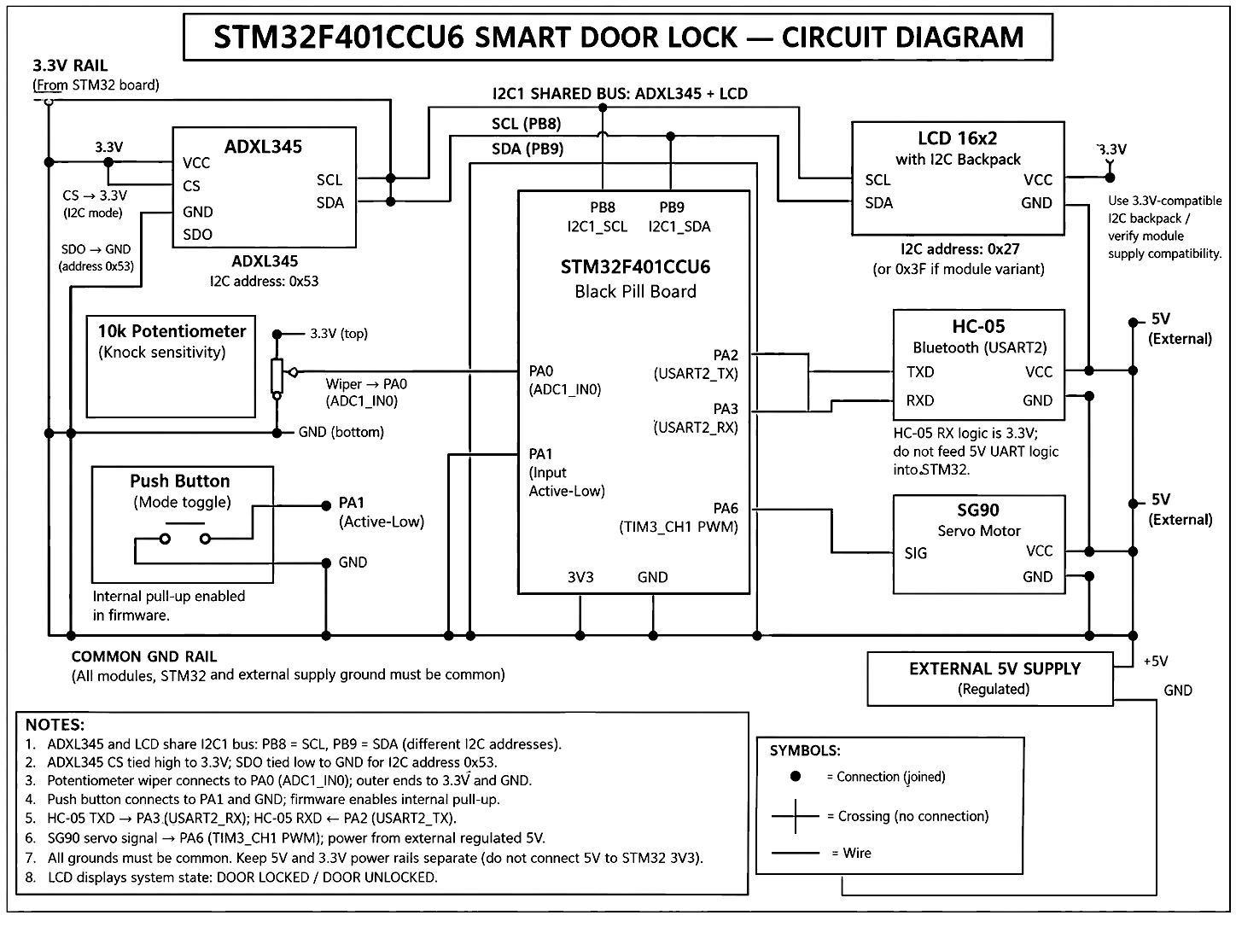
Figure 1. Circuit diagram of the STM32F401CCU6 smart door lock
6. Pin Mapping
Pin | Function | Peripheral | Connects to
PB8 | I2C1 SCL | I²C1 | ADXL345 SCL and LCD SCL (shared bus)
PB9 | I2C1 SDA | I²C1 | ADXL345 SDA and LCD SDA (shared bus)
PA0 | ADC1_IN0 | ADC | 10 kΩ potentiometer wiper
PA1 | GPIO input, active-low | GPIO | Push button to GND (internal pull-up)
PA2 | USART2_TX | USART2 | HC-05 RXD
PA3 | USART2_RX | USART2 | HC-05 TXD
PA6 | TIM3_CH1 PWM | Timer / PWM | SG90 servo signal
The ADXL345 uses I²C address 0x53 (CS tied to 3.3V, SDO tied to GND), and the LCD uses address 0x27. The LCD backpack must be 3.3V-compatible, and the HC-05 receiver is 3.3V logic.
7. Prototype
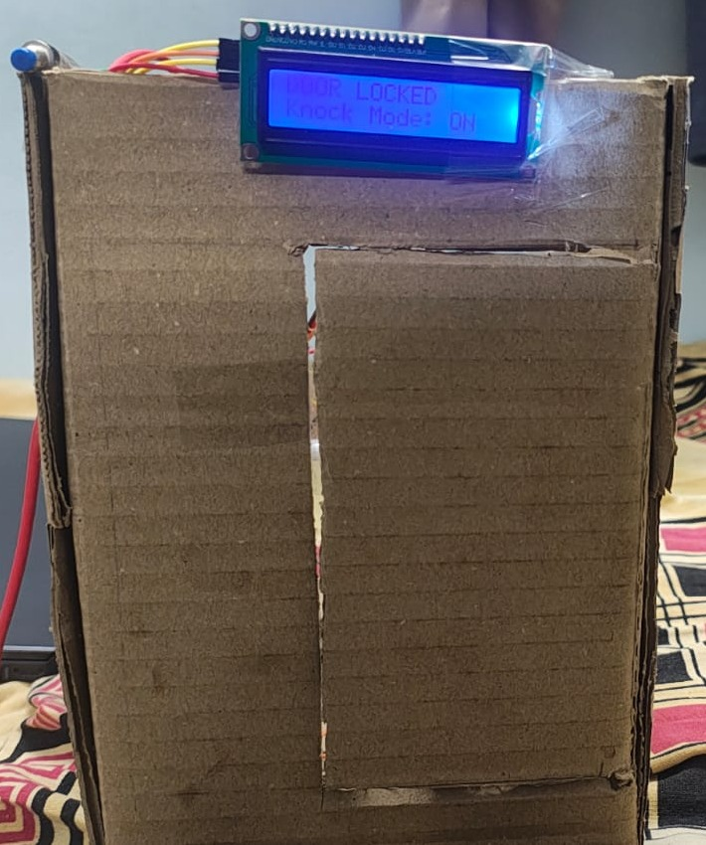  Figure 2. Door model: LCD shows DOOR LOCKED and Knock Mode ON | 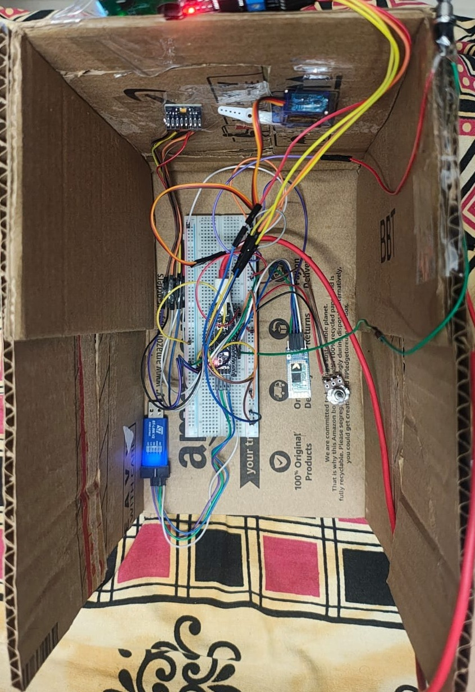  Figure 3. Interior: breadboard, STM32F401, HC-05, ST-LINK V2, potentiometer and servo
8. Testing Plan
- Correct pattern: 20 attempts with the stored pattern; the door should unlock on every attempt.
- Wrong pattern: 20 attempts with near-miss counts and gaps; the door should stay locked on every attempt.
- Sensitivity: soft, medium and hard knocks at each potentiometer setting.
- Timing tolerance: gaps varied by ±50 ms and ±100 ms.
- Bluetooth range: status messages received at 1 m, 5 m and 10 m.
- Servo reliability: 20 lock and unlock cycles with full latch travel.
Results will be recorded during testing. No measured figures are claimed in this document.
9. Limitations and Future Work
Limitations: the knock rhythm can be overheard, the pattern is stored in firmware, HC-05 traffic is unencrypted, and the cardboard model and hobby servo suit only a demonstration.
Future work: store an owner-set pattern in flash memory, add a lockout after repeated failed attempts, move to an encrypted Bluetooth LE link, and use ADXL345 interrupts to reduce polling.
10. Acknowledgement
We sincerely thank our mentor, Dr. A. Baskar, for academic guidance throughout this case study carried out under 23CSE304 – Embedded Systems, Department of Computer Science and Engineering, School of Computing, Amrita Vishwa Vidyapeetham, Coimbatore, India.

