
Web Application Development
Assignment-2

Name: Lakshmi Saketh Chebrolu
Student ID: 101734216

In this I have created a web application through which we can make shopping online and also Managers can manage the Inventory of the system.

Folder Structure in ESP:
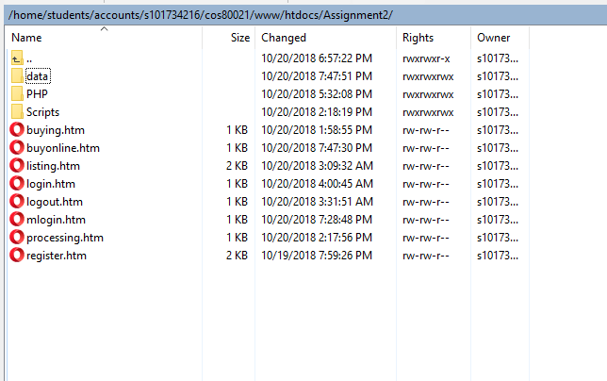

Data Folder: In this I am having the data files (manager.txt, goods.xml, customer.xml)
PHP: In this folder I am having all the PHP files.
Scripts: In this folder I am having all the JavaScript files.
Login For Customer:
Provide the proper credentials to login.
Sample credentials:
Email: saketh@gmail.com Password: test
Email: saketh2@gmail.com Password: test
Email: saketh3@gmail.com Password: test
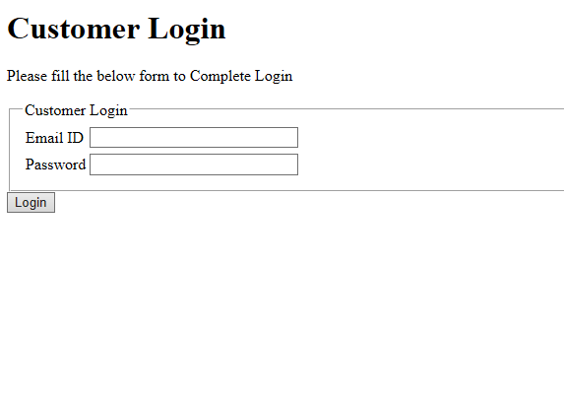
Login For Manager:
Provide the proper credentials to login.
Sample credentials: Note( Below L is capital and S is capital)
Username: Lakshmi Password: Saketh
Username: Meghana Password: Teja

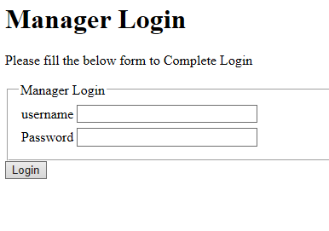
Tasks Cannot perform:
Alert “Sorry, this item is not available for sale”. This alert message I am unable to display.

