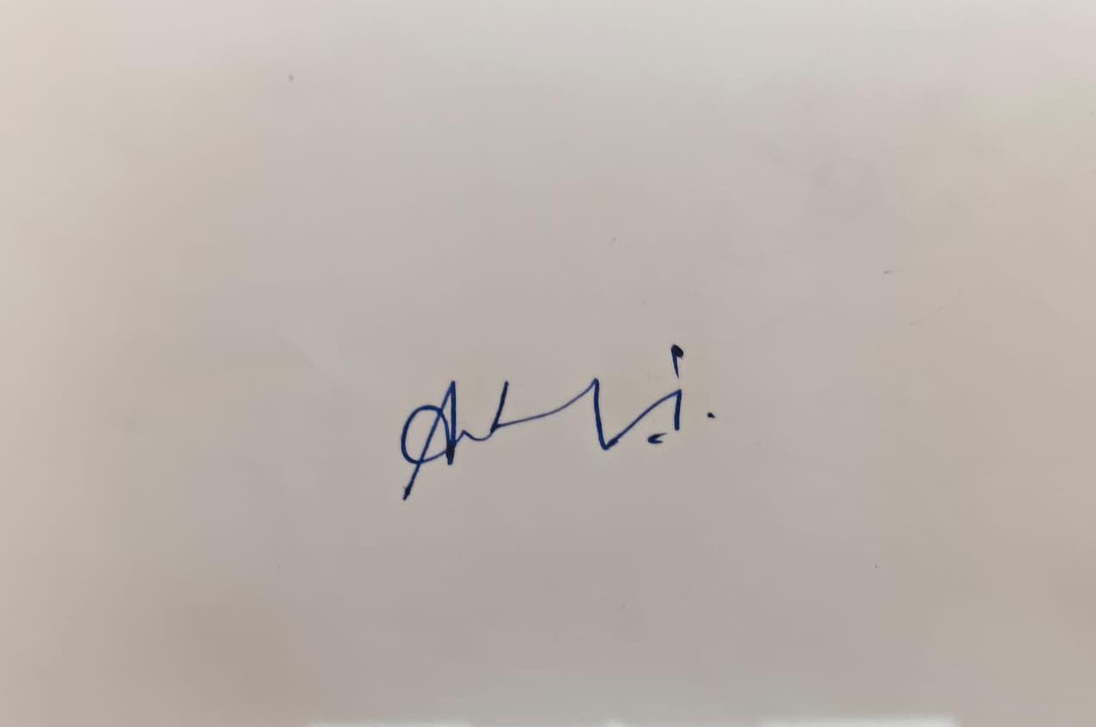
MORNING NPTEL (FN) |  | National Programme on Technology Enhanced Learning |  |  |  |  |  |  |  |  |  |  | 
Hall Ticket For |  | SEM1NOC25: CS44 Introduction To Internet Of Things - Online
Candidate Name | Andol Saketh |  |  |  |  |  |  |  |  |  |  | 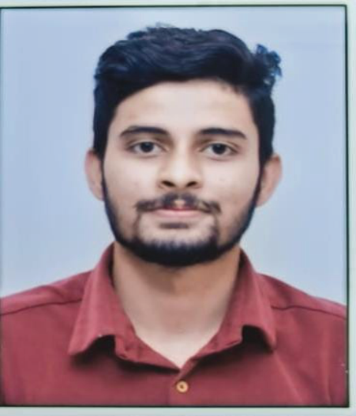
Roll No | NOC25CS44S147500342 |  |  |  |  |  | Seating Number |  |  | 47500342
Date of Birth | 18-01-2005
PwD Status | No |  | Compensatory Time Required |  |  | No |  | Scribe Required |  |  | No
Exam Date | Friday, 25 April, 2025
Reporting Time | 08:00 am |  |  |  | Gate Closure |  |  |  | 09:30 am
Exam Timing | 09:00 am |  |  |  | Shift |  |  |  | FN
Test Centre Name | Lovely Professional University- Entry Block - 28 |  |  |  |  |  |  |  |  |  |  | (Signature of  Candidate)
Test Centre Address | Jalandhar- Delhi G.T. Road, NH- 1, , Phagwara, Punjab, India - 144411
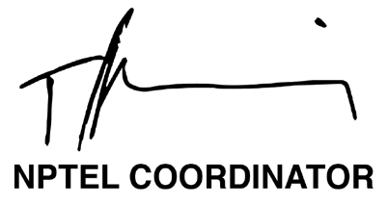 |  |  |  | 
NPTEL EXAM - 25 APRIL, 2025
General instructions for candidates - FN
(All timings mentioned here are in IST)
The total duration of the examination is 180 minutes.

Candidates will be permitted to leave the examination hall only after 10:30 am, on a need basis.
Hall ticket and Entry:
1. The Hall Ticket must be presented for verification along with one original photo identification (not photocopy or scanned copy). Examples of acceptable photo identification documents are School ID, College ID, Employee ID, Driving License, Passport, PAN card, Voter ID, and Aadhaar-ID. A printed copy of the hall ticket and original photo ID card should be brought to the exam centre. Hall ticket and ID card copies on the phone will not be permitted.
2. This Hall Ticket is valid only if the candidate’s photograph and signature images are legible. To ensure this, print the Hall Ticket on A4-sized paper using a laser printer, preferably a color photo printer.
3. TIMELINE: 8:00 am - Report to the examination venue | 8:40 am – Candidates will be permitted to occupy their allotted seats| 8:50 am – Candidates can login and start reading instructions prior to the examination | 9:00 am - Exam starts | 9:30 am - Gate closes, candidates will not be allowed after this time | 10:30 am Submit button will be enabled | 12:00 pm exam ends.
P.T.O.

4. Candidates will be permitted to appear for the examination ONLY after their credentials are verified by center officials.
5. Candidates are advised to locate the examination center at least a day prior to the examination, so that they can reach the
center on time for the examination.
STATIONERY REQUIREMENTS:
• A4 sheets will be provided to candidates for rough work. Candidates have to write their name and registration number on the
A4 Sheets before they start using it. The A4 sheets must be returned to the invigilator at the end of the examination.
• On-screen calculator will be available during the exam. Candidates are advised to familiarize themselves with this virtual
Scientific calculator well ahead of the exam.
Link: https://www.tcsion.com/OnlineAssessment/ScientificCalculator/Calculator.html
• You should bring your own pen/pencil; it will NOT be given at the examination centre.
DRESS CODE:
• Candidates are expected to come in professional attire to write the exams.
• Candidates wearing SHORTS will NOT be permitted inside the exam hall.
PERMITTED:
• You may bring non-electronic vehicle keys inside the exam hall.
• You are advised to carry your own drinking water in a transparent bottle.
• Candidates are allowed to bring sanitizer in a small transparent bottle.
NOT PERMITTED:
• Watches, wallets, mobile phones, Bluetooth devices, microphones, pagers, health bands or any other electronic gadgets, any
printed/blank/handwritten paper, log tables, writing pads, scales, geometry/pencil-boxes, pouches, calculators, pen drives,
electronic pens, handbags, goggles, electronic vehicle keys or similar such items are NOT allowed inside the examination
centre. There may not be any facility for the safekeeping of these devices outside the examination hall; it will be prudent not
to bring valuables to the examination center. Candidates will not be permitted to carry any food items in the exam centre. We
suggest that you bring a bag to keep routine belongings outside the exam hall. Neither NPTEL nor the exam provider takes
responsibility for the bag and the belongings. You may keep it outside at your own risk.
MANDATORY :
• Hall tickets have to be returned to the invigilator before leaving the exam hall. No paper can be taken out of the exam hall.
• Press the SUBMIT button on the computer after you have completed the exam.
IMPORTANT:
• A basic code of conduct during the exam should be followed, failing which, NPTEL reserves the right to take appropriate action.
• In case the exam is delayed due to any unforeseen circumstances, NPTEL will decide on the appropriate course of action as it
deems fit.
AT THE EXAM CENTRE, IF YOU ENCOUNTER ANY ISSUES WITH RESPECT TO THE COMPUTER OR EXAM OFFICIALS,
KINDLY CONTACT THE NPTEL EXAM REPRESENTATIVE, WHO WILL BE AVAILABLE AT THE CENTRE.
I HEREBY ACKNOWLEDGE THAT I HAVE READ, UNDERSTOOD AND AGREE TO FOLLOW THE ABOVE MENTIONED
INSTRUCTIONS.

Signature of the Candidate

