Andol Saketh
12221210
SET B
1. write a recursive function sumNatural(n:int):Int in Scala to calculate the sum of the first n natural numbers
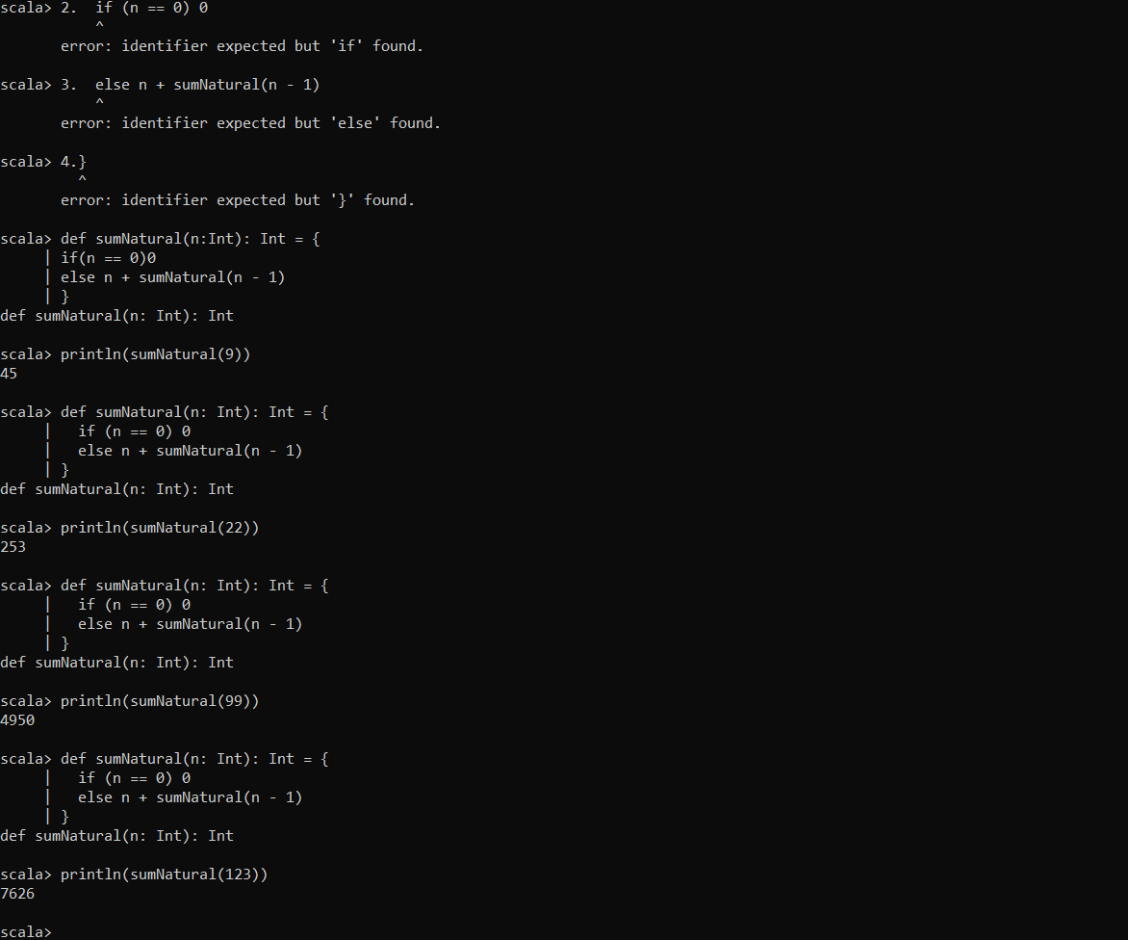

2. You are given to RDD pf key -value pairs representing product sales in a store :
[(“Laptop”,3) , (“Phone”,5),(“Tablet”,2),(“Laptop”,4),(“Phone”,1)]
Write a spark program in Scala to :
A.Use reduceBy key to calculate the total quantity sold for each product
B.Filter out products with total sales less than 5.
C.Display the remaining products with their total sales
