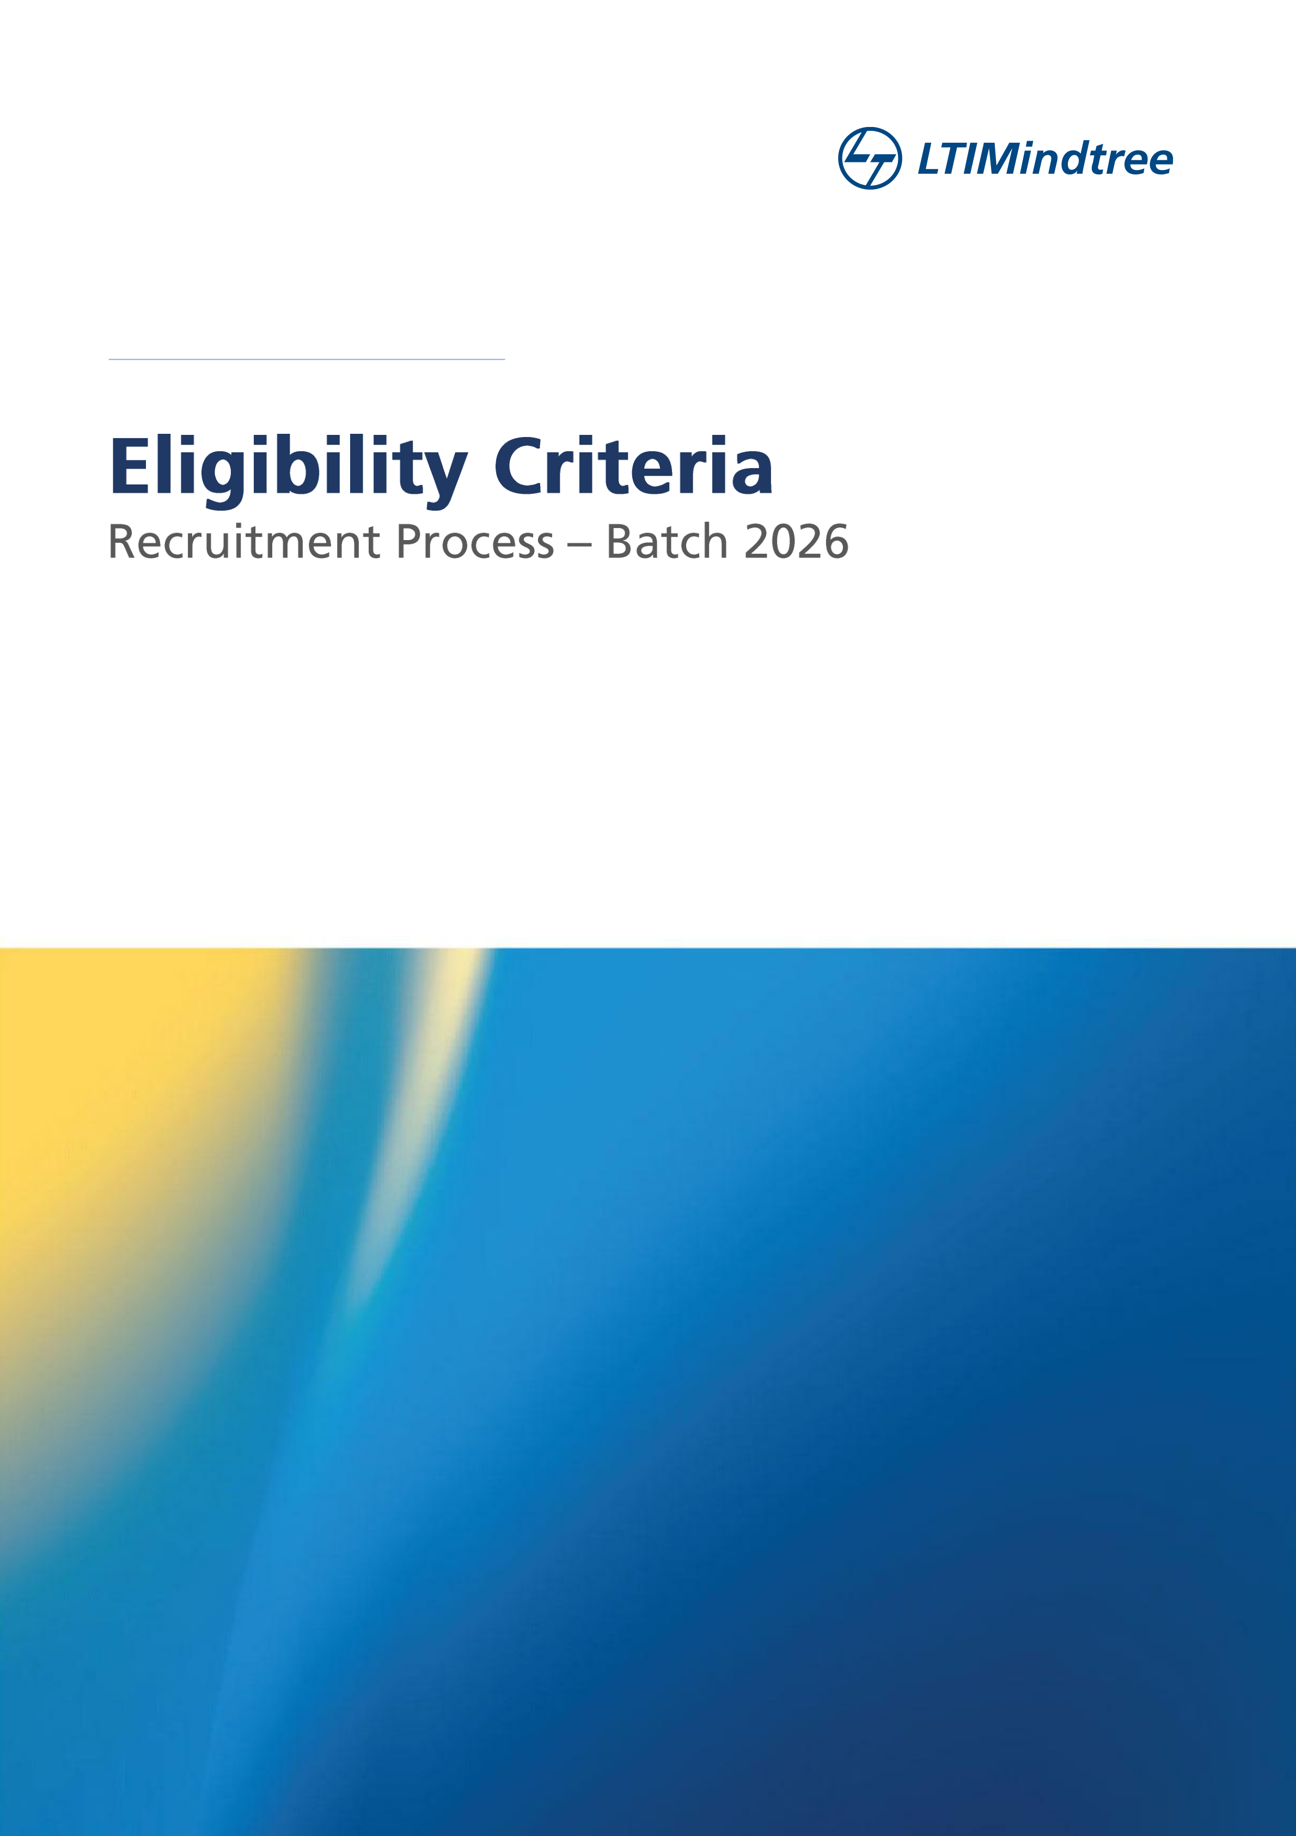

Document Version / Details Ver. 6/ 08-September-2025



Eligibility Criteria for T School Hiring – 2026 Batch
Qualification | 2026 Batch of B.E/ BTech/ ME/ MTech (all branches of engineering) /MCA/ M.Sc.-5 Yrs integrated CS & IT branches only (all education in full-time/regular courses)
Branches | All Branches of Engineering
Academic Gap | Not more than 2 years academic gap allowed. (SSC/HSC/Diploma/UG/PG)
SSC, HSC Percentages,  Diploma (if applicable),  Graduation Percentage/CGPA | Consistent academic records of 60% in 10th, 12th, Diploma (as applicable), UG and PG courses (aggregate of all semesters & subjects)  NOTE:  1.Appropriate CGPA to percentage conversion to be considered as per the  respective university norms. The scores of the Main or improvement exam  would be considered as final.  2.For candidates who have pursued both HSC and Diploma, marks scored in the  Diploma course will be considered.
Re-attempts/ATKTs  /Backlogs/Arrears (Diploma, Graduation) | 1.Initial results (% scores) declared would be considered for students awaiting re-evaluation results.  2.At the time of recruitment process, there must be no standing arrears in current education
Nature of Course | All Full-Time Courses Only
Year of Passing | 2026 Pass Outs Only
Citizenship | Should be an Indian National
Your College/Institution MUST be | UGC / AICTE / State Board Approved ONLY
Pre-Employment Verification | Not been involved in any court proceedings and/or convicted for any offence
Self-Declaration:
1. hereby declare that I meet ALL the eligibility criteria exactly as stated above.
2.I am aware that I may be subjected to immediate action by the company at any time during or after the Interview/Selection/Joining if found hiding any information/producing incorrect information or not meeting all the criteria mentioned above.
3.As a future IT professional, I am flexible towards working from any of LTIMindtree’s development centers across the country, flexible work durations/time, training and working in multiple emerging skills & domain.
4.I confirm that I have NOT appeared for any LTIMindtree interview process anywhere in the past 6 months. (If found so, LTIMindtree may take immediate action and cancel the candidature at ANY stage)
Signature: ___________________________________ Name: ___________________________________ Mobile No: ___________________________________
College Name: ________________________________
Today's Date: ___________________________________

