Academic Task Number: 2



Course code: MKT906
Course title: SOCIAL MEDIA MARKETING
Name of Instructor – Dr. Ashok Malhi

Name of the Student: Andol Saketh
Registration No.: 12221210
Section: KO029 Roll No.: 64

DECLARATION

I declare that this Assignment is my
individual work. I have not copied it from
any other student’s work or from any other source except where due acknowledgement is made explicitly in the text, nor has any
part been written for me by any other person.

Student’s Signature

SPYRIDEX

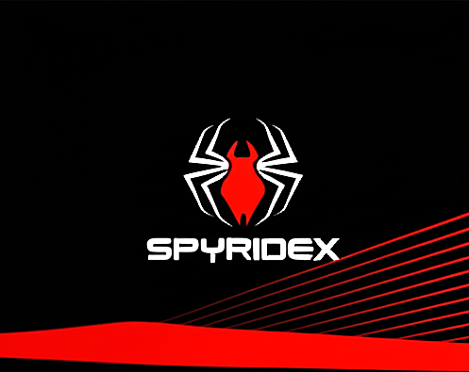
1l
Unleash the beast within. Spyridex isn't just a motorcycle; it's an extension of your spirit. Engineered for adrenaline, designed for dominance, and built for the open road. Every curve, every rev, every mile is a testament to uncompromised power and precision. Join the Spyridex revolution and redefine your ride.

This is not a machine for the meek. Spyridex is the culmination of relentless engineering and an unwavering commitment to performance. We didn't just build a motorcycle; we forged a two-wheeled weapon. Experience the instant, brutal torque and the flawless aerodynamics that cut through the wind like a razor. Own the road. Own a Spyridex.

The moment you grip the throttle, the world fades. It's just you, the machine, and the horizon. Spyridex is the sound of freedom, the blur of speed, the feeling of absolute, unrivaled mastery. It’s the legacy you leave on the road, mile after unforgettable mile. Stop riding. Start creating a legend.

YOUTUBE MARKETING

YouTube Profile:
https://www.youtube.com/@Spiderman-ridex/
``QR Code``
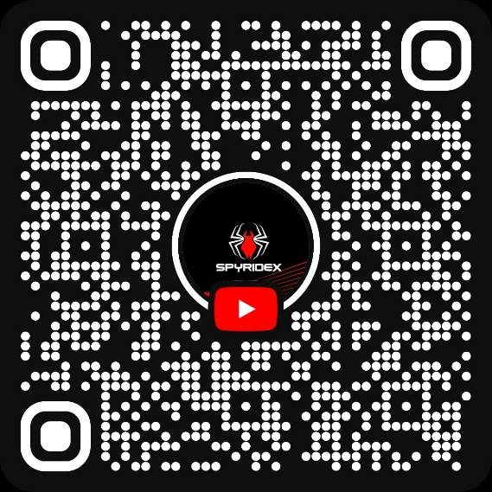

YOUTUBE PROFILE DESIGN:
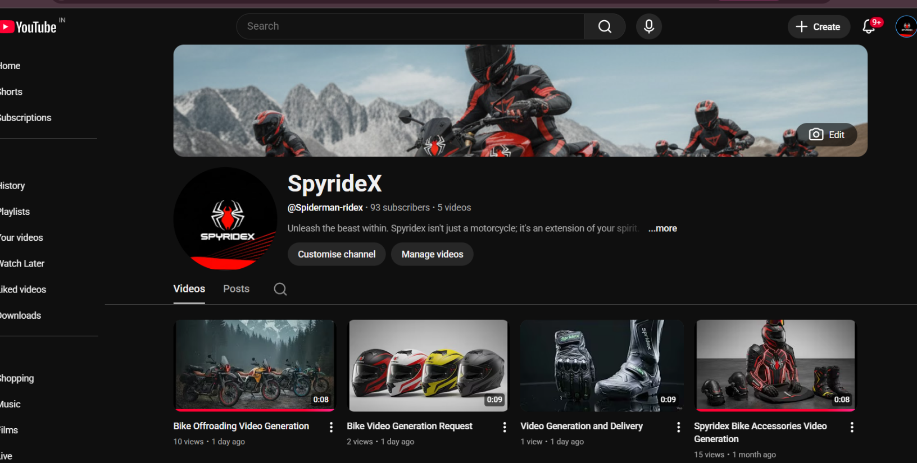

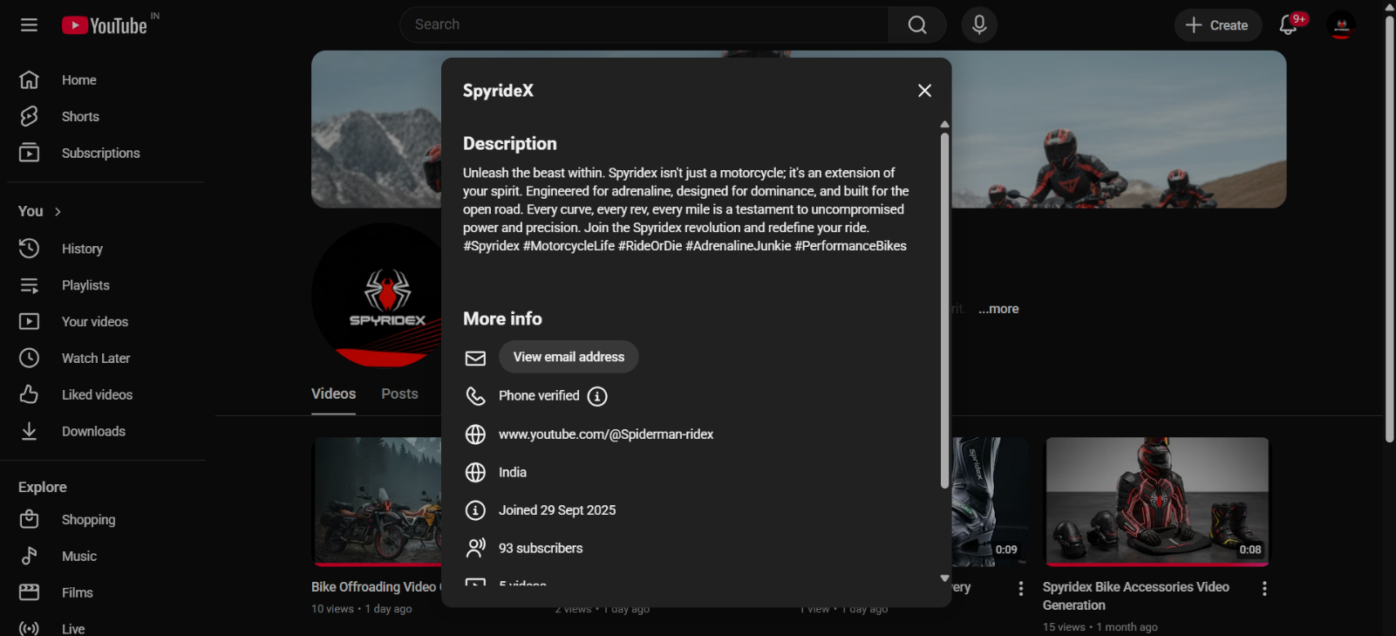

- POSTS CONTENTS:

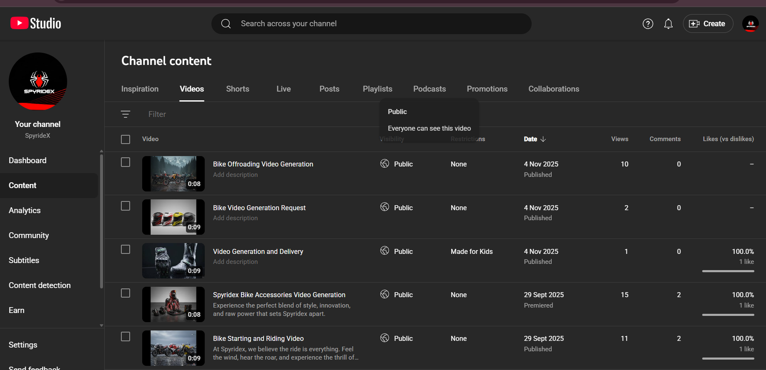
Views Posts

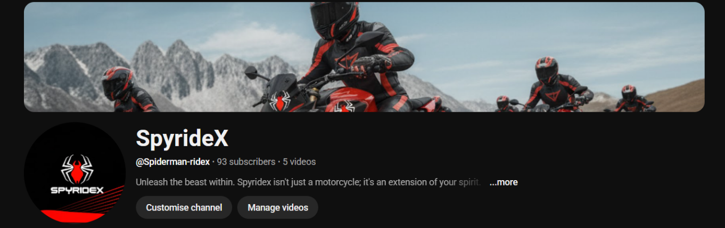
Followers/Subscribers

COMPETITOR ANALYSIS:

Here’s a summary analysis of the YouTube channel Village Cooking Channel (VCC-
https://www.youtube.com/@VillageCookingChannel/ )

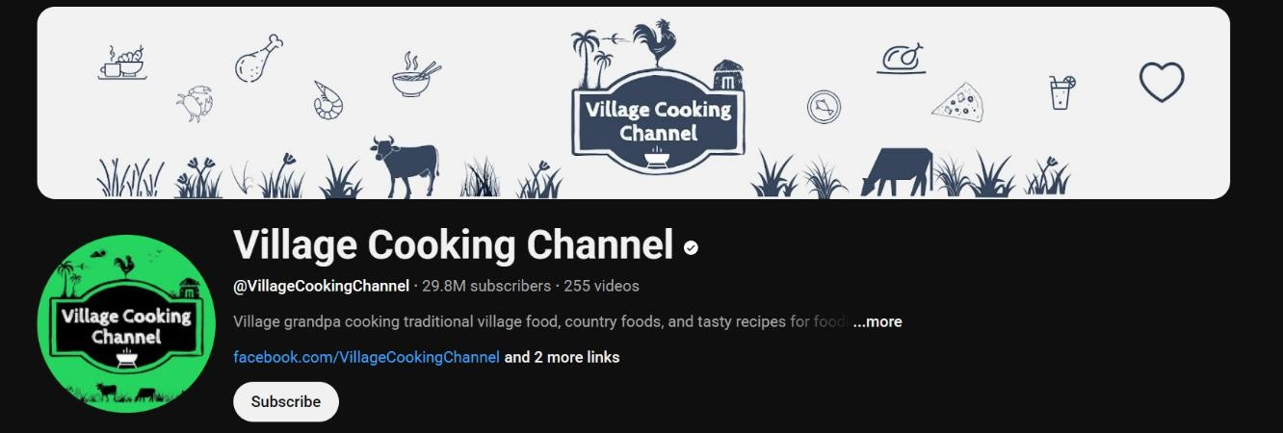

Area | What works well | What could be improved

1. Subscribers & Reach | ~ 29.8 million  subscribers and ~9.16 billion total views.  This scale gives strong authority in the food/cooking niche. | Growth rate appears relatively modest  (HypeAuditor lists  ~0.94% growth over 30 days). They may need fresh strategies to sustain high  growth.
2. Upload Volume & Consistency | ~255 videos uploaded since April 2018 (~7 years) as of 2025.  That’s a decent catalog for viewers to explore. | The video count is not extremely high given the years active — more frequent  uploads or shorter  formats could increase engagement.
3. Content Style & Niche | The niche of large- scale village cooking (“outdoor, rustic,  traditional vessels, big portions”) is  distinctive and visually appealing (per  Wikipedia). That uniqueness helps them stand out. | While distinct, the format might limit repeatability or diversification. The same style can feel repetitive over time;  variety in angle might help.
4. Engagement Metrics | Strong absolute  numbers: average likes  ~200K per video (per one audit). Also very large view-counts  indicating broad appeal. | Engagement rate is relatively low:  HypeAuditor reports  ~1.54% for overall engagement. For a channel this size, higher relative  engagement would be preferable.  Comments, shares

 |  | might be under- optimized.
5. Search Engine & | The strong brand likely | Could improve
Algorithm | helps with suggestion | discoverability with
Optimisation | algorithms; high initial | more optimized
 | view counts boost | metadata: consistent
 | ranking. | use of keywords in
 |  | titles, descriptions,
 |  | tags; perhaps crafting
 |  | more click-worthy but
 |  | also algorithm-friendly
 |  | thumbnails/titles.
 |  | Also, better use of
 |  | timestamps, chapters,
 |  | playlists for viewer
 |  | retention.

CHANNEL ANALYTICS:
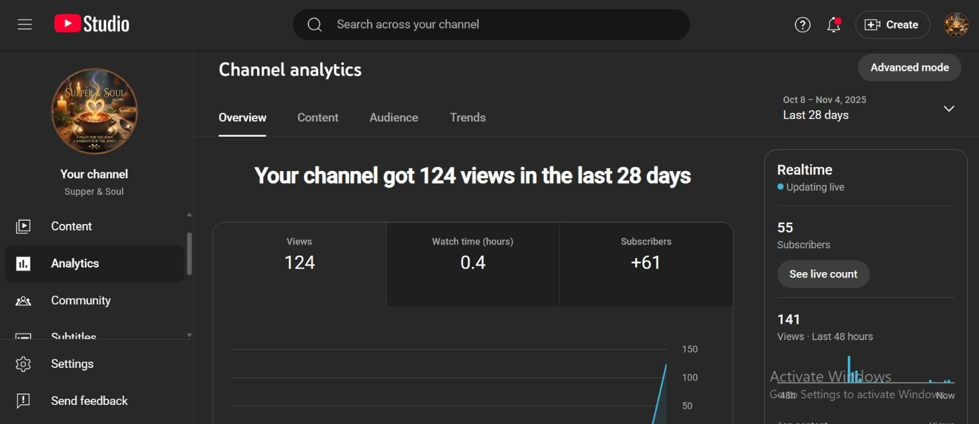
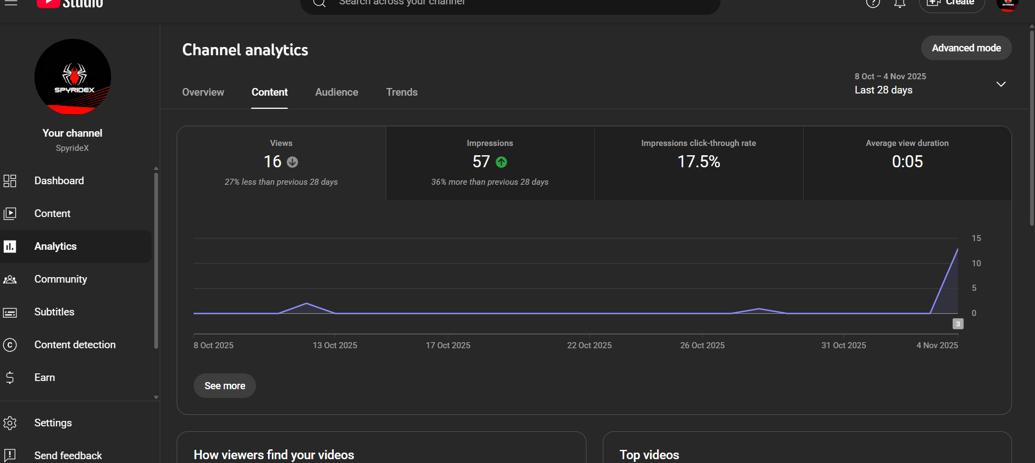

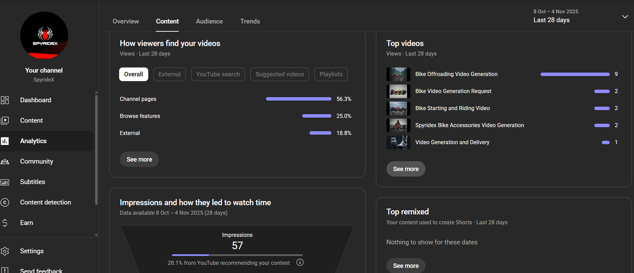

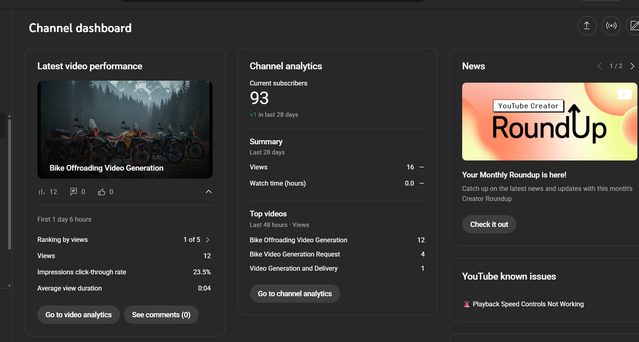

- CHANNEL PROMOTION:

 QR CODE

I have promoted my YouTube channel through sharing the link and QR code on various social media platforms like WhatsApp , Instagram to reach a range of audience and gain subscribers

