Annexure3b- Complete filing
INVENTION DISCLOSURE FORM
Details of Invention for better understanding:
1. TITLE: Artificial Intelligence-Driven Agriculture Damage Prediction System
2. INTERNAL INVENTOR(S)/ STUDENT(S): All fields in this column are mandatory to be
filled
A. Full name | Donthamsetti Harish Venkata Sai
Mobile Number | 8639283960
Email (personal) | harishdonthamsetti@gmail.com
UID/Registration number | 12218282
Address of Internal Inventors | School Of Computer Science and Engineering  Lovely Professional University, Punjab-144411, India
Signature (Mandatory) | 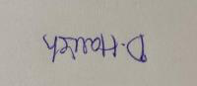
B. Full name | Rishank Kulasari
Mobile Number | 8279713781
Email (personal) | rakhramanik786@gmail.com
UID/Registration number | 12216421
Address of Internal Inventors | School Of Computer Science and Engineering  Lovely Professional University, Punjab-144411, India
Signature (Mandatory) | 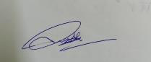

C. Full name | Nitish Chidurala
Mobile Number | 9966629299
Email (personal) | nithishchidurala@gmail.com
UID/Registration number | 12206207
Address of Internal Inventors | School Of Computer Science and Engineering  Lovely Professional University, Punjab-144411, India
Signature (Mandatory) | 

3. | DESCRIPTION OF THE INVENTION:
1.Purpose
AI operated agricultural damage system introduces a state-of-the-art approach to protect crops by taking advantage of advanced technologies such as artificial intelligence, satellite imaging and IoT sensor. This system gives farmers the right to estimate and react to dangers such as pests, diseases, extreme weather and soil. By going to future strategies from reactive reactions, the system aims to reduce crop losses, promote food production and encourage permanent agricultural practices.
2.Technical Workings
3.Multi-Source Data Integration: The system collects real-time information from different sources:
oIoT-based sensors monitor environmental parameters such as soil moisture, pH, temperature and humidity.
oHigh resolution drones and satellite drawings to assess the health and development of crops.
oWeather APIs and local climate stations provide updated meteorological data.
4.Autonomous Alert and Response System: Depending on the future analysis, the system sends the notifications and recommendations through the mobile app. This includes: oTimely pesticides for pesticides.
oAdjusted irrigation program based on weather conditions.
oActive harvesting advice under potential storm or drought.
5.AI-Powered Prediction Models: By processing this data using machine learning, the system identifies patterns and trends to predict the risk. This insect may detect indications of early warning of infections, crop diseases and climate -related dangers before continuing.

6.Autonomous Warnings and Response Systems: Depending on the future analysis, the system transmits the notifications and recommendations through a mobile app. This includes:
oTimely pesticides for pesticides.
oAdjusted irrigation program based on weather conditions.
oActive harvesting advice under potential storm or drought.
7.Secure and Transparent Data Storage: All operating data is stored using blockchain techniques, and ensures that items are tamper-proof and reliable. It is especially useful for insurance requirements, compliance with agricultural rules and long -term analysis.
8.Simple and Avaible User Interface: The system of the system is designed for ease of use and available in many languages. It shows a comfortable dashboard with real -time updates and action -rich insights.
9.Unique Attributes
1.Future Intelligence: Unlike traditional systems that only report current conditions, this invention constantly estimates the dangers of future. This future ability gives farmers the right to work prematurely, which prevents damage before the injury.
2.Completely Automated Decision Support: The system processes free raw data to action -rich insights and protects the farmer without manual analysis or the need for input. This facility reduces the requirement for agricultural advisers or technical personnel significantly.
3.Scalability: It can be implemented on smallholder farms with minimal infrastructure or scaled up for large corporate farms. The modular structure allows the technology to grow with the needs and capacity of the user.
4.Efficient Resource Management: By recommending precise application of water, fertilizers, and pesticides based on actual needs, the system minimizes unnecessary usage, reduces environmental pollution, and cuts operational costs.
5.Long-Term Planning Support: The accumulation of historical and seasonal data allows farmers to plan crop rotations, optimize planting schedules, and manage soil health over time. This leads to increased productivity and improved soil sustainability.
10.Conclusion
The AI-Driven Agricultural Damage Prediction System represents a significant leap forward in the digitization of agriculture. By integrating real-time data acquisition, AI-based risk assessment, and automated decision-making, it provides a comprehensive solution to mitigate crop losses. Its scalable, user-centric design ensures that farmers across socioeconomic and geographical boundaries can benefit from advanced technology, ultimately fostering a more resilient and productive agricultural sector.
A. PROBLEM ADDRESSED BY THE INVENTION:

The transition to electric public transportation presents several significant challenges that hinder the efficient operation of electric buses and trains. The Self-Sufficient Charging System for Electric Public Transportation addresses the following key problems:
1.Unexpected Crop Failures: Agricultural losses due to pest outbreaks, diseases, and climatic extremes often catch farmers by surprise. These unforeseen events drastically impact yields and income, especially for smallholders.
2.Limited Manual Monitoring: Manual crop inspection is labor-intensive, time-consuming, and prone to human error. It’s often ineffective on large farms or in remote areas, where early signs of trouble might go unnoticed until it’s too late.
3.Underutilization of Technology: In many regions, the use of advanced data-driven farming tools is still limited. Farmers lack access to systems that analyze historical and current data to inform proactive decisions.
4.High Input Costs: Resources like water, pesticides, and fertilizers are frequently overused due to the lack of accurate data, leading to wasteful expenditure and environmental degradation.
5.Lack of Reliable Data Records: Conventional farming lacks standardized recordkeeping, making it difficult to track crop history, evaluate performance, or present evidence for insurance claims and subsidies.
6.Barriers to Technology Access: Complex systems often fail to address the digital divide, leaving out small and marginal farmers who need support the most but lack access to user-friendly, low-cost solutions.
7.Conclusion
This invention directly addresses these critical issues by providing a scalable, intuitive, and predictive system. It equips farmers with timely, actionable information that enables better decision-making and improves resilience against agricultural risks.
B. OBJECTIVE OF THE INVENTION (Provide minimum two)
Increase Crop Protection Efficiency: One of the primary objectives of the AI-driven Agriculture Damage Prediction System is to deliver accurate and timely predictions to enable proactive measures, reducing the impact of potential threats.
Minimize Financial Risk: Another key objective is to reduce the unexpected agricultural damage that can devastate a farmer’s income. This invention reduces that risk by offering timely

alerts and tailored recommendations, allowing farmers to mitigate problems before they cause
significant loss. This is especially important for smallholder farmers who often operate on tight
margins and cannot afford unpredictable disruptions.
Encourage Eco-Friendly Farming: Precision agriculture is a key goal of the system. By
recommending actions based on actual field data, it helps reduce the excessive use of water,
fertilizers, and pesticides. This minimizes environmental impact and supports the move toward
more sustainable farming practices, which is increasingly important in the face of climate change.
Empower Data-Based Farming: The system provides farmers with easy access to actionable
insights derived from a combination of historical trends and current field conditions. With this
data, they can make more strategic decisions about crop management, resource allocation, and
seasonal planning, rather than relying solely on traditional experience or guesswork.
Make Smart Farming Inclusive: One of the central objectives is to make advanced
agricultural technology accessible to everyone. The system’s user-friendly design ensures that
even those with limited technical knowledge can benefit. By offering support in multiple languages
and requiring minimal training, it bridges the digital divide in rural areas and empowers a wider
farming community.
Support Documentation and Claims: Every piece of data collected from crop conditions to
response actions is securely logged using blockchain technology. This ensures that records are
tamper-proof and verifiable, making it easier for farmers to file accurate insurance claims, comply
with agricultural regulations, and qualify for government subsidies or financial support programs.
Blockchain-secured records ensure transparency and accuracy in data storage. This supports not
only day-to-day farm management but also provides verifiable proof for insurance claims,
government subsidies, and compliance with agricultural regulations. Enable blockchain-secured
recordkeeping for easy access to verifiable data for insurance, audits, and subsidies.
C. STATE OF THE ART/ RESEARCH GAP/NOVELTY:
Sr.
No. Study Abstract Research Gap Novelty
Crop Disease These patents describe While effective in Our system
systems that utilize AI identifying diseases advances this by
Prediction and
1 and machine learning post-symptom combining real-time
Treatment Based on models to predict crop appearance, these sensor data, climate
AI and ML Models diseases by analyzing systems may not fully information, and AI-
images and integrate real-time driven image

Sr.  No. Study | Abstract |  |  |  | Research Gap |  | Novelty
(EP4022556A4 / | environmental |  |  |  | environmental data for analysis to predict
US20220414795A1) | parameters, |  | enabling |  | proactive | disease potential |  | crop
 | early | detection |  | and | prediction. | diseases |  | before
 | treatment |  |  |  | symptoms manifest,
 | recommendations. |  |  |  | allowing |  |  | for
preemptive
interventions.
2 | This patent presents an |  |  |  |  |  |  |  |  | Our solution builds
 |  |  |  |  |  |  |  |  |  | upon this by feeding
 | integrated IoT platform
 |  |  |  |  |  |  |  |  |  | The system focuses on collected IoT data
 | Integrated IoT  System for Smart Agriculture  Management |  | that |  | collects |  |  | and
 |  |  |  |  |  |  |  |  |  | data collection and into AI models that
 |  |  | monitors |  |  | agricultural
 |  |  |  |  |  |  |  |  |  | monitoring but lacks generate |  |  | forecasts
 |  |  | data |  | in | real-time,
 |  |  |  |  |  |  |  |  |  | personalized |  | and | provide
 |  |  | utilizing |  |  | AI |  |  | for
 |  |  |  |  |  |  |  |  |  | predictive |  | customized |  | advice
 |  |  | predictive analytics to
 |  |  |  |  |  |  |  |  |  | recommendations |  | for each farmer's
 | (US10728336B2) | enhance |  |  |  | crop |  | yield,
 |  |  |  |  |  |  |  |  |  | tailored to individual unique |  |  | situation,
 | optimize food storage,
 |  |  |  |  |  |  |  |  |  | farm conditions. |  | enhancing decision-
 | and |  |  |  |  | improve
 |  |  |  |  |  |  |  |  |  | making and resource
 | distribution logistics.
 |  |  |  |  |  |  |  |  |  | efficiency.
3 | This |  |  |  | patent |  | outlines |  |  | Our |  |  | invention
 |  |  |  |  |  |  |  |  |  | merges |  |  | satellite
 | systems that use various |  |  |  |  |  |  |  |  | The approach may not imagery with on-
 | Systems | and sensors |  |  |  | and |  | data |  | fully integrate satellite ground sensor data
 | Methods for Crop analytics to monitor |  |  |  |  |  |  |  |  | imagery with real-time and |  |  | machine
 | Health Monitoring, crop |  |  |  | health, |  |  | assess |  | ground sensor data, learning algorithms
 | Assessment, | and conditions, and predict |  |  |  |  |  |  |  | potentially limiting the to provide real-time,
 | Prediction | potential issues, aiming |  |  |  |  |  |  |  | accuracy |  | and accurate, and farm-
 | (US20220107298A1) |  |  | to improve agricultural |  |  |  |  |  | timeliness | of | risk specific risk alerts,
 | productivity |  |  |  |  |  |  | and |  | assessments. |  | enabling timely and
 | sustainability. |  |  |  |  |  |  |  |  | precise
interventions.
4 | IoT-Based Farming This patent describes an |  | The system primarily We |  | apply
 | and Plant Growth IoT-based system that |  | addresses | irrigation blockchain to field-
 | Ecosystem | includes sensors and | and | fertilization level operations by
 | (US11195015B2) | automated mechanisms | optimization but does securely |  |  | logging
 | to monitor plant growth |  | not | incorporate prediction data and
 | conditions, aiming to |  | blockchain technology farming |  | actions,

Sr.  No. Study | Abstract | Research Gap | Novelty

optimize irrigation and
fertilization processes

for secure data logging supporting
and accountability in accountability, and

for | enhanced | crop | field-level operations. | simplifying
production. |  |  |  | processes related to
insurance claims and
subsidy
verifications.
Our mobile interface
5 | Various |  | mobile |  | delivers |  |  |  |  |  |  | dynamic,
 |  |  |  |  | Many existing apps real-time |  |  |  |  |  |  | insights
 |  |  |  |  | offer | static |  | or personalized
 |  |  |  |  | generalized |  | through |  |  |  |  | AI,
 | applications |  | provide
 |  |  |  |  | information |  | without available in local
 | farmers with weather
 |  |  |  |  | tailoring content to the languages, |  |  |  |  |  |  | and
Mobile Applications forecasts, market
prices, and general
for Farmers. farming advice, aiming
 |  |  |  |  | farmer’s specific land, designed to be user-
 |  |  |  |  | crops, |  | or friendly |  |  |  | even |  |  |  | for
 |  |  |  |  | environmental |  |  |  | first-time
 | to | assist | in | daily
 |  |  |  |  | conditions, and often technology |  |  |  |  |  |  |  | users,
 | agricultural activities.
 |  |  |  |  | lack |  | predictive enhancing
 |  |  |  |  | analytics capabilities. |  |  |  |  | accessibility |  |  |  | and
decision-making for
farmers
Conclusion
The AI-Driven Agricultural Damage Prediction System goes beyond existing research by weaving
together predictive analytics, real-time data from IoT sensors, satellite insights, and blockchain
technology into a single, intelligent system. Unlike previous work that focuses on isolated tools or
reactive measures, this system is designed to be proactive, accessible, and deeply integrated with
day-to-day farming activities. By helping farmers prevent damage before it happens, it opens new
possibilities for smart, sustainable, and inclusive agriculture.
D. DETAILED DESCRIPTION:
The AI-Driven Agricultural Damage Prediction System is a conceptually innovative
solution aimed at revolutionizing modern farming by predicting potential crop damage through the
use of AI and smart technologies. It is designed to empower farmers with accurate forecasts and

timely alerts that allow them to prevent or mitigate losses caused by pests, diseases, soil degradation, and extreme weather conditions. The system integrates AI-based data analytics, IoT sensors, satellite imagery, and blockchain technology into a unified predictive platform.
• 2. System Components
2.1 Sensor and Satellite-Based Data Infrastructure
• IoT Sensors: Deployed across the farm to monitor critical parameters such as soil moisture, temperature, humidity, and nutrient levels. These sensors continuously send real- time data to the analytics platform.
• Satellite and Drone Imaging: Provides visual data on plant health, crop coverage, and early signs of disease or water stress. This enables large-scale field assessments and enhances data granularity.
2.2 Communication and Integration Tools
• Sensor Communication: Data from field sensors are transmitted wirelessly using protocols like LoRaWAN, Zigbee, or 4G LTE, ensuring seamless real-time updates.
• API Integrations: The platform can be integrated with external weather forecasting systems and climate databases for enriched data analysis.
2.3 Central Intelligence Platform
• AI-Powered Analytics Engine: Machine learning models trained on agricultural datasets analyze incoming data to detect patterns associated with crop stress, pest outbreaks, or disease emergence. Predictions are continuously refined using historical and real-time data.
• Farmer Interface (Mobile/Web App): A user-friendly application displays insights, sends alerts, and recommends mitigation strategies in local languages. Farmers can track field conditions, review risk forecasts, and receive step-by-step action plans.
• Blockchain-Backed Data Logging: All data and actions are recorded using blockchain technology to ensure accuracy, traceability, and transparency, particularly for crop insurance or government compliance.
• 3. Technical Functionality
3.1 Predictive Risk Detection
• Pattern Recognition: AI identifies early warning signals from multisource data inputs— such as soil trends, temperature spikes, or pest migration patterns—before visual damage appears.

• Severity Estimation: Based on detected risks, the system classifies the threat level (low, moderate, high) and provides the appropriate response guidelines.
3.2 Real-Time Data Processing
• Continuous Monitoring: Environmental and crop health data are monitored 24/7. Any deviation from optimal thresholds triggers an analysis event.
Instant Alerts and Recommendations: Actionable insights are delivered instantly to the •
farmer’s device, ensuring rapid response to threats.
3.3 Farm-wide Optimization
• Resource Planning: Recommendations are generated to help minimize pesticide and water use without compromising crop protection.
• Temporal and Spatial Insights: The system advises on when and where to act, guiding farmers to prioritize the most vulnerable zones.
• 4. Unique Features
4.1 Scalability
• The design allows for easy scaling, whether it’s a smallholding or a large commercial estate, the modular system design allows easy deployment and expansion, without major infrastructure requirements.
4.2 Farmer-Centric Design
• Built for usability in rural settings, the system is intuitive and supports regional languages and offline functionality for areas with low connectivity.
4.3 Verified and Trustworthy Data
• Blockchain integration ensures that farm activity records and prediction data remain immutable and verifiable for future reference or policy support.
Conclusion
The AI-Driven Agricultural Damage Prediction System introduces a powerful combination of artificial intelligence, sensor-based monitoring, satellite analytics, and blockchain-backed transparency to create a next-generation farming assistant. Its proactive nature enables farmers to act before damage occurs, improving yields, reducing input waste, and contributing to a more resilient and sustainable agriculture ecosystem.
Process Workflow:

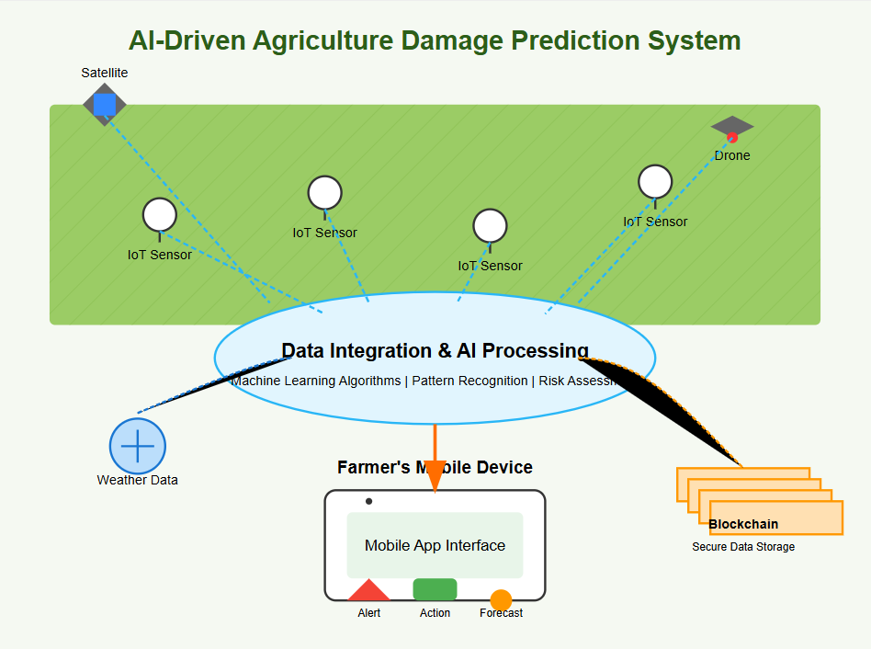

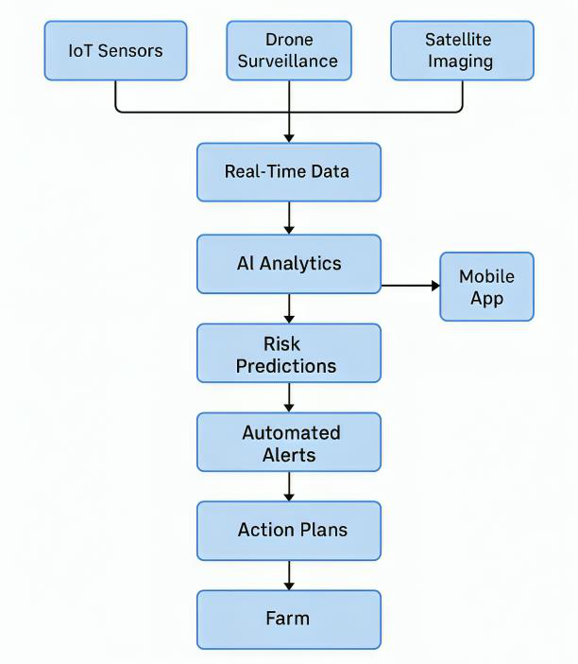
E. RESULTS AND ADVANTAGES:
The AI-Driven Agricultural Damage Prediction System introduces a fresh and forward-thinking approach to farming by turning raw data into real-time insights. Compared to traditional methods, this concept offers a smarter, more reliable, and more efficient way to manage agricultural risks: • 1. Boost in Farming Efficiency
Early Detection of Risks: The system can flag threats like pests, diseases, or • environmental stress before they cause actual damage, giving farmers a head start to protect their crops.
• Smarter Farm Decisions: With AI analyzing sensor and climate data, farmers get specific, timely recommendations that help them act quickly and wisely.
• 2. Better Use of Resources
• Targeted Input Usage: By knowing exactly where and when to apply fertilizers, pesticides, or water, farmers avoid waste and reduce costs.
• Eco-Friendly Practices: This precision helps cut down on chemical overuse and promotes more sustainable, responsible farming.
• 3. Enhanced Support for Farmers
• Live Alerts and Advice: Whether it's a disease risk or an upcoming weather event, farmers are notified right away with simple, helpful instructions.

• Designed for Accessibility: The interface is built for ease of use, with regional language
support to help farmers from all backgrounds benefit.
• 4. Scalability and Flexibility
• Fits Any Farm Size: From small local plots to commercial farms, the system can scale
without major hardware or software changes.
• Works With Existing Tools: It’s designed to integrate smoothly into what farmers are
already using, reducing barriers to adoption.
• 5. Cost-Saving in the Long Run
• Less Waste, More Yield: Efficient use of resources leads to reduced costs and better
returns on investment.
• Fewer Mistakes: Automation and intelligent alerts reduce errors that typically come from
guesswork or human oversight.
• 6. Transparent and Reliable Records
• Trustworthy Data Logs: Blockchain technology securely stores farm data, offering a
reliable digital record for audits, insurance claims, or policy support.
Compared to Conventional Approaches
• Manual monitoring takes time and often misses early signs of damage.
• Most farming apps give broad tips, not tailored, real-time advice.
• IoT tools without AI only show current data—they don't predict or recommend.
• Conclusion
This AI-driven agriculture damage prediction system stands out by giving farmers exactly what
they need—early, accurate, and actionable insights. It supports smarter farming, lowers input
waste, builds resilience, and encourages long-term sustainability.
E. EXPANSION:
To bring this idea to life and ensure it's useful across diverse agricultural settings, several
key aspects must be considered during development and rollout:
• 1. Compatibility with Crops and Locations

• Tailored AI Models: Each crop has unique risks. The system must be trained on region-
specific data to give accurate predictions.
• Adaptable to Local Conditions: Soil, weather, and farming styles vary—models should
reflect those local realities.
• 2. Hardware and Sensor Setup
• Good Coverage: Sensors must be placed strategically to reflect conditions across the
whole field.
• Built for the Outdoors: Devices should be tough enough to work in rain, heat, or dust
without frequent maintenance.
• 3. Reliable Connectivity
• Stable Networks: Whether it’s mobile data, LoRa, or Wi-Fi, the system must stay
connected to deliver real-time insights.
• Offline Capabilities: It should also collect and sync data later if connectivity is temporarily
lost.
• 4. Strong AI and Fast Processing
• Ongoing Model Training: As more data comes in, the AI must learn and adapt to become
more accurate.
• Quick Response Times: Fast processing is key to sending alerts before it’s too late.
• 5. Integration with Farming Tools
• Sync with Software: Many farmers already use digital farm tools. This system should
connect with those for smooth usage.
• Customizable Features: Letting farmers tweak the system for their own needs can help
with adoption.
• 6. Easy and Supportive User Experience
• Clear Interface: The app should be simple, visually clear, and available in regional
languages.
• Ongoing Help: Help centers, FAQs, and training support should be part of the system for
long-term use.
• 7. Compliance and Sustainability Goals

• Follow Laws and Ethics: It should comply with local data privacy rules and agricultural
regulations.
• Support for Green Farming:The system should help meet sustainability goals, like
reducing emissions and avoiding over-farming.
• Conclusion
By building with these real-world needs in mind, this system can become a trusted partner
to farmers everywhere. It will be practical, scalable, and supportive of long-term growth and
environmental stewardship.
F. WORKING PROTOTYPE/ FORMULATION/ DESIGN/COMPOSITION:
As of now, this project is at the idea and planning stage.Working prototype is not ready. It will
take at least a year to complete it.
G.EXISTING DATA:
To shape, train, and test the predictive models, the system will draw from trusted global data
sources and real-world case studies:
• 1. Global Agriculture Databases
• OECD iLibrary, FAO, Global Findex: These databases offer insights into regional crop
threats, pest activity, and seasonal weather patterns.
• 2. Real-World Pilot Insights
• Precision Farming in India: Early programs using IoT sensors reported up to 20% better
yields and 30% less water use.
• Smart Farming in Israel and the Netherlands: Success stories from AI-backed farms
prove the value of early detection and tailored interventions.
• 3. Climate and Environmental Monitoring
• Satellite Data (NASA, ISRO): Will be used for large-scale field tracking, such as rainfall
patterns and vegetation stress.
• Weather Forecasting APIs: Help predict short- and long-term climate threats.
• 4. Academic Research and Journals

• Sources like IEEE, Springer, ScienceDirect: Provide peer-reviewed studies that back the technologies and frameworks proposed in this system.
• Conclusion
By grounding this system in existing, reliable datasets and past successful implementations, it can evolve into a highly accurate, real-world-ready tool. This data-driven foundation will also guide refinement of the AI engine, improve precision, and support better outcomes for farmers.
4. | USE AND DISCLOSURE (IMPORTANT): Please answer the following questions:

A.Have you described or shown your invention/ design to anyone or in any conference? |  | NO ( No )
B.Have you made any attempts to commercialize your invention (for example, have you approached any companies about purchasing or manufacturing your invention)? |  | NO (No )
C.Has your invention been described in any printed publication, or any other form of media, such as the Internet? |  | NO ( No )
D.Do you have any collaboration with any other institute or organization on the same? Provide name and other details. |  | NO ( No )
E.Name of Regulatory body or any other approvals if required. |  | NO ( No )
5. Provide links and dates for such actions if the information has been made public (Google, research papers, YouTube videos, etc.) before sharing with us. NA
6. Provide the terms and conditions of the MOU also if the work is done in collaboration within or outside university (Any Industry, other Universities, or any other entity). NA
7. Potential Chances of Commercialization. Yes
8. List of companies which can be contacted for commercialization along with the website link.

Here are two companies that specialize in AI-powered agriculture, IoT for smart farming, or
precision agri-tech solutions. These companies may be potential collaborators or licensing
partners for bringing your concept to market:
1.CropX Technologies
oOverview: Offers a soil data analytics platform powered by IoT sensors and AI
models to improve resource usage and crop outcomes. Their technology could
support the integration of predictive modeling for damage prevention
oWebsite:
2.AgEagle Aerial Systems Inc.
oOverview: Specializes in AI-integrated drone imaging, precision agriculture, and
farm analytics. Their focus on agricultural monitoring through data-driven
insights aligns with your predictive system.
oWebsite:
9. Any basic patent which has been used and we need to pay royalty to them.
10. FILING OPTIONS: Please indicate the level of your work which can be considered for
provisional/ complete/ PCT filings - (Provisional)
11. KEYWORDS:
 AI-Driven Agriculture
 Crop Damage Prediction
 Smart Farming
 IoT Agricultural Sensors
 Predictive Analytics in Farming
 Blockchain Recordkeeping
 Sustainable Agriculture
 Precision Farming
 Satellite Crop Monitoring
 Early Risk Detection

 Agricultural Resource Optimization
 Mobile Farm Management
 Weather Impact Analysis
 Pest Outbreak Prediction
 Disease Prevention Technology
 Real-time Agricultural Alerts
 Multi-source Data Integration
 Farm Decision Support System
 Autonomous Agricultural Monitoring

(Letter Head of the external organization)
NO OBJECTION CERTIFICATE
This is to certify that University/Organization Name or its associates shall have no objection if Lovely Professional University files an IPR (Patent/Copyright/Design/any other…….) entitled "…………………." including the name(s) of, ........... …as inventors who is(are) student(s)/employee(s) studying/ working in our University/ organization.
Further Name of the University/Organization shall not provide any financial assistance in respect of said IPR nor shall raise any objection later with respect to filing or commercialization of the said IPR or otherwise claim any right to the patent/invention at any stage.
(Authorised Signatory)

