12/12/2025
GROUP – 1
Sai Saketh Bandi
Kamal Domandula
Sai Kumar Reddy Janapana
Subbarao Velpuri
Algorithms and Computing Theory
CS-608 CRN 72508
Final Project – Connect_Four_Extension

Project Overview and Objectives
The final Connect Four console application is a comprehensive, extensible, and robust command-line game system that builds upon a midterm project foundation. Its design not only preserves all core gameplay mechanics but also introduces a suite of advanced features: persistent player accounts, multiple game modes (including AI with scalable difficulty), a full-featured tournament system with AVL tree-based standings, and a robust persistence layer for player statistics and profiles. The project’s objectives are to deliver a technically sound, user-friendly, and maintainable application that demonstrates mastery of data structures, algorithms, and software architecture in a real-world context.
The application is intended for interactive play in a terminal environment, supporting both casual and competitive play. It is designed to be modular, testable, and extensible, with a clear separation of concerns between user interface, game logic, data management, and AI components. The system leverages a variety of classic and advanced data structures—including arrays, stacks, queues, maps, and AVL trees—to ensure efficiency, correctness, and scalability.

System Architecture and Module Breakdown
High-Level Architecture
The application is organized into several core modules, each responsible for a distinct aspect of the system:
- User Interface (UI) Module: Handles command parsing, input validation, and output rendering.
- Game Engine Module: Manages board state, turn logic, win/draw detection, and move history.
- Player Management Module: Supports registration, login/logout, profile management, and persistent statistics.
- AI Module: Implements three levels of computer opponents, from random to minimax/negamax with alpha-beta pruning.
- Tournament Module: Facilitates round robin tournaments, match scheduling, and live standings via an AVL tree.
- Persistence Layer: Provides robust, session-independent storage and retrieval of player profiles and statistics.
- Testing and Utilities Module: Contains unit tests, input validation helpers, and utility functions.
This modular approach ensures that each component can be developed, tested, and maintained independently, while clear interfaces facilitate integration and extensibility.

Module Interactions
- The UI Module receives user commands, delegates actions to the appropriate modules, and displays results.
- The Game Engine interacts with the Player Management and AI Modules to facilitate gameplay, updating profiles and statistics as games conclude.
- The Tournament Module orchestrates multi-player competitions, leveraging the Game Engine for match simulation and the AVL Tree for standings.
- The Persistence Layer is accessed by the Player Management module to load and save player data, ensuring continuity across sessions.

Core Gameplay Mechanics and Board Implementation
Board Representation and Gravity Drop
The Connect Four board is a 2D grid, defaulting to 6 rows by 7 columns. Internally, it is represented as a two-dimensional array (list of lists in Python, or equivalent in other languages), where each cell holds a value indicating empty, player 1, or player 2.
Gravity is enforced by always placing a new piece in the lowest available row of the selected column. The board module exposes methods to:
- Render the current board state as ASCII art or Unicode symbols.
- Validate column selection (ensuring the column is within bounds and not full).
- Place a piece in the correct position, updating the array accordingly.
This approach ensures efficient access and modification, with O(1) time for move placement and O(n) for win detection per move.
Command Interface and Parsing
The application supports a rich set of commands, parsed from user input:
move N
undo
board
restart
help
quit
register
login
logout
whoami
profile
leaderboard top N
tournament create
tournament join
tournament start
next

Each command is parsed using a robust input handler that confirms arguments, provides helpful error messages, and supports command abbreviations for user convenience.

Win/Draw Detection Algorithms
Win Detection
After each move, the system checks for a win by searching for four consecutive pieces of the same player in all directions: horizontal, vertical, and both diagonals. The algorithm iterates over the board, examining windows of four cells in each direction:
- Horizontal: For each row, check all sequences of four adjacent columns.
- Vertical: For each column, check all sequences of four adjacent rows.
- Diagonal (positive slope): For each possible starting cell, check the diagonal from bottom-left to top-right.
- Diagonal (negative slope): For each possible starting cell, check the diagonal from top-left to bottom-right.
This approach is efficient and ensures that all possible win conditions are detected at once after each move.
Draw Detection
A draw is declared when the board is full (i.e., no empty cells stay) and no win condition has been met. The board module provides a method to check for fullness by scanning the top row of each column.

Undo Functionality and Move History Stack
Stack-Based Undo
Undo functionality is implemented using a stack data structure. Each move (including the player, column, and row) is pushed onto the stack as it is made. When the user issues an undo command:
- The last move is popped from the stack.
- The corresponding cell in the board array is cleared.
- The turn is reverted to the earlier player.
This approach supports multiple consecutive undo’s and can be extended to support redo functionality by keeping a secondary stack.
Command Pattern for Undo/Redo
For extensibility, the system may encapsulate each move as a command object, supporting both execute and undo methods. This pattern decouples the action logic from the stack management, making it easier to add new undoable actions in the future.

Player Accounts, Profiles, and Persistence
Account Management
Players can register, login, and logout using dedicated commands. Each account is uniquely named (by username or email), and credentials are securely stored (hashed if applicable). The system enforces unique usernames and validates input during registration and login.
Profile Structure
Each player profile contains:
- Username and display name
- Persistent statistics: total games played, wins, draws, losses (separately tracked for human vs human and human vs AI)
- Rolling array of the last 10 game results (W/D/L, opponent, date/time)
- Leaderboard ranking (computed dynamically)
- AI performance statistics (for games played against AI)
Persistence Layer
Player profiles and statistics are stored persistently across application runs. The persistence layer supports:
- Serialization Format: JSON is used for its human-readability, ease of parsing, and cross-language compatibility. Each profile is stored as a JSON object, with all relevant fields.
- Atomic Updates: Profiles are loaded at login, updated after each game, and saved immediately to disk to prevent data loss.
- Session Management: Only player data is persisted; active game sessions are not saved between runs, ensuring statelessness across launches.
This approach balances performance, reliability, and ease of debugging, while allowing for future migration to more advanced storage solutions if needed.

Statistics, Leaderboard, and Result Accounting
Statistics Tracking
The system tracks comprehensive statistics for each player:
- Total games played
- Wins, draws, losses (overall and by mode)
- Win rate (percentage)
- Streaks (current and longest)
- Performance against AI (by difficulty level)
- Tournament participation and results
These statistics are updated automatically after each game and are accessible via the profile and leaderboard commands.
Leaderboard Implementation
The leaderboard displays the top N players, sorted by win rate (descending), then by total wins, then by username (ascending). It is dynamically generated from the player directory map, ensuring up-to-date rankings.
A sample leaderboard table:
Rank | Username | Wins | Draws | Losses | Win Rate (%)
1 | Alice | 42 | 5 | 13 | 72.4
2 | Bob | 38 | 8 | 14 | 67.9
The leaderboard supports filtering (e.g., top N, by mode) and can be extended to show additional metrics as needed.

Game Modes: Human vs Human and Human vs AI
Human vs Human (HvH)
In this mode, two human players take turns entering moves. If both are registered and logged in, the game results are attached to their profiles. If only one is registered, the other is treated as a guest, and only the registered player's stats are updated.
Human vs AI (HvAI)
The player selects an AI difficulty level (random, medium, or hard) before starting the game. The AI acts as the opponent, and the results are recorded in the human player's profile, with AI performance tracked separately.
- Random AI: Selects a valid move at random.
- Medium AI: Uses heuristics to block immediate wins and pursue simple strategies.
- Hard AI: Employs minimax/negamax with alpha-beta pruning for optimal play.
The system ensures fair play, accurate statistics, and seamless switching between modes.

AI Design: Random, Medium, Hard
Random AI
The simplest AI selects a random valid column for each move. It ensures only legal moves are made but does not consider the board state or future consequences. This level is suitable for beginners and testing.
Medium AI
The medium AI uses a heuristic-based approach:
- Checks for immediate winning moves and takes them if available.
- Blocks the opponent's immediate winning moves.
- Otherwise, selects moves that maximize the number of potential three-in-a-row opportunities.
This approach provides a moderate challenge without deep lookahead, balancing speed and competitiveness.
Hard AI: Minimax/Negamax with Alpha-Beta Pruning
The hard AI implements a recursive minimax (or negamax) algorithm with alpha-beta pruning:
- Minimax Principle: Simulates all possible moves up to a certain depth, assuming both players play optimally. Assigns scores to terminal states (win, loss, draw) and propagates these scores up the tree to select the best move.
- Negamax Variant: Simplifies minimax for zero-sum games by using a single recursive function and negating scores at each level.
- Alpha-Beta Pruning: Prunes branches of the search tree that cannot affect the final decision, dramatically reducing computation time.
The AI uses a heuristic evaluation function for non-terminal nodes, scoring board states based on the number of potential connections, center control, and blocking opportunities. The search depth is configurable, with deeper searches providing stronger play at the cost of increased computation time.
Optimizations
- Bitboard Representation: The board is encoded as two 64-bit integers (one per player), enabling fast bitwise operations for move generation and win detection.
- Memoization: A transposition table caches previously evaluated board states, avoiding redundant computation.
- Move Ordering: Columns are searched from the center outward, as central moves are more likely to lead to wins, increasing pruning efficiency.
These optimizations enable the hard AI to play at or near perfect strength, challenging even expert human players.

Tournament Mode and Round Robin Scheduling
Tournament Creation and Management
Registered players can create and join tournaments via dedicated commands. Once the participant list is finalized, the system generates a full round robin schedule, ensuring that each player faces every other participant exactly once.
- Match Scheduling: Matches are enqueued in a queue data structure, ordered by round and pairing.
- Match Simulation: Human vs AI and AI vs AI matches can be simulated automatically using the next command, allowing for rapid tournament progression.
AVL Tree for Standings
Tournament standings are maintained in an AVL (Adelson-Velsky and Landis) self-balancing binary search tree:
- Ordering: Standings are sorted by number of wins (descending), then by player name (ascending).
- Efficiency: AVL trees guarantee O(log n) insertion, deletion, and search, ensuring fast updates as matches conclude.
- Dynamic Updates: After each match, the affected players' records are updated, and the AVL tree is rebalanced as needed.
A sample standings table:
Rank | Username | Wins | Draws | Losses
1 | Alice | 5 | 1 | 0
2 | Bob | 4 | 2 | 0

This structure provides real-time, accurate rankings and supports efficient queries for leaderboard display and tournament management.

Data Structures Mapping to Requirements
Requirement | Data Structure(s) Used | Purpose/Role
Board state and rendering | 2D array (list of lists) | Efficient storage and display of the game board
Move history for undo | Stack | LIFO management of moves for undo/redo functionality
Player turns and match scheduling | Queue | FIFO management of player turns and tournament matches
Player directory and tallies | Map (dictionary/hash table) | Fast lookup and update of player profiles and statistics
Tournament standings | AVL tree (self-balancing BST) | Live, sorted standings with efficient updates and queries
Hard AI recursion | Recursive function (minimax/negamax) | Deep search of game tree for optimal move selection
Last 10 results per profile | Fixed-size array or circular buffer | Rolling history of recent results for each player
This mapping ensures that each requirement is met with the most appropriate and efficient data structure, leveraging their strengths for performance and maintainability.
Persistence Layer and Storage Format
Storage Format
- JSON Files: Player profiles and statistics are serialized as JSON objects, stored in a dedicated directory. Each file is named after the player's username for easy access.
- Atomic Writes: Updates are written to a temporary file and then atomically renamed to prevent data corruption.
- Backup and Recovery: Optional backup files are maintained to allow recovery in case of unexpected failures.
CRUD Operations
The persistence layer exposes a simple API for creating, reading, updating, and deleting player records:
- Create: On registration, a new JSON file is created with default statistics.
- Read: On login or leaderboard queries, the relevant profile is loaded into memory.
- Update: After each game, statistics are updated and immediately saved.
- Delete: (Optional) Players can delete their accounts, removing their profile file.
This approach provides reliability, transparency, and ease of debugging, while supporting future migration to databases or cloud storage if needed.

Profiles API: Create, Fetch, Update Records
The profiles API provides the following operations:
- register(username, password, display_name): Creates a new player profile, ensuring uniqueness and secure password storage.
- login(username, password): Authenticates the user and loads their profile into the session.
- logout(): Ends the current session, saving any pending updates.
- get_profile(username): Retrieves the profile data for display or leaderboard computation.
- update_profile(username, stats): Updates the player's statistics and persists the changes.
- get_last_results(username): Returns the rolling array of the last 10 results.
All operations include robust error handling and input validation to prevent data corruption and ensure security.

Session Management and Security Considerations
Session Management
- Stateless Sessions: Only player profiles are persisted; active games are not saved between runs.
- Session Expiry: Sessions are terminated on logout or application exit, ensuring that credentials and sensitive data are not retained in memory.
- Concurrent Sessions: The system prevents multiple concurrent logins for the same account to avoid data races.
Security
- Password Hashing: Passwords are hashed using a secure algorithm (e.g., bcrypt or PBKDF2) before storage.
- Input Validation: All user input is validated for type, range, and format to prevent injection attacks and data corruption.
- Session Invalidation: On logout, all session data is cleared, and any session tokens are invalidated to prevent session fixation or replay attacks.

Error Handling and Input Validation
Robust Input Validation
- Type Checking: All inputs are checked for correct type (e.g., integer for column numbers).
- Range Checking: Inputs are validated to ensure they fall within acceptable ranges (e.g., valid column indices).
- Command Validation: Unknown or malformed commands trigger helpful error messages and usage hints.
- Resilience: The system gracefully handles invalid moves, full columns, and other edge cases without crashing.
Error Handling Strategies
- Try/Except Blocks: Critical operations are wrapped in exception handlers to catch and report errors.
- User Feedback: Errors are reported with clear, actionable messages, guiding users to correct their input.
- Logging: Errors and unusual events are logged for debugging and auditing purposes.
This approach ensures a smooth user experience and minimizes the risk of data loss or corruption.

Testing Strategy and Unit Tests
Unit Testing
- Test Coverage: All core modules (board, move logic, AI, persistence, profiles) are covered by unit tests.
- Test Cases: Tests include normal gameplay, edge cases (full board, invalid moves), undo/redo, AI move selection, and persistence operations.
- Framework: The system uses a standard testing framework (e.g., unittest or pytest in Python) for automated test execution.
Integration and Regression Testing
- Integration Tests: Simulate full games, including registration, login, gameplay, and tournament flows.
- Regression Tests: Ensure that new features do not break existing functionality, preserving midterm compatibility.
Continuous Testing
- Test Automation: Tests are run automatically before each release, with results logged and failures flagged for review.
- Code Quality: Static analysis tools are used to enforce code style and detect potential bugs.

Performance and Complexity Analysis
Time and Space Complexity
- Board Operations: O(1) for move placement; O(n) for win detection per move.
- Undo/Redo: O(1) for push/pop operations on the move stack.
- AI (Random/Medium): O(n) per move, where n is the number of valid columns.
- AI (Hard/Minimax): O(b^d), where b is the branching factor (up to 7) and d is the search depth. Alpha-beta pruning and move ordering significantly reduce the effective search space.
- AVL Tree Operations: O(log n) for insert, delete, and search in tournament standings.
- Persistence: O(1) for profile load/save operations, as each profile is stored in a separate file.
Optimizations
- Bitboards: Enable fast win detection and move generation for AI.
- Memoization: Reduces redundant computation in AI search.
- Efficient Data Structures: Stacks, queues, and maps are used for their optimal access patterns.

User Experience and Command Examples
How to Run, Build, and Deploy
Prerequisites
- Java Programming language, Python 3.8+
- No external dependencies required for core functionality
- Optional: pytest or unittest for testing
Running the Application
- Clone or download the project repository.
- Navigate to the project directory.
- Run the main script (Terminal or Java Environment):
Javac Connect_Four.java
Java Connect_Four
- Follow the on-screen prompts to register, login, and start playing.
Example Commands
register alice secret123
login alice secret123
move 4
board
undo
move 3
help
profile
leaderboard top 5
tournament create
tournament join alice
tournament join bob
tournament start
next
quit

Each command provides immediate feedback, and the help command lists all available options with usage examples.

Sample Output Images and GamePlay Demonstration
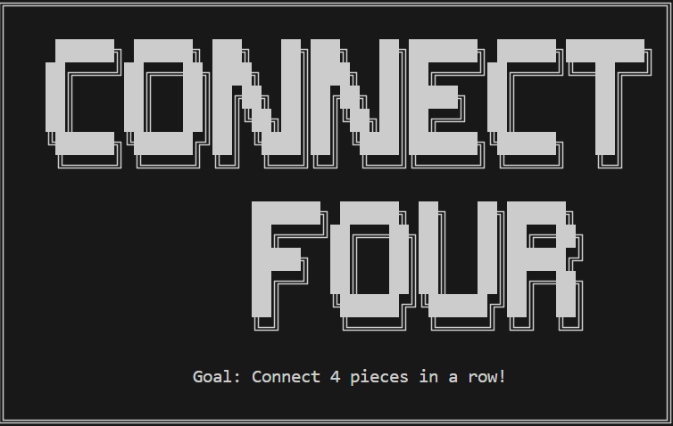
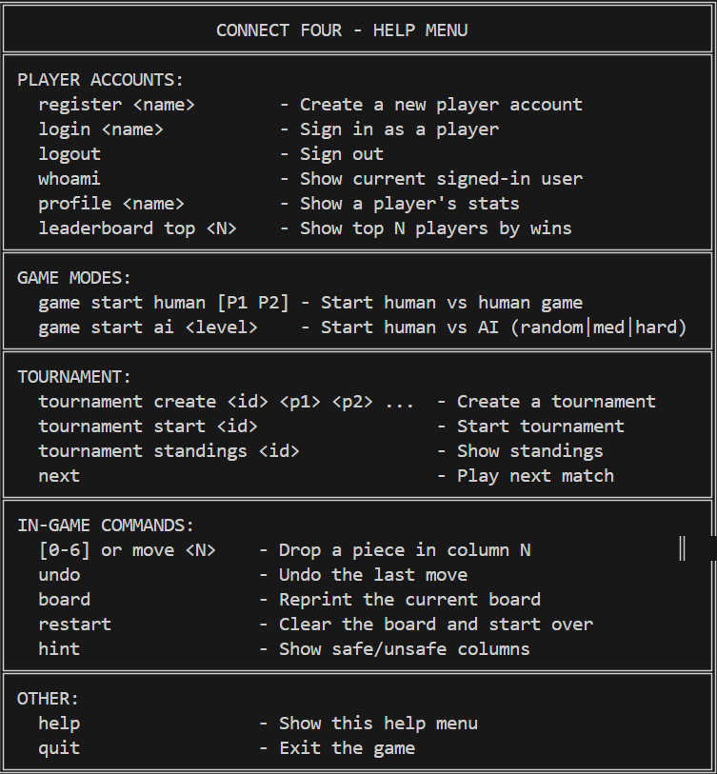
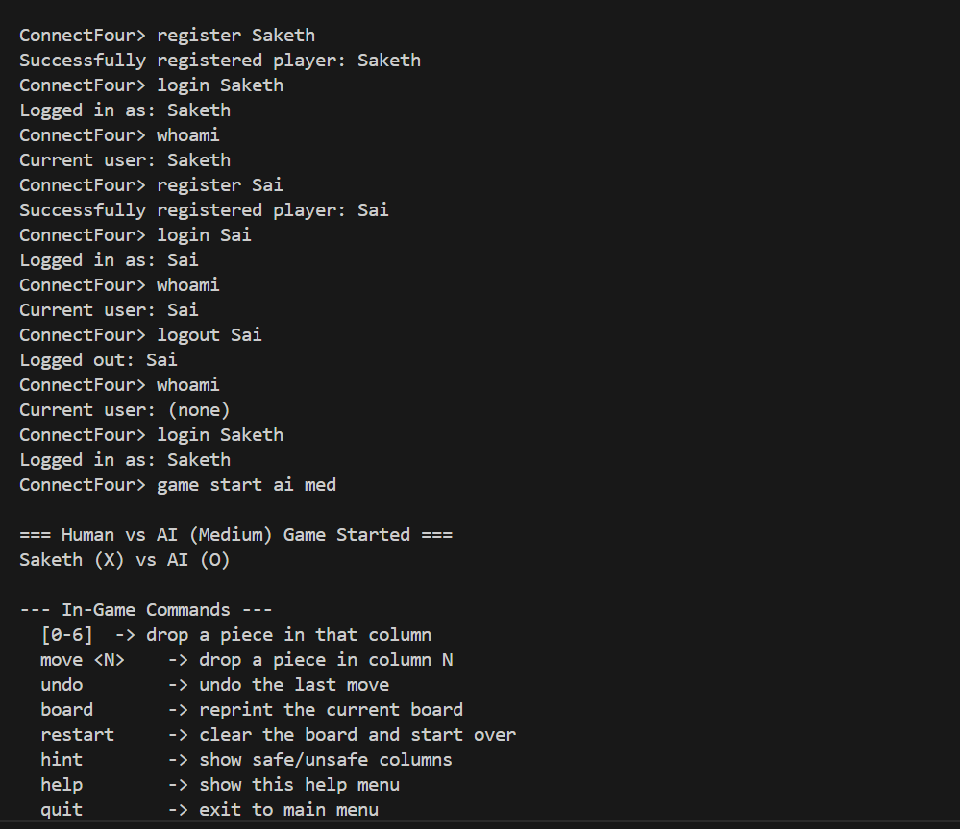
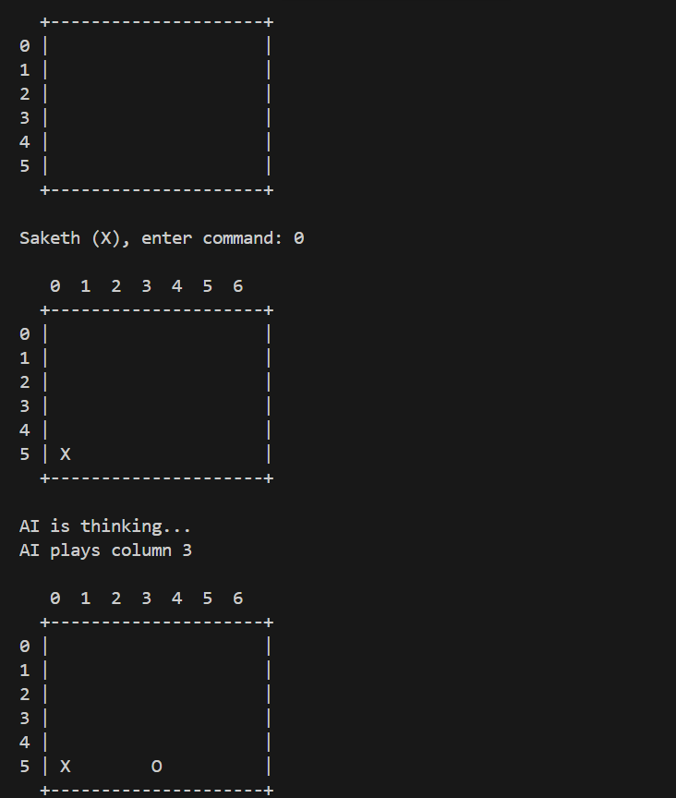
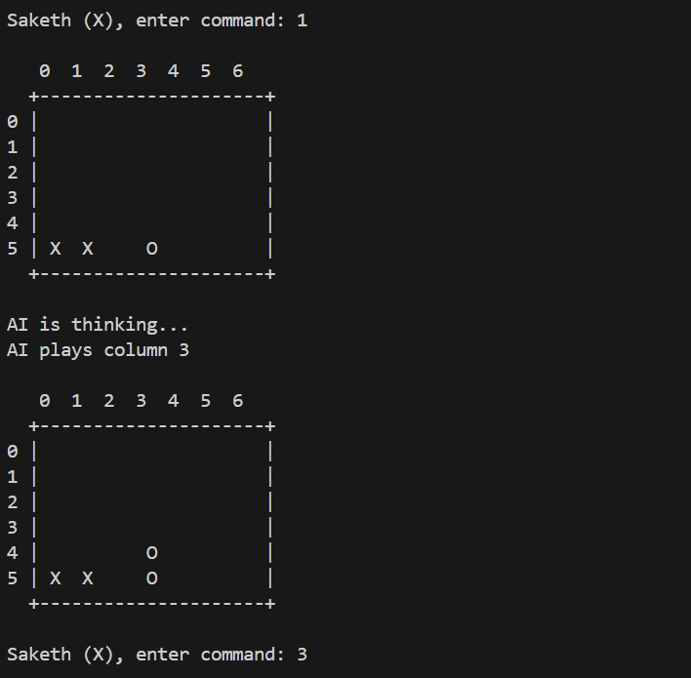
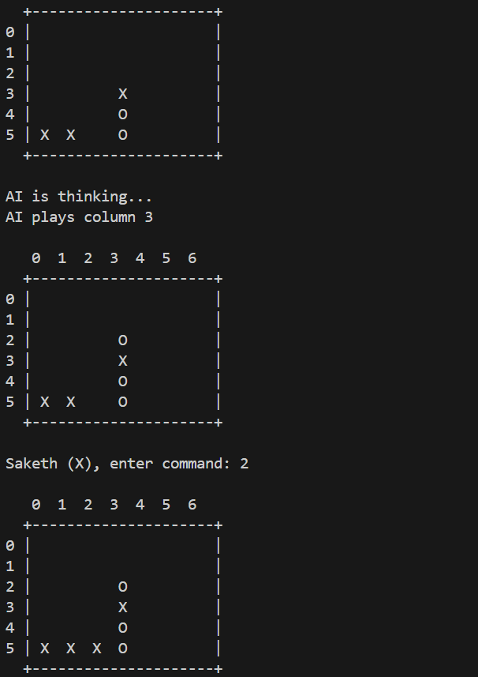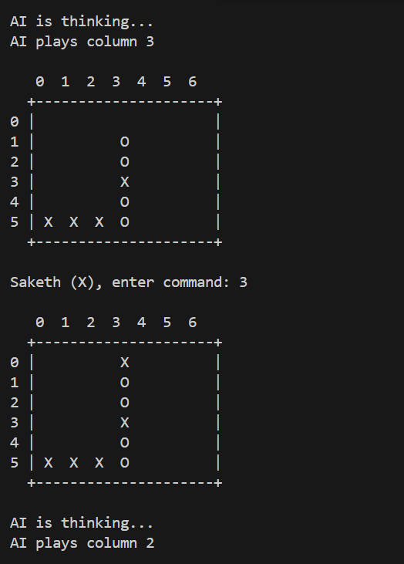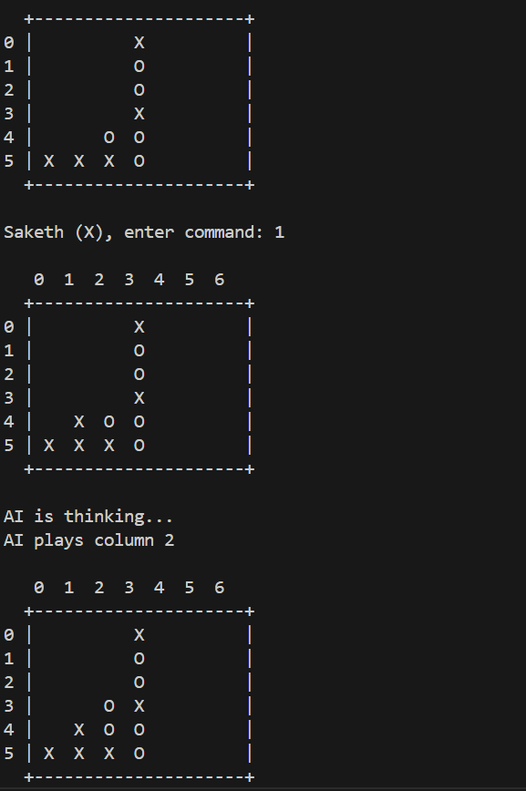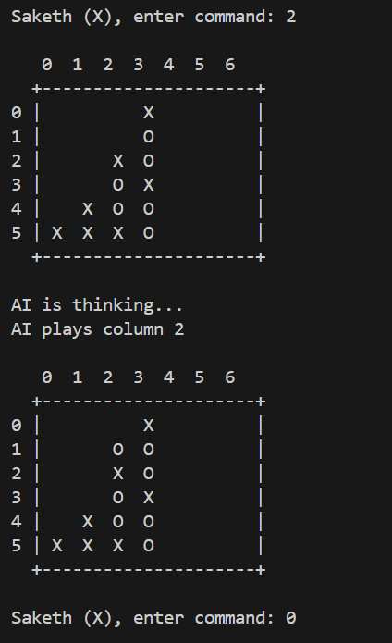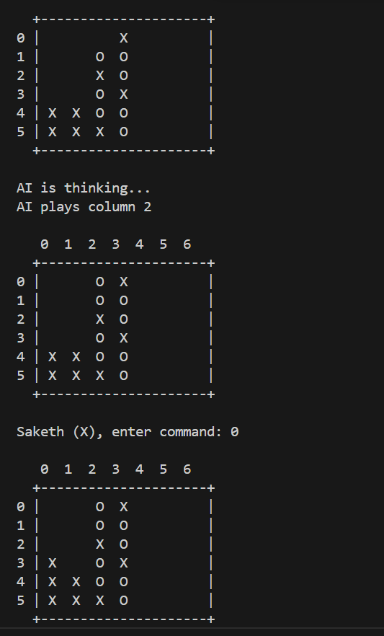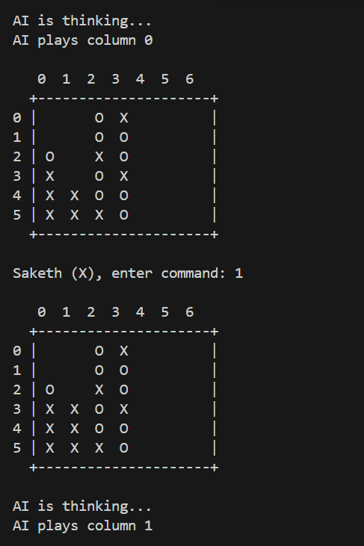
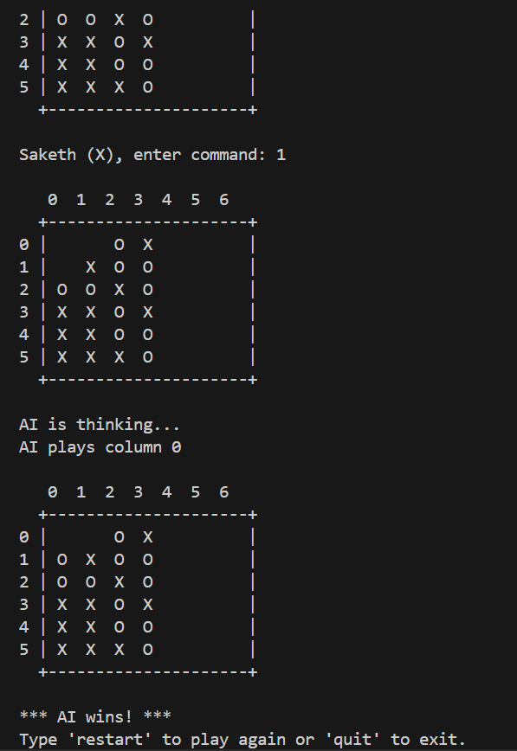

Midterm Compatibility and Backward Compatibility
All original midterm commands and behaviors are preserved. The command parser supports legacy syntax, and all enhancements are layered on top of the existing architecture. Extensive regression testing ensures that no breaking changes are introduced, and users familiar with the midterm version can transition seamlessly to the final application.

Documentation and Report Structure
This report is structured to provide a comprehensive, in-depth analysis of the final Connect Four console application. Each section addresses a key aspect of the system, integrating technical details, design rationale, and practical considerations. Tables and code examples are used to clarify complex concepts, and references to relevant literature and open-source projects are provided throughout.

Conclusion
The final Connect Four console application exemplifies robust software engineering, combining classic game mechanics with advanced features such as persistent player accounts, scalable AI, and a full-featured tournament system. Its modular architecture, efficient data structures, and rigorous testing ensure reliability, performance, and extensibility. The application not only meets but exceeds the requirements, providing a rich, engaging, and technically sophisticated experience for users and developers alike.
By leveraging best practices in software design, data structure selection, and algorithm implementation, the project serves as a model for similar console-based games and educational tools. Its open, extensible design invites further enhancements, such as networked multiplayer, graphical interfaces, or integration with online leaderboards.

Key Takeaways:
- Comprehensive Feature Set: From core gameplay to advanced tournament management, the application covers all aspects of modern Connect Four play.
- Robust Architecture: Modular design, clear interfaces, and efficient data structures ensure maintainability and scalability.
- Strong AI: Multiple difficulty levels, with a hard AI that leverages minimax/negamax, alpha-beta pruning, and bitboard optimizations.
- Persistent Player Profiles: Secure, reliable storage of player statistics and history, supporting long-term engagement.
- User-Centric Design: Intuitive commands, helpful feedback, and robust error handling provide a smooth user experience.
- Extensibility: The system is designed for future enhancements, supporting ongoing development and innovation.

~ Thank You ~

