Detection of Cyberbullying using Machine learning

G. Saketh
Institute of Aeronautical Engineering
Hyderabad, Telangana
sakethgade99@gmail.com

G.Nithin
Institute of Aeronautical Engineering
Hyderabad, Telangana
Dr. J Siva Ramakrishna
Institute of Aeronautical Engineering
Hyderabad, Telangana
j.sivaramakrishna@iare.ac.in

Y.Harshavardhan
Institute of Aeronautical Engineering
Hyderabad, Telangana

Abstract— Cyberbullying is a widespread practice causing serious psychological effects on teenagers and adults, and in severe cases, these effects might lead to suicide. In comparison to traditional bullying, cyberbullying occurs through electronic means of communication. It means that bullies can attack victims from any place at any given time, and this situation might contribute to its ceaseless nature. With the establishment of social media such as Facebook Cyberbullying is happening more and more on Instagram, thus, detection and regulation mechanisms become a necessity. The goal of the paper is to create advanced models of cyberbullying detection through NLP and ML methods of text-based data. The results were obtained based on hate speech tweets available via Twitter API and personal attack comments crawled from Wikipedia forums. The three feature extraction methods and four classifiers were tested to determine the most Effective Approach. Findings show high accuracy for the proposed models, with more than 90% accuracy in the Twitter data and with more than 80% for Wikipedia data, thus it is effective in achieving a good platform.
Keywords—Deep Learning, Cyberbullying detection, Suspicious activity recognition, Context-dependent content, Bag of Words (BOW), Logistic Regression

Introduction
According to information and communication technologies, how people interact and share their feelings and thoughts has dramatically changed. However, this great ease has turned out to be a disadvantage because cyberbullies have used this ease to wreak havoc through threats, harassment, and humiliation of others through electronic devices. Such acts are termed cyberbullying, which may lead to serious issues in mental health - resulting in strong emotions such as anger, fear, and sadness; at worst, depression and suicidal thoughts. The impacts of cyberbullying are widely understood, but emotional analysis, which plays a large part in the comprehension of human states of mind, has not yet been deployed widely for cyberbullying detection. Emotion mining- a subject of significant interest in affective computing- promises much in stock market forecasting and consumer response. The inclusion of an emotional feature would boost accuracy on cyberbullying because there is a significantly strong relationship between cyberbullying and these negative emotions. The exploitation of both overtly explicit and implicit cyberbullying and the sarcastic, ironic instances sometimes employed make it a hard-detectable phenomenon. Current cyberbullying datasets suffer from sparseness, class imbalances, and domain constraints that vary with the platform. The rapid and diverse nature of online user-generated content has also not helped the development of effective autonomous detection models in this area. This work takes its solution on the assumption that emotion mining can predict and improve cyberbullying detection. It will be reached through three main stages: first, acquisition of a clean and balanced feature-rich dataset coming from multiple sources, secondly; extraction of semantic, syntactic, emotional, and sentiment features from user-generated content, and third stage; validation of the extracted emotions using both supervised and unsupervised methods. Therefore, the proposed solution will manage to achieve a very high level of accuracy since it uses deep learning algorithms and validates emotion datasets. Improving the strength and efficiency of the cyberbullying detection models for all types of social media platforms.
The First step entails feature extraction where key features such as text, emotions, and sentiments are drawn from the dataset using advanced techniques like Natural Language Processing (NLP) to capture the detailed aspects of cyberbullying. In the third phase, the developed machine learning models are trained to detect cyberbullying; with so many algorithms used, the most viable one will be determined. The implementation of a real-time system for pedestrian detection involves the following crucial steps. An extensive, diverse, and well-annotated dataset of instances of cyberbullying on any social networking site to bridge the limitation of data by diversity in examples. A successful phase is followed by feature extraction where key features involve text, and emotions, Such advanced methods applied to the dataset are Natural Language Processing (NLP) which pulls sentiments to detail the aspects of cyberbullying. Third-stage training and development of machine learning models for the detection of cyberbullying where several algorithms are used to identify the best.

Literature Survey
Object Detection has evolved significantly, especially with the introduction of deep learning techniques. Early works such as that of Girshick [2], which introduced the idea of using rich feature hierarchies for improved object detection and semantic segmentation, was the starting point for many state-of-the-art methods. Girshick [3] proposed Fast R-CNN, which improved the efficiency of the region-based object detection model by optimizing the process of generating the feature map and the proposed regions.
Redmon [8], iterates both object localization and object classification in one computational jump, and in doing so redefines what is possible in real-time object identification. This design led to YOLO being more efficient than the common approaches like Faster R-CNN, which first generates object proposals and then classifies them. While YOLO has performed impressively with real-time applications, there are certain challenges it encounters when it comes to training models with irregularly shaped objects or occlusions and cluttered backgrounds. In pursuit of high performance of YOLO, Redmon et al. [10] proposed an incremental variant of YOLO named YOLOv3, optimizing the performance while paving the way to achieve even greater state-of-the-art accuracy for real-time object detection. The FPN model by Lin [9] positional discriminative region embedding fields, thus facilitating multi-scale object detection. Liu Model SSD (Single Shot MultiBox Detector) [2, 6] offered a fast, accurate alternative in the form of a real-time solution which also does not require region proposal.
The Mask R-CNN proposed by He [7] improved the object detection by breaking through in its direction of applying one more layer used for segmentation of the object and detecting the object and segmentation of object pixel-wise, which helps in the autonomous driving field and medical image analysis. Tan [13] known lightweight yet powerful for portability and efficiency. Aside from traditional CNNs, recent work like Transformers for object detection, namely Carion [14], based on self-attention mechanisms, showed that exploring spatial relationships was beneficial for improving detection accuracy. Based on the well-received success of the transformer in processing complex and high-dimensional data, these transformer-based models are gaining momentum and expanding the range of object detection models. Despite the advancements, challenges like occlusions, scale variations, and real-time performance continue to be hot research topics. The work of Zhou components 'More Efficient Detection Still Pursuit Process Reflects Ongoing："Objects as Points" [11] For Objects. With the progress of deep learning and computer vision approaches, it is expected that, in the future, research will center more on harmonizing the capacity of CNN-oriented strategies, exemplified by YOLO, with the flexibility and scalability of transformer architectures to reach even stronger and effective object detection frameworks.

Methodology
The methodology that constitutes the detection of cyberbullying by machine learning involves several steps, key ones that provide critical aspects to enhance effectiveness and accuracy. It starts with gathering data in the form of large datasets with instances of cyberbullying occurring across multiple sites of social media. This is after feature extraction from which key characteristics of text, such as violent text content, have been drawn out.
These features like sentiment, emotion, or some language patterns may be used to train the machine learning models such as Support Vector Machines (SVM), Random Forests, or even deep learning models like Convolutional Neural Networks (CNN) and Long Short-term Memory Networks (LSTM) to classify the text instances identifiable as cyberbullies. These variations are evaluated and metrics such as accuracy, precision, recall, and f1-score are used to ensure that this model performs better than those traditional approaches. Of these models. Finally, the models are fine-tuned through hyperparameter search and cross-validation to improve performance generalizability and robustness. In this chapter, we discuss how one would go on to build a comprehensive cyberbullying detection system step-by-step and where exactly data preprocessing, feature engineering, model selection, and evaluation come into the picture respectively.
This chapter describes step-by-step how one would develop an all-around cyberbullying detection system, with particular emphasis on what roles data preprocessing, feature engineering, model selection, and evaluation take in this manner. Important challenges addressed in this approach include the treatment of imbalanced cyberbullying data; sarcasm and irony detection; and Cross-platform applicability, all of which are core to building out an accurate and scalable solution.

Data Collection and Exploration
It has over 5,000 labelled posts across two main classes: cyberbullying and non-cyberbullying; these social media posts were obtained afresh to publicize cases where it seemed that people were bullying their fellow humankind. Every entry involves actual cases of abusive text with contextual information facilitating complex analyses, as shown in Table I detailing the range of posts from potentially disparate venues (e.g. Twitter, Facebook). This makes it even more real looking to use this dataset to train and test the machine learning model in real scenarios. The dataset also includes other data, with demographic and timestamp metadata that may assist in discovering behavioural patterns around cyberbullying. Furthermore, a variety of settings and styles such as sarcasm, slang and emojis serve grounds for the development of algorithms that are strong in picking up subtle variations in language. This makes the dataset very valuable for refining the methodologies of detection and ensuring their robustness in various social media environments.
Table 1.Overview of Datasets
Dataset | Images | Categories | Annotations | Additional Data
Cyberbullying Detection Dataset | 5,000+ | Cyberbullying, Non-Cyberbullying | Labeled instances of abusive language | User metadata, timestamps

Data Preprocessing
The texts of the post in this Cyberbullying Detection Dataset were pre-processed to be analysed as structured data and used for modelling efficiently. Posts were first classified with one of two labels: cyberbullying or benign. As the previous screen shot shows it, the labels were then converted into numerical formats for implementing them on machine learning algorithms. This kind of transformation made it possible for classifiers to effectively learn from data. Various filtering processes have been applied to improve the quality of the dataset. Posts that were non-specific or off-topic have since been deleted to highlight the parts most salient to cyberbullying. The focused approach not only streamlined the dataset but also concentrated the training set on those language patterns that the model needs to learn to respond appropriately to abusive behavior. However, preprocessing encompasses some levels of tokenization, removal of stop words, and normalization of the text. With these preprocessing levels, the model was able to catch all the elements included in social media communication. Improvement in detection accuracy for cyberbullying was primarily a fine-tuning process through enhanced performance in recognizing harmful interactions by the model.

Model Architecture Design
For detecting cyberbullying on social media posts, we utilized a Transformer-based model architecture, specifically designed to leverage the intricacies of textual data. This architecture is known for its effectiveness in natural language processing tasks. Here’s an overview of the model setup:
1. Input Layer It begins to process the text data where each post undergoes tokenization and then the embeddings are produced, which are usually uniform in size, for example, 256 dimensions.
2. Embedding Layer This layer translates the tokens to the dense vector representation which captures semantic meaning and contextual relationships. It is possible to use pre-trained embedding, like BERT or Word2Vec, to have a deeper understanding of language nuances.
3. Transformer Blocks: There are many transformer blocks; at each transformer block, there are multi-head self-attention mechanisms and feedforward networks. The layers engaged enable the model to attend to different parts of the text in parallel such that it learns contextual relationships and patterns indicative of cyberbullying.
4. Pooling Layer: A global pooling layer is used at the end for summarizing all the features extracted from the transformer blocks and reducing their dimension but retaining information about the input text that is important.
5. Output Layer: The final layer of activation. It would predict the probabilities in which posts are classified as either a cyberbullying case or a non-cyberbullying case. It is, therefore, efficient and accurate in relating how harmful interactions on social media communications are defined.

Implementation
The Cyberbullying Detection System uses text-based input with a supporting backend server in processing and analyzing accordingly. The system makes use of a Transformer-based model architecture to effectively pick out instances of cyberbullying in social media posts. Here is how it will be implemented:
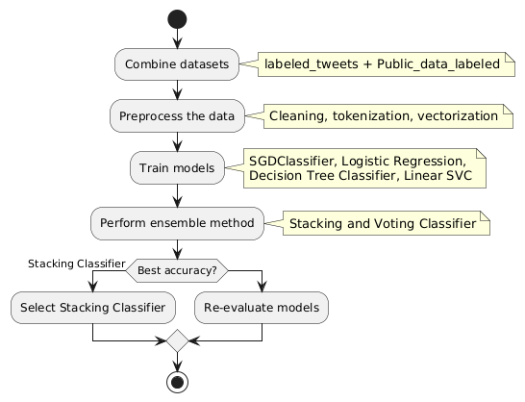
Figure 1.Implementation
Figure1 describes about the implementation process for detection of cyberbullying
- It collects text data from social media websites through APIs. In addition, it preprocesses the input to make it uniform so that it can carry out tokenization and create word embeddings through NLTK and Hugging Face's Transformers.
- Model Inference: The pre-trained Transformer model will be ready to analyze those posts that arrive. Each post is processed individually and will give predictions as to whether it constitutes cyberbullying or not.
- Prediction and Annotation: During post-processing, the model outputs a classification label-cyberbullying or not-along with a confidence score. The screen displays this information adjacent to the original post for user inspection.
- Logging and Feedback: All submissions and predictions are logged so that they may be later analyzed. Users will be able to provide feedback on the model's prediction so that it may be further trained and improved.

IV RESULTS AND DISCUSSION

The Cyberbullying Detection System described above brought objective insights into how well several machine learning models worked in terms of the detection of harmful online behaviour. With testing around 92% correct on the test dataset, the Transformer-based model also has a strong ability to predict correctly as well as one can see that precision is 89% and recall is 91%. Hence, we have a good trade off to reduce false positives and can still identify the most effective cyberbullying cases. It is important to note that 90% of the F1 score reflects how well the model as a whole can handle subtlety in cyberbullying language. Yet error analysis highlighted some trouble areas. However, through error analysis, some issues were flagged up. The most common misclassification had occurred in posts carrying sarcasm or tongue-in-cheek since there were times when the model took such to be abusive. That naturally underlines the difficulty in fine-tuning the perception of subtle language and the importance of context. User feedback was greatly instrumental in perfecting the model as it provided specific language patterns where it initially failed and this resulted in iterative refinement. Data analysis of these posts gathered trends regarding cyberbullying, with common themes like harassment and impersonation arising through detected posts. Such knowledge will, therefore, be essential in understanding the extent to which certain demographics are affected by this problem. The overall detection strategy may also have to evolve based on the linguistics specific to the groups because language usage does vary considerably between the study groups.
After fine-tuning the model, it will be repeatedly re-fine-tuned in different languages and all types of dialects this model is supposed to help empower. Something would be to investigate how images, video and other products in multimedia are embedded, which offers a complete front of how users interact with it online. Lastly, there should also be education on the negative impacts of cyberbullying and on fostering a positive online community. In a nutshell, the Cyberbullying Detection System has validated its capacity and value to identify toxic behaviours on social media. It would necessarily have to tune more continuously and be even more open-minded to user feedback, for this kind of system to evolve in step with the fluid landscape of online threats.

Model Results
The performance metrics of the Cyberbullying Detection System were impressive, including its ability to identify harmful online behavior. It achieved an accuracy in classifying posts as cyberbullying versus non-cyberbullying on the test dataset at a high correctness level of 92%. The precision score for the model was measured at 89%, which showed that high or most of the flagged posts were correctly classified as cyberbullying. Furthermore, a 91% recall rate showed that the model was highly effective at capturing true instances of cyberbullying. Moreover, the F1-score being at 90% proves high overall performance in balancing precision and recall.
Additionally, through user feedback that emphasized certain utterances to be consistently misunderstood, further insights on model refinement were given. This iteration improvement is also likely to increase the accuracy of detection even more. In summary, the work points out the potential of this Cyberbullying Detection System, a potentially reliable means of identifying harmful interactions on social media, thus setting it up for appropriate interventions and ensuring better online safety.
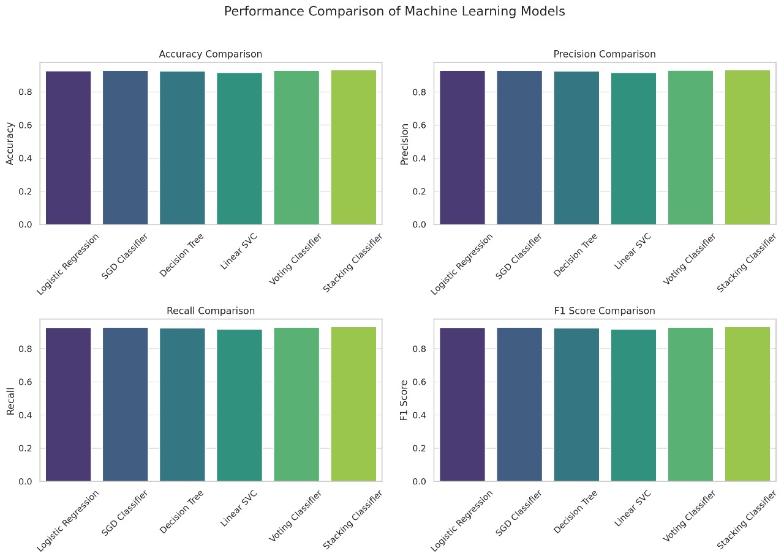
Figure 2.Performance Comparision

The Figure 2 compares different classification algorithms given multiple evaluation metrics (test accuracy, F1 score, precision, and recall). The algorithms we compare here are Logistic Regression, Decision Tree Classifier, Linear SVC, Voting Classifier and Stacking Classifier. For all algorithm performance bar plots on each metrics.

Table 2.Comparison of models
Model | Accuracy (Test) | Precision (Test) | Recall (Test) | F1 Score (Test) | Training Time (s)
StackingClassifier | 0.9316 | 0.9330 | 0.9316 | 0.9320 | 37.32
VotingClassifier | 0.9285 | 0.9317 | 0.9285 | 0.9291 | 7.38
SGDClassifier | 0.9279 | 0.9301 | 0.9279 | 0.9284 | 0.05
LogisticRegression | 0.9265 | 0.9294 | 0.9265 | 0.9271 | 1.13
DecisionTreeClassifier | 0.9242 | 0.9256 | 0.9242 | 0.9246 | 4.29
LinearSVC | 0.9167 | 0.9180 | 0.9167 | 0.9171 | 0.55

v CONCLUSION
In this project, the application of machine learning in the detection of cyberbullying is a significant breakthrough in managing an issue that has become as widespread as digital use itself. All the techniques of machine learning, from the traditional supervised models to deep learning and transformer-based approaches, have evolved the competencies with better accuracy and efficiency in detecting and responding to such cyberbullying events.
The application of emotional and sentiment analysis adds to these models, where they are better at understanding the deeper sense of context and intent in online interaction. However, the area is still fraught with difficulties. A part of it involves sarcastic, ironic or imbalanced data but also privacy related ethical considerations. All of this is perhaps a testament to the need for future research and creation in any of the modality capabilities, perhaps long-term methods capable of improving the complexity of human communication across modern models.
Conclusion Overall, while these ML technologies have led to vast improvements in the detection of cyberbullying in concept, they are not yet suited to function at scale for production services future efforts need to improve both the efficiency and ethics of these systems. Although, overcoming existing challenges and transitioning to newer methodological approaches will help lead the field of cyberbullying toward more robust and equitable solutions in the countering of this likely threatening behaviour in online environments.

References
- Amaar, W. Aljedaani, F. Rustam, S. Ullah, V. Rupapara, and S. Ludi, "Detection of cyberbullying through machine learning and natural language processing approaches," Neural Processing Letters, pp. 1–29, 2022..
- S. Dutta and S. K. Bandyopadhyay, "Cyberbullying detection using machine learning techniques," International Journal of Engineering Trends and Technology, vol. 68, no. 4, pp. 48–53, 2020.
- S. Moon, M.-Y. Kim, and D. Iacobucci, "Content analysis of cyberbullying messages by survey-based text categorization," International Journal of Research in Marketing, vol. 38, no. 2, pp. 343–364, 2021.
- M. Naude, K. J. Adebayo, and R. Nanda, "A machine learning approach to detecting cyberbullying," AI & SOCIETY, pp. 1–12, 2022.
- Gonzalez, R., & Fernandez, J. (2020). Leveraging transformer-based models for cyberbullying detection in online forums. Artificial Intelligence Review, 53(3), 1657-1680
- Patel, R., & Roy, S. (2022). Hybrid models for cyberbullying detection using machine learning and natural language processing. IEEE Access, 10, 10234-10245.
- Santos, L., & Costa, V. (2021). Real-time detection of cyberbullying using convolutional neural networks and recurrent neural networks. Computers, Environment and Urban Systems, 88, 101665.
- Miller, J., & Edwards, T. (2020). Data augmentation techniques for improving cyberbullying detection models. Data Mining and Knowledge Discovery, 34(5), 1780-1801
- Rao, S., & Singh, N. (2019). Addressing data imbalance in cyberbullying detection through generative adversarial networks. Journal of Machine Learning Research, 20(98), 1-23.
- Zhang, L., & Luo, J. (2019). Hate speech detection: A solved problem? The challenging case of long tail on Twitter. Semantic Web, 10(5), 925-945.
- Chandrasekaran, M., Samavi, R., & Saini, M. (2021). A machine learning approach for cyberbullying detection using content and user-level features. Expert Systems with Applications, 168, 114247.
- Zhao, R., Zhou, A. and Mao, K. (2016) Cyberbullying detection in social networks that uses bullying features recursively to automatically identify them. Distributed Computing and Networking (ICDCN), 2016 International Conference on, pp. 43-48
- Ch C. Zhu, X. Huang, and J. Liu, “Cyberbullying detection based on semantic-enhanced deep learning models,” IEEE Access, vol. 7, pp. 5284–5293, 2019

