Game Design Document

Fill up the following document

1. Write the title of your project.

Super Fighting Game

1. What is the goal of the game?

The player has to defet the opponent player

1. Write a brief story of your game.

In this game you have to defet the opponent player to get points

And you have to fight to get WWE belt

1. Which are the playing characters of this game?

* Playing characters are the ones who respond to the user based on the input from the user.
* Cars, monkeys, dinos, wizards, etc., are the playing characters in the game.

|  |  |  |
| --- | --- | --- |
| Number | Character Name | What can this character do? |
| 1 | Human 1 | He can do fighting |
| 2 | Human 2 | He can do fighting |
| 3 |  |  |
| 4 |  |  |
| 5 |  |  |
| 6 |  |  |
| 7 |  |  |
| 8 |  |  |

1. Which are the Non-Playing Characters of this game?

* Non-Playing characters are the ones that don't have an action or behavior when the user interacts with the game.
* Hurdles, stones, bananas, coins, etc., are non-playing characters in the game.

|  |  |  |
| --- | --- | --- |
| Number | Character Name | What can this character do? |
| 1 |  |  |
| 2 |  |  |
| 3 |  |  |
| 4 |  |  |
| 5 |  |  |
| 6 |  |  |
| 7 |  |  |
| 8 |  |  |

Draw your imagination of this game. What does this game look like?

* Draw the game either on your computer or on paper.
* Add images of the game scenes to show each of the playing and non-playing characters at least once.

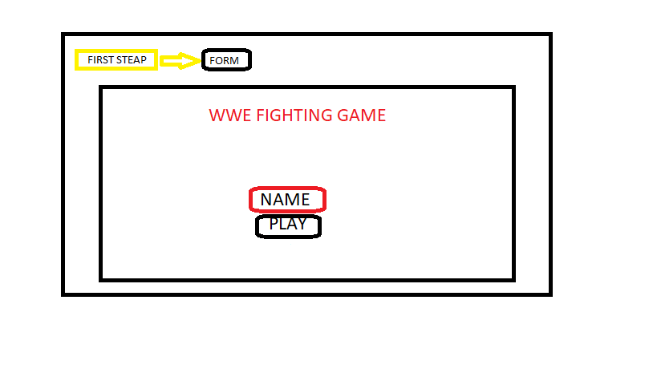

This is opening page of this game title,name and play

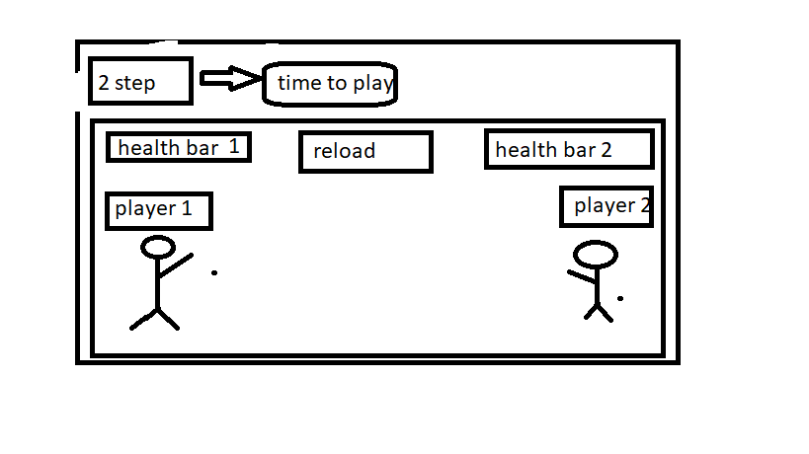

In this step you have to fight and win

How do you plan to make your game engaging?

I will make it has multiplayer game to play with his friends