Software Requirements Specification (SRS) Document
Project Mystique - Team 37 - Amuluru Sai Kamal , K.L.N.Saketh , S.Preetham Reddy

Brief problem statement
In the supply chain the goods cannot be monitored constantly and can be tampered at any stage . So Statwig helps in keeping a record of the supply chain at any given instant by using IoT and Block- chain Technology . It provides real-time tamper-proof end-to-end tracking that identifies inefficiencies and issues in any supply chain .

System requirements
The application requires JS , HTML , CSS and GoLang . In addition it requires the following libraries :
JQuery in JS
Bootstrap for CSS

Users profile

There will be two types of login : Admin and User . The admin would be able to see all the actions of the users and validate them . User can see his /her related packages. It is an application which primarily focuses on the transport of vaccines. But it can be used by startups and companies which want to track sensitive packages. It will be a huge help for pharmaceutical companies where temperature of the medicines is to be monitored and it prevents smuggling and discrepancies in data tampering.

Usage Model and Diagrams

Feature requirements (described using user stories)

User Stories for the Home page as a General User:
No. | User Story Name | Description | Release
1 | Sign-up | Initialization :  If the user is not registered on the website he must click on the this button which redirects him to the signup page . | R1
2 | Login | When this button is clicked the person will be redirected  to the login page . | R1
3 | Home | On clicking this button the user is redirected to the home page. | R1
4 | What We Do | On clicking this button the user will be redirected to the What We Do section in the same page . | R1
5 | Contact Us | When this button is clicked the user will be redirected to the Contact Us section in the same page . | R1

User Stories for the Login page as a General User :
No. | User Story Name | Description | Release
1 | Login | If this button is clicked after entering information into the fields correctly the user will be logged in and redirected to his user page . Else he will be asked to enter the information again . | R1
2 | Cancel | On clicking this button the user will be redirected to Home page . | R1

User Stories for the Sign-up Page as a General User:
No. | User Story Name | Description | Release
1 | Sign-up | If this button is clicked after filling up the fields correctly then the admin receives a request from the user regarding his sign up . It depends on the admin whether to approve it or not . If the user didn’t fill up the details correctly then he will be asked to enter the information again . | R1
2 | Cancel | If this button is clicked the user will be redirected to the Home page . | R1

User Stories for User Page as a General User and Company User:
No. | User Story Name | Description | Release
1 | Settings | Upon clicking the settings button the user will be shown various options like personal settings, logout, etc. This feature remains the same in all successive pages. | R2
2 | Visualization of blocks | This page displays the blocks linked to all the products added by that user and on hovering over the blocks, the he/she can see the information corresponding to that block. Underneath the blocks ,the user can see the packages he/she is related to. By clicking on a certain package the user is redirected to the Package Tracking Page where he/she can see the status of that package. The blocks displayed are the ones which were most recently added to the blockchain. | R1
3 | Add Package | Upon clicking this button the user will be redirected to the Add Package page where he/she can fill details about the package and add it to the blockchain. | R1
4 | Search Bar | Using this the user can search for a particular package using the package ID or name or any other value. | R2
5 | Filtration | On clicking this option/button, a pop-up get displayed in which the user can see various parameters like date, location,etc according to which he can filter the packages and the blocks displayed in the page. | R1
6 | All Packages | On clicking this button, the user is taken to the initial stage of this page(all the filtrations are removed). Clicking on the logo does the same thing. This features remains the same in all the successive pages. | R1
7 | Personal Settings | The user can change his personal settings when he/she selects the personal settings option from the settings menu. | R1

User Stories for User Page as Admin(website):
No. | User Story Name | Description | Release
1 | Settings | Upon clicking the settings button the admin will be shown various options like management of users, requests from users, etc in addition to those available to the general user. | R2
2 | Visualization of blocks | This page displays the blocks linked to all the products of all the users and on hovering over the blocks, the admin can see the information corresponding to that block. Underneath the blocks ,the admin can see the packages related to every user. By clicking on a certain package the admin is redirected to the Package Tracking Page where he/she can see the status of that package. | R1
3 | Create Blockchain | On clicking this the user is redirected to page where he can:  1.) Create a block chain  2.) Alter the permissions of various users and can also make certain users as company admins .  3.) Can alter the permissions of company admins . | R2
4 | Manage Companies | On clicking this the user is redirected to a page where he can :  1) Delete companies .  2) Approve requests of companies and add them .  3) Assign companies a company admin and give permissions to him . | R2

User Stories for User Page as Company Admin(website):
No. | User Story Name | Description | Release
1 | Settings | Upon clicking the settings button the company admin will be shown various options like management of company users, requests from company users, etc in addition to those available to the general user. | R2
2 | Visualization of blocks | This page displays the blocks linked to all the company products and on hovering over the blocks, the company admin can see the information corresponding to that block. Underneath the blocks ,the company admin can see the packages related to the company. By clicking on a certain package the company admin is redirected to the Package Tracking Page where he/she can see the status of that package. | R1

User Stories for Package Tracking page as a General User:
No. | User Story Name | Description | Release
1 | Tracking Of Package | This shows the status of the package when hovered over the truck(symbol). When hovered over a certain pit stop we can see the status of the package when it was at that pit stop. The information is shown using pop-ups. | R1
2 | Search Bar | The Search bar helps us in searching for a certain pit stop or block and the visualization would change accordingly. | R2
3 | All Blocks | The representation above shows only a certain number of blocks, so to see all the blocks corresponding to that package the user has to click this button. The user is redirected to the All Blocks page. | R1

User Stories for Add Package page as a General User:
No. | User Story Name | Description | Release
1 | Add Package | The User can add a package after filling up the details correctly. | R1

User Stories for All Blocks page as a General user:
No. | User Story Name | Description | Release
1 | Search Bar | The user can use this to search for a particular block with some specific parameters. | R2
2 | Filtration | The user can use this option to filter the list of blocks according to a set of specifications like time of creation, location,status, etc. | R1

Use case diagram
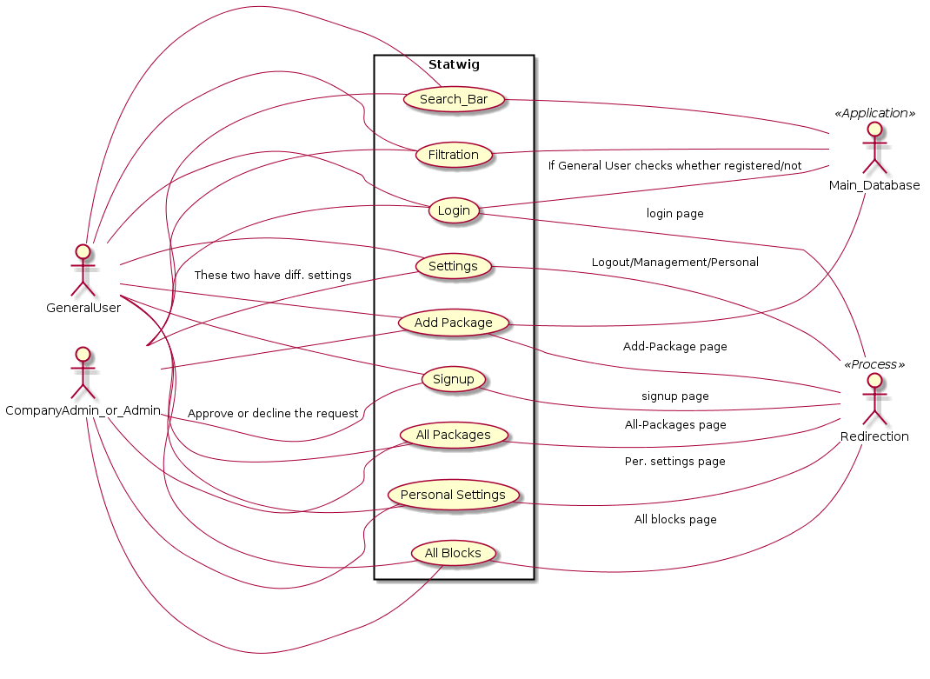

Use case description

Use-Case Number: | UC-01
Use-Case Name: | Sign-up
Overview: | This user case is to describe the sign-up process .
Actors: | User
Precondition | NULL
Flow: | Main (success) Flow:  1. When the user clicks the sign-up button , he will be redirected to the sign-up page.  2. In the sign-up page the user fills the required fields.  3. Then on clicking the sign-up button a request will be sent to the Admin .  4. If he clicks the Cancel button anywhere in between he will be redirected to the Home page.
Alternate Flows:
3. Password should contain atleast one special character , one capital letter and one number . If any of these constraints is broken then the user will be asked to enter the information once again .
3. If the passwords entered in the password field and the confirm password field are different then the user would have to enter the information once again .
Post Condition: | A request is sent to the Admin with the details of the particular user .
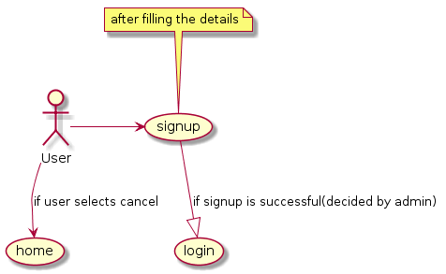

Use-Case Name : | Login
Overview : | This user case is to describe the process of login
Actors : | User
Precondition : | The user should be registered
Flow : | Main (success) Flow:  1. When the user clicks the login button , he will be redirected to the login page .  2. In the login page the user fills the required fields .  3. Then on clicking the login button the user will be redirected to his user page .  4. If he clicks the Cancel button anywhere in between he will be redirected to the Home page .
Alternate Flow:
3. If the user enters the wrong username/password he will be asked to enter it again .
Post-condition : | The user would be logged in and can see his user page .

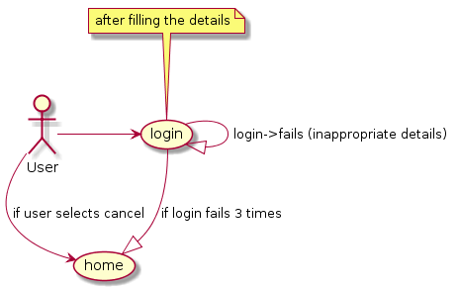

Use-Case Number : | UC-03
Use-Case Name : | What We Do
Overview : | This use case is to describe the functionality of What We Do button.
Actors : | User
Precondition: | NULL
Flow : | Main (success) flow:  1. When the user clicks the button he will be redirected to the What We Do section in the same page .  2. This section describes the projects and works that Statwig is doing .
Alternate flows :
NULL
Post-condition : | The user can see the What We Do section .

Use-Case Number : | UC-04
Use-Case Name : | Contact Us
Overview : | This use case is to describe the functionality of Contact Us button.
Actors : | User
Precondition: | NULL
Flow : | Main (success) flow:  1. When the user clicks the button he will be redirected to the Contact US section in the same page .  2. This section has the location of the company and contact numbers .
Alternate flows :
NULL
Post-condition : | The user can see the Contact Us section .

Use-Case Number : | UC-05
Use-Case Name : | Logo
Overview : | This use case is to describe the functionality of the logo.
Actors : | User
Precondition: | NULL
Flow : | Main (success) flow:  1. If the user is not logged in , on clicking the logo the page will be refreshed and he can see the latest information about the blocks .  2. If the user is logged in he will be redirected to the All Packages page and can now see the latest information of the packages .
Alternate flows :
NULL
Post-condition : | The user can see the updated information .

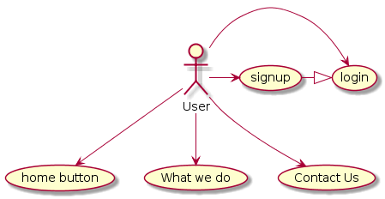

Use-Case Number: | UC-06
Use-Case Name: | Settings
Overview: | This user case is to describe the settings option present in all the successive pages after login.
Actors: | User (all types)
Precondition | User must be logged in.
Flow: | Main (success) Flow:  1. When the user clicks the settings button , a pop-up appears with a certain set of features depending on the type of user. For the general user ,it has logout, personal settings. The company admin has control over his company users. The admin has control over all users. The permissions for a certain user can be modified using the appropriate feature in this menu (management) by the company Admin/Admin .  2. The user chooses the appropriate option and this invokes a certain page/function.
Main Flow types:
2. If the user clicks on the Logout button,then the user is logged out and redirected to the Home Page.
2. If the user clicks on the Personal Settings button, then the user is redirected to a page where he can modify his personal settings.
2. If the user(admin/company admin) has a control over a certain set of users, then he/she can change their privileges using the management option.
Post Condition: | True.

Use-Case Number: | UC-07
Use-Case Name: | Add Package
Overview: | This user case is to describe the process of adding a new package to the blockchain.
Actors: | User
Precondition | User must be logged in.
Flow: | Main (success) Flow :  1. The user is redirected to this page when he/she clicks on the Add Package button.  2. The user fills the details corresponding to the package in the appropriate input boxes.  3. He/she clicks on the Add button to add the package to the blockchain and start tracking it.
Alternate Flows:
3. If the user clicks on the cancel button, then he/she is redirected to the All Packages page.
Post Condition: | True.

Use-Case Number: | UC-08
Use-Case Name: | Search Bar
Overview: | This user case is to describe the searching process using the Search Bar.
Actors: | User
Precondition | User must be logged in.
Flow: | Main (success) Flow:  1. The user gives a certain property of the package/block that he wants to search for as input and clicks on the search button.  2. If the search is successful then the page shows the blocks/packages satisfying the the properties.
Alternate Flows:
2. If the search is not successful then the page shows the original page with a error message.
Post Condition: | The search is successful.

Use-Case Number: | UC-09
Use-Case Name: | Filtration
Overview: | This user case is to describe the filtration process .
Actors: | User
Precondition | The user must be logged in.
Flow: | Main (success) Flow:  1. The user clicks on the Filtration button and then a pop-up appears.  2. Then the user selects the limits/options for certain properties like time, geo location, status, etc.  3. The user clicks on the Apply button.  4. The page now shows the filtered output if it is successful.
Alternate Flows:
4. If the search failed then the original page is shown.
Post Condition: | The filtration process is successful.

Use-Case Number: | UC-10
Use-Case Name: | All Packages
Overview: | This user case is to describe the All Packages button .
Actors: | User
Precondition | The user must be logged in.
Flow: | Main (success) Flow:  1. When the user clicks on the button,then he/she is redirected to the original all packages page.  2. If there are any filtrations in the all packages page,then they are removed and the original page is displayed.
Alternate Flows:
NULL
Post Condition: | The user can see all the packages .
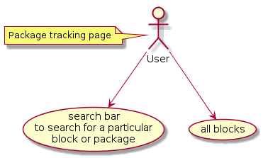

Use-Case Number: | UC-11
Use-Case Name: | Personal Settings
Overview: | This user case is to describe the process of changing the personal settings.
Actors: | User
Precondition | The user must be logged in.
Flow: | Main (success) Flow:  1. The user chooses the personal settings from the Settings menu and is directed to the personal settings page.  2. In this page the user can modify his personal settings.  3. The user clicks on the Apply button.  4. The user is redirected to the All packages page.
Alternate Flows:
3. If the modified values are not meeting the appropriate conditions then the user has to change them and then apply them.
Post Condition: | The settings that the user has changed will now be applied .

Use-Case Number: | UC-12
Use-Case Name: | All Blocks
Overview: | This user case is to describe the process when the user clicks on the All Blocks button.
Actors: | User
Precondition | The user must be logged in and should be in the Package Tracking Page.
Flow: | Main (success) Flow:  1. The user clicks on the All Blocks button from the Tracking of Package page.  2. The user is redirected to the All Blocks page where he/she can see the list of all the blocks regarding to the package.  3. The user can filter out the output from the page using the filter option.
Alternate Flows:
NULL
Post Condition: | The user can see all the blocks .

Use-Case Number | UC-13
Use-Case Name | Manage Companies
Overview | This use case describes the process of managing companies.
Actors | User(Admin)
Precondition | The User must be logged in as Admin.
Flow | On clicking the Manage Users option the admin will be redirected to a page where he can perform the following things :  1) Delete companies.  2) Approve requests of the companies and create them in the application.  3) Can create company admins and manage their permissions .
Postcondition | The users would now use the application according to updates made by Admin.

Use-Case Number | UC-14
Use-Case Name | Create Blockchain
Overview | This use case is used to describe the process of creating a blockchain
Actors | User(Admin)
Precondition | The User must be logged in as the Admin
Flow | On selecting this option the user is redirected to a page where he can:  1.) Create a block chain .  2.) Alter the permissions of various users and can also make certain users as company admins .  3.) Can alter the permissions of company admins .
Post-condition | The blockchain will be created and the company admin would be notified .

