@relation student

@attribute age {<30,30-40,>40}

@attribute income {low,medium,high}

@attribute student {yes,no}

@attribute credit-rating {fair,excellent}

@attribute buyspc {yes,no}

@data

%

<30,high,no,fair,no

<30,high,no,excellent,no

30-40,high,no,fair,yes

>40,medium,no,fair,yes

>40,low,yes,excellent,no

>40,low,yes,fair,yes

30-40,low,yes,excellent,yes

<30,medium,no,fair,no

<30,low,yes,fair,no

>40,medium,yes,fair,yes

<30,medium,yes,excellent,yes

30-40,medium,no,excellent,yes

30-40,high,yes,fair,yes

>40,medium,no,excellent,no

%

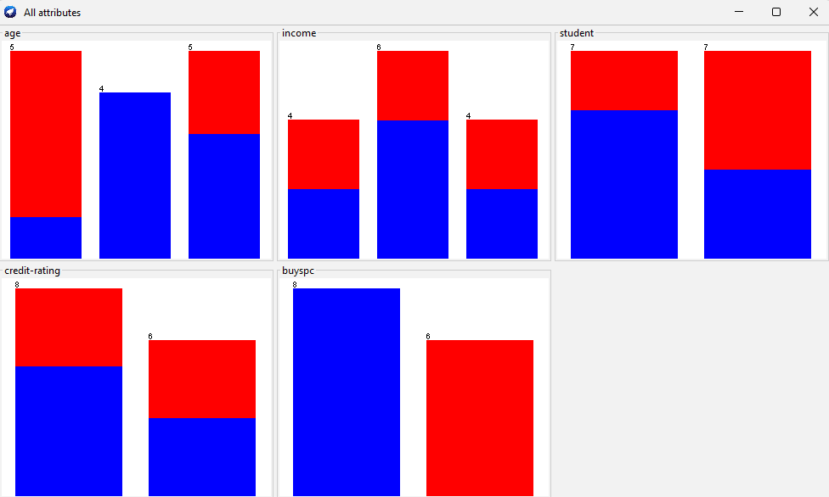

@relation library

@attribute book-type {textbook, magazine, reference}

@attribute membership-type {basic, premium, student}

@attribute quiet-area {yes, no}

@attribute computer-access {yes, no}

@attribute events {yes, no}

@data

%

magazine,basic,yes,yes,no

reference,premium,yes,yes,yes

textbook,student,yes,no,no

textbook,basic,yes,no,no

magazine,premium,no,yes,yes

textbook,premium,no,no,no

magazine,basic,yes,no,no

reference,basic,no,yes,no

textbook,student,yes,yes,no

textbook,basic,no,no,no

magazine,student,no,no,yes

textbook,premium,no,no,yes

%

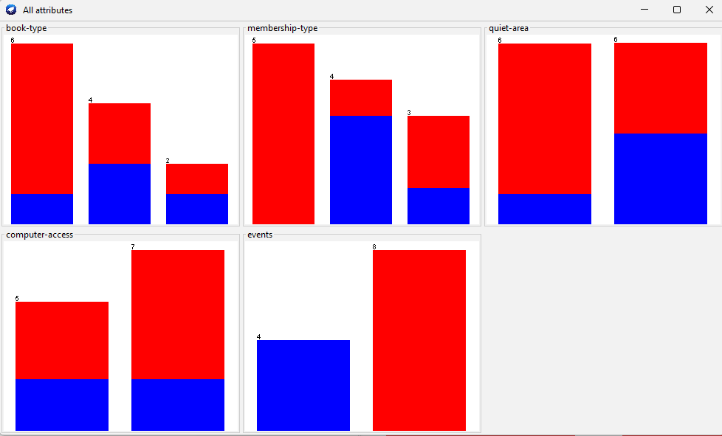

@relation hospital

@attribute capacity {low,medium,high}

@attribute type {childrens,elders,old}

@attribute rating {good,bad}

@attribute time {6am,7am,8am}

@data

%

low,old,bad,8am

high,childrens,good,7am

medium,elders,good,6am

low,elders,bad,7am

low,childrens,bad,6am

high,elders,bad,8am

high,old,bad,8am

medium,childrens,good,7am

low,old,bad,7am

low,childrens,good,6am

high,elders,good,7am

high,old,good,8am

medium,childrens,bad,7am

%

