COMPARATIVE PERFORMANCE ANALYSIS OF
MACHINE LEARNING CLASSIFICATION ALGORITHMS
USING SCIKIT-LEARN
Final Project Report
Breast Cancer Wisconsin (Diagnostic) Dataset
Team Members:
1. Saketh Ram - Roll Number: 24261A1239
2. Ujwala - Roll Number: 24261A1235
Department: Information Technology (IT)
College: Mahatma Gandhi Institute of Technology (MGIT), Hyderabad
Academic Year: 2026-2027
Submitted in partial fulfillment of the academic mini-project requirements

Abstract
This project explores and classifies the Breast Cancer Wisconsin (Diagnostic) dataset bundled with Scikit-learn. Part 1 examined 569 records and 30 numerical features, found no missing, non-finite, or duplicate complete rows, and prepared one stratified 80/20 holdout split (455 training and 114 testing samples). StandardScaler was fitted only to training features; standardized features were used for Support Vector Classifier (SVM), while Random Forest, Gaussian Naive Bayes, and Gradient Boosting used the original features. On this test split, SVM achieved the highest accuracy (0.9825), malignant-positive F1-score (0.9762), and malignant recall (0.9762). Its matrix records one missed malignant case and one benign case classified malignant. These results are an educational comparison on one holdout set and do not establish clinical validity.

1. Introduction and Background
Supervised classification learns a mapping from labeled examples to class predictions. Comparing models on the same held-out observations illustrates differences in their predictive behavior. In medical-diagnosis examples, aggregate accuracy can hide errors for a clinically important class. This project therefore treats malignant (label 0) as the positive class for precision, recall, and F1-score and discusses missed malignant cases explicitly.

2. Problem Statement
Implement and compare four Scikit-learn classification algorithms on the Breast Cancer Wisconsin (Diagnostic) dataset, measure their performance consistently, and identify the model with the strongest measured results while highlighting malignant-class recall.

3. Objectives
- Load and explore the built-in dataset without an external data download.
- Check dimensions, class balance, data types, missing values, duplicates, and non-finite values.
- Create one reproducible stratified split and prevent test-data leakage during scaling.
- Train four classifiers on the shared split and compare their test-set predictions.
- Interpret class-specific metrics and confusion matrices from verified output files.

4. Dataset Description and Source
The dataset is loaded with sklearn.datasets.load_breast_cancer(); it is included with Scikit-learn and needs no external CSV. It contains 569 samples and 30 real-valued features computed from digitized fine needle aspirate images. The feature set describes cell-nucleus characteristics in mean, standard-error, and worst-value groups. Target mapping: 0 = malignant; 1 = benign.
Dataset fact | Observed value
Samples / features | 569 / 30
Malignant (label 0) | 212 (37.26%)
Benign (label 1) | 357 (62.74%)
Missing / non-finite feature values | 0 / 0
Duplicate complete rows | 0

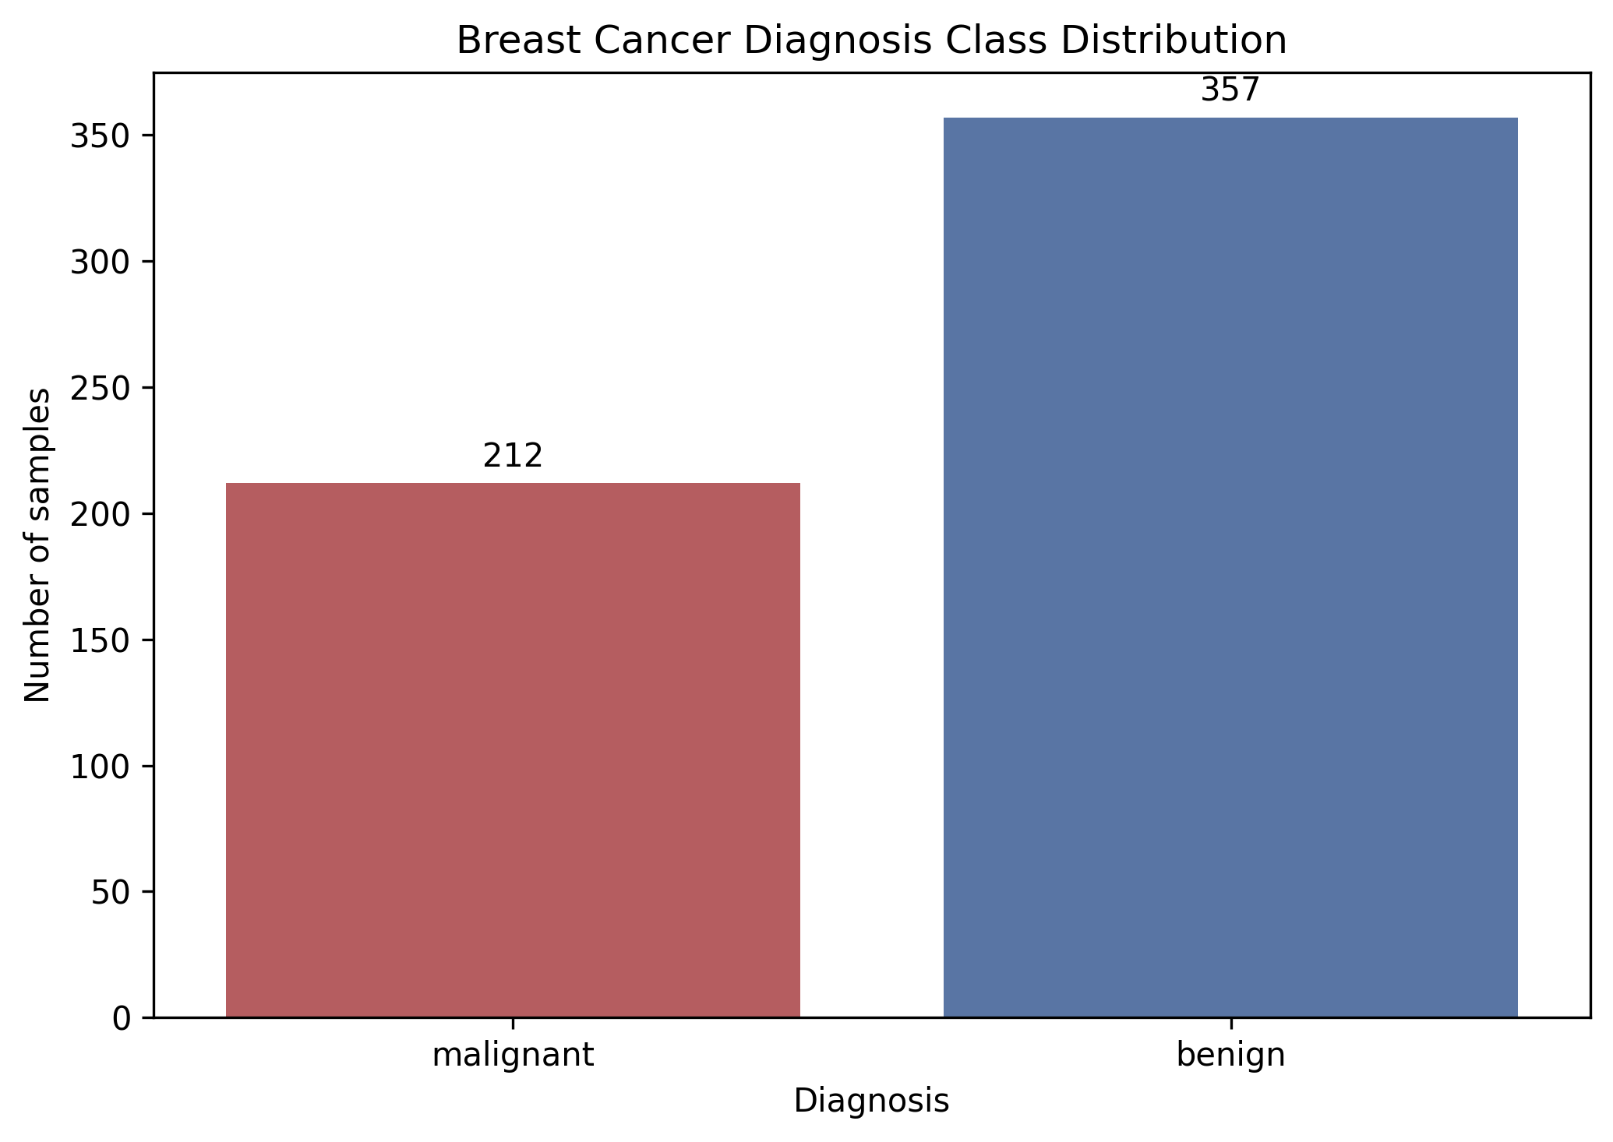
Figure 1. Class distribution in the complete dataset.

5. Software and Libraries
The implementation uses Python 3, NumPy, Pandas, Matplotlib, Seaborn, and Scikit-learn. Python-docx was used to generate this report only; it is not required to run the experiment. Scikit-learn supplies the dataset loader, splitting and scaling utilities, classifiers, and metrics.

6. Methodology and Workflow
- Load the bundled dataset into a Pandas feature DataFrame and target Series.
- Explore feature types/statistics and check missing, non-finite, and duplicate values.
- Split once with test_size=0.20, random_state=42, and stratify=y.
- Fit StandardScaler on X_train only, then transform train and test features; retain unscaled features.
- Train four classifiers on the identical train/test indices; scale features only for SVM.
- Evaluate held-out predictions and save the CSV, confusion matrices, and comparison charts.
Implementation: preprocessing.py contains Part 1 data preparation; main.py orchestrates model training; evaluation.py contains reusable metrics and evaluation plots.

7. Data Exploration and Preprocessing
The saved dataset summary reports the 569-by-30 shape, numerical data types, describe() statistics, feature-level missing/non-finite counts, complete-row duplicate count, class frequencies, and per-feature minimum, maximum, mean, and standard deviation. No rows or columns required deletion or imputation.
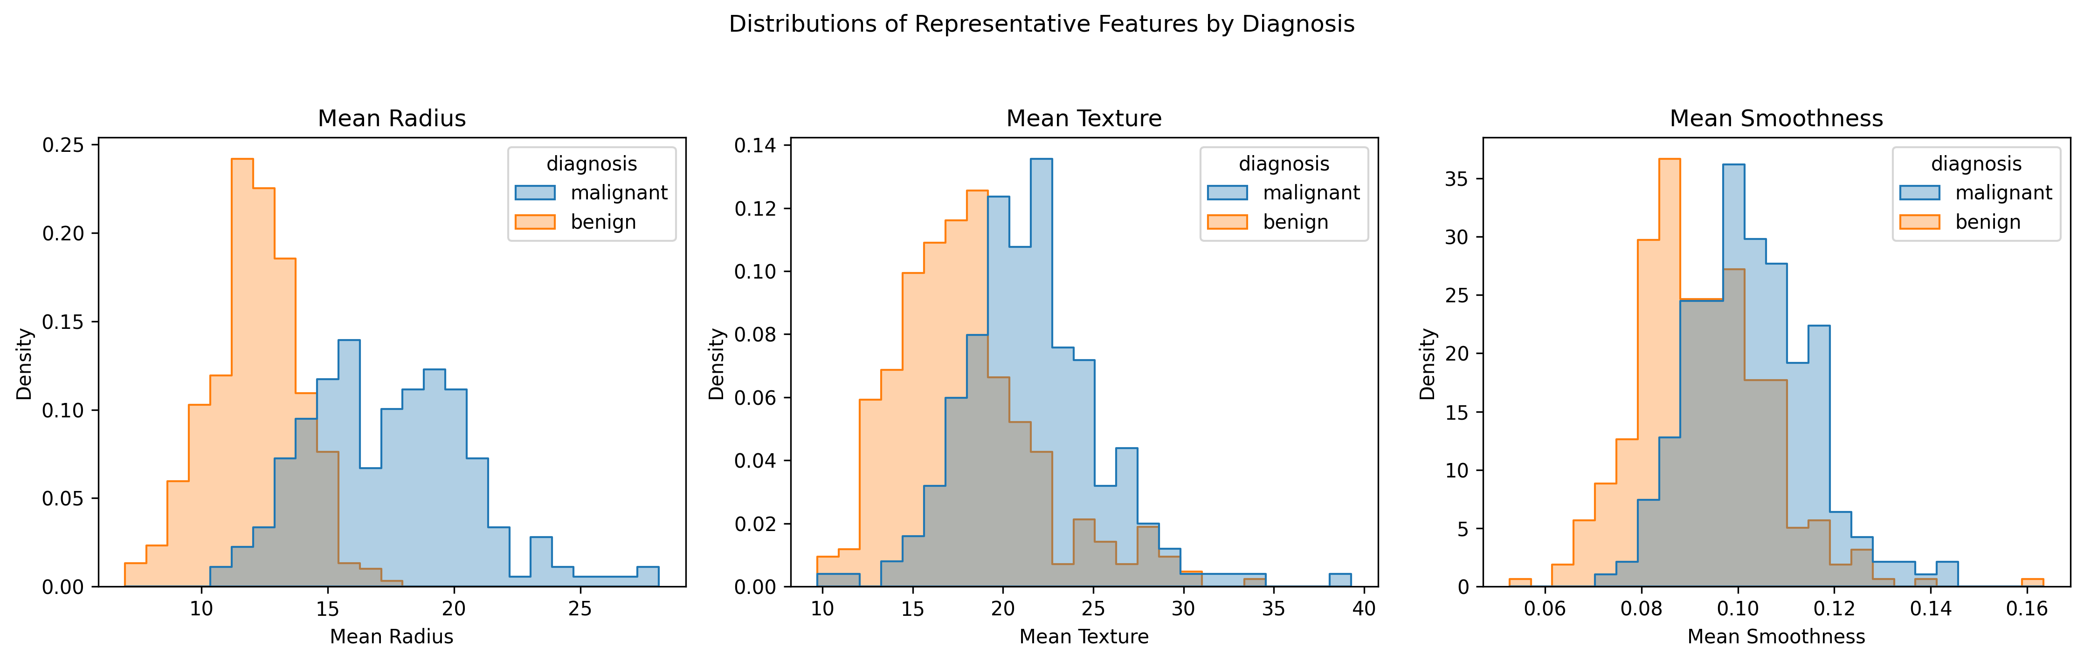
Figure 2. Representative feature histograms by diagnosis.
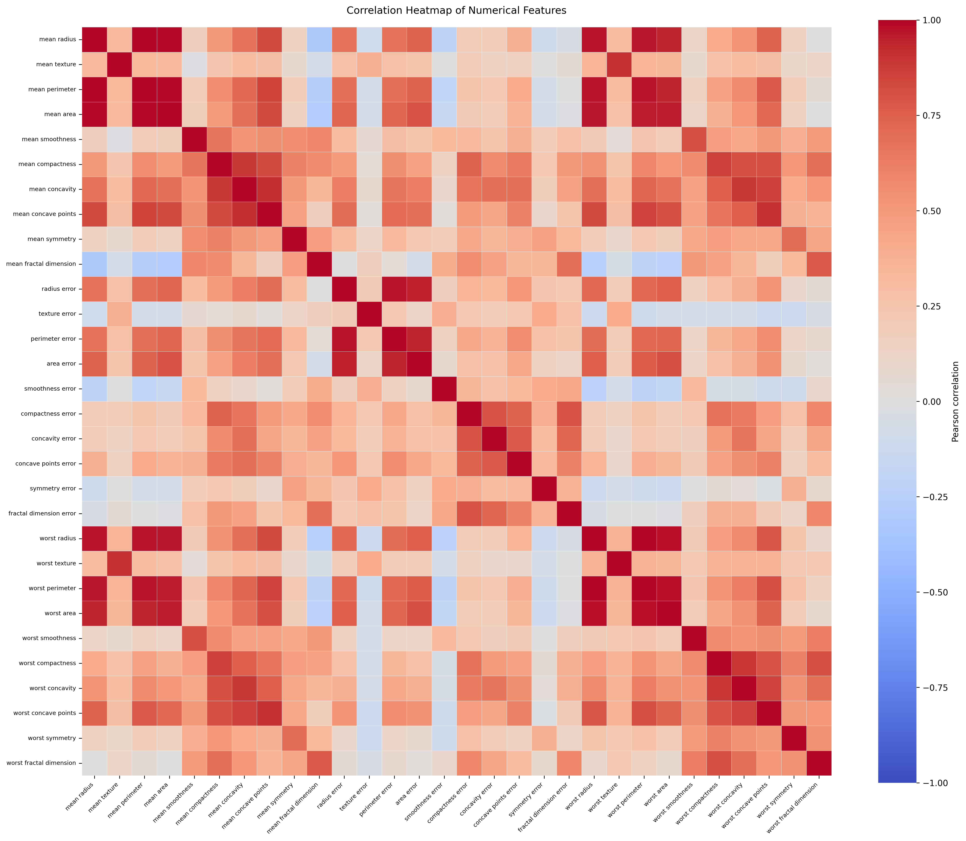
Figure 3. Pearson correlations among numerical features.

8. Classification Algorithms

Random Forest Classifier
An ensemble of decision trees trained with randomized samples/features; tree votes are aggregated for prediction. Settings: 300 estimators, random_state=42, parallel fitting.

Support Vector Classifier (SVM)
An SVC seeks a separating boundary with a large margin. The RBF kernel represents nonlinear boundaries. Settings: C=1.0, gamma='scale'; uses standardized features.

Gaussian Naive Bayes
A probabilistic classifier applying Bayes' rule with a conditional-independence assumption and Gaussian feature likelihoods; uses Scikit-learn defaults and unscaled features.

Gradient Boosting Classifier
A sequence of shallow trees is added to improve on earlier residual errors. Settings: 100 estimators, learning_rate=0.1, max_depth=3, random_state=42.

9. Train/Test Split and Scaling Strategy
A single stratified split uses test_size=0.20, random_state=42, and stratify=y: 455 training samples and 114 test samples. The test set contains 42 malignant and 72 benign observations. StandardScaler is fitted only on X_train and then applied to train and test features, preventing test-set statistics from influencing the scaling transform. The original features remain available. SVM uses scaled features; the other models use unscaled features. Target labels are not transformed.

10. Evaluation Metrics
Malignant is the positive class. TP is malignant correctly classified malignant; FN is malignant predicted benign; FP is benign predicted malignant; TN is benign correctly predicted benign. Scikit-learn uses zero_division=0 for precision/recall/F1 and classification reports.
Metric | Formula | Interpretation
Accuracy | (TP + TN) / total | Fraction of all predictions correct.
Malignant precision | TP / (TP + FP) | Of malignant predictions, fraction truly malignant.
Malignant recall | TP / (TP + FN) | Of actual malignant cases, fraction detected.
Malignant F1 | 2 × P × R / (P + R) | Harmonic mean of malignant precision and recall.

Benign precision, recall, and F1 are also in the CSV; classification reports cover both classes. Confusion-matrix rows are actual classes and columns are predictions, ordered malignant then benign.

11. Experimental Results
Values below are copied from outputs/comparison_results.csv and rounded to four decimal places; the CSV stores six decimal places. P, R, and F1 refer to the malignant positive class.
Model | Acc. | Mal. P | Mal. R | Mal. F1 | Ben. P | Ben. R | Ben. F1
Random Forest | 0.9474 | 0.9286 | 0.9286 | 0.9286 | 0.9583 | 0.9583 | 0.9583
Support Vector Machine (SVM) | 0.9825 | 0.9762 | 0.9762 | 0.9762 | 0.9861 | 0.9861 | 0.9861
Gaussian Naive Bayes | 0.9386 | 0.9268 | 0.9048 | 0.9157 | 0.9452 | 0.9583 | 0.9517
Gradient Boosting | 0.9561 | 0.9744 | 0.9048 | 0.9383 | 0.9467 | 0.9861 | 0.9660

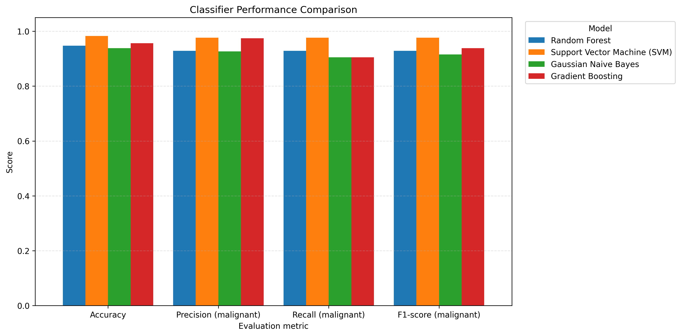
Figure 4. Accuracy and malignant-class precision, recall, and F1-score by model.

11.1 Confusion Matrices
Model | Actual malignant → [malignant, benign] | Actual benign → [malignant, benign]
Random Forest | [39, 3] | [3, 69]
Support Vector Machine (SVM) | [41, 1] | [1, 71]
Gaussian Naive Bayes | [38, 4] | [3, 69]
Gradient Boosting | [38, 4] | [1, 71]

Matrix order is [[TP, FN], [FP, TN]]. SVM detected 41/42 malignant samples and correctly classified 71/72 benign samples. Random Forest had 3 false negatives and 3 false positives; Gaussian Naive Bayes had 4 false negatives and 3 false positives; Gradient Boosting had 4 false negatives and 1 false positive. Each matrix sums to the 114 test observations and agrees with the saved CSV metrics.
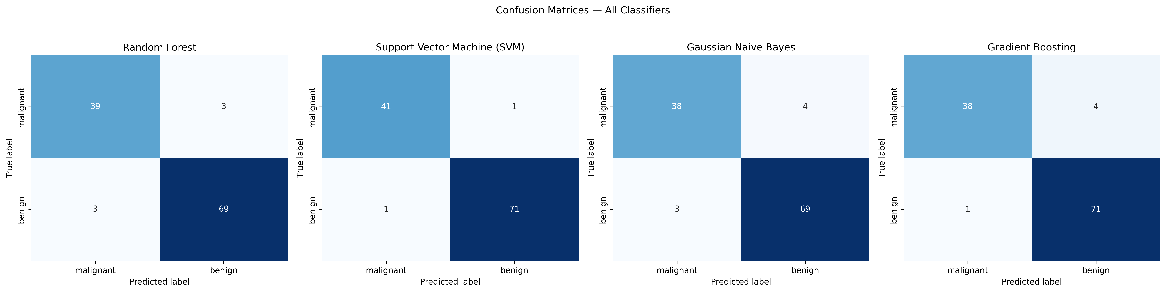
Figure 5. Combined confusion matrices; rows are actual labels and columns are predictions.

12. Results Analysis and Best-Model Selection
On this 114-sample holdout set, Support Vector Machine (SVM) is the measured best model under malignant-class F1-score (0.9762). It also achieved accuracy 0.9825, malignant precision 0.9762, and malignant recall 0.9762. Its matrix contains 41 true positives, one false negative, one false positive, and 71 true negatives: 112 correct classifications of 114.
Malignant recall matters because a false negative means a malignant sample was predicted benign. Support Vector Machine (SVM) had the highest measured malignant recall (0.9762), missing one of 42 malignant test cases. Random Forest detected 39/42 (0.9286); Gaussian Naive Bayes and Gradient Boosting each detected 38/42 (0.9048). These counts are not a clinical safety assessment.
Gradient Boosting had malignant precision 0.9744 but recall 0.9048: it produced one false positive but missed four malignant cases. This illustrates why precision or accuracy alone does not describe the full error profile.

13. Conclusion
The project completed dataset exploration, leakage-conscious preprocessing, and a four-model comparison on one shared stratified holdout split. SVM performed best on accuracy, malignant-class F1, and malignant-class recall in the recorded experiment. The confusion matrices show the different false-negative and false-positive patterns. These conclusions apply only to this split and these model settings.

14. Limitations and Future Enhancements
- Evaluation uses one 80/20 split; repeated cross-validation and independent external validation were not performed.
- Parameters were not systematically tuned; uncertainty intervals and significance tests were not calculated.
- The dataset is relatively small and has unequal class counts (212 malignant; 357 benign).
- No calibration, threshold analysis, subgroup/fairness analysis, or prospective clinical evaluation was done.
- Future educational work could use stratified cross-validation, training-fold-only tuning, uncertainty estimates, and additional metrics with qualified domain oversight.
Important: This project is for educational use only. It is not clinically validated, is not a medical device, and must not be used to diagnose or guide treatment.

15. References
1. Scikit-learn, load_breast_cancer API. https://scikit-learn.org/stable/modules/generated/sklearn.datasets.load_breast_cancer.html
2. Scikit-learn, Breast cancer Wisconsin diagnostic dataset. https://scikit-learn.org/stable/datasets/toy_dataset.html#breast-cancer-dataset
3. Scikit-learn, train_test_split API. https://scikit-learn.org/stable/modules/generated/sklearn.model_selection.train_test_split.html
4. Scikit-learn, StandardScaler API. https://scikit-learn.org/stable/modules/generated/sklearn.preprocessing.StandardScaler.html
5. Scikit-learn, RandomForestClassifier API. https://scikit-learn.org/stable/modules/generated/sklearn.ensemble.RandomForestClassifier.html
6. Scikit-learn, SVC API. https://scikit-learn.org/stable/modules/generated/sklearn.svm.SVC.html
7. Scikit-learn, GaussianNB API. https://scikit-learn.org/stable/modules/generated/sklearn.naive_bayes.GaussianNB.html
8. Scikit-learn, GradientBoostingClassifier API. https://scikit-learn.org/stable/modules/generated/sklearn.ensemble.GradientBoostingClassifier.html
9. Scikit-learn, classification metrics. https://scikit-learn.org/stable/modules/model_evaluation.html#classification-metrics

