Hardware Specifications

Using our system description and schematics, a small model of our system consists of having 4 API servers, a load balancer, 1 MySQL Management Node, 2 MySQL Data Nodes, and 4 Redis Caches. 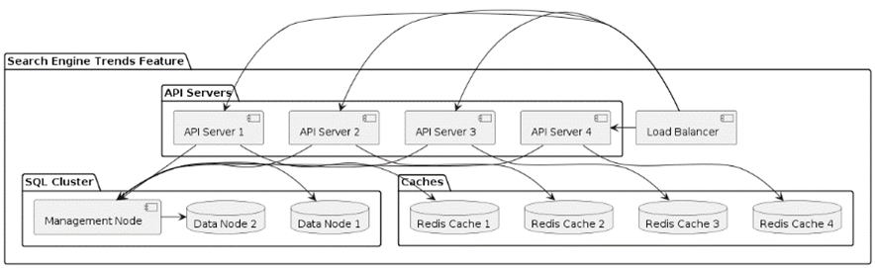

The 4 API Servers would have the following configuration:

* Dell R740xd 12 LFF
* CPU: 2 x Intel Xeon Bronze 3104 (6C 8.25M Cache 1.70 GHz)
* RAM: 4 x 32GB DDR4 RDIMM 2133MHz
* RAID: RAID DELL PCI-e H730 (1GB+FBWC)
* POWER SUPPLY UNIT: 2 x Power supply Dell 1100w
* LAN ADAPTER: 4 ports 1GB Base-T RJ-45 NDC
* OS: Ubuntu
* HDD 12 BAY: SSD 1.92TB SATA 2.5”

Each server would cost roughly $2,109 according to [servermall.com](https://servermall.com/) Dell PowerEdge R740xd Server custom configuration.

The 1 MySQL Management Node and 2 MySQL Data Nodes would have the following configuration:

* Dell R740 16SFF
* RAM: 8 x 32GB DDR4 RDIMM 2133MHz
* RAID: RAID DELL S140
* POWER SUPPLY UNIT: 2 x Power supply Dell 750w
* LAN ADAPTER: 4 ports 1GB Base-T RJ-45 NDC
* OS: Ubuntu
* HDD 12 BAY: SSD 1.92TB SATA 2.5”

Each server would cost roughly $1,193 according to [servermall.com](https://servermall.com/) Dell PowerEdge R740 Server custom configuration.

Then the 4 Redis Caches would have the following configuration:

* Dell R640 10SFF
* RAM: 8 x 32GB DDR4 RDIMM 2133MHz
* RAID: RAID DELL S140
* POWER SUPPLY UNIT: 2 x Power supply Dell 750w
* LAN ADAPTER: 4 ports 1GB Base-T RJ-45 NDC
* OS: Ubuntu
* HDD 12 BAY: SSD 1.92TB SATA 2.5”

Each server would cost roughly $1,804 according to [servermall.com](https://servermall.com/) Dell PowerEdge R640 Server custom configuration.

The final load balancing server would have the following configuration:

* Dell R340 4SFF
* RAM: 4 x 16GB DDR4 RDIMM 2666MHz
* RAID: RAID DELL S140
* POWER SUPPLY UNIT: 2 x Power supply Dell 550w
* LAN ADAPTER: 2 port 1Gb/s
* OS: Ubuntu
* HDD 12 BAY: SSD 960GB SATA 2.5”

The server would cost roughly $1,615 according to [servermall.com](https://servermall.com/) Dell PowerEdge R340 Server custom configuration.

These 12 servers immulate the mock data topology for a small system that wouldn’t be able to sustain 1 million concurrent users. The 4 API servers with their current hardware specifications can hold roughly 4000 concurrent users for all 4 api servers. The 3 mysql cluster servers with their current hardware specifications can hold roughly 26,000 users for the 3 mysql servers. Then the 4 redis cache servers with their current hardware specifications can hold roughly 20,000 users for the 4 redis caches. With these specifications it seems our current system would be able to maintain about 50,000 current users.

If we were to upgrade the system to sustain 1 million concurrent users we would need to at least have 4 times the amount of servers that the small data topology has. If the cost of having the initial 12 servers is about $19,500 of upfront costs. We would need about 20 instances of these 12 server system, if we want to upscale for 1 million simultaneous users. With one of the 12 server systems costing roughly $19,500 having 20 instances of the 12 server system would cost about $390,000 for servers costs only.