Customer Churn Prediction for a European Retail Bank
A Data-Driven Approach to Identifying and Reducing Customer Attrition
Samruddhi Raut | Finance Analyst Intern | Unified Mentor Private Limited

1. Abstract
Customer churn — when an existing customer closes their account or stops using a bank's services — directly erodes recurring revenue and increases customer-acquisition costs. This project analyzes a dataset of 10,000 European retail-bank customers to identify the demographic, financial, and behavioral factors most associated with churn, and to build a machine-learning classifier that flags customers at high risk of leaving. A Random Forest model achieved an accuracy of 82% and a ROC-AUC of 0.86, outperforming a baseline Logistic Regression model. The findings are packaged into an interactive Streamlit application so that relationship managers can score any customer's churn risk in real time and prioritize retention outreach.

2. Introduction
Customer retention is significantly more cost-effective than new-customer acquisition, particularly in retail banking, where switching costs for customers are low and competition is high. The objective of this study is twofold: first, to understand which customer attributes are most predictive of churn through exploratory data analysis; second, to build and evaluate a supervised classification model capable of predicting churn with sufficient precision and recall to be operationally useful for a retention team.

3. Dataset Description
The dataset consists of 10,000 anonymized customer records from a European bank, covering three markets: France, Germany, and Spain. Each record includes 14 attributes: a customer identifier, surname, credit score, geography, gender, age, tenure with the bank, account balance, number of products held, credit-card ownership, active-membership status, estimated salary, and the target variable, Exited (1 = churned, 0 = retained).
- Total records: 10,000
- Overall churn rate: 20.4% (2,037 of 10,000 customers exited)
- Markets represented: France (50.1%), Germany (25.1%), Spain (24.8%)
- No missing values were present in the raw data

4. Exploratory Data Analysis
The churn rate is imbalanced, with roughly one in five customers exiting. This imbalance was addressed during modeling using class-weighting rather than resampling, to preserve the natural distribution.
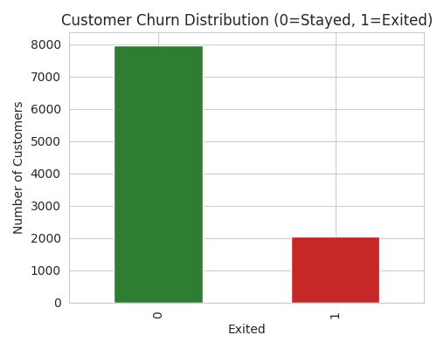

4.1 Churn by Geography
Germany stands out with a churn rate considerably higher than France or Spain, despite having roughly half as many customers. This suggests market-specific factors — competitive pressure, product fit, or service quality — are contributing disproportionately to attrition in that region.
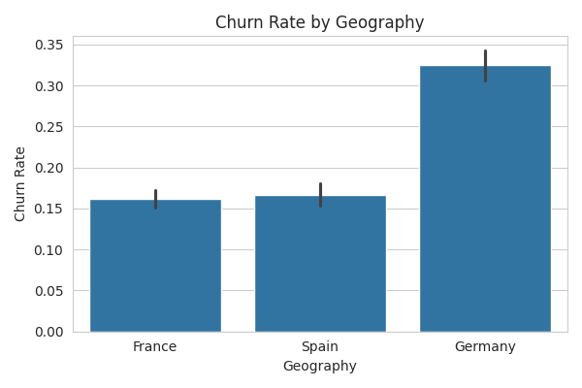

4.2 Churn by Gender and Age
Female customers churn at a modestly higher rate than male customers. Age shows a clearer pattern: churned customers skew older on average, with churn risk rising notably for customers over 45, potentially reflecting shifting financial needs or reduced engagement with digital banking channels.
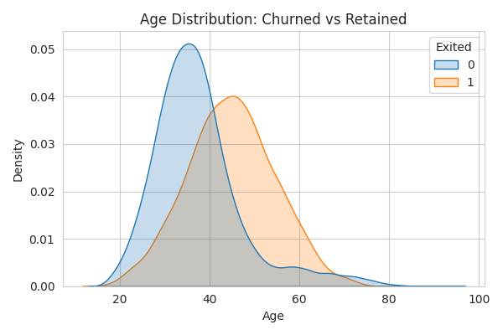

4.3 Balance and Product Holdings
Customers with a zero account balance churn less often than those holding a balance, but customers who hold only one product churn far more than those with two. Customers with three or four products are rare but churn much more often, likely reflecting customers who are dissatisfied enough to have negotiated or accumulated products defensively.
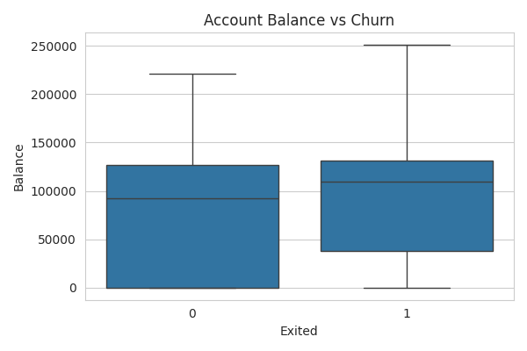

4.4 Correlation Analysis
A correlation heatmap of numeric features confirms that no single variable dominates the prediction; churn is a function of several moderately correlated factors rather than one strong driver, which supports the use of an ensemble model over a simple rule-based approach.
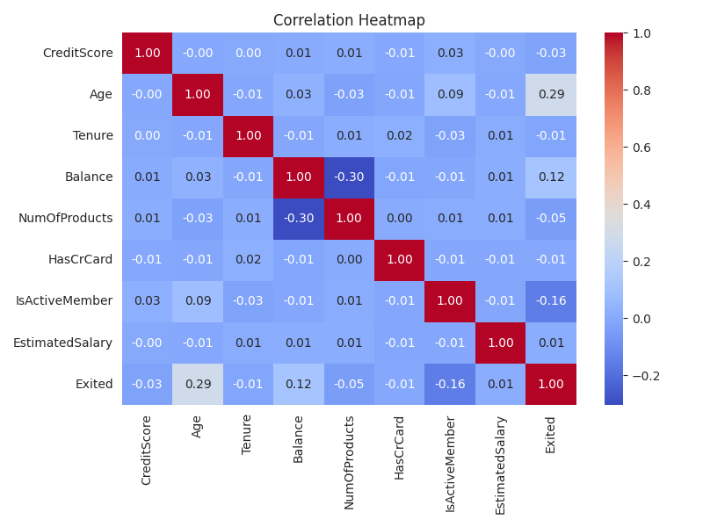

5. Methodology

5.1 Feature Engineering
- Geography and Gender were label-encoded into numeric form.
- A BalanceSalaryRatio feature was engineered to capture financial cushion relative to income.
- An IsZeroBalance flag was added to separate customers who hold no deposit balance.
- CustomerId, Surname, and Year were dropped as they carry no predictive signal.

5.2 Model Training
The data was split 80/20 into training and test sets, stratified on the target variable to preserve the churn ratio in both sets. Two models were trained and compared: a Logistic Regression baseline (with feature scaling) and a Random Forest classifier (unscaled, class-weighted to counter imbalance).

6. Results
Model | Accuracy | Precision | Recall | F1 | ROC-AUC
Logistic Regression | 0.704 | 0.379 | 0.713 | 0.495 | 0.773
Random Forest | 0.819 | 0.543 | 0.705 | 0.613 | 0.859

The Random Forest model was selected as the final model. It offers a substantially higher ROC-AUC (0.86 vs. 0.77), meaning it separates churners from non-churners far more reliably, while maintaining comparable recall — critical for a retention use case, where failing to flag an at-risk customer (a false negative) is costlier than a false alarm.
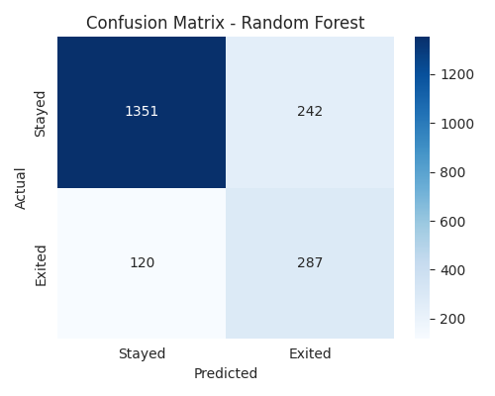

6.1 Feature Importance
Age, number of products, and account balance emerged as the strongest predictors of churn in the Random Forest model, followed by whether the customer is an active member and their credit score.
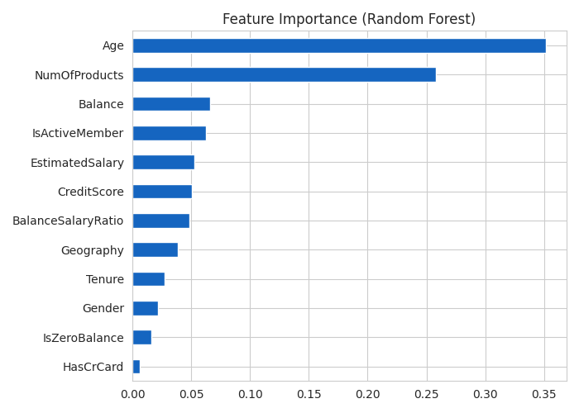

7. Business Recommendations
- Prioritize retention outreach for customers in Germany, where churn is disproportionately high.
- Design engagement campaigns targeting inactive members, since activity status is one of the strongest churn signals.
- Encourage single-product customers to adopt a second product (e.g., savings-to-credit-card bundling) to improve stickiness.
- Build lightweight, age-appropriate digital experiences for customers over 45, who show elevated churn risk.

8. Conclusion
This project demonstrates that customer churn in retail banking can be meaningfully predicted using readily available demographic and account data. The resulting Random Forest model, deployed as an interactive Streamlit application, gives the bank's retention team a practical, real-time tool to identify at-risk customers and act before they leave — turning a reactive loss into a proactive retention opportunity.

9. Tools & Technologies
- Python (pandas, NumPy) for data cleaning and feature engineering
- scikit-learn for model training and evaluation
- Matplotlib / Seaborn for exploratory visualization
- Streamlit for interactive model deployment
- GitHub for version control and project hosting

