E - Commerce Project - Power BI Project

by Saket Jha

Objective Questions:
- What is the total number of attributes in the customer table?
Answer: The customer table contains 3 attributes: CustomerID, Customer Age, Customer Gender.
- How will you get the “Customer’s” ages in the “Order” tables according to customer IDs?
Answer: First I have Ensured the relationship:
Customers[CustomerID] → Orders[CustomerID]

Then I created a calculated column in orders table using DAX:
Customer Age = RELATED(Customers[Customer Age])
- In analyzing the dataset with Power BI, ensure data cleaning to address inconsistencies and missing values before further analysis.
Answer: following are the measures taken by me to clean the data before analysis:
- Data Transformation: I started by loading the dataset into Power Query Editor, which provided a robust environment for transforming and cleaning the data.
- Removing Empty Rows: I ensured that all columns in the dataset were free of empty rows. Empty rows can lead to inaccuracies in analysis, so I removed them to maintain data integrity.
- Eliminating Unnecessary Columns: In addition to cleaning up empty rows and correcting data types, I also identified and removed unnecessary columns that were not relevant to the analysis.
- Correcting Data Types: The dataset included "Order Date" and "Delivery Date" columns, which were not initially in the correct format. I changed these columns to the "Date" data type to enable accurate date-based analysis, such as calculating delivery times or filtering by order dates.
- Handling Missing Values in the "Reason" Column: The "Reason" column, which indicated the reason for product returns, had some empty rows. I replaced empty rows related to returned products with "Unknown reason" and for delivered products, I filled the empty rows with "NA" This ensured the data was complete and logically consistent.

- How can we calculate the total revenue generated by all the sales?
Answer: To calculate the Total Revenue, I have created a New Measure to sum the Sale Price Column.
The DAX formula is total sales = SUM(Orders[Sale Price])
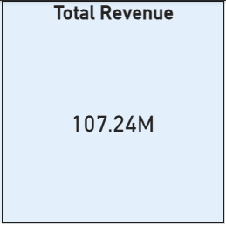
- What is the total number of unique customers who made purchases each year? Is there any increase in the number over the years?
Answer: In the below shown line chart and table, we can see how many customers made purchases each year.
In x-axis measure derived using DAX Unique Customers = DISTINCTCOUNT(Orders[CustomerID]) and in y-axis order date by Year.
We can clearly see that the number of unique customers remained relatively consistent from 2015 and 2019 (about 17,500 per year), but there was a significant increase in 2020 with over 25,000 customers. This suggests a significant increase in client acquisition in 2020.
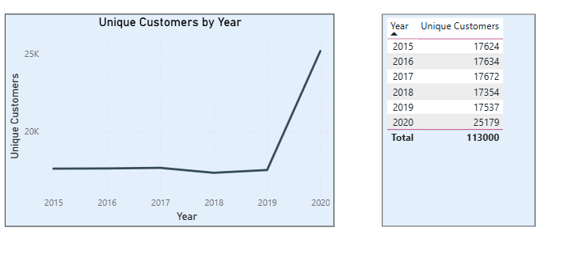
- How can we determine the total number of unique products available in the company?
Answer: To determine the total number of distinctive products in the company, I created a DAX measure using the DISTINCTCOUNT function in the Product column: Unique Products = DISTINCTCOUNT(Orders[Product]). This measure accurately counts only unique product names throughout all orders, ignoring duplicates. In Power BI, I displayed the results as a card visual shown below.
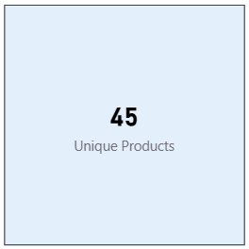
- What is the average number of days it takes for products to be delivered, get the metric for only the delivered orders.
Answer: To determine the average number of days for the products to be delivered, I have a created a new measure using DAX
Average delivery day = AVERAGEX(FILTER(Orders,Orders[Status]="Delivered"),
DATEDIFF(Orders[OrderDate],Orders[Delivery Date],DAY))
Then I displayed the value as card shown below.
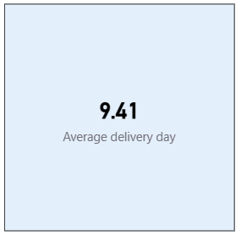
- Which products, categories, and subcategories are the most popular? Answer: To evaluate performance across different hierarchies, I developed Top 5 Bar Charts using specific volume and frequency metrics:
Product Analysis: Ranked by Sum of Order Quantity using a Top N filter. The Avon Soft Musk Eau de Toilette Spray (50ml) was the top performer with 14.4K units sold.
Category & Subcategory Analysis: Ranked by the total number of orders to measure transaction frequency.
    - Categories: Fashion led with 20.6K orders, followed by Health and Beauty with 18K orders.
    - Subcategories: Vitamins & Dietary Supplements was the most frequent driver with 12.8K orders.

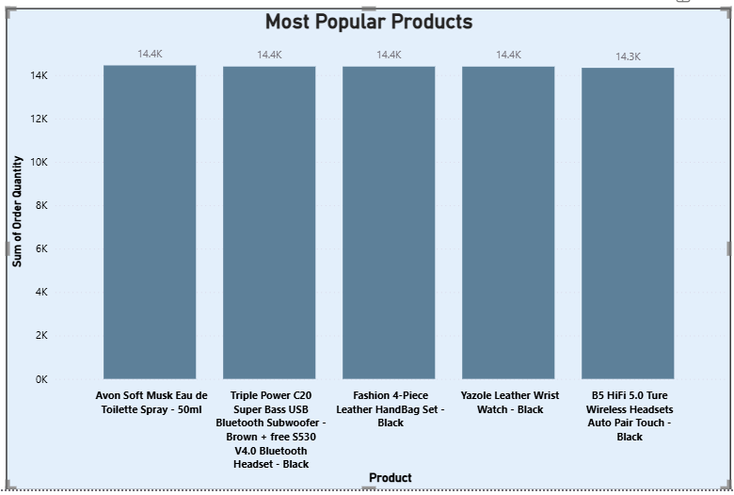
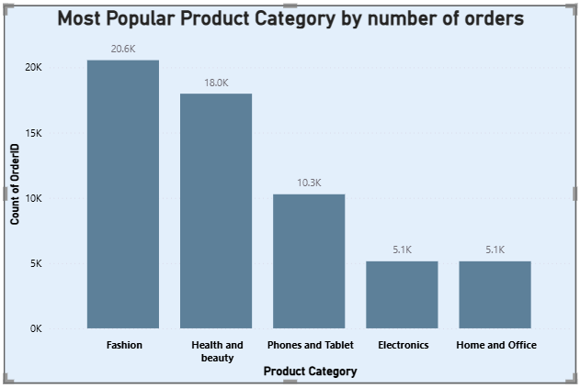
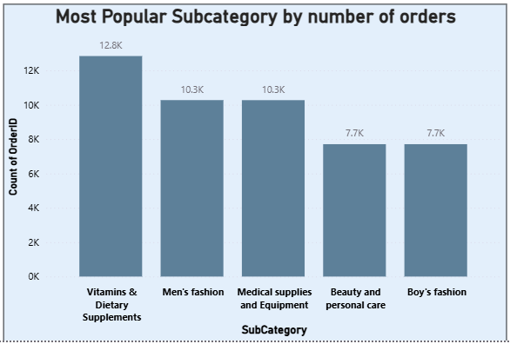
- Which products have seen an increase or decrease in sales over the year? Answer: I calculated total sales using the Sale Price, then used SAMEPERIODLASTYEAR to derive previous-year sales. By comparing the two, I identified which products experienced year-over-year growth or decline. Products with positive YoY change indicate increased demand, while negative values highlight underperforming products requiring attention.
Following DAX were used:
- Total Sales = SUM ( Orders[Sale Price] )
- Previous Year Sales = CALCULATE ( [Total Sales], SAMEPERIODLASTYEAR ( Date[Date] ) )
- YoY Sales Change = [Total Sales] - [Previous Year Sales]
- YoY Sales % = DIVIDE ([Total Sales] - [Previous Year Sales], [Previous Year Sales] )
- Sales Trend = IF ( [YoY Sales Change] > 0,"Increase","Decrease")
For visualization I have created a Table visual with Product, Total Sales, Previous Year Sales, YoY Sales Change and YoY Sales %
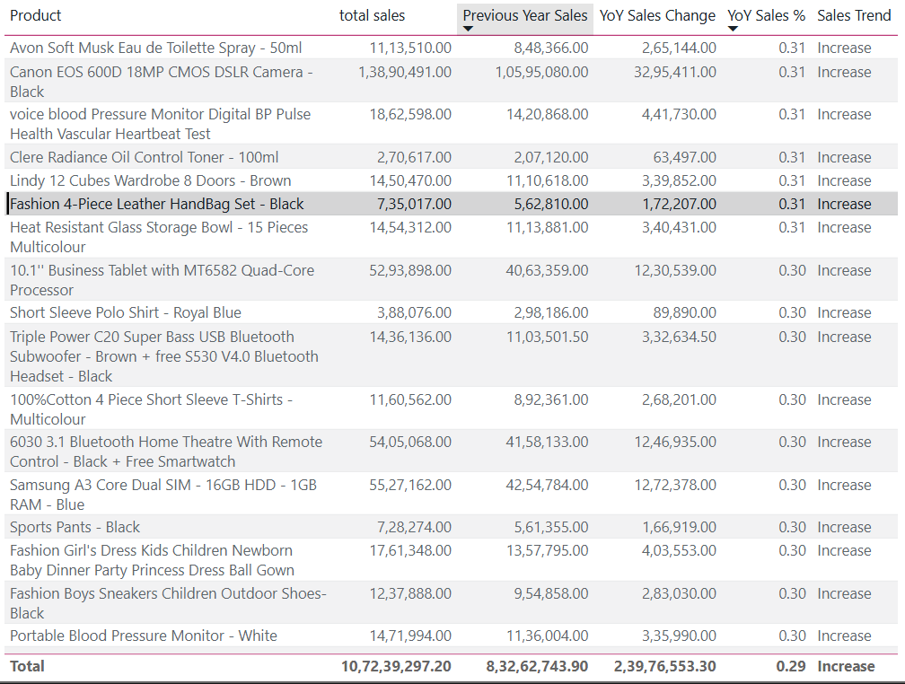

- While modeling the data relationships, what will be the type of relationship between the customer ID of Orders and customer tables?
Answer:
- Power BI automatically created a One-to-Many relationship between Customers [CustomerID] and Orders [CustomerID] upon data import.
- This relationship allows smooth filtering, accurate aggregation, and seamless cross-table analysis.
- Since CustomerID is unique in the Customers table and repeated in the Orders table, the relationship was recognized instantly.

- How have you handled the null values in the data?
Answer: Handling null values effectively ensures your analysis is based on clean, reliable data. Here is a simplified summary of the steps taken:
- Removed Missing Key Data: Deleted rows where critical fields like Order Date, Delivery Date, or Customer ID were empty, as these are essential for tracking.
- Applied Averages for Missing Numbers: Replaced blank Unit Prices and Order Quantities with their respective averages to keep revenue and volume calculations consistent.
- Filled Categorical Gaps: Updated missing Product Categories, Genders, and Delivery Types using Power Query to ensure no gaps in filtering.
- Standardized Status and Reasons: * Set missing statuses to "Delivered" where appropriate.
- Replaced empty "Reason" entries with "Not Applicable" or "Unknown Reason" to maintain clear records using DAX IF(Orders[Status]="Delivered","Not applicable" ,IF(ISBLANK('Orders'[Reason]),"Unknown Reason",'Orders'[Reason])).
- Were there any data format issues in the data, and if there were/are how you would handle them?
Answer: To clean the Amazon e-commerce dataset for accurate analysis, I performed the following steps using Power Query Editor in Power BI:
- Data Loading: Imported the dataset into the editor to begin the transformation and cleaning process.
- Handling Empty Rows: Removed all empty rows to ensure data integrity and prevent inaccuracies in the final results.
- Correcting Data Types: Converted columns like Order Date and Delivery Date from text/general formats to the Date data type to enable time-based analysis.
- Removing Duplicates: Identified and deleted duplicate records to ensure the data was unique and not skewed.
- Data Type Consistency: Standardized all columns by ensuring numerical values were correctly formatted as numbers rather than text, allowing for proper calculations and aggregations.
- When we add a column in Power Query what’s the code that comes in M language in the formula bar? What do you know about M-query?
Answer: In Power Query, adding a new column generates a specific M code formula in the formula bar. For example:
= Table.AddColumn(Source, "NewColumn", each [ExistingColumn] * 2)
This formula creates "NewColumn" by taking every value in "ExistingColumn" and multiplying it by 2.
What is M Query?
M Query (the Power Query Formula Language) is a functional language used to transform, manipulate, and clean data within Power BI and Excel. It allows you to define precise, step-by-step data transformations, including:
- Data Restructuring: Filtering, aggregating, and merging multiple datasets.
- Custom Logic: Performing specialized calculations and data transformations.
- Advanced Automation: Defining parameters and managing complex data scenarios.

- Identify the top 5 most valuable customers using a composite score that combines three key metrics: (SQL)
  - Total Revenue (50% weight): The total amount of money spent by the customer.
  - Order Frequency (30% weight): The number of orders placed by the customer, indicating their loyalty and engagement.
  - Average Order Value (20% weight): The average value of each order placed by the customer, reflecting the typical transaction size.
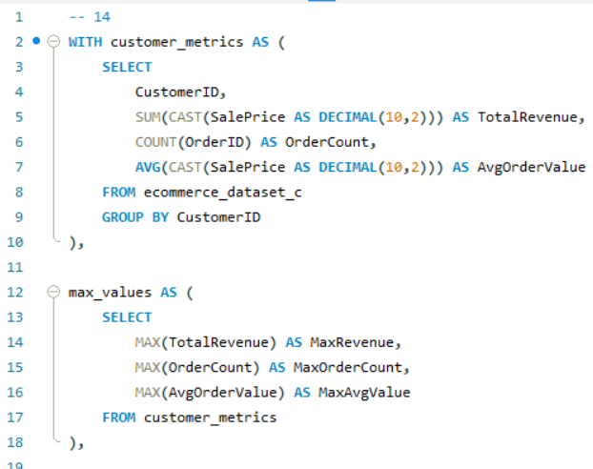
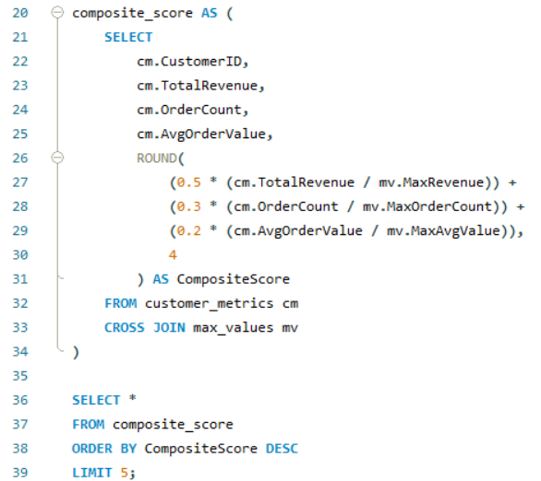

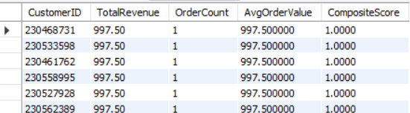
- Using above given SQL query, I calculated each customer's total revenue, order frequency, and average order value.
- Each measure was normalized using its maximum value, bringing all values to a 0-1 scale.
- To calculate a composite score, utilized the weight formula (0.5 * Revenue + 0.3 * Order Count + 0.2 * Average Value).
- Sorted and identified the top five customers with the highest scores.

- Calculate the month-over-month growth rate in total revenue across the entire dataset. (SQL)
Answer: To
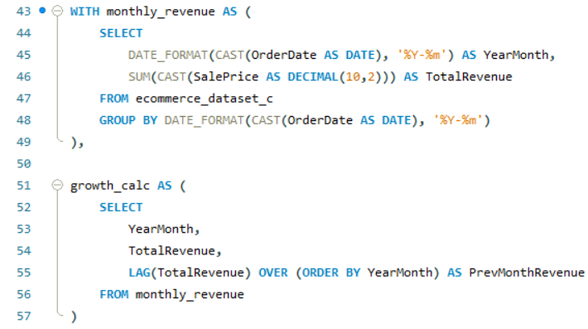
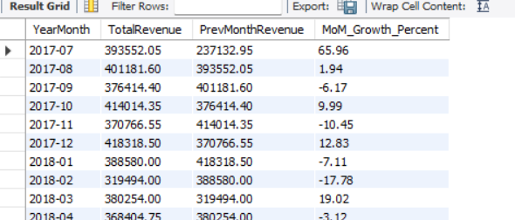
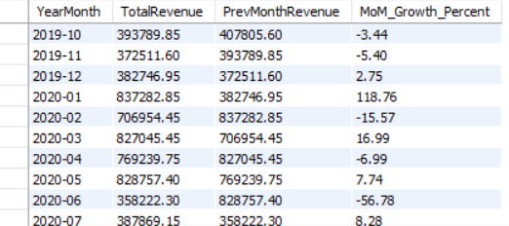
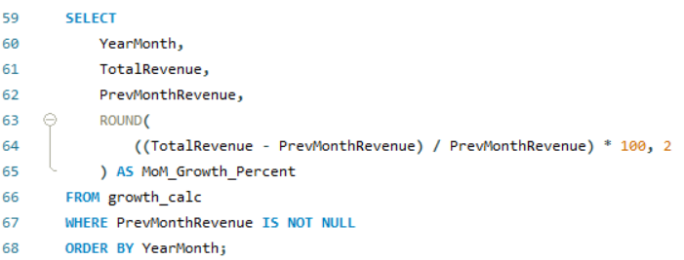

- Converted OrderDate to YearMonth using DATE_FORMAT(CAST(AS DATE), '%Y-%m'), and calculated monthly total revenue using SUM(SalePrice).
- Used LAG() to fetch the previous month’s revenue and applied the MoM growth formula: ((Current - Previous) / Previous) * 100.
- Final output shows each month's revenue, previous month's revenue, and MoM growth %, excluding the first month where no previous data exists.

- Calculate the rolling 3-month average revenue for each product category. (SQL)
Answer:
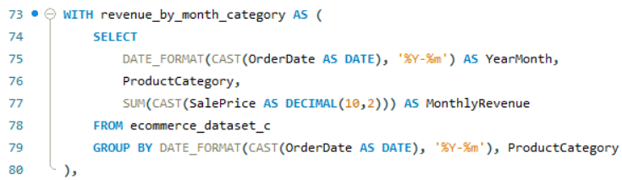
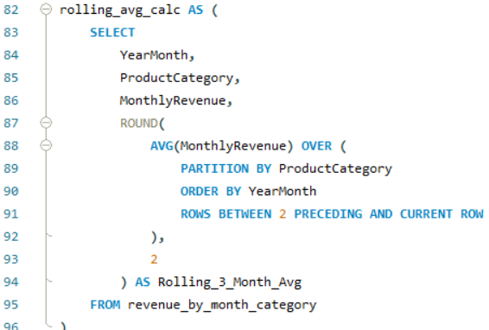
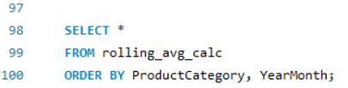
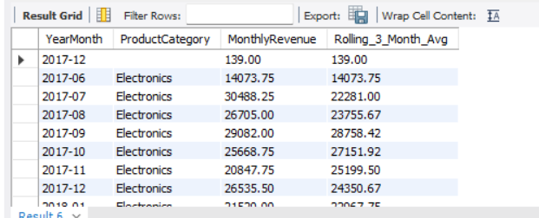
- Extracted YearMonth from OrderDate and aggregated monthly revenue per ProductCategory.
- Used a window function with ROWS BETWEEN 2 PRECEDING AND CURRENT ROW to compute a 3-month rolling average, maintaining continuity across months.
- Final output shows monthly revenue alongside the smoothed 3-month average, enabling trend analysis for each product category.

- Update the orders table to apply a 15% discount on the `Sale Price` for orders placed by customers who have made at least 10 orders. (SQL)
Answer:
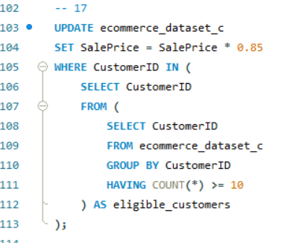
- Using a GROUP BY and HAVING subquery, i identified customers who placed 10 or more orders.
- To avoid the MySQL problem caused by updating and selecting from the same table in one step, I wrapped the subquery in an alias.

- Calculate the average number of days between consecutive orders for customers who have placed at least five orders. (SQL)
Answer:
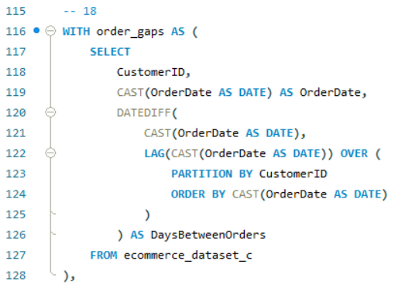
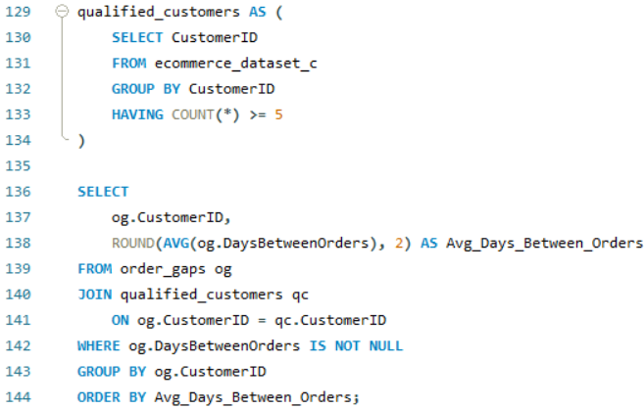
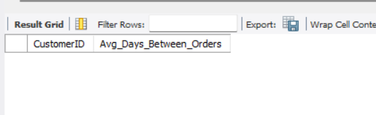
- I used a LAG() window function to calculate the number of days between consecutive orders for each customer by comparing their current and previous OrderDate.
- A subquery filtered only those customers who placed at least 5 orders using GROUP BY and HAVING COUNT(*) >= 5.
- The final result was empty, indicating that no customer in the dataset placed 5 or more orders, hence no qualifying data was available for average gap calculation.

- Identify customers who have generated revenue that is more than 30% higher than the average revenue per customer. (SQL)
Answer:
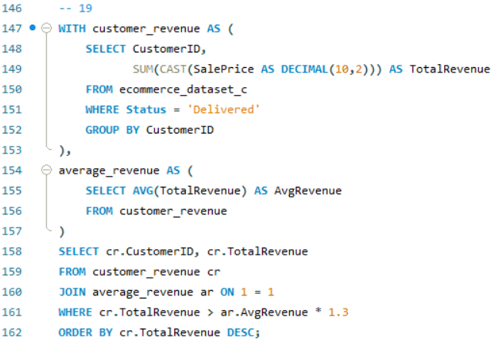
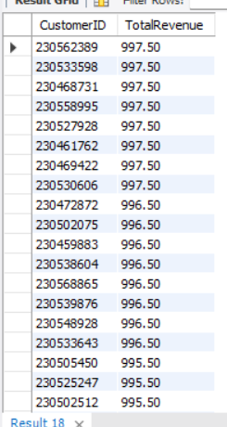

- Converted SalePrice from text to decimal and summed revenue for each customer with 'Delivered' status.
- Calculated average revenue and filtered customers with revenue > 130% of that average.
- Displayed top-performing CustomerIDs with their TotalRevenue in descending order.

- Determine the top 3 product categories that have shown the highest increase in sales over the past year compared to the previous year. (SQL)
Answer:
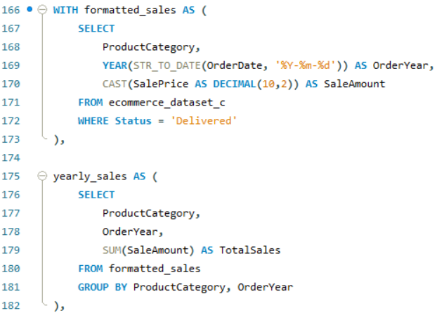
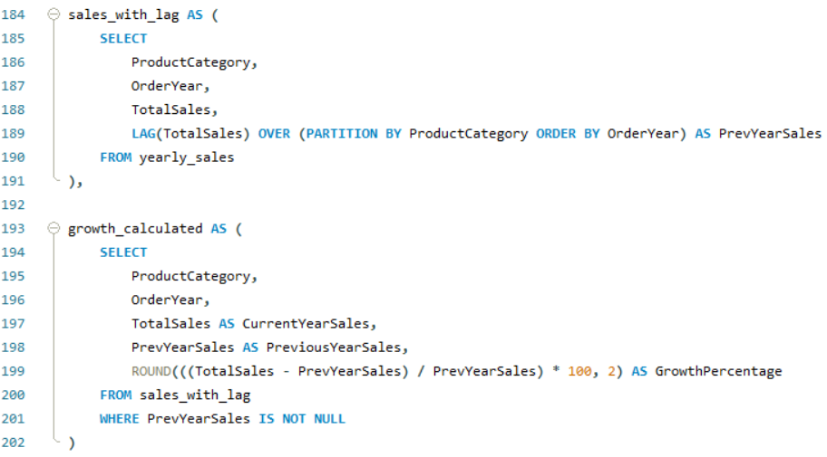
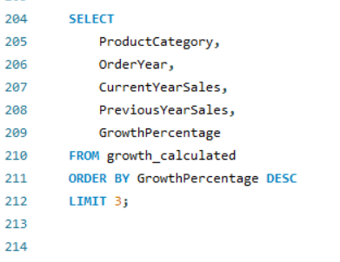

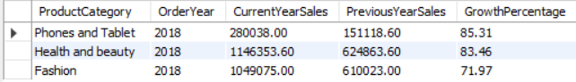

- Extracted year from OrderDate and calculated yearly sales totals per ProductCategory.
- Used LAG() to fetch the previous year's sales and computed growth percentage.
- Filtered top 3 categories with highest growth using ORDER BY GrowthPercentage DESC LIMIT 3.

Subjective Question:
- Explain the revenue breakdown by year and by-product. Evaluate how different products contribute to annual revenue and come up with suggestions to increase the sales of the low-selling items.
Answer:
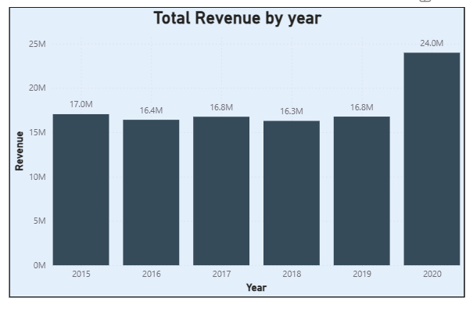
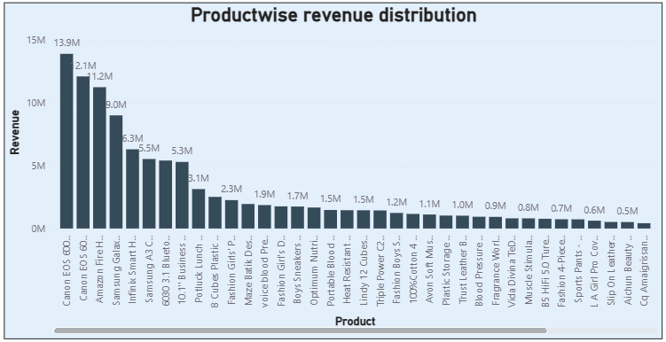

- The visualization revealed that some products consistently contribute the majority of revenue, while others have significantly lower sales.

- To increase sales of low-performing products, strategies such as targeted promotions, bundling them with high-selling products, or offering seasonal discounts could be implemented. Additionally, insights from the matrix suggest identifying years with low overall sales for specific products and launching marketing campaigns or loyalty programs during those periods to boost revenue.
- How many products were returned? Use a DAX function to get this metric. Examine the possible reasons for returns and consider how this metric could indicate improvements in product descriptions or quality control.
Answer:
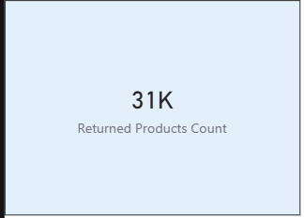
DAX: Returned Products Count = CALCULATE(
COUNT('Orders'[OrderID]),
'Orders'[Status] = "Returned")

The possible reasons for the returns could be:
- Defective items - Delivering the defective items makes customers lose interest in the quality of the brand.
- Delivery Missing item/part - Product description should mention clearly all the components and should provide a checklist of what's included.
- Onsite Description Mismatch - Product description should match with the products that are going to deliver otherwise it leads to customer dissatisfaction. Make sure to regularly update the description in the online platform.
- Product not fitting expectations - Make sure the size chart provided in the product description shows multiple options for customers to choose perfect size.
- Delivery wrong item - Have multiple checkpoints to see if the right product is going for a package before delivering the product.
- Unknown Reasons - There are some unknown reasons for the product to be returned.

Strategy for Improvement

- Quality Control: If "Defective" is the top reason, use the Unit Price and Product Category to see if high-value items are failing more often. This justifies the cost of stricter pre-shipment inspections.
- Product Descriptions: Calculate a Return Rate % by Category. If "Clothing" has a high return rate due to "Fit issues," adding an AI-driven sizing tool or more customer reviews (Ratings) can reduce returns.
- Correlation with Ratings: Use the Rating field to see if low ratings consistently correlate with specific return reasons. A product with a 2-star rating and a high "Defective" return rate should be pulled from the catalog immediately.

- Whenever a customer goes to Amazon, they’ll filter the most rated products to buy the better category. Can you verify this using any visualization or table that the ratings of products impact their sales value?
Answer: From the given data, it is evident that products with lower ratings have higher sales. This could be for several reasons like immediate need of the product, low price of the product, availability of the specific product in the platform, specific brand etc.
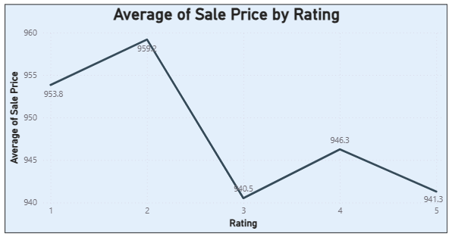

- Investigate how revenue distribution varies across different locations. Explore which geographical areas contribute most to sales and consider the strategic implications for regional marketing and distribution efforts. How might location-based trends inform the company's market segmentation and resource allocation approach?
Answer: From the below Map chart, we can see the revenue distribution across different locations. As we can see North America and African regions contribute most to sales. As for distribution, collaborate with regional delivery partners to accommodate smooth delivery. Regional marketing should involve the traditions of that particular region so that it affects the sentiment of the customers and it attracts more customers

Location based trends help the company to identify key locations where they can focus more on marketing promotions as they can generate more revenue compared to other locations. Company can also increase distribution channels and establish more warehouses for fast delivery of the products.
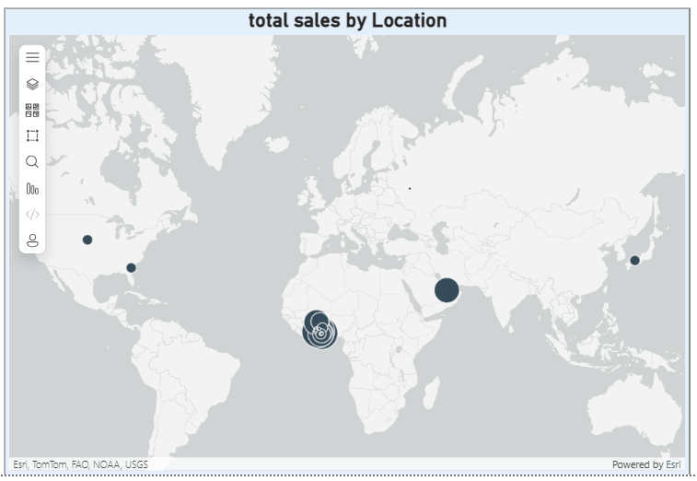

- Determine which month could benefit from enhanced promotional offers to boost sales. Can you suggest some targeted marketing strategies here?
Answer:
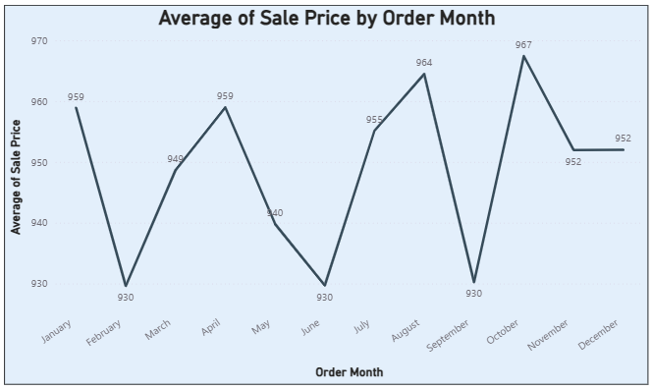
- From the above Line chart, we can see the Month wise sales in the company. As we observe the chart February, June and September sales are slightly less compared to other months. From enhanced promotional offers these months could benefit to boost sales.

- Targeted marketing strategies like Time limited sales, special discounts and incentives on that particular month could increase the sales. Go for more advertising on that particular month with the special deals

- Identify which products may require increased marketing efforts. Which items have high prices yet underperform in sales?
Answer:
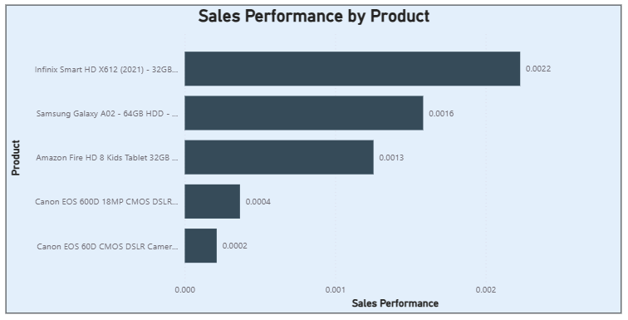
- From the above Bar chart, these are the 5 underperformed products with high prices
- which may require increased marketing efforts.
- First I calculated sales performance by using DAX formula “DIVIDE” i.e. Sales Performance = DIVIDE(Orders[Order Quantity], Orders[Sale Price]).
- With the average of sales performance against products by using Bar chart and using filters for lowest 5 products I got the results.
- Despite having high price, the sales of these products are very low.

- Assess which products should have discounts. How can targeted incentives drive sales and customer loyalty for specific products?
Answer: I used a filter in Power BI on Total_Sales_Qty to show products with sales quantities less than 6000. We also checked Avg_UnitPrice to ensure that there is enough pricing margin for potential discounts without compromising profitability.
- A table visual has added measures for Total_Sales_Qty, Avg_UnitPrice, and Total_Revenue.

- Added a visual filter for Total_Sales_Qty < 6000.

- Reviewed the resulting products, comparing unit price to total revenue.

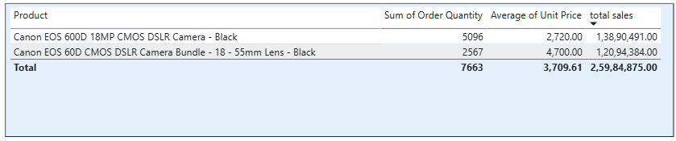

Both products have low sales volumes but still generate significant revenue, indicating strong potential if sales volume is improved.

Recommendations:
- Offer targeted discounts or bundle offers to attract new customers while maintaining profit margins.

- Create urgency by offering limited-time deals and festive promotions.

- Combine discounts with loyalty rewards or future purchase vouchers to increase repeat sales.

- To generate interest, launch targeted marketing campaigns aimed at photography enthusiasts and semi-professionals.

- Come up with a loyalty program to benefit the company’s customers. From the available lot of customers come up with strategies to bucket them and provide benefits under different loyalty programs.
Answer: Upon auditing the data structure, I found that each customer had only recorded one order. Since I couldn't track how often they shopped, I pivoted my strategy to focus on how much they spent and how recently they visited. I built a 'Customer Metrics' table to consolidate these insights—calculating spend, recency, and the variety of products purchased. This allowed me to bin customers into four clear loyalty tiers, giving stakeholders a simple, adjustable way to see who our most valuable patrons are.
- Created a Customer Metrics table using SUMMARIZECOLUMNS to aggregate TotalRevenue, LastOrderDate, RecencyDays, and ProductVariety for each customer.
- Created Tier calculated column with revenue-based rules: Platinum: ≥ 3,000, Gold: ≥ 1,500 and < 3,000, Silver: ≥ 500 and < 1,500, Bronze: < 500
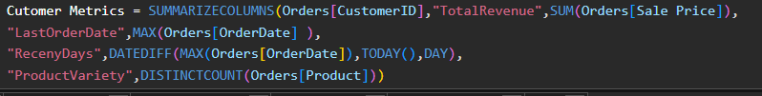
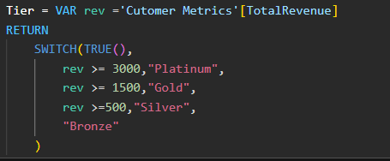
Below shown charts shows the customer variation:
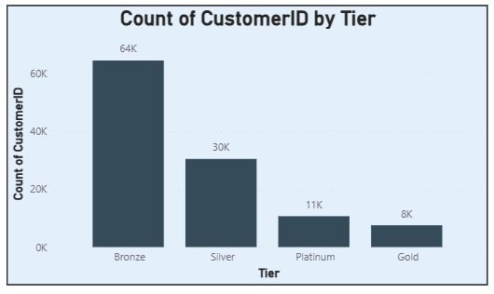
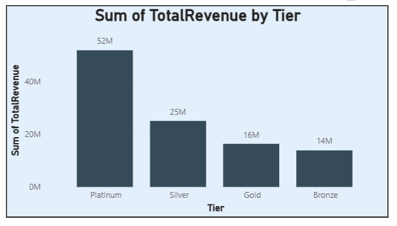
- The majority of customers (64K) are in the bronze tier, that generates only ₹14M revenue.
- The Platinum tier has the fewest customers (11K) but the highest revenue (₹52 million).
- Silver tier has approximately 30K customers and contributes ₹25M, indicating strong mid-tier engagement.
- Gold tier has ~8K customers and contributes ₹16M, indicating potential for tier growth.

Recommendations:
- Upsell Bronze customers to higher tiers using targeted promotions or bundled offers.
- Retain Platinum customers through loyalty programs, priority service, and personalized offers.
- Convert Silver to Platinum by incentivizing higher order values and more frequent purchases.
- Analyse Gold tier purchasing patterns to understand why growth is slower than Silver and implement targeted campaigns.

- Using the DAX functions Calculate and a row iteration DAX function calculate the total sales for the Product Category “Fashion” and delivery type “Shipped from Abroad”. What are the other types of DAX functions you have used in the project?
Answer:
- I have Designed a specific metric to isolate total revenue for the Fashion category, specifically focusing on the "Shipped from Abroad" logistical segment.
- Leveraged the CALCULATE function to modify the filter context, ensuring the engine ignores other categories and delivery types to focus only on this high-priority intersection.
- Implemented SUMX as an iterator function to perform row-by-row calculations ($Quantity \times Price$). This approach ensures that the math is executed at the transaction level before being aggregated, maintaining data integrity.
- By combining these functions, I ensured that the resulting value is surgically precise, including only relevant transactions and providing a clear view of international fashion performance.
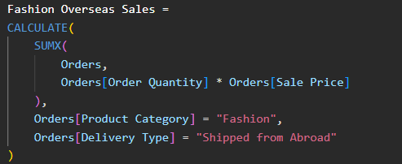
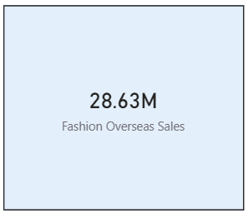
Beyond the CALCULATE and SUMX logic, the project utilized these key function categories:
- Aggregation: SUM and AVERAGE for basic totals and the Average delivery day metric.
- Time Intelligence: DATEDIFF to calculate RecencyDays and SAMEPERIODLASTYEAR for year-over-year trends.
- Logical: SWITCH and IF to categorize customers into Loyalty Tiers based on spend thresholds.
- Filter Control: ALL to calculate percentage contributions and DISTINCTCOUNT for tracking Unique Products.

- Wait Times Correlated with Demographics and Care: Explore how average wait times vary across different product categories to optimize scheduling and staffing.
Answer: The wait time is calculated as the difference between OrderDate and DeliveryDate (DeliveryDays). I used DAX to calculate the average wait time for each ProductCategory. Created a calculated column DeliveryDays = DATEDIFF(Orders[OrderDate],Orders[Delivery Date],DAY) to measure the exact waiting period in days.
Added a clustered column chart with ProductCategory on the X-axis and Avg_WaitTime_ByCategory on the Y-axis
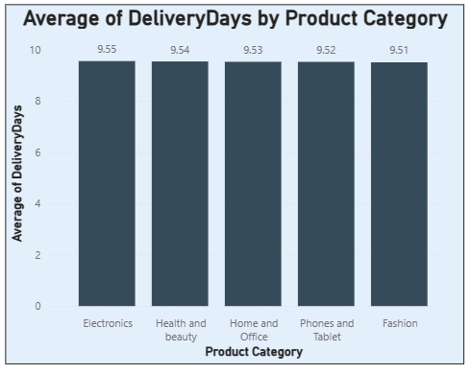
•The Electronics category has the longest average wait time, at 9.55 days.
•The average wait time for all other categories, including Health & Beauty, Home & Office, Phones & Tablets, and Fashion, is 9.5X days.
•The differences are slight, implying consistent delivery performance across categories.
Recommendation:
•Maintain consistency in wait times, as they are nearly identical.
•Find out why Electronics is slightly higher (logistics partner, stock availability, or shipping zone concentration).
•Use consistent performance as a selling point in marketing communications.

- Explore if there is any relationship between the Delivery type and waiting time between ordering and receiving an item.
Answer: To look into the relationship between delivery type and wait time, I first added a calculated column DeliveryDays to the Orders table, which represents the number of days between OrderDate and DeliveryDate. Then I created a DAX measure called Avg_WaitTime using: Avg_WaitTime = Average(Orders[DeliveryDays]). I used a clustered column chart with DeliveryType on the X-axis and Avg_WaitTime on the Y-axis to compare average wait times for each delivery method.
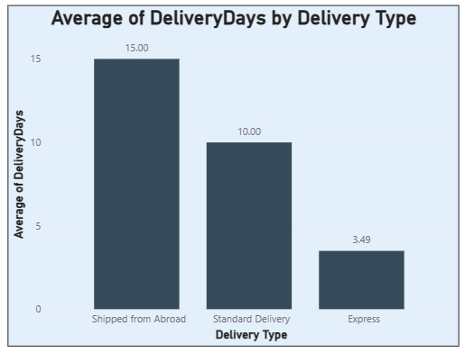
- Orders shipped from abroad have the longest average wait time (15 days), which is most likely due to international shipping and customs clearance.
- Standard Delivery takes approximately 10 days on average, which represents the typical domestic delivery time.
- Express Delivery is much faster, averaging only 3.5 days.
- The method's promised delivery speed and the average wait time show a clear inverse relationship.
- For time-sensitive products or customers prioritizing fast delivery, Express Delivery should be promoted.
- Improve efficiency in Standard Delivery by optimizing local distribution networks to reduce the gap with Express delivery.
- Review partnerships and logistics processes for Shipped from Abroad to cut delays and improve customer satisfaction.

- Is there any relationship between shipping charges and product type?
Answer: To find the relationship between shipping fee and product category, I Calculated the average shipping charge for each product category to check for variations. Created a measure: Avg_ShippingCharge = AVERAGE(Orders[ShippingFee]) and Used a Clustered Column Chart with:X-axis → ProductCategory, Y-axis → Avg_ShippingCharge.
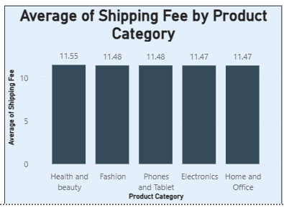
- The average shipping charge for all product categories is identical at around 11.5.
- This means product type does not influence shipping fee in this dataset.
- Since shipping charges are uniform, differentiation based on weight, size, or delivery urgency could be explored for more accurate cost allocation.
- If the goal is competitive pricing, the business could reduce or waive shipping fees for high-demand categories to attract more customers.

- Come up with strategies to decrease the low rating orders after analyzing different factors like waiting time, shipping type, unit price, etc.
Answer: To come up with different strategies to decrease the low rating orders, I have analysed the waiting time, sale price for each rating.
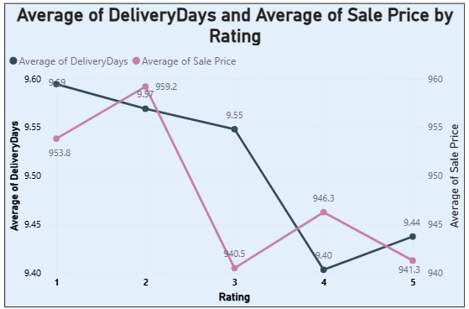
here are the key strategies to decrease low-rating orders by focusing on delivery time and sale price:
- Reduce Delivery Time for Lower Ratings: The chart shows that 1-star ratings have the highest average delivery time at 9.59 days, while 4 and 5-star ratings have much lower averages (9.40 and 9.44 respectively).
- Offer Faster Shipping Options: Implement express or priority delivery to target the delay seen in low-rating categories.
- Optimize Pricing for 2-Star Orders: There is a significant spike in the average sale price for 2-star ratings (959.2). Reducing prices or increasing the perceived value for these items could prevent poor ratings.
- Maintain Low Prices for High Satisfaction: 5-star ratings correlate with the lowest average sale price (941.3). Keeping unit prices competitive is a proven driver for top ratings.
- Improve Consistency: Since 3-star ratings actually have the lowest price (940.5) but mid-range delivery times, focus on improving delivery speed for these "average" experiences to push them toward 4 or 5 stars.

- Using the time intelligence DAX function, create a table to compare each month’s sales with the previous year’s same month’s total sales. So there will be four columns in the output year, month, total sales, previous_years_sales.
Answer: I Built a proper date dimension (DateTableQ14) with daily rows and related it to Orders[OrderDate] (Many-to-one, Single direction). Marked it as a Date table so time-intelligence works. Used measures with time intelligence to compare each month’s sales to the same month last year.
Dax formula for Last Year Total Revenue: LY Total Revenue = CALCULATE([Total Revenue],SAMEPERIODLASTYEAR(Orders[OrderDate]),ALLEXCEPT(Orders,Orders[OrderDate]))
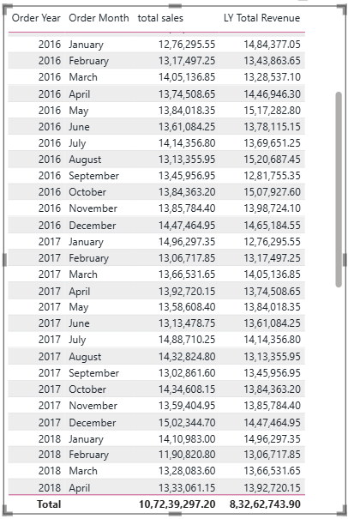
- What do you understand by PowerBI gateway? What are its use cases?
Answer: A Power BI Gateway is a software bridge that allows the cloud-based Power BI Service to communicate securely with data sources located on-premises (inside your private network) that are not directly accessible from the cloud.

Because your local data is protected by firewalls, the Power BI Service cannot "reach in" to grab it. The gateway acts as a secure, outbound-only tunnel that allows the cloud service to fetch your data without exposing your internal network to the internet.

Key Use Cases

- Scheduled Data Refreshes: This is the most common use case. If you have an Excel file on a local server or a SQL Server database, the gateway allows Power BI to automatically trigger an update (refresh) of your reports on a set schedule so your dashboards stay current.

- DirectQuery & Live Connections: In scenarios where you need real-time data or have datasets too large to import into the cloud, the gateway facilitates a "live" connection. Power BI sends a query through the gateway, the database processes it locally, and only the results are sent back.

- Security & Compliance: Because the gateway does not require opening inbound firewall ports, it keeps your data behind your company’s existing security perimeter. Sensitive data remains in your local environment, and only the necessary query results are transmitted to the cloud.

- Enterprise Scaling: In a business environment, a Standard Gateway allows multiple users to share a single connection to a database. This prevents every user from needing to manage their own connection credentials and ensures consistent, governed access to corporate data.

Gateway Modes

- Standard Mode: Designed for enterprise use. It supports multiple users, multiple data sources, and high availability (through clustering).
- Personal Mode: Intended for a single user. It is lightweight, easier to set up, but cannot be shared with others and is limited to simple data refresh scenarios.

- How would you approach this problem, if the objective and subjective questions weren't given?
Answer:
- Define Business Objectives: Identify core goals and pain points to align the analysis with what the business actually needs.
- Decompose Complex Issues: Segment the main problem into manageable parts, such as sales trends, customer habits, and product performance.

- Establish Actionable KPIs: Create measurable targets (e.g., retention, growth) that directly track progress toward solving the identified problems.

- Execute Data Analysis: Use SQL and Power BI to gather and interpret data, adjusting metrics to ensure they remain accurate and relevant.

- Deliver Strategic Insights: Present findings with clear, data-driven recommendations designed to solve the problem and improve performance.

