Agenda
Python Programming for Data Engineering
Python for Data Engineering
- API Data Extraction
- Database Connectivity Basics
Hands-On
- CSV Data Cleaning
- JSON Data Transformation
- API-Based Data Extraction
- Mini Project: Python ETL Pipeline
SQL and Dimensional Data Modeling
SQL Fundamentals
- Relational Database Concepts
- DDL, DML and DQL
- SELECT, WHERE, ORDER BY
- GROUP BY and HAVING
- DISTINCT and CASE Expressions
SQL Joins and Advanced Queries
- INNER, LEFT, RIGHT and FULL Joins
- Subqueries and CTEs
- UNION and UNION ALL
- Window Functions
- ROW_NUMBER, RANK, DENSE_RANK
- LEAD and LAG

Python Programming for Data Engineering
Python for Data Engineering
- API Data Extraction
- Database Connectivity Basics
Hands-On
- CSV Data Cleaning
- JSON Data Transformation
- API-Based Data Extraction
- Mini Project: Python ETL Pipeline
SQL and Dimensional Data Modelling
SQL (Structured Query Language) & Dimensional Data Modelling are essential concepts in Data Engineering, Data Analytics, Business Intelligence, & Data Warehousing.
SQL is used to store, retrieve, manipulates, & analyze data in relational databases. Dimensional data modelling is used to organize data for efficient reporting & analytical queries.
SQL Fundamentals
Relational Database Concepts
A relational database management systems (RDBMS) stores data in tables consisting of rows & columns. Tables can be connected through relationships.
Popular RDBMS include:
- Microsoft SQL Server
- MySQL
- PostgreSQL
- Oracle Database
- SQLite
Important database concepts
Concept | Explanation
Database | Collection of organized & structured data
Table | Stores data in rows & columns
Row | Represents one record
Column | Represents an attribute
Primary Key | Uniquely identifies each record
Foreign Key | Establishes a relationship between tables
Constraint | Enforces rules on stored data
Schema | Defines the structure & organization of database objects
Index | Helps improve data retrieval performance

e.g.
Employees Table
EmployeeID | Name | Salary | DepartmentID
101 | Amit | 50000 | 1
102 | Priya | 65000 | 2
103 | Rahul | 45000 | 1
104 | Sneha | 70000 | 3
105 | James | 80000 | 5

Departments Table
DepartmentID | DepartmentName
1 | IT
2 | HR
3 | Finance
4 | Legal

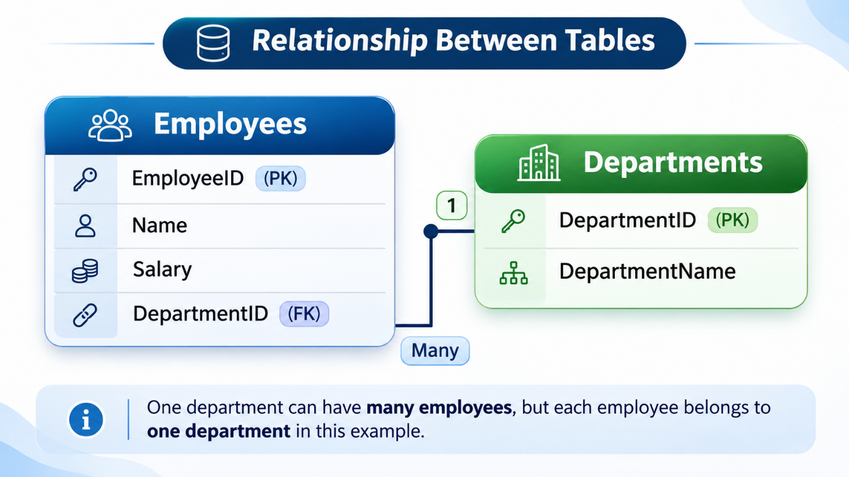
DDL, DML and DQL
DDL – Data Definition Language
Commands in DDL:
- CREATE
- ALTER
- DROP
- TRUNCATE
e.g.
Create a table
CREATE TABLE Employees (
EmployeeID INT PRIMARY KEY,
Name VARCHAR(100),
Salary DECIMAL(10,2),
DepartmentID INT
);
Add a new column
ALTER TABLE Employees
ADD Email VARCHAR(100);
Delete the table
DROP TABLE Employees;

DML – Data Manipulation Language
Commands in DML:
- INSERT
- UPDATE
- DELETE
e.g.
INSERT
INSERT [INTO] Employees
[(EmployeeID, Name, Salary, DepartmentID)]
VALUES
(101, 'Amit', 50000, 1);
UPDATE
UPDATE Employees
SET Salary = 55000
WHERE EmployeeID = 101;
DELETE
DELETE [FROM] Employees
WHERE EmployeeID = 101;

DQL – Data Query Language
Commands in DQL:
- SELECT
e.g.
SELECT
SELECT *
FROM Employees;

DCL – Data Control Language
Commands in DCL:
- GRANT
- REVOKE

TCL – Transaction Control Language
Commands in TCL:
- COMMIT, ROLLBACK, SAVEPOINT

SELECT, WHERE, ORDER BY
e.g.
SELECT Name, Salary
FROM Employees;

SELECT *
FROM Employees
WHERE Salary > 50000;

Common Operators
- =
- !=
- >
- <
- >=
- <=
- BETWEEN AND
- IN
- LIKE
- IS NULL
- IS NOT NULL
- AND
- OR
- NOT
e.g.
SELECT *
FROM Employees
WHERE Salary >= 50000
AND DepartmentID = 1;

ORDER BY
e.g.
SELECT Name, Salary
FROM Employees
ORDER BY Salary ASC;

SELECT Name, Salary
FROM Employees
ORDER BY Salary DESC;

SELECT *
FROM Employees
ORDER BY DepartmentID ASC, Salary DESC;

GROUP BY and HAVING
e.g.
SELECT
DepartmentID,
COUNT(*) AS TotalEmployees,
SUM(Salary) AS TotalSalary,
AVG(Salary) AS AverageSalary
FROM Employees
GROUP BY DepartmentID;

SELECT
DepartmentID,
COUNT(*) AS TotalEmployees
FROM Employees
GROUP BY DepartmentID
HAVING COUNT(*) > 1;

Difference between WHERE and HAVING
WHERE | HAVING
Filters individual rows | Filters aggregated groups
Applied before grouping | Applied after grouping
Cannot directly filter aggregate results | Can filter aggregate results
Can be used without GROUP BY | Often used with GROUP BY

DISTINCT and CASE Expressions
e.g.
SELECT DISTINCT DepartmentID
FROM Employees;

SELECT COUNT(DISTINCT DepartmentID)
AS TotalDepartments
FROM Employees;

SELECT
Name,
Salary,
CASE
WHEN Salary >= 65000 THEN 'High'
WHEN Salary >= 50000 THEN 'Medium'
ELSE 'Low'
END AS SalaryCategory
FROM Employees;

SQL Joins and Advanced Queries
INNER, LEFT, RIGHT and FULL Joins
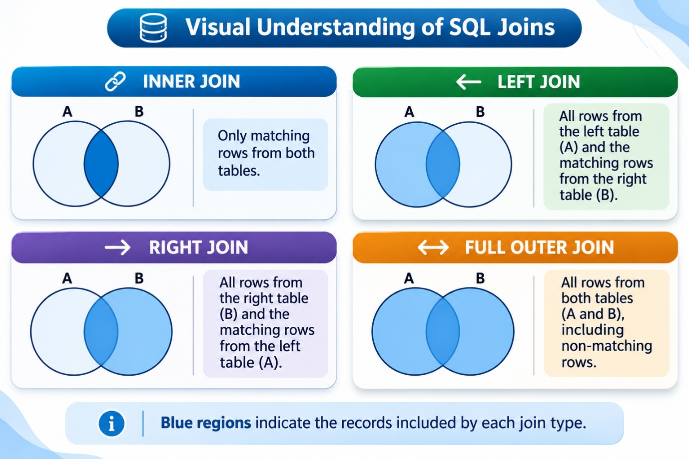
e.g.
INNER JOIN
SELECT
E.Name,
D.DepartmentName
FROM Employees E
INNER JOIN Departments D
ON E.DepartmentID = D.DepartmentID;

LEFT JOIN
SELECT
E.Name,
D.DepartmentName
FROM Employees E
LEFT JOIN Departments D
ON E.DepartmentID = D.DepartmentID;

RIGHT JOIN
SELECT
E.Name,
D.DepartmentName
FROM Employees E
RIGHT JOIN Departments D
ON E.DepartmentID = D.DepartmentID;

FULL JOIN
SELECT
E.Name,
D.DepartmentName
FROM Employees E
FULL OUTER JOIN Departments D
ON E.DepartmentID = D.DepartmentID;

CROSS JOIN
SELECT
E.Name,
D.DepartmentName
FROM Employees E
CROSS JOIN Departments D
ON E.DepartmentID = D.DepartmentID;

Subqueries and CTEs
e.g.
SELECT Name, Salary
FROM Employees
WHERE Salary >
(SELECT AVG(Salary)
FROM Employees);

WITH DepartmentAverage AS (
SELECT
DepartmentID,
AVG(Salary) AS AvgSalary
FROM Employees
GROUP BY DepartmentID
)
SELECT *
FROM DepartmentAverage
WHERE AvgSalary > 50000;

UNION and UNION ALL
e.g.
SELECT Name FROM Employees2025
UNION
SELECT Name FROM Employees2026;

SELECT Name FROM Employees2025
UNION ALL
SELECT Name FROM Employees2026;

UNION vs UNION ALL

UNION | UNION ALL
Removes duplicate rows | Retains duplicates
May require additional deduplication work | Generally more efficient
Useful for unique result sets | Useful for combining raw datasets

Window Functions
e.g.
SELECT
ColumnName,
FunctionName() OVER (
PARTITION BY ColumnName
ORDER BY ColumnName
) AS Result
FROM TableName;

SELECT
Name,
DepartmentID,
Salary,
SUM(Salary) OVER (
PARTITION BY DepartmentID
) AS DepartmentTotal
FROM Employees;

ROW_NUMBER, RANK, DENSE_RANK
e.g.
SELECT
Employee,
Salary,
ROW_NUMBER() OVER (
ORDER BY Salary DESC, Employee
) AS RowNum
FROM EmployeeSalary;

SELECT
Employee,
Salary,
RANK() OVER (
ORDER BY Salary DESC
) AS SalaryRank
FROM EmployeeSalary;

SELECT
Employee,
Salary,
RANK() OVER (
ORDER BY Salary DESC
) AS SalaryRank
FROM EmployeeSalary;

LEAD and LAG
e.g.
SELECT
MonthName,
Sales,
LAG(Sales) OVER (
ORDER BY MonthNumber
) AS PreviousMonthSales
FROM MonthlySales;
Output
Month | Sales | PreviousMonthSales
January | 10000 | NULL
February | 15000 | 10000
March | 12000 | 15000
April | 18000 | 12000

SELECT
MonthName,
Sales,
LEAD(Sales) OVER (
ORDER BY MonthNumber
) AS NextMonthSales
FROM MonthlySales;

Output
Month | Sales | NextMonthSales
January | 10000 | 15000
February | 15000 | 12000
March | 12000 | 18000
April | 18000 | NULL

