Agenda
Python for Data Engineering
- Working with Pandas and NumPy
- Data Cleaning and Transformation
- Date and Time Operations
- API Data Extraction
- Database Connectivity Basics
Hands-On
- CSV Data Cleaning
- JSON Data Transformation
- API-Based Data Extraction
- Python ETL Pipeline

Python for Data Engineering
Python is one of the most widely used programming languages in data engineering because of its simplicity, flexibility, extensive libraries, & ability to integrate with database, APIs, cloud platforms, & big data technologies.
Data Engineering is the process of collecting, extracting, cleaning, transforming, storing, & delivering data so that it can be used for analytics, reporting, machine learning, business intelligence, AI.
Python helps data engineers automate these activities & develop reliable data pipelines.
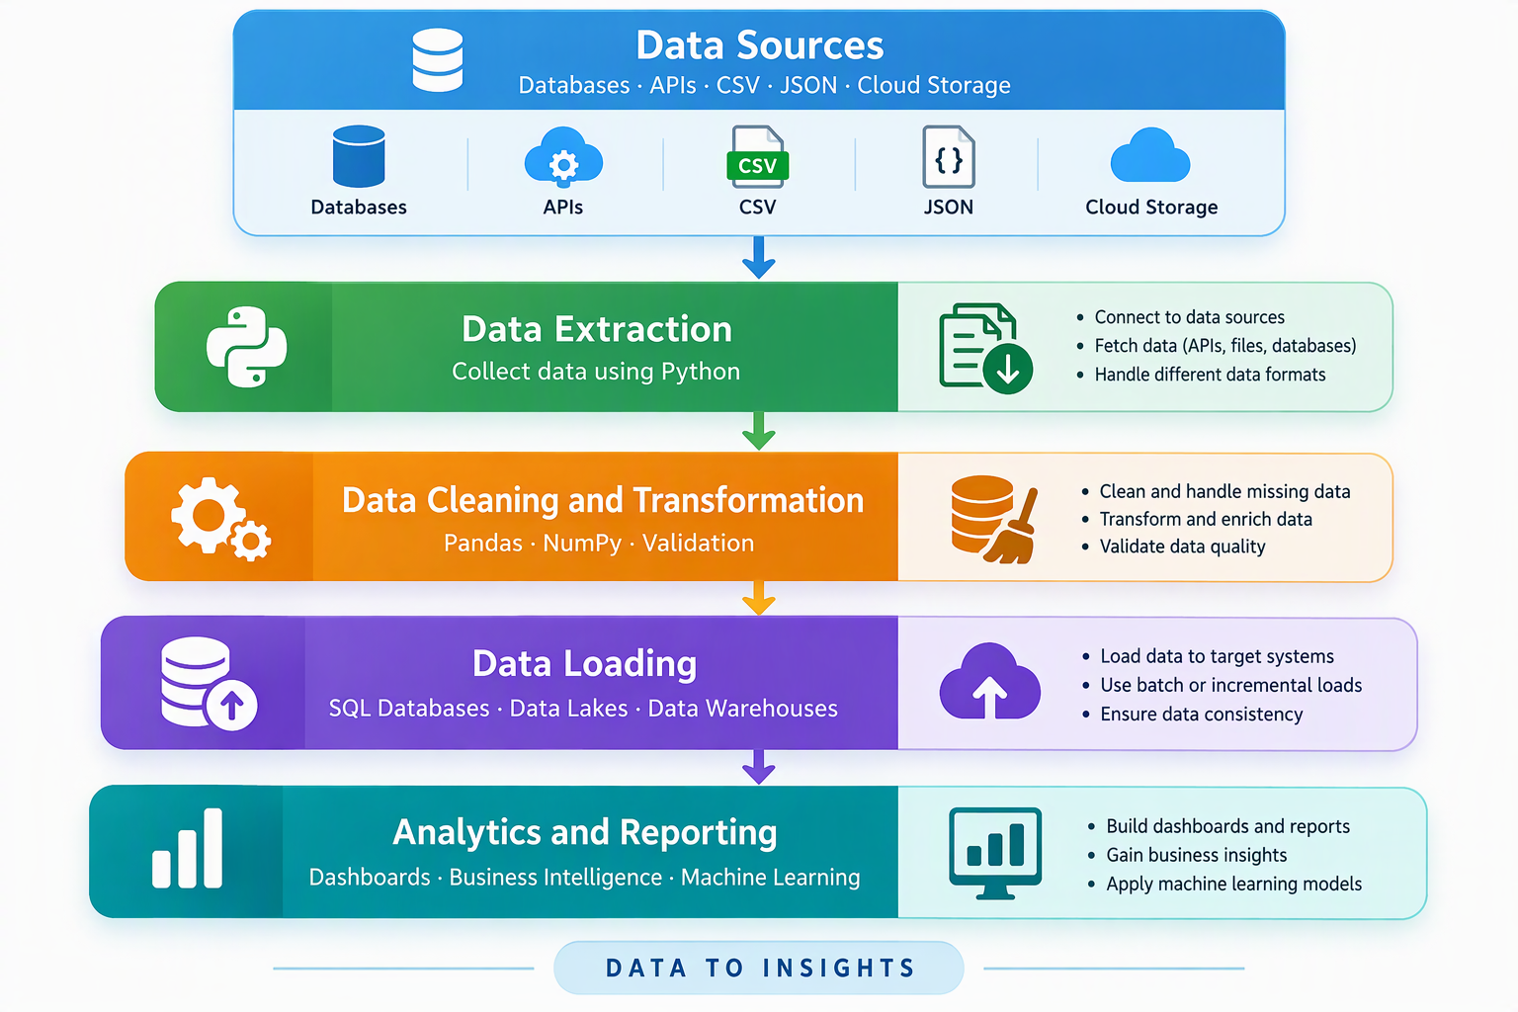

Working with Pandas and NumPy
Pandas & NumPy are two important Python libraries for processing & analyzing structured data.
Pandas is open-source Python library designed for data manipulation, cleaning, transformation, & analysis. It is particularly useful for working with structured datasets such as tables, spreadsheets, CSV files, & database records.
Core data structures in Pandas
- Series – It is a one-dimensional labelled data structure that can store values such as integers, floating-point numbers, strings, & dates.
- DataFrame – It is a two-dimensional, tabular data structure consisting of rows & columns, similar to a relational database table or Excel worksheet.

Employee DataFrame Example
Employee ID | Name | Department | Salary
101 | Amit | IT | 50,000
102 | Priya | HR | 45,000
103 | Rahul | Finance | 60,000
104 | Neha | IT | 55,000

Important Pandas Operations
- Data Loading – Pandas can read data from multiple sources, including CSV, JSON, Excel, SQL Databases, Parquet Files. This allows engineers to integrate information from different systems into a common processing environment.
- Data Inspection – Before processing dataset, engineers examine its structure & quality. Typical inspection activities include:
  - Identifying the number of rows & columns.
  - Checking column names & data types
  - Viewing sample records.
  - Identifying missing values.
  - Generate statistical summaries.
- Data Filtering – Filtering selects records that satisfy particular conditions.
- Data Grouping & Aggregation – Grouping organizes records according to common attributes, while aggregation calculates summary values.
- Data Merging & Joining – Pandas can combine datasets using common columns or indexes. Common join types in Pandas include inner joins, left join, right join, full joins.
- Data Sorting – Sorting arranges records in ascending or descending order based on selected columns.
- Data Exporting – After processing, Pandas can write data into files or databases for further use.
What is NumPy?
NumPy (Numerical Python) is a Python library designed for efficient numerical computations. It provides powerful multidimensional arrays & mathematical operations that are generally more efficient than conventional python lists for large collections of homogenous numerical data.
Key features of NumPy
- NumPy Arrays – A NumPy Array is a collection of elements, usually of same data type, stored in an efficient structure.
- Vectorized Operations – Vectorization allows mathematical operations to be applied to entire arrays without writing explicit Python loops for each element. This often improves performance.
- Mathematical & statistical operations – NumPy supports calculations such as sum, mean, median, standard deviation, minimum, maximum, & various mathematical functions.
- Array Reshaping – Reshaping changes the dimensions of an array without changing its underlying elements, provided the total number of elements remain compatible.
- Broadcasting – Broadcasting allows NumPy to perform operations on arrays with compatible but different shapes.
Pandas vs NumPy
Feature | Pandas | NumPy
Primary purpose | Data manipulation | Numerical computing
Main structure | Series, DataFrame | ndarray
Data types | Mixed column types | Usually homogeneous
Missing data | Extensive handling | Depends on data type
Grouping and joining | Built-in support | Limited
Best suited for | Structured business data | Numerical arrays and calculations
Role in Data Engineering
Pandas is commonly used to clean, filter, merge, & transform datasets, while NumPy supports efficient numerical calculations.
Data Cleaning and Transformation
Data collected from different sources is often incomplete, inconsistent, duplicated, or incorrectly formatted.
Data cleaning improves the accuracy, consistency, & usability of data.
Data Transformation converts data from its original format into a structure suitable for downstream application.
Data Cleaning
- Handling Missing Values
Missing values occur when information is unavailable or not recorded.
e.g.
Customer ID | Name | Age | City
101 | Amit | 30 | Mumbai
102 | Priya | NULL | Pune
103 | Rahul | 28 | NULL
Common techniques to handle missing values include:
- Deletion
- Imputation
- Default Value
- Forward or backward filling
- Removing Duplicate Records
Duplicate records can occur because of repeated file ingestion, API retries, or incorrectly planned database operations.
Deduplication identifies duplicate records & retains the appropriate record according to business rules.
- Correcting Data Types
Data types determine how information is stored & processed.
- Standardizing Data
It ensures values follow consistent formats
- Handling Outliers
Outliers are values that differ significantly from most observations.
- Data Validation
It checks whether records satisfy expected rules.

Data Transformation
Transformation converts data into a format that meets business or analytical requirements.
- Filtering
- Aggregation
- Joining
- Creating Derived Columns
- Normalization & Scaling
- Restructuring Data
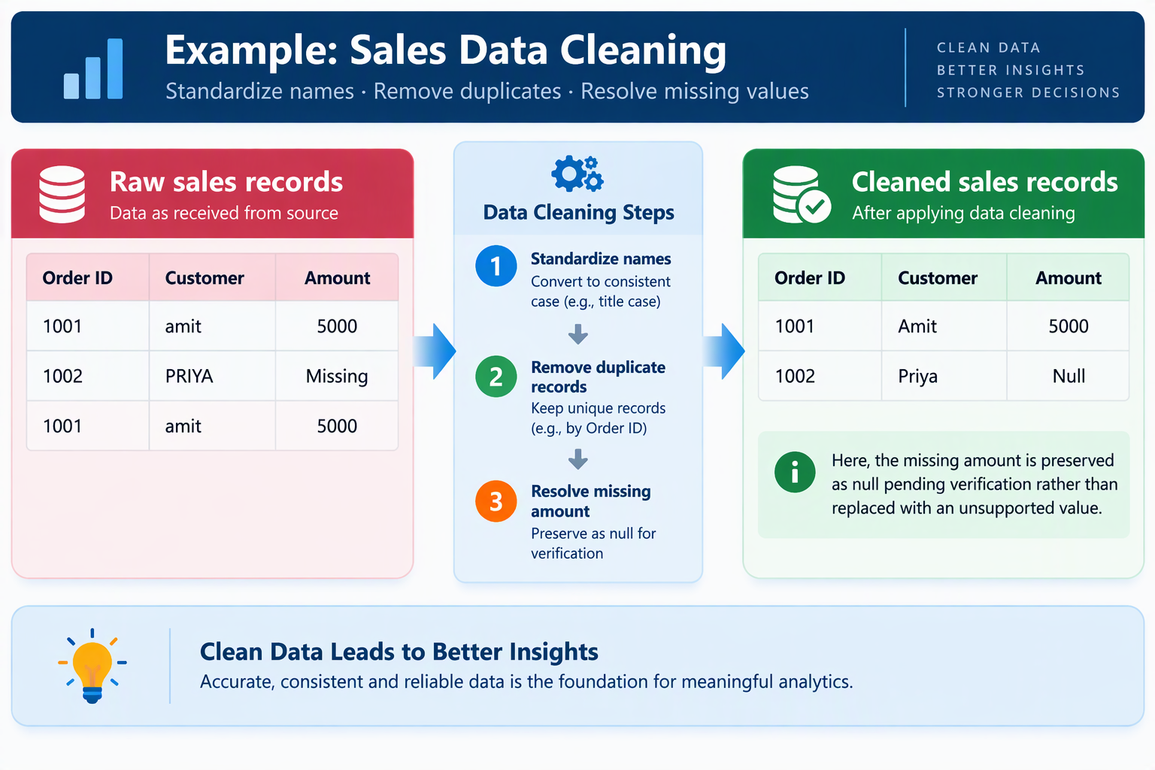

Importance of Data Cleaning & Data Transformation in Data Engineering
Cleaning & Transformation help ensure that reports are accurate, business rules are consistently applied, datasets are compatible across systems, & downstream applications receive reliable information.

Date and Time Operations
Date & Time processing is essential in data engineering because many datasets contain timestamps.
Python provides the built-in datetime module, while Pandas offers extensive date & time processing capabilities
Date & Time Types
- Date
- Time
- DateTime
- Timestamp
- TimeDelta
Common Date & Time Operations
- Date Parsing
- Date Formatting
- Date Arithmetic
- Extracting Date Components
- Time Zone Conversion
- Time-Based Aggregation
- Date Filtering
Common Date & Time Challenges
- Formats
- Missing Timestamp
- Time Zone Difference
- DayLight saving time
- Invalid Dates

API Data Extraction
An API allows software applications to communicate & exchange information.
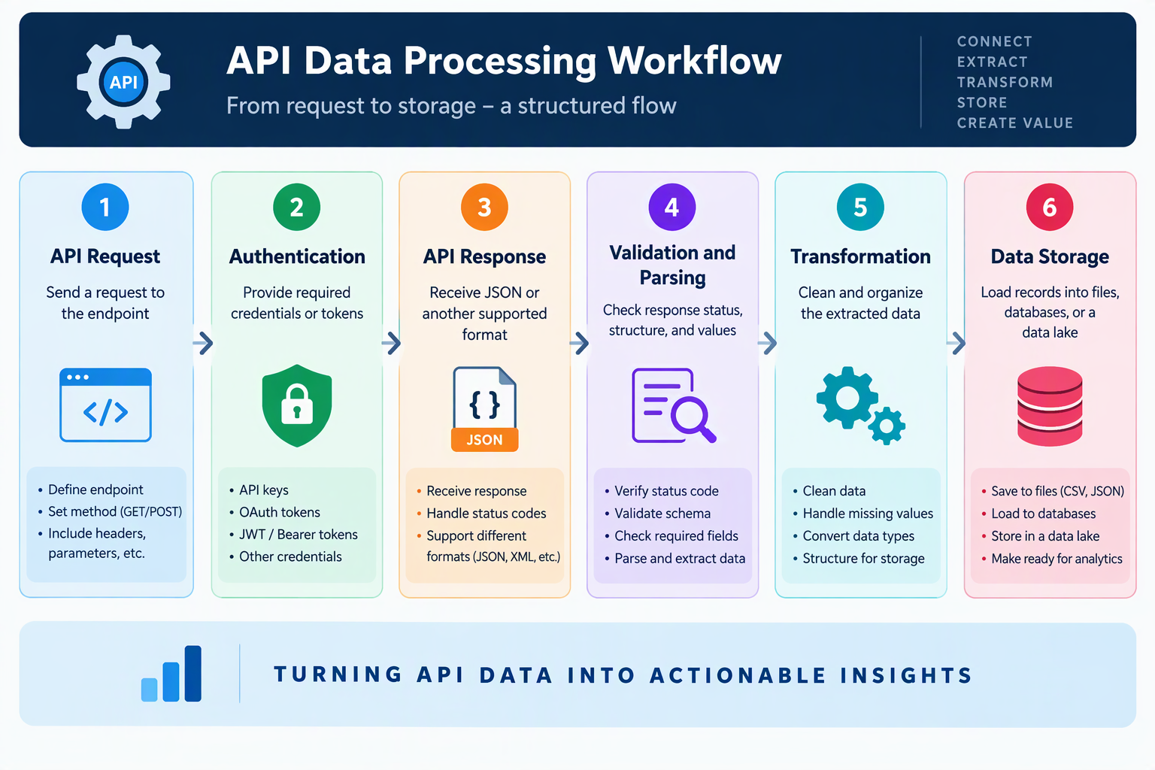

Database Connectivity Basics
Database connectivity allows Python applications to communicate with database management systems.
Data engineers use database connections to extract records, execute queries, load transformed data, and automate data movement.
Types of Databases
- Relational Databases
- NoSQL Databases
How Python connects to a Database
Requirements:
- Database Driver
- Connection Configuration
- Establishing a Connection
- Executing Queries
- Processing Results
- Closing Connections

