Agenda
Python Programming for Data Engineering
Python Fundamentals
- Introduction
- Variables and Data Types
- Operators and Expressions
- Conditional Statements
- Loops and Iterations
Python Data Structures
- Lists, Tuples, Sets, Dictionaries
- List and Dictionary Comprehensions

Python Programming for Data Engineering
Python Fundamentals
- Introduction to Python
Python is a high level, interpreted, general-purpose programming language widely used for developing software applications, task automation, building web sites, & creating ML & AI solutions.
Key features of Python language
- Simple & Easy to learn
- High-Level programming language
- Interpreted language
- Dynamically typed language
- Object-Oriented language
- Platform independent
- Open source
- Extensive standard library
Applications of Python
  - Web Development
  - Data Analysis & Visualization
  - AI & ML
  - Automation & Scripting
  - Data engineering
  - Cloud computing
How Python works?
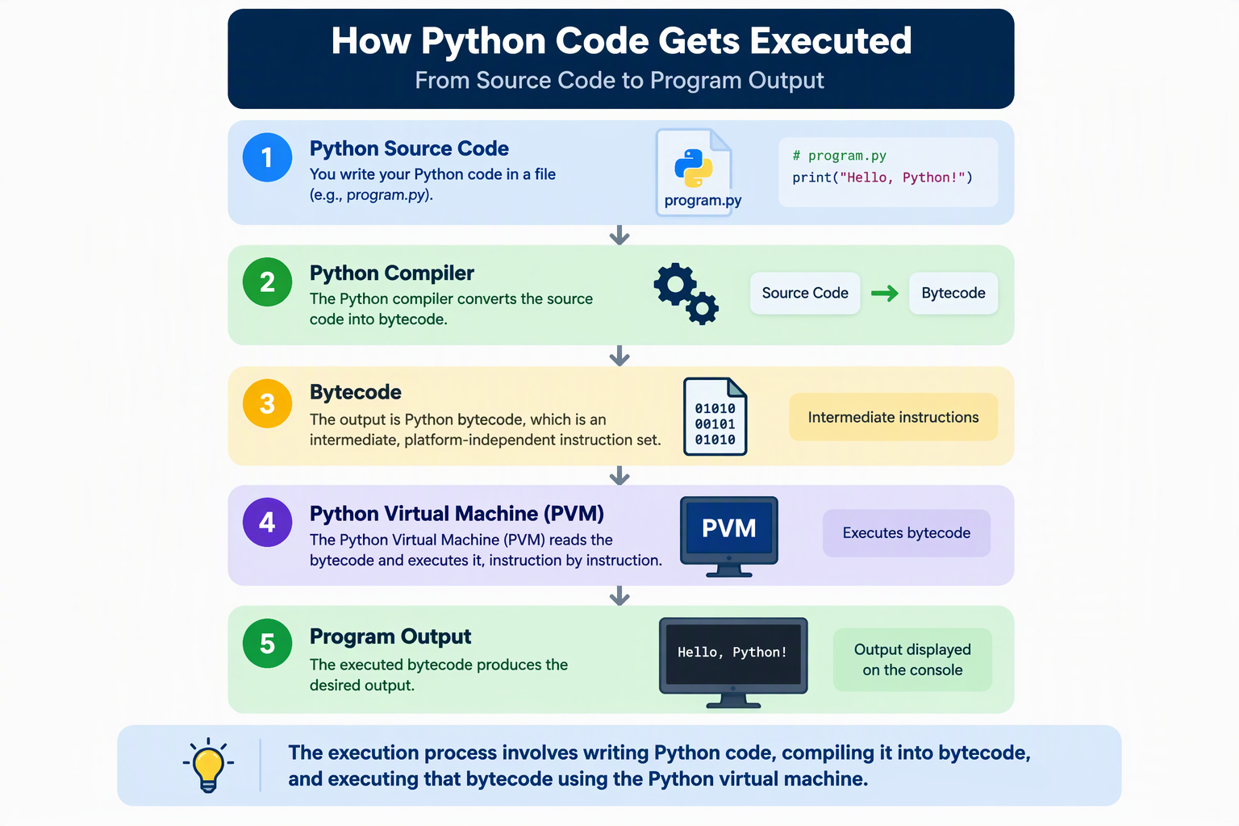
- Variables and Data Types
- Operators and Expressions
- Conditional Statements
- Loops and Iterations
Python Data Structures
- Lists
- Tuples
- Sets
- Dictionaries
- List and Dictionary Comprehensions

