Agenda
Inheritance
- Single Inheritance
- Access Control
- Method Hiding
- Initialization
Virtual Methods and Polymorphism
- Virtual Methods and Dynamic Binding
- Method Overriding
- Polymorphism
- Abstract Classes
- Sealed Classes

Inheritance
Inheritance is one of the four fundamental principles of Object-Oriented Programming (OOP), along with Abstraction, Encapsulation, and Polymorphism.
Inheritance allows a class to acquire the accessible properties, methods, and other members of another class.
It helps developers create relationships between classes, reuse existing functionality, and organize applications into logical hierarchies.
Important terminology
Term | Description
Base Class | The class whose functionality is inherited
Derived Class | The class that inherits from another class
Parent Class | Another name for the base class
Child Class | Another name for the derived class
IS-A Relationship | Represents the relationship between a derived class and its base class
Code Reusability | Reusing existing functionality without rewriting it
e.g.
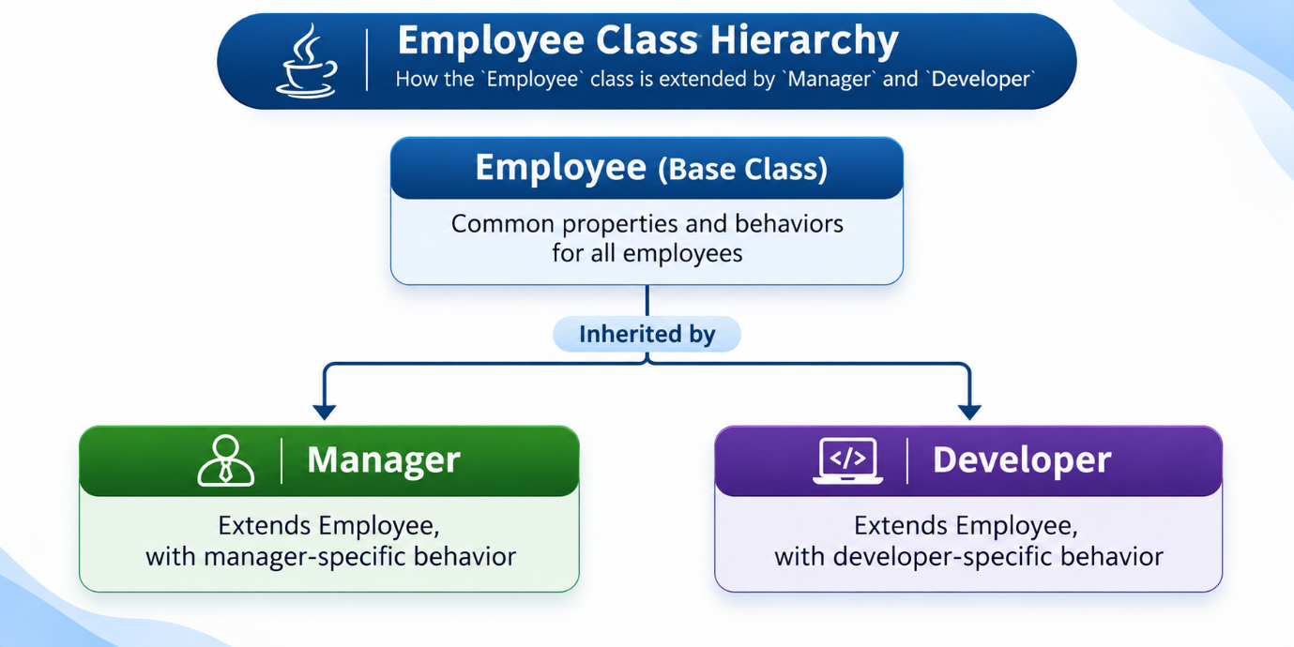

Single Inheritance
Single inheritance is a type of inheritance in which one derived class inherits directly from one base class.
e.g.
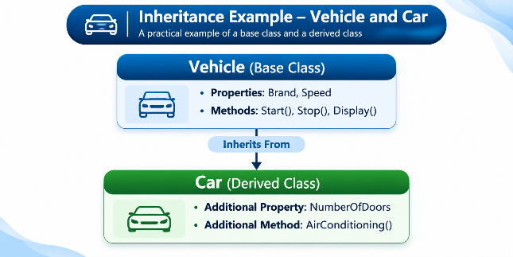
Characteristics of Single Inheritance
- One direct base class: A derived class can have only one direct class parent.
- Code reusability: Common functionality is defined in the base class.
- Extensibility: Derived classes can add new functionality.
- Maintainability: Common changes can be implemented centrally.
- Hierarchical organization: Classes are organized according to logical relationships.
Important Points
- C# does not support multiple inheritance of classes.
- C# supports implementing multiple interfaces.
- A class can inherit from another derived class, creating multilevel inheritance.
- Every class ultimately derives from System.Object.
- A class marked sealed cannot be inherited.
- A class marked abstract cannot be instantiated directly but can serve as a base class.
Advantages
- Reduce duplicate code
- Improves maintainability
- Encourage logical organization
- Supports method overriding & runtime polymorphism
Limitations
- Inheritance creates dependency between base & derived classes
- Changes in base class behavior may affect derived class
- Excessive inheritance can make applications difficult to maintain
- Inheritance should represent a genuine IS-A relationship.
Access Control
Access controls determine which members of a class can be accessed from other classes, including derived classes & objects.
C# provides access modifiers to control the visibility of class members.
Access modifiers in C#
Access Modifier | Description
public | Accessible from anywhere the containing type is accessible
private | Accessible only within the declaring type
protected | Accessible within the declaring class and derived classes
internal | Accessible within the same assembly
protected internal | Accessible from the same assembly or from derived classes in other assemblies
private protected | Accessible within the declaring class or derived classes in the same assembly

Access control comparison
Assume the member is declared in a public base class, with ordinary access through permitted instances.
Modifier | Same class | Derived class, same assembly | Derived class, other assembly | Unrelated class, same assembly
public | Yes | Yes | Yes | Yes
private | Yes | No | No | No
protected | Yes | Yes | Yes | No
internal | Yes | Yes | No | Yes
protected internal | Yes | Yes | Yes | Yes
private protected | Yes | Yes | No | No

Why is access control important?
Access control helps achieve encapsulation, security of implementation details, & maintainability.
Method Hiding
Method hiding occurs when a derived class declares a method with the same name and signature as an accessible method in its base class, causing the derived method to hide the inherited method.
In C#, method hiding can be explicitly indicated using the new keyword.
How method hiding works
Suppose a Manager object is created.
There are two ways of referencing that object:
- Through a Manager-type reference.
- Through an Employee-type reference.
e.g.
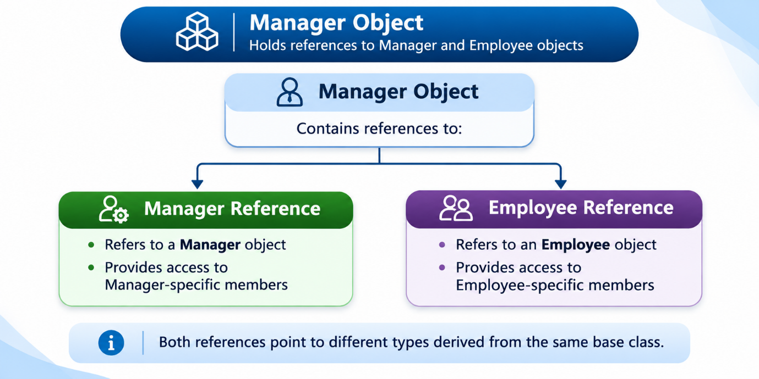
The new keyword explicitly indicates that the derived method is intended to hide an inherited member.
f a derived method hides an accessible inherited method without using new or override, the compiler generally produces a warning.

Method Hiding vs Method Overriding
Feature | Method Hiding | Method Overriding
Keyword | new | override
Base method must be virtual | No | Yes, or abstract/override
Method selection | Based on compile-time reference type | Based on runtime object type
Runtime polymorphism | No, for the hidden method | Yes
Base method replaced in virtual dispatch | No | Yes
Primary purpose | Introduce a separate derived-class implementation | Customize inherited virtual behavior

Important characteristics
- Method hiding does not remove the original base-class method.
- The base-class method remains available through appropriate base-class access.
- The derived method hides the inherited method for calls made through the derived type.
- Method hiding does not provide runtime polymorphism in the way overriding does.
- Method hiding should be used deliberately because it can create confusing behavior.
When should method hiding be used?
Method hiding can be useful when a derived class needs to introduce a member with the same name as a base-class member but does not intend to participate in its virtual behavior.
In most situations where derived classes need to specialize behavior, method overriding is preferable.

Virtual Methods and Polymorphism
Virtual Methods & Polymorphism allows the developers to create flexible, reusable, & extensible applications. And are closely related to Inheritance, because they determine how objects of derived classes behave when accessed through their base classes.
Polymorphism is an Object-Oriented Programming concept that allows one interface or method name to represent different forms of behavior.
Runtime polymorphism occurs when the method implementation to execute is determined during program execution.

It is primarily achieved using:
- Inheritance
- Virtual methods
- Method overriding
- Abstract methods
Advantages of Polymorphism
- Code Reusability: Common functionality can be defined in base classes.
- Flexibility: Different objects can implement the same operation differently.
- Maintainability: New derived classes can be introduced without changing existing code that works through the base class.
- Extensibility: Applications can support additional behaviors easily.
- Loose Coupling: Code can depend on common abstractions instead of specific implementations.
Virtual Methods and Dynamic Binding
A virtual method is a method defined in a base class that can be overridden by a derived class to provide its own implementation.
In C#, the virtual keyword is used to declare a virtual method in base class.
A derived class uses the override keyword to replace the inherited implementation.
Important Characteristics of Virtual Methods
1. Defined in a Base Class
A virtual method is declared in a class that provides functionality for derived classes.
2. Overriding Is Optional
Derived classes are not required to override a virtual method.
If a derived class does not override it, the inherited implementation remains available.
3. Supports Runtime Polymorphism
The appropriate overridden implementation is selected at runtime.
4. Can Have a Default Implementation
Unlike abstract methods, virtual methods normally provide an implementation in the base class.
5. Can Be Overridden Across Multiple Inheritance Levels
An overridden method can be overridden again by further derived classes unless overriding has been explicitly prevented.
Virtual Method vs Method Overriding
Virtual Method | Method Overriding
Declared in the base class | Implemented in the derived class
Uses virtual keyword | Uses override keyword
Provides an overridable implementation | Replaces inherited virtual behavior
Overriding is optional | Requires an inherited virtual, abstract, or override method
Establishes an extension point | Customizes the extension point

When to Use Virtual Methods
Virtual methods are useful when:
- A base class provides common functionality.
- Derived classes may need customized behavior.
- A default implementation is meaningful.
- Future extensions may require different implementations.
Abstract Classes
An abstract class is a class that cannot be instantiated directly and is intended to serve as a base class for other classes.
In C#, the abstract keyword is used to declare an abstract class.
Characteristics of Abstract Classes
1. Cannot Be Instantiated
An abstract class cannot be used to create an object directly.
Objects must be created from concrete derived classes.
2. Can Contain Abstract Methods/Properties
Abstract methods are declared without a method body.
They specify an operation that concrete derived classes must implement, unless an intermediate derived class remains abstract.
3. Can Contain Concrete Methods
An abstract class can contain fully implemented methods that are inherited by derived classes.
For example, a payment system may have a common amount-validation method shared by every payment type.
4. Can Contain Fields and Properties
Abstract classes can define fields, properties, constructors, and other members.
These members allow common data and functionality to be shared.
5. Supports Constructors
An abstract class can have constructors.
Although it cannot be instantiated directly, its constructor can execute during the initialization of a derived-class object.
6. Supports Inheritance
A class can inherit from an abstract class.
C# allows a class to inherit from only one direct base class, whether abstract or concrete.
7. Supports Polymorphism
An abstract base-class reference can refer to an object of a concrete derived class.
This allows different derived objects to be handled through a common abstraction.
Abstract Methods vs Concrete Methods
Feature | Abstract Method | Concrete Method
Implementation | No method body | Has a method body
Purpose | Defines required behavior | Provides actual behavior
Keyword | abstract | No special keyword required
Overriding | Required in a concrete derived class if inherited unimplemented | Optional only if declared virtual or override
Where used | Abstract classes | Abstract and concrete classes

Advantages of Abstract Classes
- Establish a common structure for related classes.
- Enforce implementation of essential operations.
- Allow sharing of common functionality.
- Reduce duplicate code.
- Support runtime polymorphism.
- Improve consistency across derived classes.
When to Use Abstract Classes
Use an abstract class when:
- Multiple classes have a strong parent-child relationship.
- Common fields or implemented methods need to be shared.
- Some operations must be implemented differently by each concrete derived class.
- You want to prevent direct creation of a general base-class object.

Sealed Classes
A sealed class is a class that cannot be inherited by another class.
In C#, the sealed keyword is used to prevent further inheritance.
Once a class is declared sealed, no other class can derive from it.
Characteristics of Sealed Classes
1. Prevent Inheritance
A sealed class cannot be used as a base class.
2. Can Be Instantiated
Unlike abstract classes, sealed classes can generally be instantiated, provided they have an accessible constructor.
3. Can Inherit from Other Classes
A sealed class can inherit from a nonsealed base class.
It simply prevents further inheritance.
4. Can Implement Interfaces
A sealed class can implement one or more interfaces.
5. Can Override Inherited Virtual Methods
A sealed class can override virtual methods inherited from its base class.
However, no subclass can override those methods further because the class cannot be inherited.

6. May Enable Runtime Optimizations
Because the runtime knows a sealed class cannot have subclasses, the compiler or JIT may be able to optimize certain method calls.

Sealed Methods in C#
A sealed override prevents a particular overridden method from being overridden again in further derived classes.

Abstract Class vs Sealed Class vs Normal Class
Feature | Abstract Class | Sealed Class | Normal Class
Direct object creation | No | Yes, if constructor accessible | Yes, if constructor accessible
Can be inherited | Yes | No | Yes
Can contain abstract methods | Yes | No | No
Can contain implemented methods | Yes | Yes | Yes
Can override inherited virtual methods | Yes | Yes | Yes
Can be declared both abstract and sealed | No | No | Not applicable
Primary purpose | Define shared structure and required behavior | Prevent inheritance | General-purpose class design

Virtual Methods vs Abstract Methods vs Sealed Overrides
Feature | Virtual Method | Abstract Method | Sealed Override
Keyword | virtual | abstract | sealed override
Has implementation | Yes | No | Yes
Overriding required | No | Yes, for a concrete subclass inheriting it unimplemented | No further overriding allowed
Defined in | Class | Abstract class | Derived class
Supports runtime polymorphism | Yes | Yes | Yes, through its inherited virtual dispatch
Main purpose | Allow customization | Require implementation | Prevent further overriding

