Agenda
Introduction to .NET
- What is .NET?
- .NET Framework and .NET Core
- Application Models
- Managed Code
- Visual Studio 2026
- C# Console and GUI Programs
Introduction to .NET
.NET is a modern software development platform developed by Microsoft. It provides a comprehensive environment for building, executing, & maintaining different types of applications.
- What is .NET?
.NET is a free, open-source, cross-platform development platform created by Microsoft for developing a wide variety of software application.
It provides programming language, runtime services, libraries, development tools, & frameworks that help developers create reliable, secure, & scalable applications.
.NET supports development for:
  - Desktop Applications
  - Web Applications
  - Websites
  - REST APIs & backend services
  - Mobile Applications
  - Cloud-based applications
  - Enterprise Applications
  - Background Services
  - Internet of Things (IoT) applications
  - Games & certain AI-enabled applications
Modern .NET supports Windows, Linux, macOS, although individual application frameworks may be limited to specific operating systems.
Main components of .NET
.NET consists of several important components that work together to provide a complete development environment.
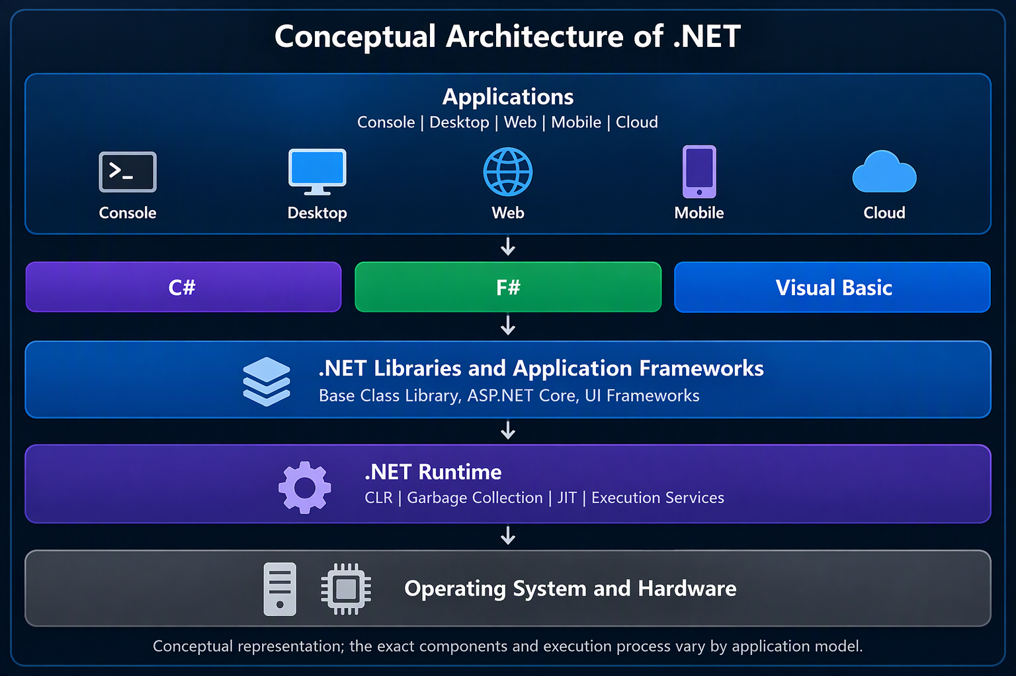
Common Language Runtime (CLR)
The CLR is the execution environment responsible for running managed .NET applications.
Its major responsibilities include:
  - Memory management (Automatic)
  - Garbage collection
  - Exception handling
  - Type Safety & runtime type checking
  - Thread management
  - Just-in-time compilation
  - Runtime security mechanisms
  - Coordination of managed execution
Base Class Library (BCL)
The Base Class Library is a collection of reusable classes, interfaces, & types provided by .NET.
It supports common operations such as:
  - String & text processing
  - File & directory management
  - Collections & data structures
  - Date & time processing
  - Networking
  - Input & Output
  - Multithreading
  - Exception handling
  - Data Serialization
The BCL provides consistent functionality across many different application types.
Software Development Kit (SDK)
The .NET SDK provides the tools required to develop .NET applications.
It includes:
  - Language compilers & build tools
  - Project templates
  - The .NET command-line interface (.NET CLI)
  - Package management support (NuGET)
  - Testing & publishing tools
  - Runtime & framework components needed for development
The SDK is primarily intended for developers, while a runtime-only installation is intended for systems that need to execute compatible applications.

Important characteristics of .NET
Feature | Description
Cross-platform | Modern .NET runs on Windows, Linux, and macOS.
Open-source | Source code for modern .NET is publicly available.
Language interoperability | Multiple .NET languages can share compatible libraries and types.
Object-oriented support | Supports classes, objects, inheritance, abstraction, and polymorphism.
Automatic memory management | Garbage collection manages most managed-memory allocation and reclamation.
High performance | Uses optimized runtimes, JIT compilation, and other performance technologies.
Security | Provides type safety, managed memory protections, and security-related libraries.
Scalability | Supports applications ranging from small utilities to large distributed services.
Rich ecosystem | Includes frameworks, packages, tools, and community resources.

Advantages of .NET
  - Developer productivity – Developers can use mature libraries, integrated tools, & consistent programming models.
  - Maintainability – Strong typing, modular design, & object-oriented features help organize large applications.
  - Performance – Runtime optimization, efficient memory management, & modern compilation techniques support demanding workloads.
  - Enterprise integration - .NET works with databases, identity systems, cloud platforms, & enterprise infrastructure.
  - Long-term support – Microsoft provides defined support lifecycles for .NET releases, including Long-Term Support (LTS) versions.
- .NET Framework and .NET Core & Modern .NET
Evolution of .NET
1 2002 .NET Framework (1.0 to 4.8)
2 2016 .NET Core 1.0 (1.0 to 3.1)
3 2020 .NET 5 (.NET 5 to .NET 11)
https://en.wikipedia.org/wiki/.NET_Framework_version_history
https://en.wikipedia.org/wiki/.NET

Comparison: .NET Framework vs .NET Core vs modern .NET
Feature | .NET Framework | .NET Core | Modern .NET
Initial release | 2002 | 2016 | 2020 (.NET 5)
Platform | Windows | Cross-platform | Cross-platform
Open-source | Partially | Yes | Yes
Performance | Mature legacy runtime | Optimized runtime | Continued optimization
Web development | ASP.NET | ASP.NET Core | ASP.NET Core
Desktop development | WinForms, WPF | Supported on Windows in .NET Core 3.x | Supported on Windows
Cloud development | Possible, older architecture | Strong support | Strong support
New feature development | Limited | Superseded | Active
Support status | Supported versions maintained | End of support | Depends on release

- Application Models
  - Console Applications
  - Windows Forms Applications
  - Windows Presentation Foundation (WPF)
  - ASP.NET Core Web Applications
    - Standard Web Applications
    - MVC Applications
    - Web APIs
  - .NET MAUI Applications
  - Cloud & Microservices Applications
  - Background & Worker Services

Comparison of .NET application models
Application model | Interface | Primary platform
Console | Text-based | Windows, Linux, macOS
Windows Forms | Graphical | Windows
WPF | Graphical | Windows
ASP.NET Core | Web/browser or HTTP | Cross-platform server
Web API | HTTP endpoints | Cross-platform server
.NET MAUI | Native graphical | Windows, Android, iOS, macOS
Worker Service | Usually no direct UI | Cross-platform
Blazor | Web-based UI | Browser/server, depending on hosting model

- Managed Code
Managed code is program code that executes under the supervision of the .NET runtime (CLR).
The runtime provides services such as memory management, garbage collection, exception handling, type safety, and execution management.
How managed code executes?
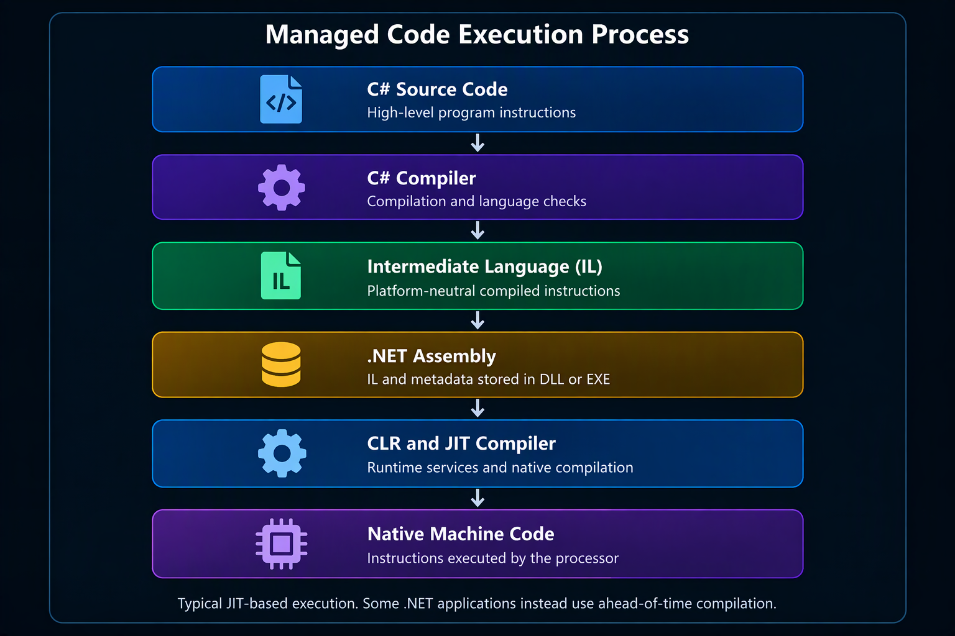
- Visual Studio 2026
Microsoft Visual Studio is an Integrated Development Environment (IDE) developed by Microsoft.
It combines software development tools into a single environment for creating, debugging, testing, building, and publishing applications.

Important Terminology
Term | Meaning
.NET | Microsoft's modern software development platform
.NET Framework | Original Windows-focused .NET implementation
.NET Core | Cross-platform predecessor of modern .NET
CLR | Common Language Runtime
BCL | Base Class Library
CTS | Common Type System
CLS | Common Language Specification
IL | Intermediate Language
JIT | Just-in-Time compilation
SDK | Software Development Kit
IDE | Integrated Development Environment
Assembly | Compiled .NET unit containing code and metadata
Managed Code | Code executed under .NET runtime management
Garbage Collection | Automatic reclamation of unreachable managed objects
GUI | Graphical User Interface
WinForms | Windows Forms desktop UI framework
WPF | Windows Presentation Foundation
XAML | Extensible Application Markup Language
ASP.NET Core | Modern .NET web application framework
.NET MAUI | Multi-platform App UI framework
NuGet | Package management ecosystem for .NET

